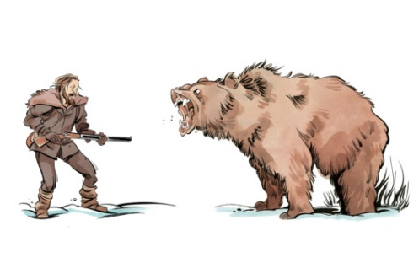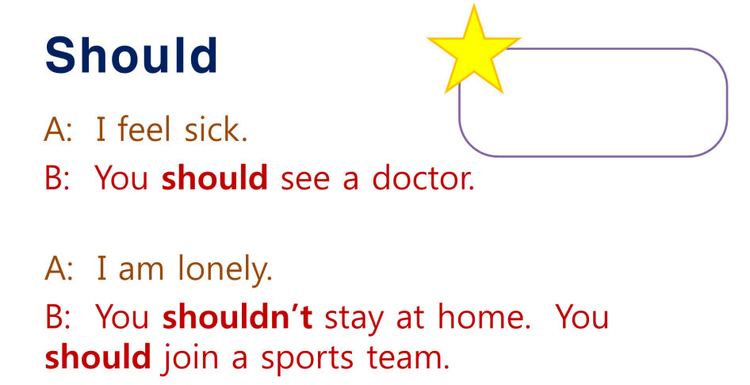

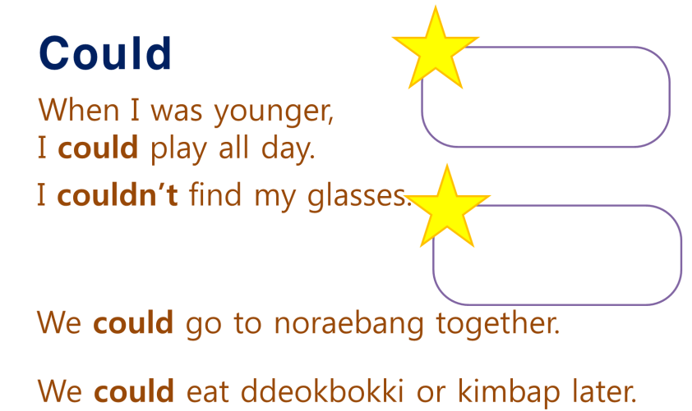

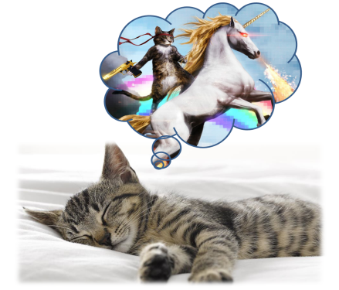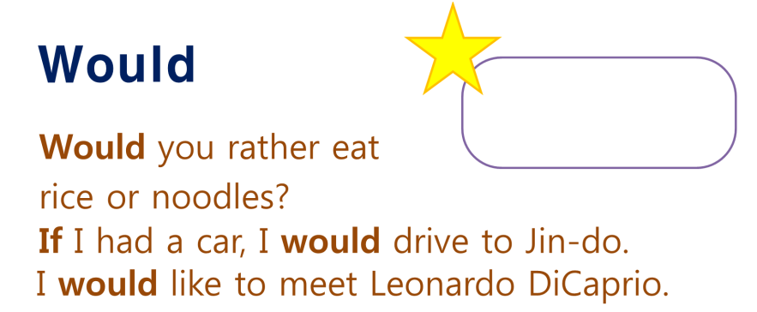

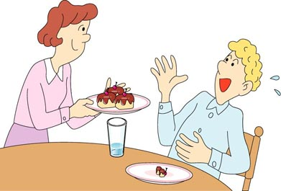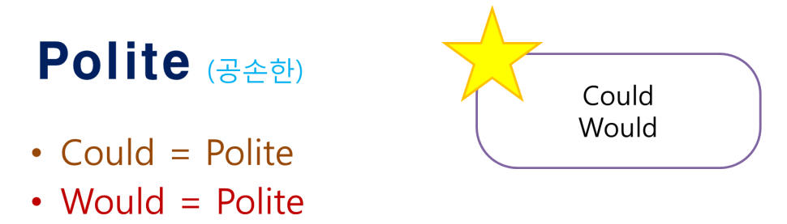

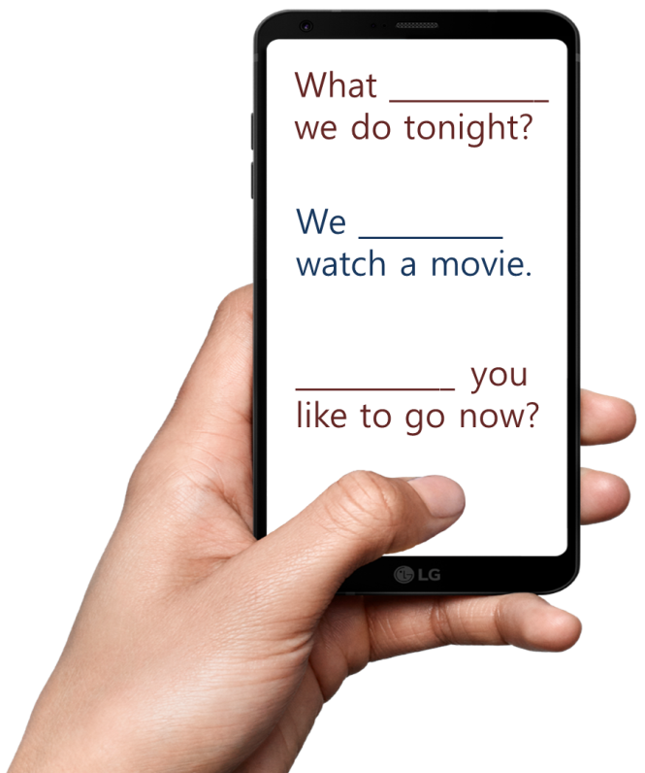

If I met an alien, I _________________ scream.

The dishes are dirty. I _________________ wash the dishes.

I wish I _________________ buy some food.

If I were you, I _________________ do that.

I did everything I ________­­­_________ for you.

Don’t make me angry. You _________________ like me when I’m angry.

If it was easy, everyone _________________ do it.

