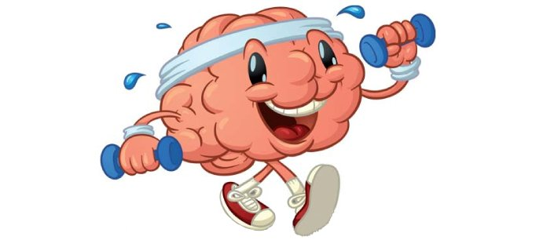
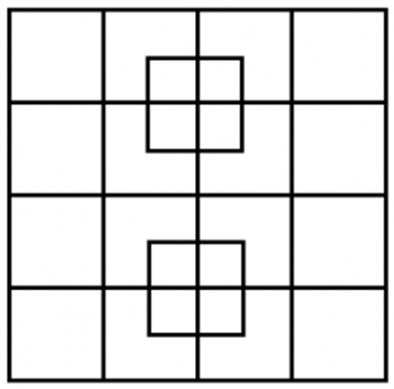
Is your brain getting enough exercise? You may think you have difficulty to remember things because of dying brain cells, but the more likely reason is a simple lack of use. Studies have shown that our brains are in their prime between the ages of 40 and 60. As a mature adult, you may not remember all the information you learned in school, but you’re in a better place to use what you have remembered. So why do some older people forget so many things? Like a muscle, the brain must be kept in shape. Stuck in a daily routine, it can become lazy and weak. Therefore, you must challenge it regularly to keep it healthy. You can easily do this by stretching it with puzzles.
- Why do you have a difficult time remembering things?
- When is our brain in it’s prime?
- Why do some people forget so many things?
- How can you stretch your brain?
