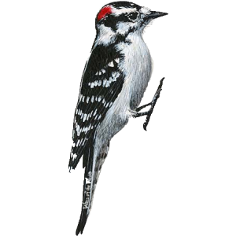
Woodpeckers spend their days banging their heads against trees. So why don’t they get headaches? Research has shown that the impact of a woodpecker’s brain against its skull is spread over a relativity large surface area. This makes the vulnerability of a woodpecker’s brain to injury very slight compared to those of a human brain. Furthermore, a woodpecker’s brain fits tightly inside it’s skull. This allows for hardly any movement, and there is little risk of injury. A woodpecker’s brain is also protected by the concentration of each impact on the areas of the skull that are the thickest. Consequently, much of the force that the woodpecker experiences is absorbed by its thick neck muscles rather than its brain.

