Writing III
Tim Schilstra
www.esltoybox.com

Goals of Class
- Trainees will be exposed to various writing activities while studying the history of English language. These activities will be useful for teaching students.
- Trainees will write creatively. They will write a character-based story.
- Trainees will gain confidence through writing creatively.
- Trainees will learn formal writing skills by writing an essay.
- Trainees will be able to create evaluation rubrics and metrics for classroom activities.

Course Outline

Unit 1: History of English | 13 hours
- Cognitive Tradeoff Hypothesis
- Cave Drawings
- Communication Over Time and Space
- Code Breaking
- Runes
- Beowulf
- Middle English
- Bubonic Plague
- End of Middle English
- Modern English
- Beyond English
- American English
- Riverboat Gamblers
- Cowboys and Rednecks
- Future of English
Unit 2: Character-Based Stories | 13 hours
- Character Creation
- Character Introduction
- Plot Outline
- Creative Writing
- Rising Action
- Climax
- Reading and Feedback
Unit 3: Formal Writing | 11 hours
- Topic Choice
- Research

Description of Units

History of English
In this unit, we will explore the history of written English. We will discuss how languages differ from other communication strategies by comparing us to animals. We will discover how English characters arose from cave paintings, to runes, to adoption of the Latin alphabet. We will look at how English has changed over the centuries and gain an understanding of where words, phrases, and idioms come from. We will see how an island specific language has grown into the lingua franca for the planet. We will discuss how English has changed based on geography with a special emphasis on American English. Finally, we will take a look at how English might evolve in the future and participate in thought experiments revolving around English writing.

Character-Based Stories
In character based writing, we will explore our creative skills. One of the hallmarks of fluency is to be able to use a language creatively. You will have the chance to spread your wings in the context of writing a short story. There will still be some structure so as not to cause too much stress. You will also be working in groups, responsible for your own characters. We will explore what makes a character great and how they interact with their world. We will use a writing process to help build our stories and then share them after we finish.

Formal Writing
In academia, we are often evaluated on our writing skills. The most common way this is done is through essay writing. We will write essays together while focusing on proper formatting. We will also use this opportunity to discuss evaluating students. We will create our own rubrics for evaluating the essays. After completing the essays, we will use those rubrics to mark our essays.

Writing III
Language is a strange thing. Many people believe that it is what separates us from the animals. But how true is that? Many mammals and birds have been shown to use a type of language as well as some insects (bees) and mollusks (squid). However, human language is unique. In this course we will study how English writing and indeed the language as a whole has evolved over time and how it will continue to change. We will take a look at the history of English. We will discover where certain words come from by looking at borrowed (loan) words. The history of Britain and the countries it has come into contact with have greatly influenced the English language. We will also participate in writing activities with the focus on two main types of writing: creative writing and formal writing. In the creative writing part of this course, we will look at creating a relatable character and creating a story that is character based. Through this activity, we will improve our creative writing skills. We will also be writing an essay in this course. We will use this opportunity to learn about a new subject and how to write formally. As we go through this section of the course, we will talk about creating writing assessments and how to give feedback to students in a way to encourage their writing. We will also look at writing games that can be used in the classroom. In the end, you will have a lot of opportunity to practice writing and to improve your writing skills. You will also gain ideas and knowledge on how to get students writing in the classroom.

Cognitive Tradeoff Hypothesis
Humans are certainly not the only animal capable of communication. All animals need to transmit information. Animals use communication to find mates, establish dominance, defend territory, coordinate group behavior and care for their young. They do this by using visual, auditory, chemical (pheromones) or tactile cues. Communication can happen between members of the same species or between different species. A common example of this is brightly colored frogs communicate to other species that they are poisonous. Another example is that of the common house cat. Adult cats rarely meow at each other. If you ever watch a video of a cat with an action camera, you will find that their vocalizations are very different from the meows we are used to. Baby kittens meow at their parents, but it is lost over time. Adult cats only meow at humans. It seems that this might be a strategy cats have developed to specifically communicate with humans. The most common forms of communication seem to be auditory. Chemical, tactile and electrical communication is quite local and the environment can be a factor. Visual cues are quite common as they are a great way to communicate information quickly, accurately and with emotion. However, auditory communication seems to be the most common. Information in sound is a useful way to communicate with other animals that are not close to you or that you cannot see. Another interesting aspect of communication is its relationship to time. How do animals communicate information over time and do they need to? Social animals (orcas, primates, ants, etc) can give information to other members who might not have first-hand knowledge. For example, ants leave a trail of pheromones after they find a food source to help others also find it. When the food is gone, the ants stop producing the pheromone. There are many strategies used by animals to communicate with each other.
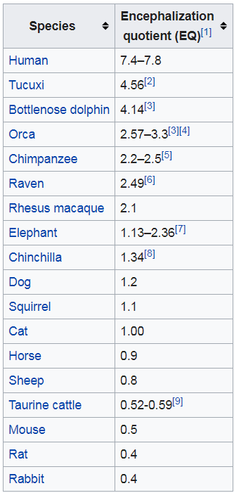
Over time communication techniques are continually developed to provide more specific information. This may lead to language. As we study other animals more intensely, we are discovering that language is not a unique human attribute. Orcas are also fascinating animals. It seems that orcas have well developed languages. Groups of orcas (pods) are unable to communicate with each other but pass information to the next generation with a complex series of clicks, whistles, pops and clacks. They also use visual and tactile cues to help the young learn how to hunt. The different pods of orcas have unique hunting styles that include; beaching (jumping out of the ocean to catch prey), tonic immobility (turning a shark or ray upside down paralyzes them), the wave technique (orcas create a wave to tip over a sheet of ice to get to sea lions), and the elbow drop (jumping on top of baleen wales to drown them). Young orcas are brought along on the hunt to learn. Sometimes the older orcas will keep an injured prey alive for the young orcas to practice hunting on. This is just one example of animal language. Some animals have refined communication to include aspects of language we find in human languages. Campbell’s Monkeys seem to use suffixes. Bengalese Finches use syntax to attract mates. Bottlenose dolphins have also been shown to use demonstratives, prepositions, conjunctions and locatives. Other animal languages that have been studied include: bird songs, bee dances, African forest elephant vocalizations, mustached bat echolocation, prairie dog alarm calls, whale songs, sea lion nonverbal cues, and Caribbean reef squid color changes.
But human language seems to be the most developed form of communication. For example, we are the only species we know about that uses written communication. Our oral language is also well developed including many grammatical structures not found outside of our species. An interesting theory that accounts for this is the Cognitive Tradeoff Hypothesis. Basically, this hypothesis states that to develop language we had to decrease other abilities. A brain requires a lot of energy to work. The more advanced a brain is, especially relative to body size, the large the need for glucose. “Encephalization Quotient” shows how large an animal’s brain is compared to what you would expect for an animal that size. This chart shows that humans’ brains take up much more of our bodies than other species. The maintenance of such a large brain, we need to give it more energy (glucose) than other species do. This means that other parts of our body had to decrease in ability to make room for our evolving brain. One such example is the comparison of musculature between humans and other primates. We are much weaker. The Cognitive Tradeoff Hypothesis says that we gave up our muscles to have a larger brain. Evolutionarily speaking, we rely on our brains more than others animals to survive.
We have also lost some brain function to make room for language. Communication involves a lot of areas of the brain. For example, when you read, you use your optic nerve and visual cortex to receive the information. Then you require the angular gyrus, Wernicke’s area, insular cortex, basal ganglia and cerebellum to process the information. If you wanted to respond by writing a message, you will need to use even more areas of the brain. In our first lesson of this section we will look at how a chimpanzee brain is different from a human brain. We will look at how Tetsuro Matsuzawa has analyzed short term memory in chimps. This may be one of the tradeoffs of having well developed language.

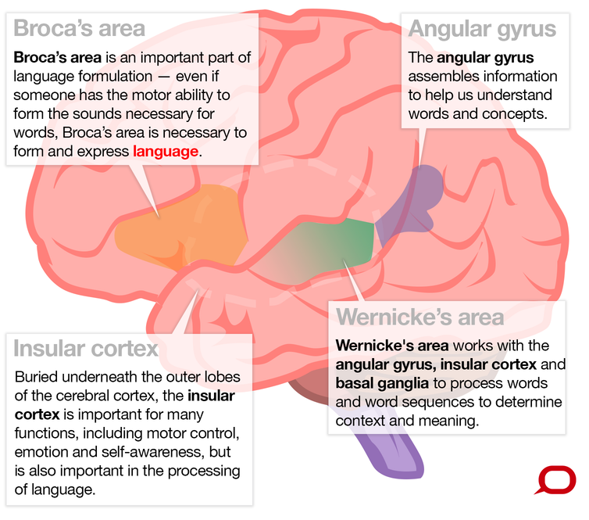

Writing is a strange thing. We produce symbols that have no intrinsic meaning, but we assign sounds (meaning) to these symbols. We can use this form of communication to give information to others all over the world and over time. But how did we get to this point? In the next section we will look at how English has evolved from cave paintings.

History of English Writing
Writing is a way for humans to communicate over large distances and over time. We can still hear the words of famous poets long after they have passed away. This makes writing a very important tool for communication in humans. It allows us to pass on information, store information and record information for the future. Our earliest forms of writing could be considered cave drawings. It was the first time that we attempted to represent the world around us in print. The idea of a written language would the thousands of years away, but cave paintings were our first attempt at symbolizing the natural word in print. The oldest cave paintings are 35,000 to 40,000 years old and often depict animals. Food sources would have been one of the most important things to communicate at that time. Cave paintings show what animals lived in the area. Some people believe that the paintings were made to magically (superstition) increase the number of prey in the area, others believe that the paintings represented dreams by shamans, while others think the paintings were merely to record the nature around them.
But cave paintings are not a language. They are more art than a form of communication. Over time, however, these paintings took on meaning. Prior to the invention of writing, pictograms and ideograms were used for communication. A pictogram is an icon or picture used to represent a physical thing. Similarly, ideograms are icons or pictures that represent ideas. Cave paintings could be considered pictograms, whereas early Egyptian hieroglyphs should be called ideograms. While these systems had the advantage of being understood easily (as long as the reader had context hints), they were too difficult to use as a complete written language. Too many different symbols would be required to share thoughts and opinions. It is much easier to convey details using words. Over time ideograms were simplified and used to represent more information than the original pictogram. By 3500 BCE, the first attempts at a writing system started to develop. The Kish tablet was made in this period. We can see how the pictograms are becoming more simplified and representative.
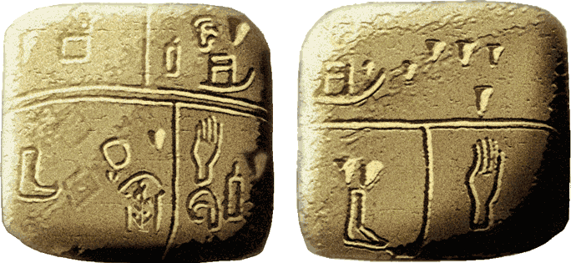
Another interesting story is that of Blisssymbols. Blissymbols is a writing system developed by Charles K. Bliss between 1942 and 1949. He wanted to create an internationally understandable writing system that is based on ideographs. Currently there are over 5000 authorized symbols in the alphabet comprised of simple symbols. They have been successfully used to help individuals with severe speech impediments communicate. It has also been used to bridge the gap between parent languages.
Logograms are symbols that represent words, phrases or morphemes of a particular language rather than concepts or objects. The earliest writing systems are example of logograms. Egyptian hieroglyphs, Sumerian cuneiform, and Chinese characters are logograms. A more recent example is Toki Pona. Toki Pona is an artificial language created by Sonja Lang and published in 2001. The purpose of this language was to simplify thoughts. She uses 120 logograms to make her alphabet. It was her attempt to minimalize language down to what is most important.

Old English
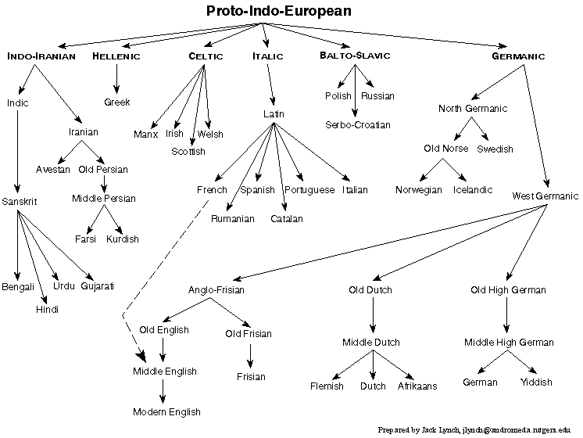
Before our recognizable Latin alphabet was imported from the Romans, runes were used as a form of writing on the British Isles. The collection of characters is known as the Futhorc. They were used from the 5th century until the Normal conquest in 1066. Futhorc can be found in Frisia as well. Frisia was an area near England, but on the continental coast. Old English was heavily influenced by Old Frisian. They shared the same linguistic family, fishing area and traded with each other frequently. Frisian is considered the closest relative to English today, the Anglo-Fris branch of West Germanic. Both languages have diverged in the centuries since they were together, but we share a lot of similar words. A rhyme has survived through the years to show the similarities in the languages. “Brea, bûter en griene tsiis is goed Ingelsk en goed Frysk.” means, “Bread, Butter and green cheese is good English and Good for Fris.” Since the pronunciation is quite similar, the rhyme works in both languages. A few other examples of words that came from Fris include: heart, sheep, where, sea, storm, summer, seed, two, three, four and here.
As the Germanic tribes moved into Britain after the collapse of the Roman Empire, they brought the Anglo-Fris language. They also ran into conflict with the Celts, but surprisingly we did not inherit many words from them. Crag, comb, brat, and brock are uncommon words that have survived. Place names however show Celtic influence. London, Dover and the Thames River all derive their name from the Celts. Furthermore, town and cities ending in –ing (the people of), -ton (village), and –ham (farm) can trace their etymology to the Celts.
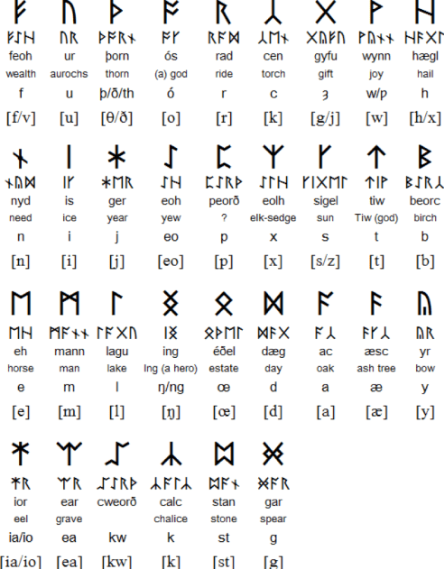
Words from Old English aren’t dead. Anglo-Saxon words like; youth, son, daughter, in, on, into, and, the, numbers, drink, love and game are preserved from the earliest form of English. As a matter of fact approximately 25,000 words from Old English are still used today. Pronunciation and spelling changes over time, but Old English has survived. Considering that the Oxford Dictionary includes 171,476 headwords, and the average English speaker has about 10,000 words in their active vocabulary, the number of Anglo-Saxon words is significant. Coincidently, the largest dictionary by number of entries is 우리말샘 (Woori Mal Ssaem 2017) with 1,100,373 entries.
One of the earliest individuals to heavily influence the English language was Augustine of Canterbury. He is considered the Apostle to the English and the founder of the English Church. As a missionary from Rome, he brought the Latin alphabet with him to the British Isles. The Latin alphabet replaced the Furthorc runes and would be used in scholarly and Christian texts for centuries. Runes were useful to the Anglo-Saxons because it was easy to carve into wood and rocks, but now paper became the medium of choice. The Latin alphabet, with its curves was easier to differentiate symbols. It is a much better choice for writing and reading paper documents. In Furthorc, each letter represents a phoneme. Latin wasn’t made for English, so this marks a point in English history where it diverged from a phonetic language (where there is a direct link between spelling and pronunciation).
It is from this time period that one of the most important pieces of literature in English, the epic poem of Beowulf, was produced. While it is impossible to pinpoint the date this was first written down, the oldest manuscript we have has been dated to the late 10th century. The story likely originated as an oral tale with events set in the 6th century. It was recorded for us in Old English using the Latin alphabet. The poem is the longest one from Old English with about 40,000 words (3,100 distinct words). Beowulf was written to be read aloud. It is praised for its description and action. It is a great example of the indicative mood which kept the listener invested in the story. Beowulf also gives us insight into how words were constructed in Old English. Object names were more descriptive and less of a label. Beowulf made use of compound words with a metaphorical undertones (kennings). Ribs were a bone-cage, blood was battle-sweat, a sea was a whale-road, and a harp was joy-wood.
Another strong influence on Old English were the Vikings. Vikings were also known as Norse, Norsemen, Northmen, Danes, the Great Army, the Great Sea Wolves and Sea Rovers. They began showing upon the East coast of Britain in the 8th century. They sacked towns and looted holy places. The Christian treasures were nothing more than gold adornments to them. At first they would just take from the coastal town, but by 840 they would end up settling in England as well. At one point, the Danes controlled Northumbria, East Anglia, and parts of Mercia with ambitions to continue South-West. The British Isle was in danger of being completely settled by the Danes until King Alfred rose to power. King Alfred was the first king to have success against the Danes, eventually forcing them into a peace treaty. He is credited with saving England and saving the English language. For this he gained the title of Alfred the Great. To this day, he is one of only two English men to be bestowed the honor this title. The English and Danes would share ownership of Britain until Alfred’s grandson, Athelstan, took control of Danelaw (the area controlled by the Danes). However, many of the inhabitants were now of Scandinavian ancestry.
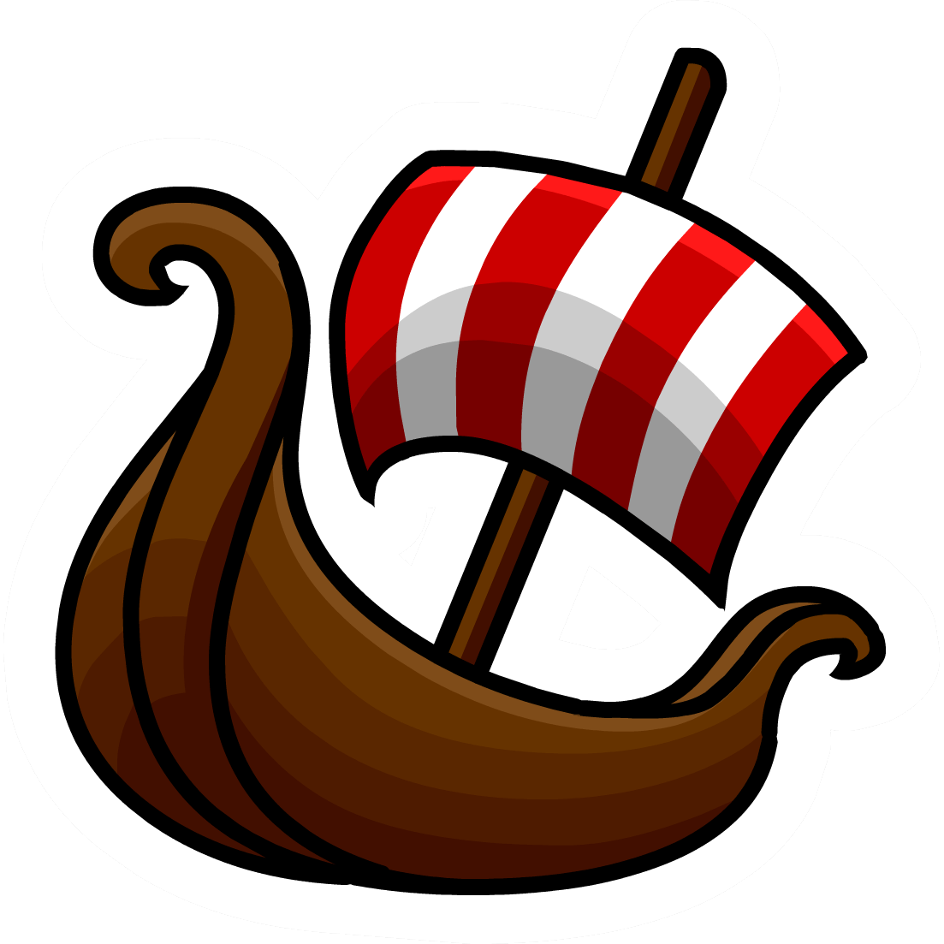
With the Norsemen, new words entered the English vocabulary. It is estimated that 85% of Anglo-Saxon words were lost as the result of Viking and Norman invasions. Around 400 words were borrowed from Old Norse including; egg, die, bread, freckle, anger, neck, ugly, window and many other words. They also gave us the sk sound in words like sky and skull. A very common name suffix (-son) came from a naming practice of the settlers. They also gave us they, them, and they’re. When two words with the same meaning were equally used, they gained slightly different meaning. Old English had craft, hide and sick; while Old Norse had skill, skin and ill. The settlers also added some inflectional endings that became confused (for example, -um and –an). Because of this prepositions started being used. Norse gods became the days of our week. Woden’s (Odin) day is Wednesday, Thor’s day is Thursday, Freya’s day is Friday and so on. Old Norse had a profound effect on the English language.
In addition to saving England from the Great Heathen Army, King Alfred was also responsible for preserving and expanding the English language. Alfred believe that the army would not prosper without Christian wisdom. So, he set out to make education more available. Part of this was making education more available by using the language of the people, English. Traditionally, education was always in Latin. King Alfred commissioned texts to be written in English. If people wanted further education, they would need to use Latin. Alfred the Great was the savior of Old English.

Middle English
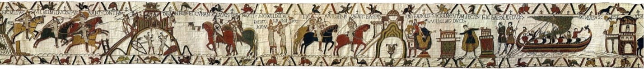
The history of England and, indeed, English were dealt a large blow in 1066 with the Norman invasion. With the Normans in control, English went underground and didn’t return to prominence until 300 years later. During those 300 years, English became a peasants’ language and underwent a lot of changes. English was rarely written in this time, but was commonly spoken.
Normandy was an area of what is now France. It was ceded to Rollo (Viking) by Charles III in 911. In exchange, Rollo converted to Christianity and helped to repel other Viking invasions. These Normans lost their Viking ties and spoke a rural dialect of France. Normandy would expand in 924 and 933 and would to look northwards to claim more land. By 1066, the kingdoms of England had unified. William the Conqueror took advantage of Edward the Confessor’s death and successfully invaded England. Norman rulers would go on to also claim Sicily and control the lands from Scotland to the Pyreneans. The Normans brought their language with them. It was a dialect of Old French and referred to as Anglo-Norman French. The new ruling class consisted of 190 men, of which 11 had nearly all the power. None of these rulers could speak English. French was adopted for state business and administrative purposes, though Latin was the official language for government. Interestingly, some of the earliest French manuscripts were written in England as Latin was the language of the church and education. From 1066 until the 14th century, England would be ruled by a French King.
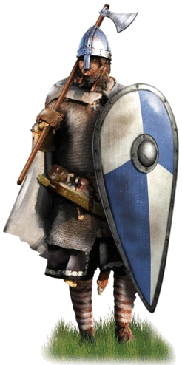
Although French had a large impact on the country, everyday lives did not include much French. Businessmen had to conduct business with French speakers. English was introduced to the words: city, market, porter and over 500 food words. When France reclaimed Normandy in 1204, the remaining Normans in England would marry into English family. Nurses and maids probably taught English to Norman aristocratic children along with their mothers. Perhaps aristocrats would have spoken English to their servants and French among other dignitaries. Many nobles would need to start learning French from books as it was a foreign language by this time. The Normans had a larger influence on the English language than any other group of people. From war times we gained the terms: battle, enemy, castle, army, soldier, garrison, and guard. During their rule they imposed their language with the likes of; throne, royal, servant, govern, liberty, authority, traitor, judge, jury, acquit, villain, serf, prison, jail and accuse. The Anglo-Norman language also influenced English by adding some suffixes; -age, ance/ence, -ant/ent, -ment, -ity, and –tion.
One interesting leftover of this situation can be found in the meat we eat. Since the servants and farmers supplying the meat only spoke English, they talked about cows (ox), calves, sheep, deer, pigs and chicken. But the aristocratic consumers labeled these as beef, veal, mutton, venison, pork and poultry. Nowadays the animals have Old English roots and the meats have Old French roots. An apple meant any type of fruit in Old English, but now meant just one type. An English middle class made of businessmen arose and picked up many French words like merchant, money, price, discount, bargain, contract and partner. French was the international language of trade at the time. The Normans gave England access to trade with new countries, where more words made their way into the English language. From Arabic, we got hazard, alchemy, loot, amber, syrup and checkmate (meaning the king is dead).
Grammar became much simpler during the Norman occupation with some rules completely disappearing. “The” could be used as a pronoun in Old English, but in Middle English it took its place as a definitive article. Word order was also becoming solidified prior to the invasion. Now, English became fractionalized. There was extensive variation between regions, especially in pronunciation and spelling. The few gendered suffixes all but disappeared during Middle English, though some remnants exist like -ess (princess, actress). The 11 different inflections for adjectives in Old English were reduced to just plural and singular. A common suffix in Old English (-en) was replaced by the French (-s). A few Anglo-Saxon plurals survive: men, women, children, brethren and oxen. Dual nouns and pronouns were replaced by simpler plural forms. There were some changes in tense, especially third person. The Subject-Verb-Object order became entrenched. Some characters from Old English were dropped in favor of the Norman alphabet at this time. We lost eth (ð), thorn (þ), Wynn (ƿ), Yogh(ȝ), Ash(æ), and Ethel (œ). These changes were likely the result of two language systems trying to merge. Rules are lost and the language is simplified.
Norman French was the new normal. It helped to define English even as it was trying to replace it. As with animals and meat, the import of new language served as a way to narrow the language used to make it more exact. A small axe in English was a hatchet in French. Each word added made the language more specific. There are small differences between; ask (English) and demand (French), answer (English) and respond (French), wish (English) and desire (French), might (English) and power (French), sight (English) and vision (French), as well as liberty (English) and freedom (French). These weren’t quite synonyms but added nuance to the English language. The humble trades kept their Anglo-Saxon roots (baker, miller, shoemaker), while newer and more skilled trades adopted French words (mason, painter, tailor). Some French words simply replaced the Old English. Crime replaced firen, people replaced leod and beautiful replaced wlitig. The French also changed some English spellings. For example, the Normans wrote “wh” instead of “hw”, but also added a w to some h- words that were not needed (whole).
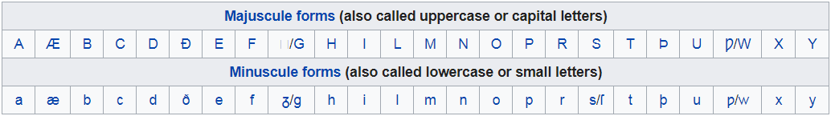

By the 14th century English was the unifying language. French was fading from use and no one could speak Latin fluently. Even the Christians started to dabble in English. The bestiary (a catalogue of beasts for Christians to reference) was written in Latin until the 14th century. However, in 1349 England and all of Europe would be hit with a catastrophe. The Bubonic Plague (Pasteurella Pestis) came to Europe on the backs of black rats. To be more precise, the lice living on the back of the rats carried the bacteria. A quarter to a third of England’s population died. Peasants were more likely to survive because they had less contact with people. Much of the royalty and people living in cities were hit hard. The number of clergymen was cut in half. They had a lot of contact with sick people due to their position in society. Some clergy simply ran away. In their place, the church was forced to replace them with laypersons. These new members had a hard time understanding the Latin texts. However, only a priest could read the bible. This kept the church in control of its parishioners. It also didn’t hurt that it was compulsory to attend church. The next advance in the English language would come from this tumultuous time.
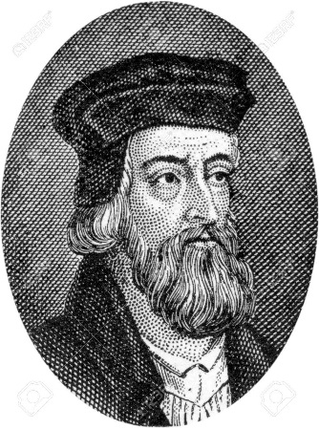
John Wycliffe was a 14th century English philosopher, priest, translator, and seminary professor at the University of Oxford. He believed that all people should be able to examine the bible with their own eyes. Of course, the church did not like this idea. So, Wycliffe secretly translated the bible by hand with his associates. If he was successful, he would overthrow the powerful through words, a novel idea. Between 1382 and 1395, Wycliffe’s team (as Wycliffe died in 1384) was responsible for producing what is now known as the Wycliffe Bible. His team was prolific. Despite having his bible declared heretic and unlawful (and burned), more than 150 copies still exist today. This suggests that his bible was distributed widely and in great numbers. His team considered the Latin texts to holy and so translated the bible word for word. This lead to some interesting sentences like, “Lord go from me, for I am a man sinner.” Some Latin words appeared in English writing for the first time: emperor, justice, profession, cradle, angel, glory and multitude. Wycliffe also had to coin new terms like: woe is me, and eye for an eye, birthday, communication, dishonor, godly, graven, humanity, oppressor, pollute, unfaithful, visitor and zeal. Wycliffe’s bible is considered one of the most influential English texts of all time.
The Black Death had also shifted the balance of power in England. There were fewer laborers, so they could demand more money, better working conditions and more power over the land. Wages for laborers rose. Property values decreased and peasants bought up the lands. People were rising through society and they brought English along. By 1385 English had replaced French in classroom. In 1362 English was acknowledged as an official language for official business. In 1399 King Henry IV ascended to the throne. He was the first ruler (since the Norman invasion) whose mother tongue was English.
Few English works survive from this period with one notable exception. Geoffrey Chaucer produced the most famous work of this time period, The Canterbury Tales. The Canterbury Tales are 24 short stories complied into one book. The stories are told by a group of pilgrims on their way to Canterbury. Chaucer, who was a seasoned traveler changed the type of language and chose different ways of spelling based on the characters in story. He used longer French borrowings for poetic effect. He forwent the English terms hard, unhap, cenship, and uncunning for difficult, disadventure, dishonesty and ignorant in ‘Hens and Cocks’. And when he needed a more earthy style he uses Old English words. In Miller’s Tale we are reintroduced to the Old English words farting, restless, friendly, learning, restless and wifely. Chaucer used almost 500 French loan words in Canterbury Tales. He introduced the public to dialects but he worried that his stories would be misunderstood or lose meaning if the reader didn’t know the dialect. He became the standard bearer of English form and was the first person buried in “Poet’s Corner.” He made the London dialect the standard English. Of the 2000 words he introduced to English, many were probably everyday London words. Chaucer may have been one of the prime movers in getting rid of the honorific form of English. This can be seen in his disregard for distinguishing thou and ye in polite company. Some consider Chaucer’s English to be the last example of pure English, while others credit with him providing the footprint for Modern English. Whichever you believe, be assured that Chaucer was most important writer of Middle English.
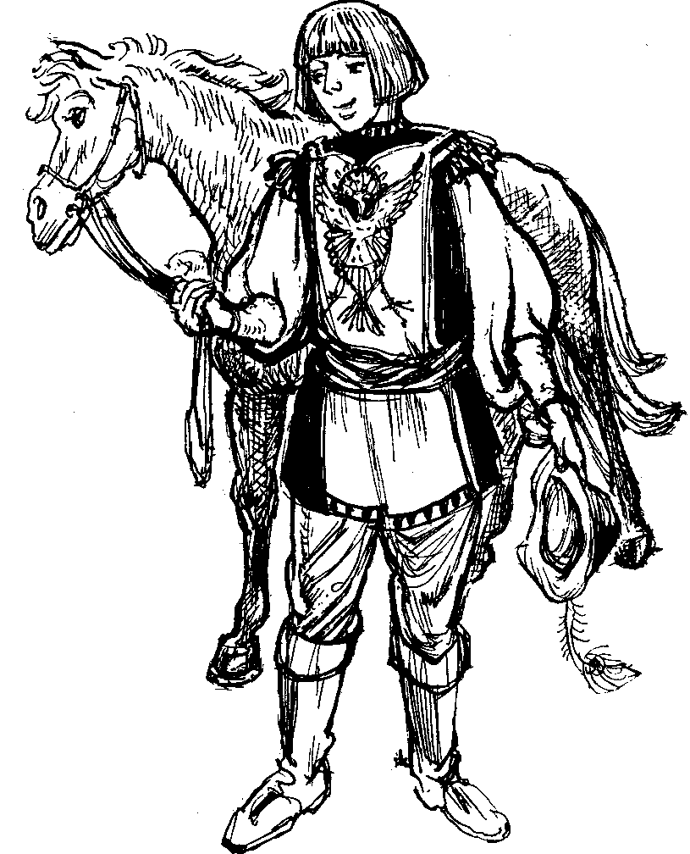

Modern English
It is generally accepted that the end of Middle English and the beginnings of Modern English occurred during the Great Vowel Shift. During a relatively short period (100 – 200 years) a radical change to pronunciation occurred. Long vowels began to be made higher and further forward in the mouth. This vowel shift also separated English from most other European languages. It also separated the phonetic pairs between long and short vowels. It is not entirely certain why pronunciation changed, but it appears to be an entirely English phenomenon. This is when modern pronunciation arose. Some spellings changed to better reflect this change in pronunciation. Stan became stone, rap became rope, derk became dark, and herte became heart. Most words however retained their original spelling, which causes confusion even today. There were some pronunciation changes to be aware of. The voiceless fricatives in laugh and cough began to be pronounced with an f sound. We stopped pronouncing some consonants like: the b in dumb and comb, the l in walk and talk, and the initial g and k in knee and gnaw. In 1569, the grammarian, John Cheke proposed removing all silent letters.
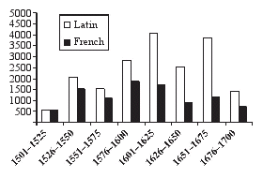
Another heavy influence on the shift to Modern English was the English Renaissance. This era may also be referred to as the “Elizabethan Era” or “Shakespearean Era”. The Renaissance Era is a period of European history covering the 14th to 17th centuries. During this time, there was a resurgence in the popularity of classical languages like Latin and Greek. Often words were directly lifted from these sources and inserted into English. From this period, we see the introduction of: genius, species, militia, focus, lens and nausea. The Greek suffixes -ize and -ism were brought to English around this time. If a more appropriate word could be found, it was used in place of the English equivalent though the replaced words were retained. This is why we find masculine in addition to manly, feminine in addition to womanly, and paternal in addition to fatherly. Scholars adopted Latin so vigorously and awkwardly that the term ‘inkhorn’ was coined to describe them. Most inkhorn terms have been dropped but a fair number are retained in English including: dismiss, disagree, celebrate, commit, capacity, ingenious, industrial and external. There were further consonant pronunciation loses in English. Island, school, scissor, herb, and people now included silent letters (S,H,C,P). In the end, English became recognized as scholarly language and it moved away from the peasant language of Middle English.
The printing press had a larger impact on all languages than any other invention. This was true for English as well. The printing press was introduced into England by William Claxton in 1476. The first book printed in English was Claxton’s translation, “The Recuyell of the Historyes of Troye.” The “Canterbury Tales” and “Tales of King Arthur” became best sellers. English literature became cheaper and more available. These books pushed English above Latin in popularity. However, English was still divided into 5 major dialects. Each dialect had its own form of spelling with variations inside of it. The word church could be spelled 30 different ways: churche, cherche, chirch, chyrch, charge, chyche, schyrche, etc. The endings -eth and -th were used in the South (goeth), but were written as -es and -s in the North. The word though could be spelled in an unbelievable 500 different ways! There were also regional pronunciations. The ending –ing was said as -and in the North, -end in the East Midlands, and -ind in the West Midlands. The printing press was also limited to European languages. Runic based symbols like thorn (þ) were not found on the printing press. So, publishers began using y in its place. The word now spelled ye. In England today, you might find old drinking establishments called “Ye Olde Pubbe”. And now you know why. The printing press illuminated the need for a standardize spelling for English.

Publishers played an important role in standardizing English. What they wrote on their pages became entrenched as the proper way to spell something. There were, of course, differences between publishing houses and regions, but their decisions guided the English language. The publishers chose to use the northern English they, their, and them over the London equivalents of hi, hir and hem (which were easily confused with he, her, and him). Sometimes the spelling was changed for practical reasons like fitting a text on a paper or justification of printed lines. Double letters and ending e’s seem to be arbitrarily used (dog/dogg/dogge).
The Chancery of Westminster took on the task of standardizing English for official documents starting in the 1430s. They dropped the Ich spelling in favor of I. They also entrenched the modern spellings of such, right, not, but, these, any, many, can, cannot, but, shall, should, could, ought and thorough amongst others. Where there were many local words, the Chauncery chose one correct spelling for use in official documents. So, lond became land. Xal and schal became shall. Rithe became right. Hath and doth became has and does. But the Chauncery was not perfect. There were two schools of thought; traditionalists and reformers. The reformers wanted the spelling of words to reflect how they are pronounced while the traditionalists argued for words to be spelled in one of the ways they were originally written. The traditionalist won. [If you are reading this, try completing the worksheet on word origins at the end of the article. Show me the finished copy and win a prize]. We can blame the traditionalists for: boxes, oxen, mice and all of the confusion about plurals. They wanted words of French origin to sound more Latin, so they added silent b’s to debt and doubt. Similarly, words thought to be Greek in origin had their spellings adjusted as well. An h was added to throne and theater. Rhyme was given an h because rhythm had one. They added an l to could because there was one in should and would.
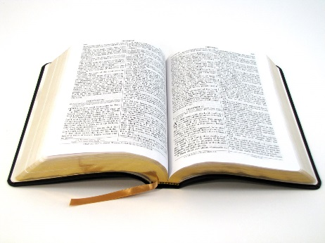
Two religious texts became milestones in English literature during the early days of Modern English. The “Book of Common Prayer” (1549) and the King James Version of the Bible (1611) were introduced to English churches. The King James Bible was the culmination of more than two centuries of attempts to create an English bible. John Wycliffe made the first attempt but was labeled a heretic. William Tyndale also tried to get the Holy Bible into the hands of English commoners. He printed his bible (1526) secretly in Germany and smuggled them into England. Eventually he was caught, found guilty of heresy and executed in 1536. Tyndale’s version added completely new English words like fisherman, landlady, scapegoat, taskmaster, viper, sea-shore, zealous, clear-eyed, and broken-hearted. He also coined common phrases such as “Let there be light”, “My brother’s keeper”, “the apple of mine eye”, “flowing with milk and honey”, “sign of the times”, “ye of little faith”, “eat drink and be merry”, “salt of the earth”, “a man after his own heart”, “the spirit is willing but the flesh is weak”, “a stranger in strange land” and “let my people go”. All of these phrases were later used in the King James Version. Next to Shakespeare, Tyndale is arguably the most important English writer. A few years after Tyndale’s execution, King Henry VIII diverged from Roman Catholicism and encouraged Bibles to be written in English. The King James Version was compiled by 54 scholars and clerics over the span of 70 years. It was purposefully written to sound like Middle English or even Old English to give it a godly tone.
Dictionaries and Grammars rose to prominence during the early stages of modern English. The first English dictionary was written by Robert Cawdrey in 1604. Although it preceded Italian and French dictionaries, it was limited to just 2,543 words. It was not a serious attempt at defining the English language. That honor goes to Nathaniel Bailey in 1721 who wrote “An Universall Etymological English Dictionary”. However, the first dictionary that was considered reliable was Samuel Johnson’s “Dictionary of the English Language”. Published in 1755, it included 43,000 words. It included many inkhorn words like digladation, cubiculary, onionatry and assation. It was a large undertaking and Johnson became the pride of the nation after taking 7 years with only 6 assistants to complete the work. It included etymologies and quotations to show how the words are used. However, he omitted words he couldn’t explain, obsolete words, medical words, and vernacular for arts, trades and sciences because he wasn’t an expert in those fields. He also left out rude words. Furthermore, his definitions and etymologies were questionable. For example, his definition for cough is, “A convulsion of the lungs, vellicated by some sharp ferocity.” In the end, his dictionary did not embalm the language, but was an outstanding work in its own right. Following Johnson’s dictionary were many more dictionaries as well as specialized dictionaries and glossaries. Thomas Sheridan attempted to cement the language in his book, “British Education”. In his book, he attempted to regulate spelling, vocabulary as well as pronunciation. He released, “British Education” in 1756 and believed that if everyone spoke the same way, they would treat each other as equals. However, it divided people by those followed his rules and those who did not.
As Modern English evolved, there was an increase in doubled vowels (soon), or the use of a silent e to mark long vowels (name). Double consonants were used to mark short preceding vowels (sitting). Letters that were interchangeable in Middle English gradually took on their own role as a vowel or a consonant (u vs v, i vs j). The virgule was a slash with a defined role was replaced by a comma. The period or full-stop was restricted to the end of a sentence. Semi-colons began to be used in addition to colons, quotations were used to mark speech and capital letters were used to start a sentence, proper names, and important nouns. The grammarian John Hart was particularly influential in these changes. There was now a large market for grammar books.
Grammar was a preoccupation of the middle class. The upper class were above the rules and didn’t care while the lower class had no incentive to learn or follow the new rules. But the middle class used grammar and elocution as a badge of entry into polite society. William Cobbet regarded grammar as “of more importance than all the other branches of book-learning put together. It gives you, when you possess it thoroughly, a real and practical superiority over the far greater part of men.” The leader in this wave of grammar was Robert Lowth. He released “A Short Introduction to English Grammar” in 1762. During this period, grammarians established the practice of using comparatives to describe pairs of objects and superlatives for describing three or more objects. They said that incomparables (perfect, unique, round) could not be compared (less perfect, more unique, less round). They established key differences in words like lie / lay and will / shall. They allowed prepositions to end sentences and even tried to change vocabulary. They tried abolishing the words fib, bigot, banter, fop, flimsy, workmanship, selfsame, nowadays, and furthermore.
While Modern English was evolving, we saw the Golden Age of English Literature. Between 1500 and 1650, an estimated 10,000 to 12,000 new words were coined. Issac Newton broke from tradition and wrote “Opticks” in English and introduced the phrases lens and refraction. Francis Bacon wrote in Latin and English and coined medical terms like thermometer, pneumonia, skeleton and encyclopedia. Thomas Elyot gave us words like animate, describe, dedicate, esteem, maturity, exhaust and modesty. Thomas More added absurdity, active, communicate, education, uptopia, acceptance, exact and explain to our lexicon. John Milton coined approximately 630 new words including lovelorn, fragrance and pandemonium. Philip Sydney (who died at a young age of 31) was a fan of compound words and gave us dumb stricken, far-fetched, eye pleasing as well as miniature among other words. He was also the first to use conversation to describe using language to negotiate meaning. He was a true romantic poet with 2225 of his quotations in the Oxford Online Dictionary. He liked to add words together to make mental images: milk-white horses, well-shading tree, honey-flowing eloquence, hang-worthy necks and long-with-love-acquainted eyes. He also gave us the phrases my better half and much loved spouse. However, there was one writer who stood out amongst all other writers. He was, of course, William Shakespeare.
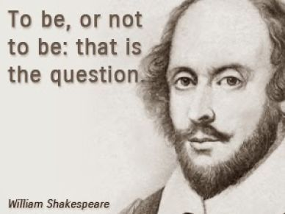
Shakespeare did more for the English language than any other writer in history. His 38 plays, 154 sonnets and other major works are still comprehensible and taught in schools today. His plays are performed all over the world and have become more than 300 film adaptations. It seems everyone knows at least one Shakespeare quote. Over 2,000 words we use today were first written by him including: obscene, accommodation, barefaced, misanthrope, leapfrog, advertising, reliance and courtship. At his time, English was in flux and he used that to his advantage. He brought regional words into the greater vocabulary. After using high language to show off, he would often use monosyllabic words to define what he had said previously or to provide clarity. Those monosyllables work great when trying to convey emotion. Like Phillip Sydney, he had an appreciation for compound words. He gave us eyeballs, leapfrog, hugger-mugger, baby-eyes, faire-play, widow-comfort and ill-tuned. He was also aware of the inkhorn controversy and used the inkhorn terms dislocate, emulate, initiate, demonstrate, meditate, eventful, horrid, modest, and vast. He also equipped English with many phrases; “to thine own self be true”, “What the dickens?”, “In my mind’s eye”, “To hold the mirror up to nature”, “make a virtue of necessity” and “vanish in to thin air.” Additionally he gave us critical, frugal, aerial, homicide, brittle, bump, hint, hurry, lonely and gloomy.

Beyond England
Every time English has come in contact with other cultures, the vocabulary has grown and our language has changed. Since the early trade relationship with the Fris, English has become richer thanks to the influence of other cultures. In the 16th and 17th centuries, Britain was developing their own international trade and naval supremacy. It is estimated that 10,000 to 15,000 new words entered the English language during this time. Freer trade put them in contact with many cultures and languages. English gained the Italian words; carnival, fiasco, arsenal, casino, piano, umbrella, rocket, and design. We received armada, bravado, cork, barricade, and cannibal from the Spanish. Breeze, tank, fetish, marmalade and molasses came from the Portuguese. The Germans gifted English with kindergarten, dollar, gimmick, bum, dumb and ouch. Low German (Dutch/Flemish) speakers gave us the rude words; damn, booze, bugger, crap, scum, smuggle, and fucking along with the words knapsack, landscape, easel, yacht, cruise, boss and lottery. The Basque people contributed bizarre and anchovy. Norwegians added iceberg and troll. Saga and geyser come from Icelandic while sauna comes from Finnish. The Persians gave lemon, caravan, bazaar and tambourine. Jar, magazine, algebra, algorithm, admiral, sherbet, coffee, alcohol and mattress were also Arabic in nature. Coffee also has Turkish roots along with yogurt, caviar, horde, chess, kiosk, tulip and turban. Mammoth is unsurprisingly Russian. Bamboo, amok and gong are Malay. The Tamil language brought curry to English. The Japanese added tycoon, geisha, karate and samurai to the lexicon. We can thank the Chinese for giving us lychee, typhoon and tea. Taboo and tattoo were Polynesian terms. Korean has given some loanwords to English as well: Hangul, Korea, won (money), hapkido, taekwondo, bibimbap, bulgogi, soju, moonie (member of the Sun Myung-Moon church), and kimchi. English has accumulated many words through trade.

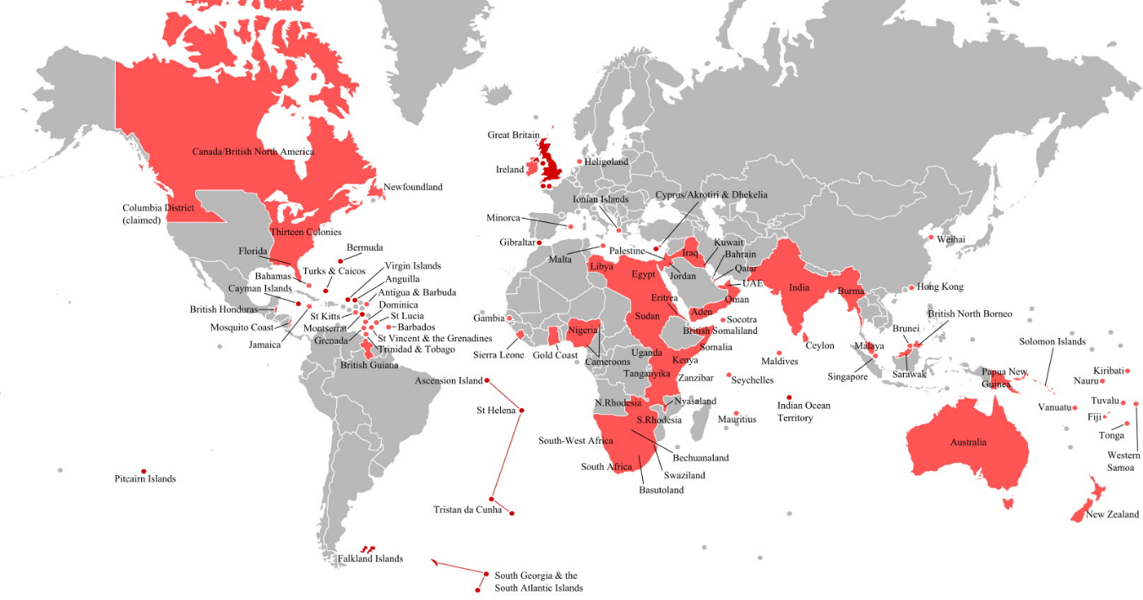
Britain went on to colonize much of the world. It is said that the sun never set on the British Empire. By the 20th century, at one time or another, the British controlled land on all of the continents with the exception of Antarctica (though they got about as close as possible). Britain owned nearly ¼ of all land on earth. While they were trading goods with those countries, they were also exchanging language. The effects of British rule is still seen in the widespread nature of the English language. Indian English and Australian English fed new terms back in to the mother tongue. The New World took the language to new levels with the rise of the American superpower. In 1852, the German linguist, Jacob Grimm called English, “the language of the world” and predicted that it was “destined to reign in the future with still more extensive sway over all parts of the globe.
The East India Company was originally set up to trade with Mughal India and the East Indies. The company would go on to seize control over large parts of India, South East Asia and Hong Kong. It would go on to account for half of the world’s trade. India was and is a rich mixture of languages with 22 official languages, 122 major languages and 1599 recorded languages and dialects. Sanskrit, Hindi, Urdu, Tamil, and Malayalam words have escaped the subcontinent and found their way in to English, sometimes via another language or culture. The word mango has an interesting story. Malayalam and Tamil languages call the fruit mangai, which became manga to the Portuguese. English derived mango from replacing the last letter of the Portuguese word. The words shawl, cashmere, veranda, pajamas, shampoo, jungle, thug and nirvana are of Indian derision. The word mugger comes from the Hindi word for crocodile, a master of ambush. In return, English was adopted as a unifying official language. After independence, English was to be slowly phased out, but there was no simple choice for what to replace it with, so English is used to unify the other languages. British occupation definitely had its short comings, but they also helped end child-marriage, Sati, polygamy, untouchability and introduced widow remarriage. The British also helped India to rediscover India’s past. In particular William Jones rediscovered the ancient links between English and Indian languages. His work would establish the Indo-European link.
The British established the colony of New South Wales in 1788. Over one thousand settlers including 778 convicts built a settlement at Sydney Cove. Convicts would routinely be sent there until 1868. A large wave of immigrants arrived during the gold rush in the 1850s of which included a large number of people who spoke English as a second language. This also had an effect on Australian English. English evolved in Australia to the point that it gave back some phrases to the motherland. G’day mate, good on you (good onya) are Australian inventions. Australian English includes a rarely used plural of you, yous. The terms outback and bush are considered true Aussie words, but both were used historically in other English speaking countries. The origin of Dinkum (fair dinkum) is unknown, but it means true. Many local words from the aboriginals were fed back into English through the Australians. Dingo, kangaroo, koala, boomerang, hard yakka, and didgeridoo are derived from aboriginal languages. Australians are also fond of using diminutives like; arvo (afternoon), bottle-o (bottle shop), Barbie (barbeque), and mozzie (mosquito).
The Philippines, Pakistan, and Nigeria are countries with more English speakers than England. The Philippines were a Spanish colony from 1521 to 1898. Then it became an American colony until 1948. During its 5 year reign, American imparted English on the Philippines and they still abide by American standards for writing and grammar. Some peculiar words has arose such as: gimmick (a night out with friends), Kikay Kit (women’s makeup), ref (refrigerator), sala (living room), chicken (meaning easy), dollar-speaking (someone who usually speaks English in public) and videoke (video karyoke). From the Philippines, English inherited: boondocks, cooties, and yo-yo. English was brought to Nigeria during Britain’s occupation of the land between 1851 and 1960. Tango, juju, jumbo, safari, impala, okra, and Ubuntu have their origins in Nigerian languages. Pakistan was amongst the last areas to be annexed by the British’s colonization of the Indian subcontinent. However, Pakistan did not become a country until 1947. English became the de facto official language. It is currently one of two official languages, along with Urdu. There are many similarities between Indian and Pakistani English. The words cummerbund, rickshaw and ghee come from Urdu. Other Urdu words have infiltrated Pakistani English but not English at large. These include: melas (festival), ustadd (teacher), kulfi (ice cream), and jawan (soldier). Some interesting colloquialisms include: petrol pump (gas station), light gone (power outage), got no lift (no one helped me), Yorker (suddenly dangerous situation), and drinking a cigarette (smoking a cigarette). English has had an interesting relationship with a lot of countries around the world.
The English experiment in the Americas is a fascinating story. Since being brought over to the new world with the Puritan settlers, English has been changed and refined in a new culture. With the rise of America to the largest superpower in the world, this new English has become the standard for most people. A language that once had to go underground for 3 centuries is now the language of the most powerful country in the world. So, how has American English changed since arriving in the new world? Here we will discuss the updates and additions to English through the Americas.
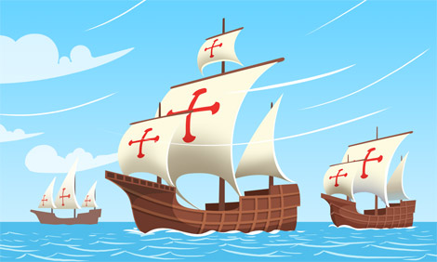
In the 16th century there were many countries that claimed ownership of the new territory. Spain, Portugal, France, Russia, Netherlands and of course Britain all made land claims here. The Spanish were mostly interested in gold, the French were mostly interested in fur trade, but the British were the first to be interested in colonizing the new lands. The first people to try settling were a group of English Protestants called the Puritans. These Christians felt that there was still too much influence of the Roman Catholic Church in England, so they wished to make a new home in America. Their goal was not to mix in with the local population, but to recreate a new England in the new world. They immediately put up fences to keep the native population and wilderness out of their settlement. But the first year was a quite difficult for them. They probably would not have survived if it weren’t for a chance encounter with a native. Amazingly, the puritans were greeted by a local native in English. It would seem that this person had picked up some English from trading with international fishermen. Even more crucially, he introduced the Puritans to Tisquantum (Squanto) who once was abducted by English explorers and sold into slavery. He escaped and travelled to England where he learned English and worked until he eventually found his way back homeland. Without Squanto, the Pilgrims would have survived. He taught them how to grow plants and use natural resources. He also acted as a liaison between the pilgrims and natives in the area. Without Squanto, it is possible that English would not have survived in the New World.
The Puritans tried to cleanse the English language of blasphemy, slander, cursing, lying perjury, scolding, swearing, treason and defying authority. Improper use of language was a crime. And it would seem that they were not interested in borrowing words from the local languages either. In the past, whenever English encountered a new language or culture new words were introduced. However, the Puritans took very few. Of those words English was given skunk, wigwam and squash. In this New England, words took on slightly different meanings. In Britain lumber was rubbish, but in America it meant cut timber. Haul meant to move by force in Britain, but America redefined it to mean transport in a vehicle. The British used the word shop where Americans use the word store.
As more settlers came accents began to blend together. In England there were many regional accents, but in New England there were no regional accents at this time. To upper class British citizens regional accents were vulgar. They remarked that Americans spoke English better than the English. The American Declaration of Independence was written in classical English. Americans took pride in this. There was a sense that no child would ever be left behind because of their accent. So, Americans standardized pronunciation and (crucially) spelling in a book nicknamed, the Blueback Speller. Written in 1783 by Noah Webster “The American Spelling Book” was a pivotal book in the evolution of English in America. Since its first publication, this book has never been out of print. It has sold 100,000,000 copies and is second to the bible in copies sold in America. It was taught in every school. He successfully changed the English language single-handedly. Among his most famous changes were; the deletion of u in words like honour and neighbour and the switching of re in theatre to theater. He also reduced double consonants in words like traveller and waggon to the singular consonant like traveler and wagon. He replace the s in words like critise with a z, as in criticize. He also replaced the x in words (connexion) with the more familiar ct (connection). Further simplifications saw the change from: cheque to check, axe to ax, plough to plow, gaol to jail, storey to story, musick to music, and publick to public. If the original words look foreign to you, you can thank Webster for his work. The Blue Back Speller was also responsible for creation of spelling bee contests. Spelling was now important as it showed academic success and competitions were held to see who the best student was. Webster would go on to release his first dictionary in 1828. In it, he intended to exhibit the language and not add to it. Less than 50 terms were new to the country.
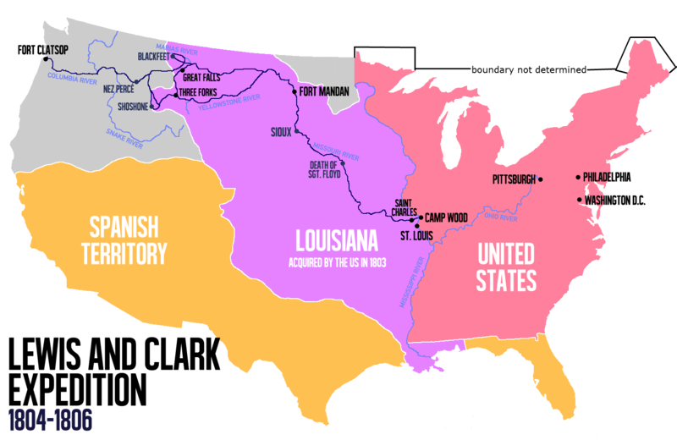
The Louisiana Purchase of 1803 nearly doubled the size of the United States over night. Americans had an incentive to head west into the wild frontier. Tasked with this job were Meriwether Lewis and his close friend William Clark. President Thomas Jefferson commissioned the expedition to find a practical route to the Pacific and to diligently take notes along the way. Lewis and Clark would go on to expand the English vocabulary through their journal entries. Since they were to report all of the new animals, plants, landscape features and cultural properties they came across, they also needed to create new terms. Lewis and Clark were very descriptive in their labels. They came across a peculiar deer that shared features of a mule, but was a deer. So, they called it a mule deer. Similarly they named animals: bighorn sheep, whistling swan, tumble-bug, leather-wing bat. Other animals were labeled by where they were found: prairie lark, prairie dog, and sand-hill crane. Other terms included buffalo grass, Yellowstone, snowberry, bluegrass, blue jay, black-tailed fallow, snow-shoe, sugar maple and bald eagle. For some creatures, Lewis and Clark made borrowings from similar species in English. For example, buffalo originally were oxen but now the term was applied to a different species. They also derived new terms from native languages: hickory, hominy, maize, moccasin, moose, opossum, persimmon, raccoon, chipmunk, and toboggan. Most importantly, they paved the way for Americans to head west.
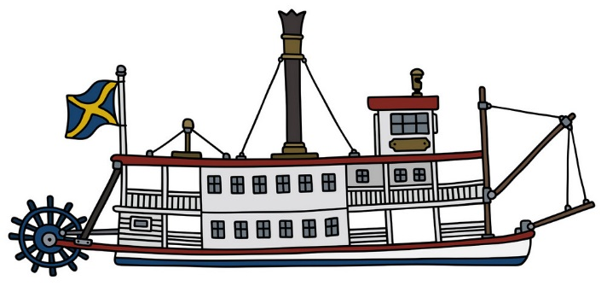
These new settlers came from different backgrounds and brought their language with them. The words cabin (Irish), dead-straight (Irish), plump (Scottish), and hotel (French) made their way into the American vocabulary. Hotel was derived from the French meaning a large house and used in England to refer to a grand house or municipal building. In the new frontier it acquired its contemporary meaning. The term redneck comes from the expansion west. The new poorer settlers would develop red necks from leaning over while working all day. These rednecks couldn’t afford to take the riverboat ferries, so they travelled by rafts – which they steered with rifts. This is where the term rift-raft comes from. High-flouting, referring to high class people, referred to the high smoke stacks (flouts) on the riverboats.

Gambling was a common pastime on the riverboats. These gamblers had their own vernacular at the gambling table, though their phrases made it in to the broader English vocabulary. Pass the buck and the buck stops here both refer to the buckhorn knife passed around the table to indicate who was dealing. Speaking of deal (giving out cards), the gamblers also gave us’ square deal, new deal, fair deal, big deal, and no big deal. Phrases like poker face, all the chips are down, up the ante, the cards are stacked against me, an ace up your sleeve and I’ll call your bluff are all riverboat gambler terms. Alcohol, a fixture in the gambling scene, introduced English to barroom, saloon, and bartender. Ben Franklin compiled 229 ways to call someone drunk. The word bootlegging comes from the practice of hiding a flat bottle of whiskey in the pant leg or boot to sell illegally to the natives (who called it firewater).
Contact with the local native tribes often led to conflict and an absorption of terms. Tomahawk, scum, canoe, kayak, persimmon are all words derived from native tongues. A buck (money) meant a buckskin (deer skin), the standard unit of trade at the time. Direct translations gave us some common phrases like Long time, no see, and no can do.
Davy Crocket introduced English to a style of writing called tall tales. These are stories that might be based on facts, but exaggerated to the point that they are literally not possible. It was a reflection of plain speaking outdoorsmen. For example, “When he talked, he made the forest shake.” But the popularity of Davy Crocket made him a cultural icon and some of the phrases in the books became part of regular English vocabulary. It’s not my funeral, fly off the handle, chip on your shoulder, sit on the fence, dodge the issue, crack up, no two ways about it, dodge the issue, knuckledown, make the fur fly, you’ll be a goner, kick the bucket, barking up the wrong tree and face the music can all be found in the Davy Crocket books.
Expansion west received a surge when gold was found in California. Many prospectors headed west to stake their claim in hopes of striking it rich – all new terms. A goldmine came to mean a surefire investment. The phrase pan out, meaning a positive outcome, came from panning for gold. A bonanza, meaning a sudden increase in wealth, was actually a Spanish word that meant, ‘fair weather’.
Ranching also became a valuable job. The term cowboy took on the meaning we use today. Many cowboys worked near the Spanish border, so more Spanish words became part of the English lexicon: ranch, corral, mustang, bronco, burro, chaps, sombrero, poncho, lasso, stampede and rodeo.
Another group of people to arrive in America were African slaves. Slave traders would fill boats with slaves from different African tribes so they couldn’t plot to take over the ship. Nitty-gritty originated as a way to describe the grit that accumulated on the bilges of slave ships. On the plantations this practice was continued. This forced the African population to adopt English as a way to communicate with each other and their masters. African sounding words mixed with English to produce banana, voodoo, zebra, gorilla, chimpanzee, samba, mamba, banjo, bongo, yam and gumbo. And the first people to hear it through the grapevine were the slaves that worked on grape plantations. The telegraph wires would get caught in the grapevines creating a lot of noise. Since they did not have access to a proper education and with the attempt to preserve their mother tongue, the African slaves created their own dialect of English. The Galla people are the best representation of this today. The white masters forced Christianity on the salves to teach them discipline, but it only showed them liberty. Songs of freedom like ‘bound for Canaan land’ were just as much about escaping north as they were biblical in nature. The American Civil War freed the slaves in 1865 and gave us the phrase hold the fort. But racism did not stop with abolition of the slave trade. The term bulldozer was used by the KKK and meant giving a dose (of whipping) large enough for a bull. Mark Twain wrote about the rampant racism in his book, ‘Huckleberry Finn’. In the book, Twain makes use of the common tongues of white and black men. His writing included a lot of bad grammar and inelegant speech, which were common markers of the language.
English is a mixture of many other languages. From its West Germanic roots to the Norman occupation to the new world, English has become the most dominating language in the world. Every time that English came into contact with another, it became richer. New terms were introduced from countries all over the world through British and American conquests. English permeates all facets of life around the world. English has become the international language of trade and communication. It is the conduit by which dissimilar cultures can share information. The history of English is a fascinating one.

Character Based Writing
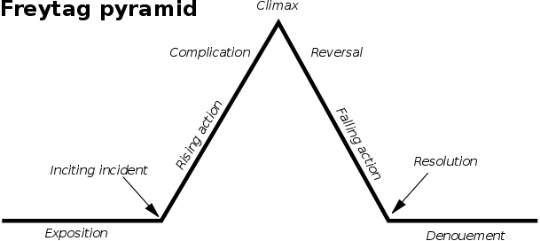
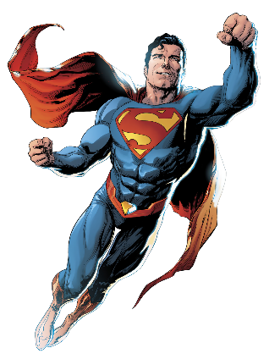
Creative writing can be the easiest form of writing but it's also a representation of the highest level of fluency. Using a language creatively is one of the scariest ways to use English for those that are taught primarily in grammar. On the opposite end, those that are taught functional English have a much easier time with this task. Grammar is second nature and developed naturally as they are exposed to the language. Think about fluency in your native tongue. Aren't kids creative? Their grammar and vocabulary have not fully developed but their imagination and imaginative use of their L1 is encouraging. Over time they naturally use proper grammatical functions as they listen to and are corrected by friends and family. So what does this tell us? Well first it should be said that first and second language are not completely analogous. But it also suggests that we should spend more time having students use English and make mistakes rather than trying to force grammar rules on them. Sight words and pre-formed sentences can be quite useful when learning to write in elementary school. However, as students age we should consider giving students the opportunity to expand their knowledge base by just letting them experiment with the language. Writing is a great opportunity to for students to be creative and to experiment with English. Students have the time to compose a well thought out sentence and story. Students also can take their time to look up words that they want to use without worrying too much because no one will know how long it took them to compile their prose. In class, you will have the opportunity to be creative with English as well. Always be aware that there is no correct way to write creatively. The following should be viewed as a list of suggestions. We will go through the stages of story creation with a special emphasis on character driven stories.
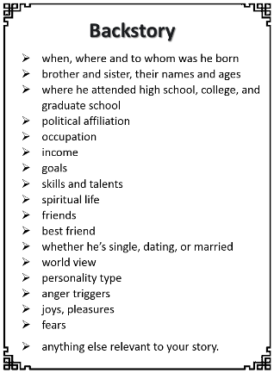
What are your favorite characters from cartoons, television shows or comic books? Why do you like them? What makes a character relatable? A well-developed character will a backstory, or a fully developed story before we see them in action. They have wants, goals and needs just like a real person. The reader will get to know the character through the story, but the writer already knows all about them. Their characters traits should be shown to the reader through interactions and how they respond to situations. The worst way to get to know a character is by having other characters talk about them. It’s boring to read, “Have you heard about Justin? I heard he hates his family.” A much better way to show this quality is by having him argue over something petty with his mother. As things escalate, the reader will understand there is some friction in that relationship. Trust the intelligence of your audience. Your readers will be able to infer qualities, you do not have to spoon-feed them information.
Introducing a character is more about revealing a characters personality than telling the reader about the character. Your main character should be introduced very quickly in your story. Try not to spend a lot of time describing the setting. Readers want to get to the good stuff. They want to get to know your characters and begin the story. The main character should start in a logical place for the story to begin. But it is ok to start with some backstory. A backstory is everything that happened before the story started and is a good way to introduce the character. If you are describing something from their past, make sure that it shows the characters personality and is relevant to their story arc. The earlier they are introduced the more time the reader will have to build a relationship with them. If you have an ensemble cast (a story that follows many main characters), you probably don’t have enough time to introduce all of the characters at the start. It may be better to show them meeting up with each other. We can learn about them by how they are interacting with each other.
Try not to have your character alone when we meet them. How your character interacts with other characters will show us their personality, rather than just describing it. It also displays their relationship with the other characters in the story. Starting with dialogue can be difficult to do however. The reader hasn’t spent any time with the characters in the book, so your main character’s voice may get lost in the crowd. Once we have invested time into the main character, it will be a lot easier to identify their voice. With that being said, dialogue is an easy way to introduce your character, as the speakers are a substitute for the reader. When the main character is introducing herself to another character, she’s also introducing herself to the reader.
Your audience wants to know what is interesting about the character as well as their details. Some important characteristics to include are; their name, age, occupation, interests, hobbies, and level of sophistication in the world of the story. A physical description is not needed for the reader to imagine the character. Take, for example, “Uncle Charlie was a butterfly collector and a toll-booth attendant for 30 years.” We have no idea what Uncle Charlie looks like, but I bet you have an image formed in your mind. Trust your readers to do the same. Allow the reader to add their own details to the character. They will be more invested in your story. Choosing an appropriate name is important for immersion. Find a name that is appropriate for the ethnicity and role in the story. An average, relatable working person require a normal name. A superhero’s name should reflect their role in society. One final note, avoid using famous names (Kenneth Hitler) as the audience will wonder if they are related to the historical figure.
You may also want to introduce your character with a physical description. As we saw in the previous paragraph, the reader doesn’t need a lot of physical description. However, if there is something physically unique about the character, you may want the reader to be aware of that early in the story. Do they have an unusual physical marker that separates them from the other characters in the story? Keep some mystery to the character. If they have a scar that runs along the side of their body, you don’t need to explain why right away. Your audience will want to know about the scar and form their own ideas. Have the reader discover how your character got their scar later in the book. Don’t forget about describing how your character moves. To do this, you may want to show the character from the point of view of another character. Another character will be able to give insight into your protagonist’s reputation. Maybe it’s a reputation that he is not aware of. Just make sure that the observing character will be involved in the rest of the story. The reader will be turned off if the observing character is immediately killed off. When describing your character, think is this description essential to your character? If that is not the case, let your audience fill in the blanks.
Personally, I think the best way to introduce a character is through action. Have your character doing something that defines there character or shows their temperament. Put your character in a situation that makes them uncomfortable or gives them an opportunity to show a personality trait. Perhaps your character is on the cusp of a life altering decision, facing a dilemma, they just got some bad news, or their life has been turned upside down. How they react to the situation will show us a lot more about their nature than directly telling the audience what about them. Alternatively, you can have your protagonist start the story in the middle of an action sequence. This is particularly effective if your story is packed with action or adventure. It sets a tone for the rest of the book. Not only does this show the character’s skills, but it might also bring your character into contact with other characters in your story. We can see how the protagonist acts in a way that will be important for the rest of the story.
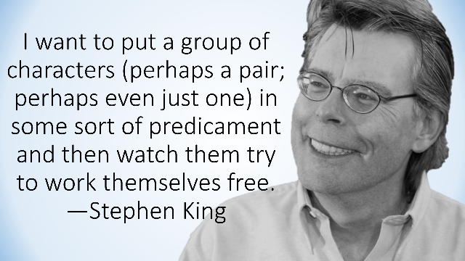
Building a good character is difficult. The reader want to be invested in the character. They should be relatable. Humans have flaws and so should your character. Your audience will see themselves in the shortcomings of your character. This will make the character more real. It will also give your character room to grow during the story. It’s essential in creating a good character arc. Your protagonist should learn from their failures. It’s really hard to write a story about Mary Sue. Mary Sue is a literary term used to describe a character that is perfect. They can’t do anything wrong. Quite frankly, these one-dimensional characters are really boring. It’s much more interesting to read about a character with strong emotions than someone who is always level-headed. Know where the line is. Your audience doesn’t want to read a story about an unredeemable character. Some traits that might make your character unredeemable include being: a wimp, scum, slob, an idiot or dirty. If you have a character with a lot of flaws, it’s important to give them a ‘pet the dog’ moment. Put them into a situation where they can show their humanity. Let the reader know that this character is a real person. Make them love the character despite their flaws.
In class we will be trying to write using a character driven plot. We might have a direction or goal for our character, but how they react will determine what happens. One good way to get to know your character is by throwing them into situations and see what happens. The American poet and other, Peter Meinke says, “In my stories, I usually begin with a character who interests me and let him or her take me where he wants to go. At any point in your story, you should be able to answer what your character wants, what their goal is at that time and to be able to justify what your character is doing. It doesn’t mean that the reader knows this information, but it will keep your plot and characters consistent. As a matter of fact, your reader should be constantly asking, “why?” Your job is to answer with a because answer. Your reader should not have all of the information to start. They need to have questions that they want answered about your character. Slowly you will reveal why they act the way they do and show them how the character changes over time. If your reader doesn’t have any questions, they have no reason to continue reading.
When writing your story, consider the internal conflict of your character. What motivates your character during this story, adventure or external situation? Some questions you may want to ask yourself include:
- What are your character’s goals?
- What is the most important thing about your character?
- What are your character limitations? Where do they draw the line?
- What does your character need?
- If it’s the main character, is this the most important moment in this character’s life? If not, why aren’t you writing about that?
- What makes your character different?
- Why should the audience care about the character?
- What are your character’s flaws?
- How will your character interact with the other characters?
- What does your character want at this moment?
- What keeps her awake at night
- What is his blind spot?
- What are her secrets?
- What embarrasses him?
- What passion drives him?
- What would she sacrifice to accomplish a goal?
A great way to get your story started is by considering what the ultimate goal of the story is. In a perfect world, what would happen to this character? If you’re writing a story where a knight slays a dragon, then the perfect situation would be for your character to easily find where the dragon is and kill it with a single stab while it’s sleeping. Then consider what can go wrong. Maybe the dragon’s den is hidden, and your character must find an old, battle scarred hunter who once came across the dragon’s den and barely escaped. Maybe the dragon has iron-like scales that make your hero’s sword useless. They will need to find another way to defeat the dragon. And finally, maybe the dragon is asleep when the hero arrives, but wakes up suddenly as your character tries to sneak past to steal some gold. This technique can be applied in every situation that your character faces. What is the perfect way for your character to resolve the situation and what stands in their way? You may also consider what happens if things don’t go their way. What are the consequences for failing? Perhaps the hero isn’t able to slay the dragon.
There are two basic types of writers; planners and pantsers. Planners want to have their whole story figured out before starting to write, while pantsers (“flying by the seat of their pants”) aren’t concerned about the destination of the story, they don’t do much planning. Writing a character driven plot is more similar to pantsers than planners. However, it might be a good idea to make an outline. It is good to figure what the ultimate goal of the character in this story is. Listing steps needed to get there as well as the obstacles that might stand in the way is good if you feel the need for more structure. It can also help you from losing track of your story. It’s also a good idea to identify the character flaw, or issue that you want to resolve. You might have a plan on how that character arc will unfold.
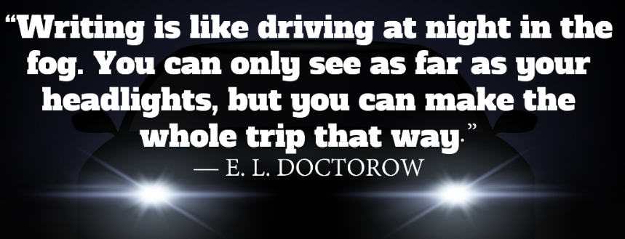
Now that you have an idea about your characters motivations and a general plot outline, you will want to start writing your actual story. After you introduce your main protagonist, you will need an inciting incident to get the ball rolling (start the story). Your character needs a reason to start on their quest, to leave the house, or motivation to make changes. The inciting incident is a way to get your character into the story. Use your character motivations to get them headed down a path that will ultimately lead them to your plot’s goal. Maybe your protagonist’s grandfather died and left a cryptic clue hidden behind an old family photo bequeathed to you. Perhaps your character’s love interest has accepted a job in another country and is set to move by the end of the month. You could even introduce your antagonist with the inciting incident. Perhaps your character is bullied by the antagonist and vows to get revenge. People do things according to their personality, motivations, needs and desires. Use your character’s personality to get them engaged with the plot.
By the time your story is finished, your character should have gone through something difficult to grow as a person. At the climax of your story, issues should be resolved. When your character accomplishes their goal, they should be completing their character arc as well. How did your character have to change in order to get to this point? The climax should be a reward for their changes, sacrifices and growth. But there are many ways to write a story and maybe yours has a bad ending. Maybe your hero dies. Maybe their character arc leads them to sacrificing themselves to save others. The final conflict in your story should challenge your character’s biggest weakness.
Charlie Jane Anders offers the following advice:
- Character is in action
- We have to see the characters dealing with the fallout
- Small moments of character insight can feel like plot twists
- A big battle or surprising explosion can mess up your characters’ plans and ideas
- Introspection is suspense
- Introspection is also foreshadowing
- Good world-building is both emotional and dangerous
- Never through your characters under the bus for a cool idea.
- Figure out what points you have to hit to make everything feel earned.
- Keep ‘em guessing
- Sometimes the emotional resolution is more important than the big plot reveal

Formal Writing
To the average Westerner, the thought of writing an essay will cause one’s blood pressure to rise. We were all forced to write many essays in our school years, it was hard work. But I think that we just weren’t taught correctly. Essays follow an easy format and you can learn a lot about a subject through your research. The main parts of an essay that we will learn are:
- Choosing a topic
- Research
- Make a thesis statement
- Prepare an outline
- Research Again
- Write the essay body – main point, sub points, supporting evidence
- Write the introduction
- Write the conclusion
- Add the references

Choosing a Topic
The first step is always the hardest. With no direction, choosing a topic for your essay can seem just as daunting. One of the reasons we hated writing essays in class was because we didn’t have a choice in what topic to write about. Trying to find an essay topic may be hard, but there are some ways to narrow down your topic choice. Often, your instructor will give you a general topic area which will help you narrow your search, but what if you have the option to write about anything?
The most important thing is to find a topic that interests you. You are going to devote a lot of time to writing this article, so having something that you are generally interested in is important. It should also be something that you have limited knowledge about. The research part of writing an essay will be a lot more fun when you are discovering new information. A lot of the time, I’ll choose a topic that I have been curious about but never had the time to look into for myself. Actually you can see that in the first part of this article. I had limited knowledge about the history of English language, but I always found it fascinating. Where words come from (etymology) is quite interesting to me. Even though I was writing an article for teacher training, I also took the opportunity to learn more about something that had interested me for a while. When choosing a topic it’s important to find something that is interesting to you.
Choose a specific topic. It is actually easier to write essays the more specific the topic is. A general topic (eg. earthquake damage) has too much information. It will be too difficult to fit all of that information into an essay, unless you plan to write a textbook. A more specific topic (eg. the 2004 underwater earthquake and damages resulting from the tsunami it created) allows you to explore something in more detail. It’s always easier to expand your topic after you start writing than to narrow it. You do not have to narrow your topic before you start researching though. In your research, you might find a particular part of your topic to be captivating (eg. deep sea creatures washed up by the 2004 tsunami). It is certainly okay to focus on that and gain a more in depth analysis of it. Be aware however that the more obscure your topic, the harder it will be to find good information.
Canuwrite.com lists ten tips for choosing a topic:
- Select something that interests you
- Choose something you know about
- Narrow your topic down to a manageable size
- Find an interesting way to approach a topic
- Start researching
- Brainstorm
- Look right in front of you
- Ask a teacher, advisor or look online
- Re-use a topic (in a different way)
- It’s the last minute! What do I do? (start writing, you might find a more interesting topic along the way)

Research
Researching your topic may be the longest part of writing an essay. The search for good, relevant information might take a while, but it is the most important part of the essay writing process. A good way to approach research is to understand that your reader will want to learn about your topic. If they choose to read your article (even if it’s a teacher who doesn’t have a choice) you owe it to them to have the best information available. Don’t waste the reader’s time with useless information or things that they already know. A good essay is captivating because it contains new and interesting information. The amount of time you spend researching is vital to the reader’s experience.
Because research takes such a long time, it’s important that you start this phase as soon as possible. Leave yourself enough time to gather the information you need before you start writing. It’s also a good idea to write down your sources along with some quick notes about the sources. It will be much easier to find specific information later. Your researching will also give you the chance to narrow down your essay topic.
Brainstorming is a great way to start your research. Here you can lay out what you already know about the subject. You can also see the areas where your knowledge is lacking. These are great areas to focus your essay on. If you find that your brainstorming has a lot of holes in it, great. It’s time to get a basic understanding of the subject. Find a resource that will introduce you to the topic. A book on your topic or Wikipedia article will give you the essential information to give you an overview of the topic. You might find your specific topic for your essay through this process. Be careful about web-based research. While Google does a decent job of giving you general information, you should go a little deeper. Google Scholar reduces the search result to ones in academic journals. In a similar way, Wikipedia is a great first step website. Anyone is allowed to edit Wikipedia pages, so the information may not be completely accurate. However, there are a lot of footnotes at the bottom of a Wikipedia page that will lead you to more reputable sources. Wikipedia has the advantage of being continually updated. It’s a pretty good place to find the newest information on a topic, just make sure the information is reliable. Tracing footnotes is also a good idea for academic resources. They will give you a better understanding of where the information came from.
Another good piece of advice is to research both sides of a topic. Learn what is being said by both sides of an argument. Try to keep an opinion mind. If your essay is persuasive, try not to form an opinion before you have all of the information. With that being said, the research process is a great time to start formulating an opinion, hypothesis or thesis statement.

Make a Thesis Statement
Now that you have completed your initial research, you should have a good idea about what you want to write about. It’s time to write a thesis statement. Your thesis statement explains your main idea, point or central message. Your thesis statement should be just a sentence or two. If you can state the objective of your essay in one or two sentences, you might need to do more research or find something more specific.
Your thesis statement is not an argument. You don’t need to justify your arguments yet. Just be clear about what you are going to discuss. Your statement should be clear and direct. For example, “COEILI has a long history of providing quality programs to Chungnam students and teachers” is far better than “My essay is about how COEILI runs good programs for the students through programs like 1 and 3 day camps, ECAP, and TEL. They also have a wonderful program for teacher training called IETTP that is effective in equipping teachers with the skills to teach English more effectively in their home schools”. If you are writing a short essay, you might also include your main points in your thesis statement: “William Tyndale is one of the most important English writers because he legitimized English through his translation of the Bible, and he created vocabulary and phrases we still use today”. After reading your thesis statement, your audience should know exactly what your article will be about.

Prepare an Outline
If you have completed your initial research and have a thesis statement prepared, it is time to create an outline. This should be a fairly easy step as the formula for a good formal essay is easy to follow. Choose the strongest arguments (main points) for thesis and write down the supporting evidence for those arguments. It is also a good idea to formulate an introductory sentence for each argument. These will serve as your body paragraphs. At this point, your introduction paragraph should start with your thesis statement and then be a list of the main points that you want to cover. Since your concluding paragraph will be quite similar to the introduction, I would suggest leaving it out of the outline at this stage. If you do wish to keep it, restate your thesis and list your main arguments. Really that is all you need to do at this point. Now you can see how your article will look. Are there areas that need more supporting evidence, more research, or additional arguments need to be added? Now is the time to decide if you are ready for writing your essay or to go back for more research. Your outline should look something like this:
- Introduction
  - Topic
  - Get audience’s attention
  - Thesis statement
- Main Idea #1
  - Supporting points
    - Detail
    - Detail
- Main Idea #2
  - Supporting points
    - Detail
    - Detail
- Main Idea #3
  - Supporting points
    - Detail
    - Detail
- Conclusion
    - Detail

Research Again
Did you find that some of your arguments needed more supporting evidence? Now is the time to go back and find more supporting information for what you want to say.

Write the Essay Body
Each body paragraph should follow the same format. First introduce your point with how it relates to your thesis. There should be a clear connection to your thesis, so it is ok to use part of your thesis again (though you should try to present it in an interesting way):
One of William Tyndale’s greatest contributions to the English language was his translation and distribution of the Holy Bible in English…
Once you have introduced your main point, it is time to put in information (evidence) to support your argument. Remember that each evidence should relate back to the main point you are making:
One of William Tyndale’s greatest contributions to the English language was his translation and distribution of the Holy Bible in English. This was an extremely difficult task that he did illegally. The church called him a heretic and he was hunted down. He was executed in 1536 for translating the bible into English. This was the first English Bible to be produced and it allowed regular civilians to analyze the biblical texts for their selves. The Catholic Church no longer had control over information. This represented a major step in the English language as it showed that the English language was legitimate. The fact that it was written in English is significant because all official documents at that time were written in Latin or French. He challenged this concept and in the years following his death, more English Bibles were produced and in 1534, King Henry VIII established the Church of England to break the Catholics power in the region…
Your concluding paragraph should restate your argument while listing the evidence you gave:
One of William Tyndale’s greatest contributions to the English language was his translation and distribution of the Holy Bible in English. This was an extremely difficult task that he did illegally. The church called him a heretic and he was hunted down. He was executed in 1536 for translating the bible into English. This was the first English Bible to be produced and it allowed regular civilians to analyze the biblical texts for their selves. The Catholic Church no longer had control over information. This represented a major step in the English language as it showed that the English language was legitimate. The fact that it was written in English is significant because all official documents at that time were written in Latin or French. He challenged this concept and in the years following his death, more English Bibles were produced and in 1534, King Henry VIII established the Church of England to break the Catholics power in the region. Tyndale’s translation of the Holy Bible into English was an important milestone in the history of English because it put the book in the hands of regular people, legitimized English as a valuable language, and changed how English was viewed by prominent figures.

Write the Introduction
After writing the body paragraphs, it will be very easy to write your introduction. Writing your introduction after your body allows you to solidify your arguments. Writing your introduction is fine, but you may end up going back and rewriting it a few times as you add more information to your body. The point form version of the introduction you made in your outline will be a good guide for writing the paragraph. To write an introduction, start by stating your thesis. Then briefly introduce each of your main points and how they relate to your thesis. Now is not the time to give evidence. You will provide the necessary evidence in the body of your essay You can conclude your introductory paragraph with what you intend to prove:
William Tyndale is one of the most important English writers because he legitimized English through his translation of the Bible, and he created vocabulary and phrases we still use today. His translation of the bible was blasphemous but lead to English being viewed as a legitimate language. We still use his words today in our everyday speech. In this essay, it will be shown that William Tyndale should be considered one of the most important character in the history of the English language.

Write the Conclusion
Your concluding paragraph is an opportunity to restate the points you have been trying to make. The first line should restate your thesis to remind the reader why they were reading the essay. Then you should go over your main points and reference your strongest evidence for each point. Finally, your last sentence is your last chance to make a strong statement about your article. It will not include new information, but it should clearly state what you proved during the essay.
William Tyndale should be considered one of the greatest figures in the history of the English language. He brought the bible to the masses, and challenged the authority of the church in matters of language. His martyrdom transformed how the elite viewed the language and a few short years after his death, a new English based church began. Tyndale’s translation also made an impact on the English lexicon. He added many common phrases we use today. He was a pioneer in the development of the English Language and has earned his place nest to Shakespeare as the two most important men in the history of English.

References
There are a few different ways to write references for your essay. Adding a reference page is important to distinguish your ideas from other academic works and to avoid plagiarism. It also gives the reader a chance to follow up on your article in more detail and see how you came to your conclusions. You can use author-date style, footnotes or endnotes. The key is to find a citation style that you like and stick to it. We will be following the Harvard Referencing Guide.
The following is from Imperial College London:
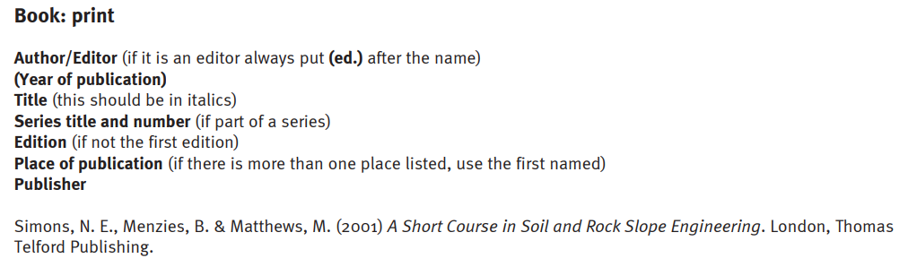
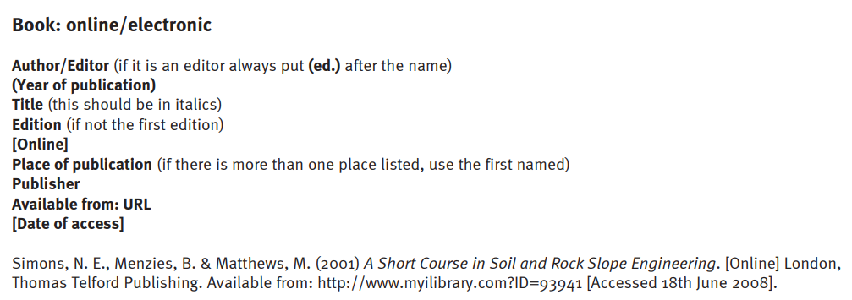
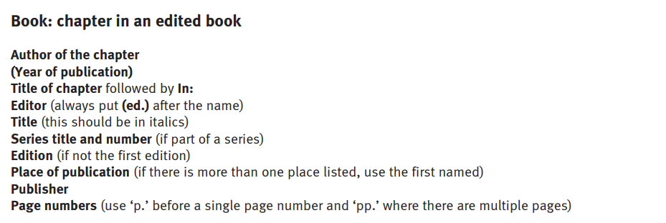
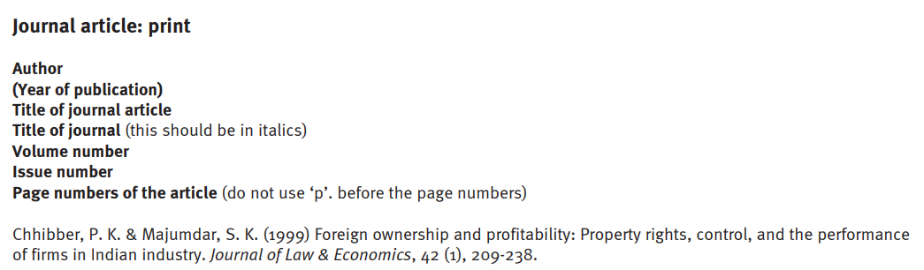
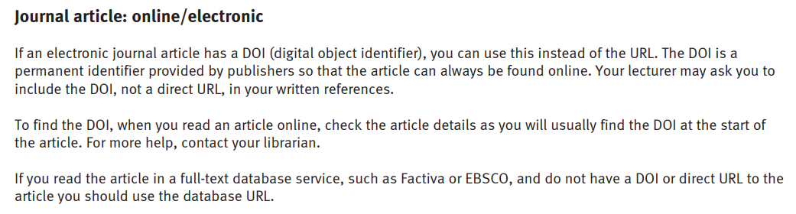
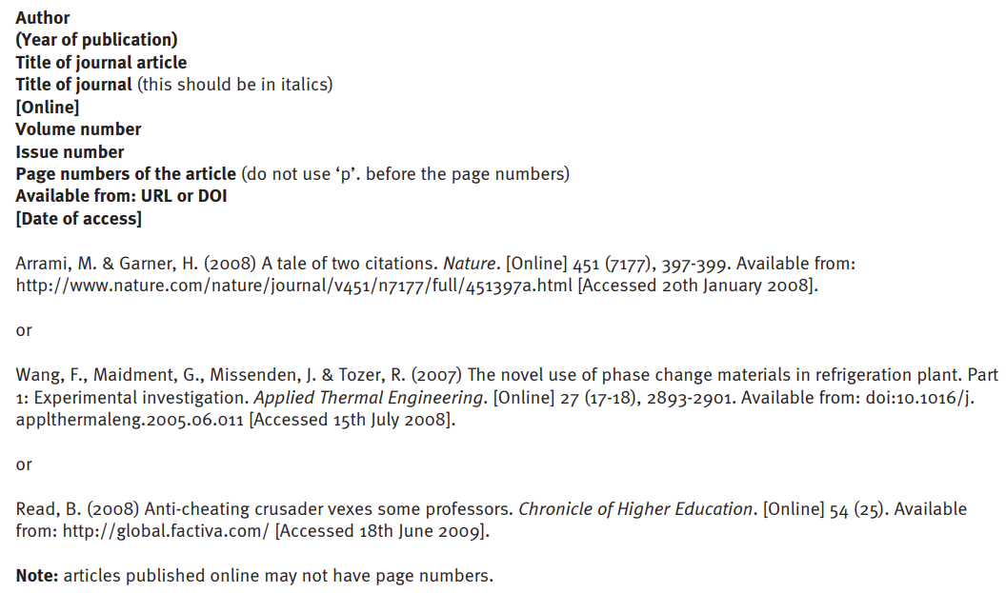
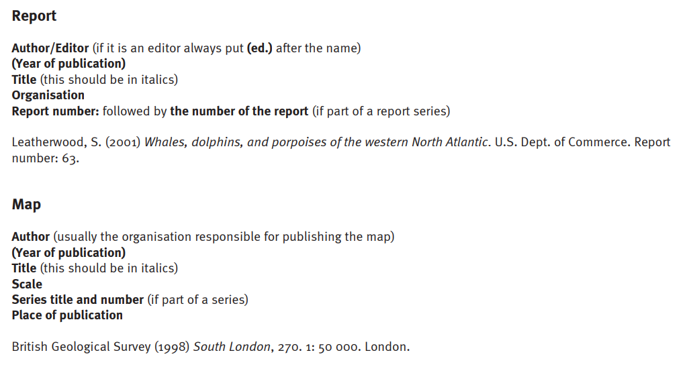
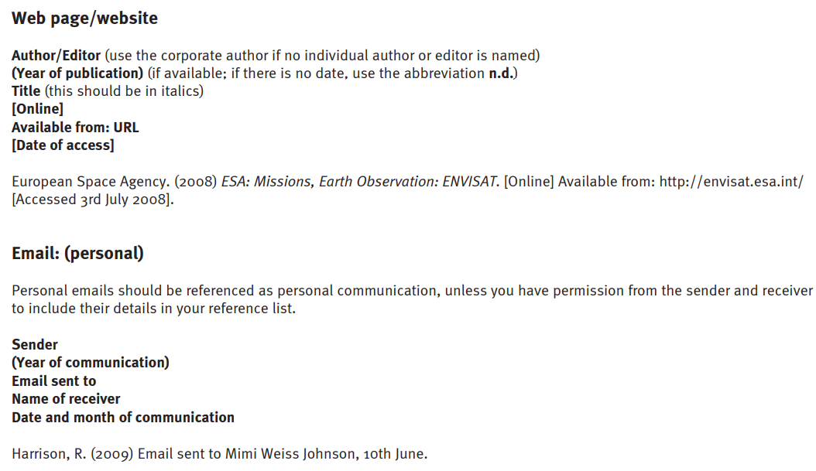
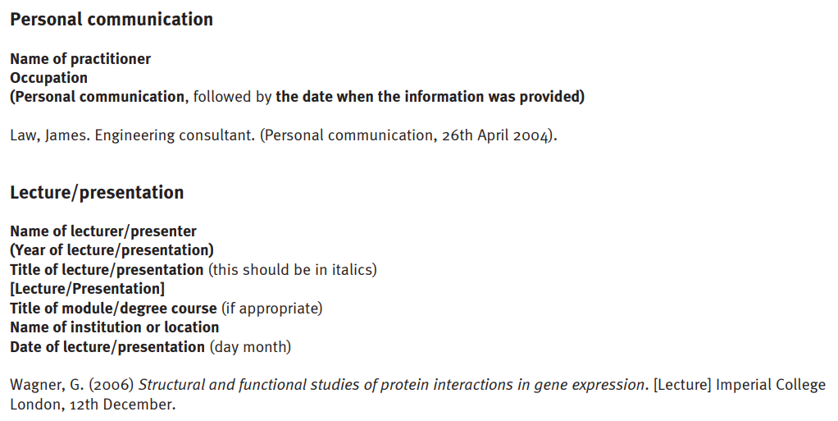

References and Additional Reading
Cognitive Tradeoff Hypothesis
Abbot, D. (2016) What Brain Regions Control our Language? And How do We Know This? [online] Available at: https://theconversation.com/what-brain-regions-control-our-language-and-how-do-we-know-this-63318 [Accessed May 10, 2019].
Abe, K., Watanabe, D. (2011) Songbirds possess the spontaneous ability to discriminate syntactic rules. Nature Neuroscience 14 (1067-1074). https://doi.org/10.1038/nn.2869
Dunning JL, Pant S, Bass A, Coburn Z, Prather JF (2014) Mate Choice in Adult Female Bengalese Finches: Females Express Consistent Preferences for Individual Males and Prefer Female-Directed Song Performances. PLoS ONE 9(2): e89438. https://doi.org/10.1371/journal.pone.0089438
Gillam, E. (2011) An Introduction to Animal Communication. Nature Education Knowledge 3(10):70 https://www.nature.com/scitable/knowledge/library/an-introduction-to-animal-communication-23648715
Herman, L.M. & Uyeyama, R.K. The Dolphin’s Grammatical Competency: Comments on Kako. Animal Learning & Behavior (1999) 27: 18. https://doi.org/10.3758/BF03199426
Inoue s., Matsuzawa, T. (2007) Working Memory of Numerals in Chimpanzees [PDF File]. Current Biology, 17(23): R1004. https://www.cell.com/current-biology/pdf/S0960-9822(07)02088-X.pdf
Kaplan, M. (2007) Unique Orca Hunting Technique Documented. [online] Available at: https://www.nature.com/news/2007/071214/full/news.2007.380.html [Accessed May 10, 2019].
Khan Academy. (2019) Animal Communication. [online] Available at: https://www.khanacademy.org/science/biology/behavioral-biology/animal-behavior/a/animal-communication [Accessed May 10, 2019].
Longman, D., Stock, JT., Wells, CK. A Trade-Off Between Cognitive and Physical Performance, with Relative Preservation of Brain Function. Scientific Reports (2017) 7:13709. https://doi.org/10.1038/s41598-017-14186-2
Matsuzawa T (2013) Evolution of the brain and social behavior in chimpanzees Current Opinion in Neurobiology 23:443–449 , doi: 10.1016/j.conb.2013.01.012
Pierce, J. (2018) Why do Cats Meow at Humans? [online] Available at: https://www.psychologytoday.com/intl/blog/all-dogs-go-heaven/201809/why-do-cats-meow-humans [Accessed May 10, 2019].
Schlenker, P., Chemla, E., Arnold, K. et al. Monkey Semantics: Two ‘dialects’ of Campbell’s Monkey Alarm Calls. Linguist and Philos (2014) 37: 439. https://doi.org/10.1007/s10988-014-9155-7
Stevens, M [vsauce]. (2018, Dec. 5). The Cognitive Tradeoff Hypothesis [Video]. Available at: https://www.youtube.com/watch?v=ktkjUjcZid0 [Accessed May 10, 2019].
Wikipedia contributors. Animal language. Wikipedia, The Free Encyclopedia. April 23, 2019, 04:26 UTC. Available at: https://en.wikipedia.org/w/index.php?title=Animal_language&oldid=893717865. [Accessed May 10, 2019].
Wikipedia contributors. Encephalization quotient. Wikipedia, The Free Encyclopedia. May 6, 2019, 22:09 UTC. Available at: https://en.wikipedia.org/w/index.php?title=Encephalization_quotient&oldid=895854520. [Accessed May 10, 2019].

History of Writing
Blissymbolics Communication International (2019). About Blissymbolics. [online] Available at: http://www.blissymbolics.org/index.php/about-blissymbolics [Accessed May 10, 2019].
Lang, S. Toki Pona. [online] Available at: https://tokipona.org/ [Accessed May 10, 2019].
Marchant, J. (2016). A Journey to the Oldest Cave Paintings in the World. [online] Available at: https://www.smithsonianmag.com/history/journey-oldest-cave-paintings-world-180957685/ [Accessed May 10, 2019].
The British Library Board. English Timeline. [online] Available at: http://www.bl.uk/learning/langlit/evolvingenglish/accessvers/index.html [Accessed May 10, 2019].
Wikipedia contributors. Ideogram. Wikipedia, The Free Encyclopedia. May 1, 2019, 16:13 UTC. Available at: https://en.wikipedia.org/w/index.php?title=Ideogram&oldid=895037075. [Accessed May 10, 2019].
Wikipedia contributors. Kish tablet. Wikipedia, The Free Encyclopedia. January 29, 2019, 16:20 UTC. Available at: https://en.wikipedia.org/w/index.php?title=Kish_tablet&oldid=880807325. [Accessed May 10, 2019].
Wikipedia contributors. Writing system. Wikipedia, The Free Encyclopedia. April 21, 2019, 08:37 UTC. Available at: https://en.wikipedia.org/w/index.php?title=Writing_system&oldid=893432089. [Accessed May 10, 2019].

Old English
Beowulf Poet. (2005). Beowulf: An Anglo-Saxon Epic Poem. (JL. Hall, Trans.). [online] Available at: https://www.gutenberg.org/files/16328/16328-h/16328-h.htm [Accessed May 10, 2019].
Christimartin11 (2019). Beowulf Kennings and Epithets. [online] Available at: https://quizlet.com/3038650/beowulf-kennings-and-epithets-flash-cards/ [Accessed May 10, 2019].
Friðriksdóttir, SD. (2014). Old Norse Influence in Modern English: The Effect of the Viking Invasion. [online] Available at: http://www.medievalists.net/2014/04/old-norse-influence-modern-english-effect-viking-invasion/ [Accessed May 10, 2019].
Lynch, J. The Indo-European Language Family Tree. [online] Available at: http://andromeda.rutgers.edu/~jlynch/language.html [Accessed May 10, 2019].
Mazo, JA. (1991). Compound Diction and Traditional Style in Beowulf and Genesis A [PDF File]. Oral Tradition 6/1 (79-92). Available at: http://citeseerx.ist.psu.edu/viewdoc/download?doi=10.1.1.536.8439&rep=rep1&type=pdf [Accessed May 10, 2019].
Millie. (2015). Early English Writing – Runes and the Futhorc. [online] Available at: http://jumpmag.co.uk/runes-and-the-furthorc/ [Accessed May 10, 2019].
Murphy, K. (2017). Frisian, The Language That’s like English. [online] Available at: https://learning.knoji.com/frisian-the-language-thats-like-english/ [Accessed May 10, 2019].
The Historical Association (2018). The Vikings in Britain: A Brief History. [online] Available at: https://www.history.org.uk/primary/resource/3867/the-vikings-in-britain-a-brief-history [Accessed May 10, 2019].
Wikipedia contributors. List of dictionaries by number of words. Wikipedia, The Free Encyclopedia. May 8, 2019, 10:21 UTC. Available at: https://en.wikipedia.org/w/index.php?title=List_of_dictionaries_by_number_of_words&oldid=896106984. [Accessed May 10, 2019].

Middle English
Allen, CL. (2016). The Definite Determiner in Early Middle English: What happened with þ e? [PDF File] Let Us Have Articles Betweixt Us – Papers in Historical and Comparative Linguistics in Honour of Joanna L. Available at: https://ebooks.au.dk/index.php/aul/catalog/download/119/107/462-1?inline=1 [Accessed May 10, 2019].
FrathWiki. (2012). Middle English. [online] Available at: https://www.frathwiki.com/Middle_English [Accessed May 10, 2019].
Machan, T. (2012). Chaucer and the History of English. Speculum, 87(1), 147-175. Available at: http://www.jstor.org/stable/41409277 [Accessed May 10, 2019].
Mastin, L. (2011). Norman Conquest [online] Available at: https://www.thehistoryofenglish.com/history_middle.html [Accessed May 10, 2019].
Norman Connections. The Anglo-Norman World. [online] Available at: http://www.normanconnections.com/en/explore/map-of-the-anglo-norman-world/ [Accessed May 10, 2019].
Poindexter, H (2017). We Used to Have Six More Letter in the English Alphabet. [online] Available at: https://qz.com/914372/we-used-to-have-six-more-letters-in-the-english-alphabet/ [Accessed May 10, 2019].
Wikipedia contributors. Middle English. Wikipedia, The Free Encyclopedia. April 21, 2019, 00:59 UTC. Available at: https://en.wikipedia.org/w/index.php?title=Middle_English&oldid=893391222. [Accessed May 10, 2019].
Wikipedia contributors. Norman language. Wikipedia, The Free Encyclopedia. May 6, 2019, 00:46 UTC. Available at: https://en.wikipedia.org/w/index.php?title=Norman_language&oldid=895705633. [Accessed May 10, 2019].
Wikipedia contributors. Old English Latin alphabet. Wikipedia, The Free Encyclopedia. January 23, 2019, 17:18 UTC. Available at: https://en.wikipedia.org/w/index.php?title=Old_English_Latin_alphabet&oldid=879828027. [Accessed May 10, 2019].
Wikipedia contributors. Wycliffe's Bible. Wikipedia, The Free Encyclopedia. April 14, 2019, 06:40 UTC. Available at: https://en.wikipedia.org/w/index.php?title=Wycliffe%27s_Bible&oldid=892391542. [Accessed May 10, 2019].
Wikisource contributors. The Canterbury Tales. Wikisource . February 28, 2018, 21:24 UTC. Available at: https://en.wikisource.org/w/index.php?title=The_Canterbury_Tales&oldid=7272813. [Accessed May 10, 2019].

Modern English
Aarts, F. (1994). WILLIAM COBBETT'S "GRAMMAR OF THE ENGLISH LANGUAGE". Neuphilologische Mitteilungen, 95(3), 319-332. Available at: http://www.jstor.org/stable/43346075 [Accessed May 10, 2019].
Mastin, L. (2011). Great Vowel Shift. [online] Available at: https://www.thehistoryofenglish.com/history_early_modern.html [Accessed May 10, 2019].
"Page View, Page 1." A Dictionary of the English Language: A Digital Edition of the 1755 Classic by Samuel Johnson. Edited by Brandi Besalke. Last modified: December 6, 2012. https://johnsonsdictionaryonline.com/page-view/&i=1. [Accessed May 10, 2019].

Beyond England
Australian English. [online] Available at: https://www.cs.mcgill.ca/~rwest/wikispeedia/wpcd/wp/a/Australian_English.htm [Accessed May 10, 2019].
Bilal, HA., Warraich, AA., Fatima, N., Tiwana, DS., Bhatti, TR. (2012). Urdu Loan Words in Pakistani English. [PDF File] Global Journal of Human Social Science, Linguistics & Education. 12(9): 2249-460x. Available at: https://globaljournals.org/GJHSS_Volume12/2-Urdu-Loan-Words-in.pdf [Accessed May 10, 2019].
Gupta, A., Bajpai, S. (2016). Impact of Western Culture and English Language on Indian Culture and Society [PDF File]. New Man International Journal of Multidisciplinary Studies. 3(3) Available at: http://www.newmanpublication.com/br/6%20www.newmanpublication.pdf [Accessed May 10, 2019].
Logan, C. (1937). Noah Webster's Influence on American Spelling. The Elementary English Review, 14(1), 18-21. Available at: http://www.jstor.org/stable/41380997 [Accessed May 10, 2019].
Oaster, B. (2017) Indigenous American Words in the English Language. [online] Available at: https://www.daytranslations.com/blog/2017/07/indigenous-american-words-english-language-9440/ [Accessed May 10, 2019].
Ostler, R. (2018). How Lewis and Clark Helped Shape American English. [online] Available at: https://www.atlasobscura.com/articles/lewis-clark-linguistics-corps-discovery-exploration [Accessed May 10, 2019].
Potter, DL. (2014). Noah Webster’s Spelling Book Method for Teaching Reading and Spelling. [PDF File] Available at: http://donpotter.net/pdf/websterspellingbookmethod.pdf [Accessed May 10, 2019].
Schweitzer, K. (2018). Life of Squanto, the Native American Who Guided the Pilgrims. [online] Available at: https://www.thoughtco.com/squanto-biography-4173238 [Accessed May 10, 2019].
Verma, R. (2015). How India Changed the English Language. [online] Available at: http://www.bbc.com/culture/story/20150619-how-india-changed-english [Accessed May 10, 2019].
Welcome to Country. (2018). 27 Aboriginal Words and Phrases that All Australian’s Should Know. [online] Available at: https://www.welcometocountry.org/26-aboriginal-words-australians-should-know/ [Accessed May 10, 2019].
Williams, D. (2018). How India Influenced the English Language. [online] Available at: https://www.translatemedia.com/translation-blog/india-influenced-english-language/ [Accessed May 10, 2019].
Wikipedia contributors. Lewis and Clark Expedition. Wikipedia, The Free Encyclopedia. May 11, 2019, 00:52 UTC. Available at: https://en.wikipedia.org/w/index.php?title=Lewis_and_Clark_Expedition&oldid=896515491. [Accessed May 10, 2019].
Wikipedia contributors. List of English words of Niger-Congo origin. Wikipedia, The Free Encyclopedia. January 24, 2019, 16:18 UTC. Available at: https://en.wikipedia.org/w/index.php?title=List_of_English_words_of_Niger-Congo_origin&oldid=879978830. [Accessed May 10, 2019].
Wikipedia contributors. Nigerian English. Wikipedia, The Free Encyclopedia. May 7, 2019, 10:29 UTC. Available at: https://en.wikipedia.org/w/index.php?title=Nigerian_English&oldid=895926075. [Accessed May 10, 2019].
Wikipedia contributors. Pakistani English. Wikipedia, The Free Encyclopedia. April 18, 2019, 13:03 UTC. Available at: https://en.wikipedia.org/w/index.php?title=Pakistani_English&oldid=893021738. [Accessed May 10, 2019].
Wikipedia contributors. Philippine English. Wikipedia, The Free Encyclopedia. May 9, 2019, 09:14 UTC. Available at: https://en.wikipedia.org/w/index.php?title=Philippine_English&oldid=896256757. [Accessed May 10, 2019].

Character Driven Writing
Allen, AR. (2011). 14 Do’s and Don’ts for Introducing Your Protagonist. [online] Available at: https://annerallen.com/2011/09/14-dos-and-donts-for-introducing-your/ [Accessed May 10, 2019].
Anders, CJ. (2016). 11 Ways to Write a Character-Focused Story That Still Feels Action Packed. [online] Available at: https://io9.gizmodo.com/11-ways-to-write-a-character-focused-story-that-still-f-1753863350 [Accessed May 10, 2019].
Ashkenazi, O. (2017). How to Craft a Character-Driven Story. [online] Available at: https://mythcreants.com/blog/how-to-craft-a-character-driven-story/ [Accessed May 10, 2019].
Blaber, B. [JelloApocalypse]. (2018, Jan. 31). Tip of the Tongue – WRITING | How to Write Characters [Video]. Available at: https://www.youtube.com/watch?v=9ojPzYcuIlA [Accessed May 10, 2019].
Column, G. (2014). Write Better: 3 Ways to Introduce Your Main Character. [online] Available at: https://www.writersdigest.com/online-editor/write-better-3-ways-to-introduce-your-main-character [Accessed May 10, 2019].
Giesel, R. (2016). How to Write a Character-Driven Plot in 4 Steps. [online] Available at: https://rachelgiesel.com/blog/character-driven-plot [Accessed May 10, 2019].
Hodges, P. (2017). How to Write Like Stephen King. [online] Available at: https://thewritepractice.com/stephen-king-situation/ [Accessed May 10, 2019].
“How to Introduce Characters: 6 Ways to be Memorable.” (2017). [online] Available at: https://www.nownovel.com/blog/how-to-introduce-characters/ [Accessed May 10, 2019].
Jenkins, J. (2019). The Ultimate Guide to Character Development: 10 Steps to Creating Memorable Heroes. [online] Available at: https://jerryjenkins.com/character-development/ [Accessed May 10, 2019].

Essay Writing
Academic Help. (2015). Choosing an Essay Topic. [online] Available at: https://academichelp.net/general-writing-tips/writing-process/essay-topic.html [Accessed May 10, 2019].
Baggett, S. (2017). How to Write a Strong Thesis Statement. [online] Available at: http://www.easybib.com/guides/how-to-write-a-strong-thesis-statement/ [Accessed May 10, 2019].
Can U Write. (2018). Top 10 Tips to Choose an Essay Topic. [online] Available at: http://canuwrite.com/essay_topic.php [Accessed May 10, 2019].
Livingston, K. Guide to Writing a Basic Essay – Write the body Paragraphs. [online] Available at: http://lklivingston.tripod.com/essay/body.html [Accessed May 10, 2019].
Oxford Royale Academy. (2014). How to Do Research for an Excellent Essay: the Complete Guide. [online] Available at: https://www.oxford-royale.co.uk/articles/essay-research-skills.html [Accessed May 10, 2019].
Ryerson University. (2016). The Essay Outline [PDF File]. Available at: https://www.ryerson.ca/content/dam/studentlearningsupport/resources/els-writing/The_Essay_Outline.pdf [Accessed May 10, 2019].
The Imperial Library. (2012). Citing & Referencing: Harvard Style. [online] Available at: https://www.otago.ac.nz/library/pdf/Harvard_referencing.pdf [Accessed May 10, 2019].
University of Illinois at Urbana-Champaign. (2013). Writers Workshop: Writer Resources. [online] Available at: http://www.cws.illinois.edu/workshop/writers/tips/thesis/ [Accessed May 10, 2019].
University of Leicester. Referencing and Bibliographies. [online] Available at: https://www2.le.ac.uk/offices/ld/resources/writing/writing-resources/ref-bib [Accessed May 10, 2019].

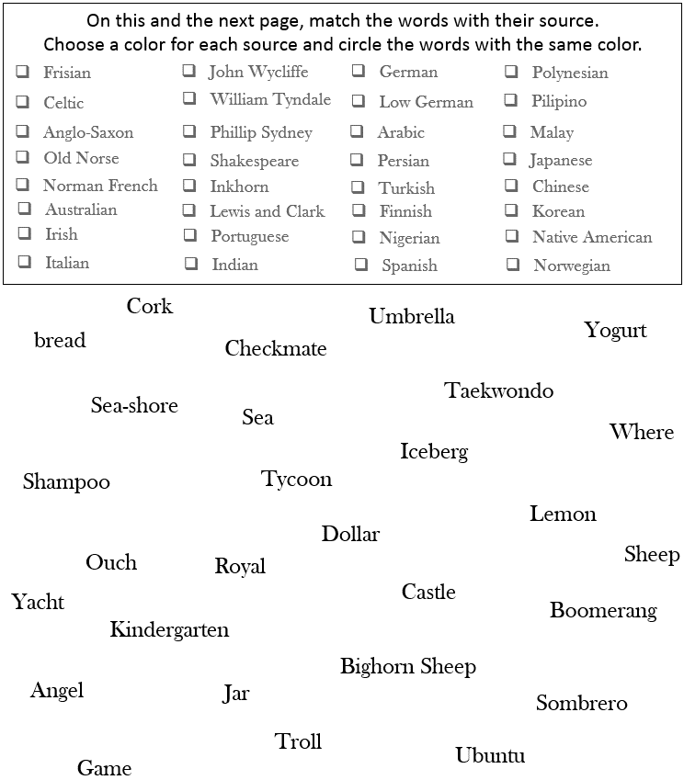
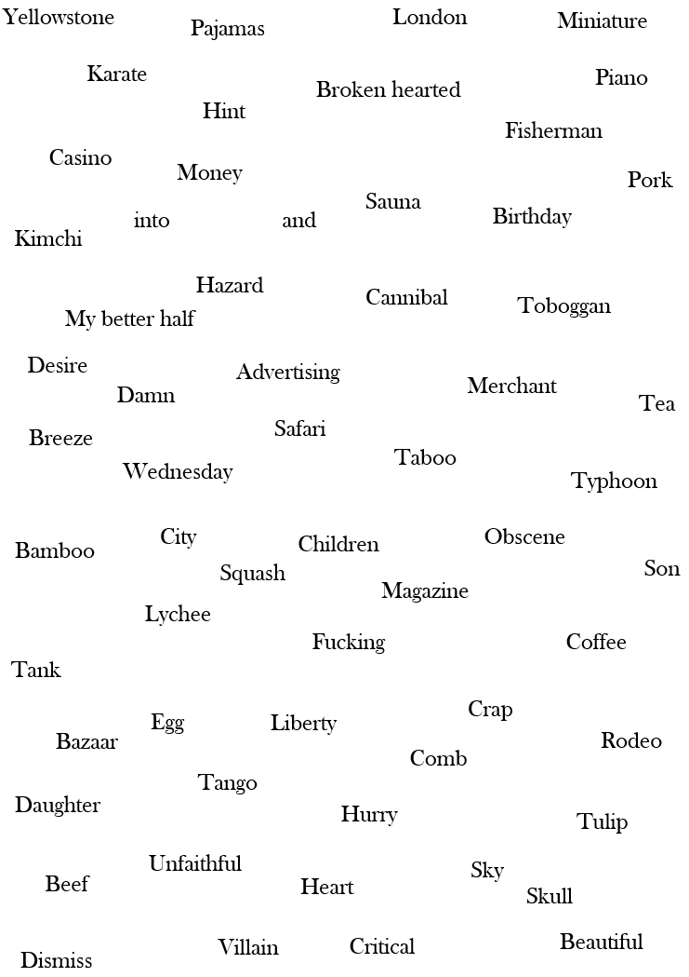
Character Name:
Age:
Gender:
Unusual physical features:

Goals:

Desires:

Occupation:
Hobbies and Interests:

Back Story:

Reputation:
Flaws:

Character Arc:

- What is the most important thing about your character?
- What are your character limitations? Where do they draw the line?
- What does your character need?
- If it’s the main character, is this the most important moment in this character’s life? If not, why aren’t you writing about that?
- What makes your character different?
- Why should the audience care about the character?
- What are your character’s flaws?
- How will your character interact with the other characters?
- What does your character want at this moment?
- What keeps her awake at night
- What is his blind spot?
- What are her secrets?
- What embarrasses him?
- What passion drives him?
- What would she sacrifice to accomplish a goal?

Think about your plot:
In a perfect world, what would happen to your character?

What could go wrong?

