Name: Date:
Signs

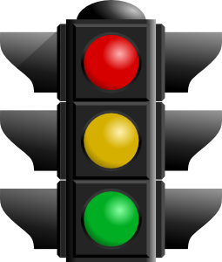
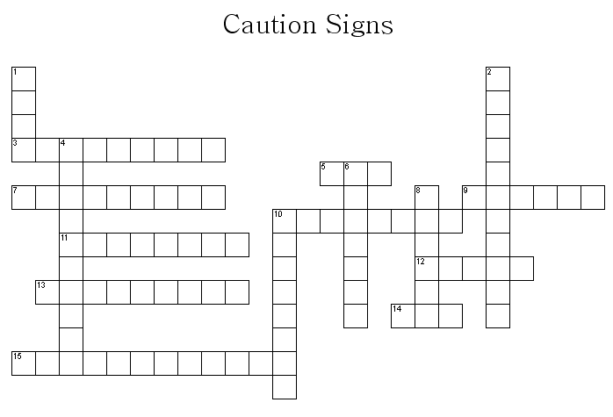

ACROSS
3. Boom =
5. Unidentified flying object =
7 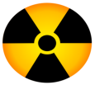 =
9. Do not eat or drink this =
10. Young people
11. Ice is ___________
12. Stop sign
13. Wind from left or right =
14. Something with water on it =
15. People ‘making’ or ‘working’ =

DOWN
1. School _____________
2. Dangerous electricity =
4. People walking =
6. Rocks falling down =
8. If there is a dangerous dog =
10. Going across the road =

