+4 AHALDWJP

+8 KGWQTQ

-12 PAZMXP FDGYB

+7 UKXTDYTLM

Key = CAT, Code = XIZGNXTE

Key = BACON, Code = HOQRWPB

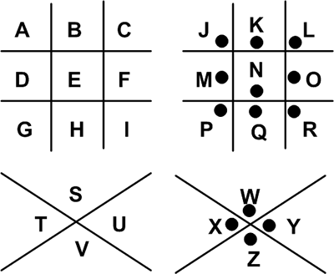

CIPHER

ENGLISH

FIND THE UNICORN
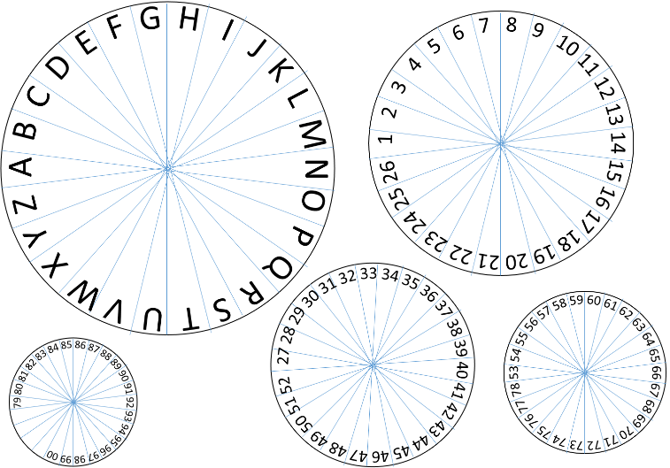
Mexican Army Cipher disk
Key = A08526483

Code = 57222596390140

Code = 9552239412 19886413

Code = 00644101405544
