Whan that Aprill, with his shoures soote
The droghte of March hath perced to the roote
And bathed every veyne in swich licour,
Of which vertu engendred is the flour;

Now therefore thus saith the Lord,
Thou shall not come down
from that bed on which thou
art gone up, but shall surely die

Thy natural magic and dire property
On wholesome life usurp immediately.

I, poor miserable Robinson Crusoe…
came on shore on this dismal,
unfortunate island, which I called
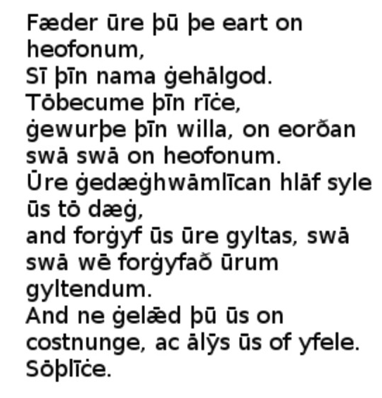
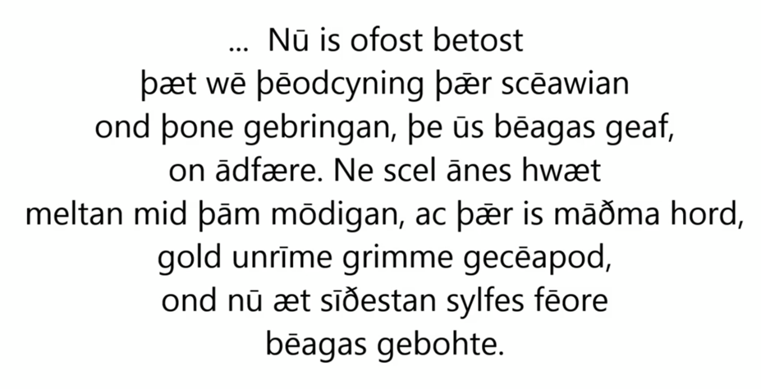
‘The Island of Despair’.

