SHIP WASHES UP ON SHORE AND REVEALS INCREDIBLE MYSTERY
By Abigail P
-
2019-06-04
Article was originally published on our site omgcheckitout.com

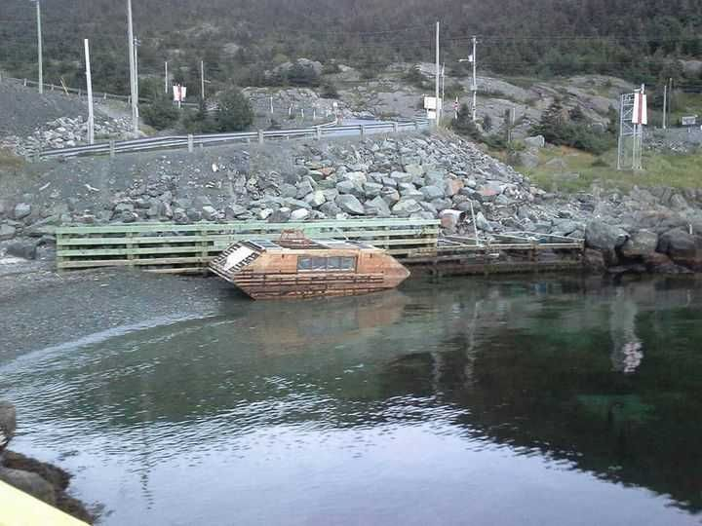
When the residents of the coastal County Mayo saw a ship approaching their shores, slowly making its way over the Atalantic Ocean's horzion, they tried to hail it on all possible radio frequencies. When the ship remained unresponsive, they did what any responsible seaside community would do, and called the local coast guard - but what the officials found when they finally boarded the ship was only the start of a story which would lead them to piece together an answer to an incredible mystery.

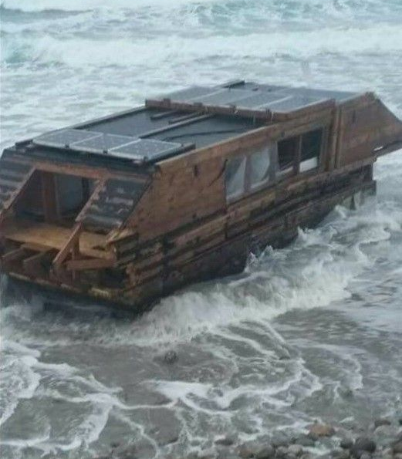
A Surprise Phone Call
As the boat got closer and closer to shore, the onlookers could tell something was wrong.
Not only was its design odd - it seemed abandoned… or perhaps, they thought, its passengers could be trapped inside, without any way to communicate with shore.
The local authorities were called up, and sent a boat in to investigate the strange seafaring vessel.

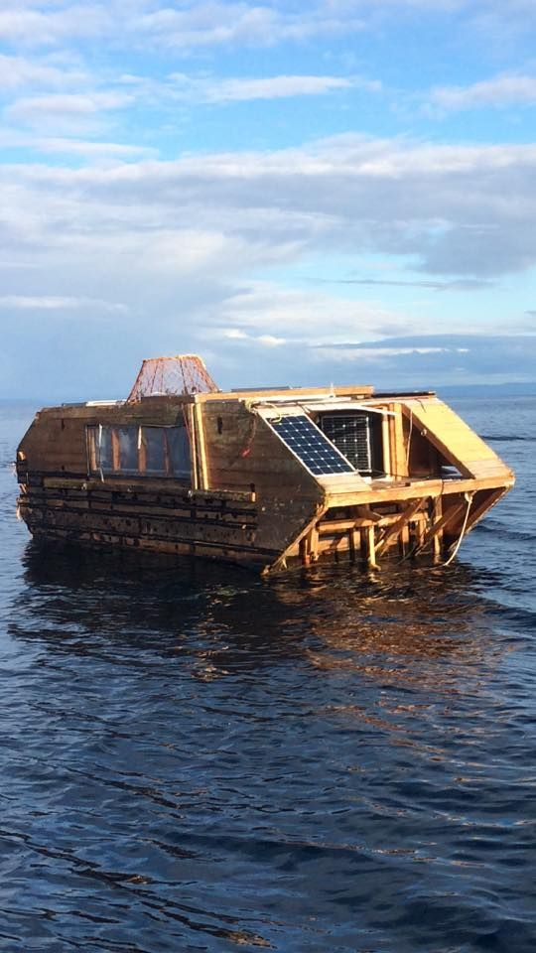
Choppy Waters
The west coast of Ireland is known for its rough and choppy waters. When the boat was found, the first thought people had was to check to see if any passengers were trapped inside. Onlookers were concerned that the boat had been washed up in a storm and that the people inside were unable to call for help.
Consequently, the first thing locals did was to call for a rescue crew to check if anybody was stuck on board. When they stepped inside, however, they found the ship to be totally empty.

A Little Context
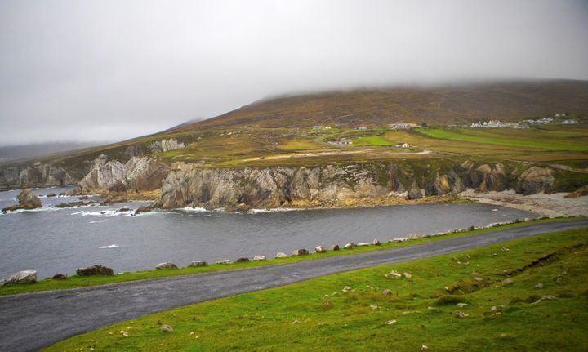
For a little context, County Mayo is one of the biggest counties in Ireland and has a population of 130,000 people. The area is surrounded by sea cliffs which are known for being some of the biggest and most impressive in Europe.
The coastal views surrounding Mayo are certainly beautiful but people generally express more interest in the strange items that are washed up on the shore. Keep reading to find out some of the unusual items people have found on Mayo’s shores.

Objects Are Washed Up Frequently
In June 2017, an American tourist stumbled across a kilogram of the illegal drug, cocaine. A few months later, a helmet and life jacket wound up on the shore with no owner in sight.
It was later concluded that the two items must have belonged to Paul Ormsby or Ciarán Smith. These are the names of the two coastguards who disappeared earlier that year after their helicopter crashed. That is not all that people have found on the mysterious beaches of Maya.

Shipwrecks
In 1917, the British sailing ship SV Arethusa sank during an attack led by German troops. The remains of the ship washed up on the Maya shore and the remains of enough wreck were discovered in 2017.
Shipwrecks don’t really come as much of a shock to the Irish people, who are used to them washing up on their shore. In 2016, however, the boat that washed up contained a hefty surprise which would catch everybody involved off guard.

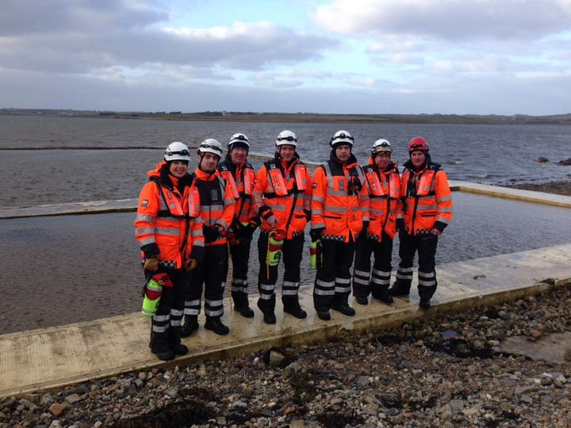
Where Was the Crew?
It was a typical day in fall when locals spotted an unfamiliar boat washed up near Cross Beach. The boat was a houseboat only it did not belong to any of the locals.
Anxious to make sure there was no one trapped on board, they phoned the Coast Guard who hurried out to check if anyone was left inside. They secured the vessel with ropes and clambered anxiously inside to check if anybody was in need of assistance.
They were very surprised, however, to discover that the boat was completely empty.

Michael Hurst
Michael Hurst from the Ballyglass Coast Guard Unit was one of the first people on the scene. He recalled rushing to the beach, expecting to find people in need of their assistance. When he discovered the boat was empty, he had no idea what to think.
“I didn’t know what to think; I was just concerned about safety and securing it,” he told The Daily Telegraph. “Then I thought: where in the name of God did this come from, and who built it?”

Makeshift Vessel
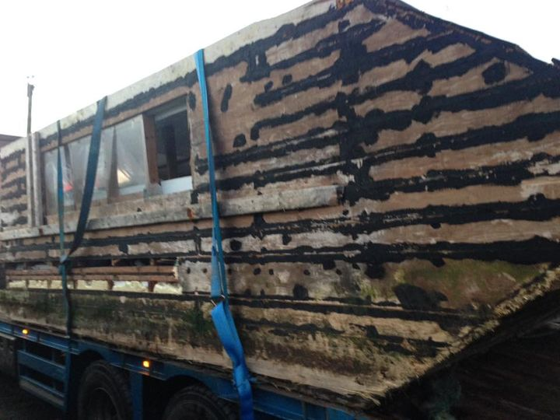
The situation was made even more unusual by the vessel itself, which was a unique specimen.
It had been made from off-cuts of timber, spray foam and polystyrene. The makeshift boat also had Perspex windows and solar panels.
It had clearly been a makeshift job which makes it even stranger that the person who built the boat was not on board. Why would somebody abandon a ship that they had taken the time and effort to build from scratch?

A Floating Caravan
What’s more, the boat was not really fit for crossing the ocean. It was fairly small and was only about 12 feet wide and 20 feet long. It really wasn’t made for long journeys. Hurst commented that the boat was more of a “floating caravan.”
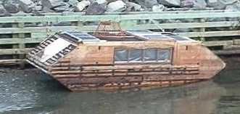
It was not in good condition and did not look particularly safe. This just made it even more surprising that the boat had ended up on a shore in Ireland, when no one in the town claimed to be responsible for the boat.

A Secret Castle
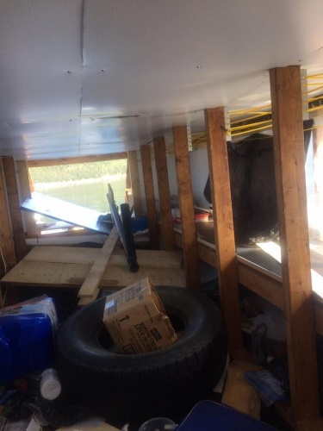
Inside, however, the boat was in pretty impressive condition. It had clearly been well maintained, which just begs even more questions about the owner.
“I wouldn’t like to go out on it. But if you were homeless, it would be like a castle,” Hurst commented.
Why would somebody take such great care of the inside of the boat only to send it sailing with no one on board? Had they expected it to sink? Or worse, had they been on board and got lost out at sea? More investigation was needed.

One Short Message
The Coast Guard decided that more thorough investigation was needed. They clambered inside the vessel and started to look closer at the details. They found something rather curious written on the walls…
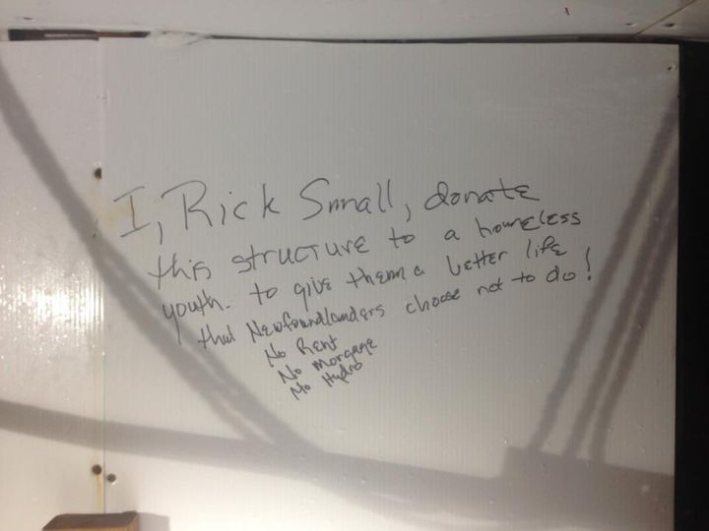
“I, Rick Small, donate this structure to a homeless youth to give them a better life that Newfoundlanders choose not to do!” the message read. “No rent, no mortgage, no hydro.”
With one short message, the maker of the boat had answered the bulk of questions that everybody had about the vessel.

Rick Small
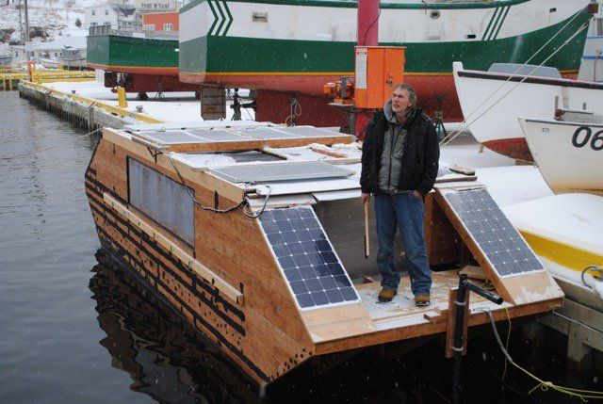
After reading this message, the investigators discovered that Rick Small is an eco-adventurer based in Ontario, Canada. After all, the Canadians have an impressive reputation for crossing the country in unique and adventurous ways, so that shouldn’t come as a big surprise.
If you don’t believe us, just look at the man who made the boat. Rick Small had in fact travelled the 4,375 miles from British Columbia to Newfoundland on a tricycle powered by solar energy. It doesn’t get more hardcore than that!

Contacting Canada
Once the mystery was sussed, the Irish Coast Guard reached out to the authorities in Halifax, Canada. They wanted to inform them of the discovery and were excited to let them know just how far the boat had travelled before it washed up.
The Canadian officials were just as surprised as they were. They could not believe that the boat had made it so far! Reportedly, Small originally intended to sail his boat across the Atlantic himself. It was actually the Canadian authorities who managed to discourage him from making the journey.

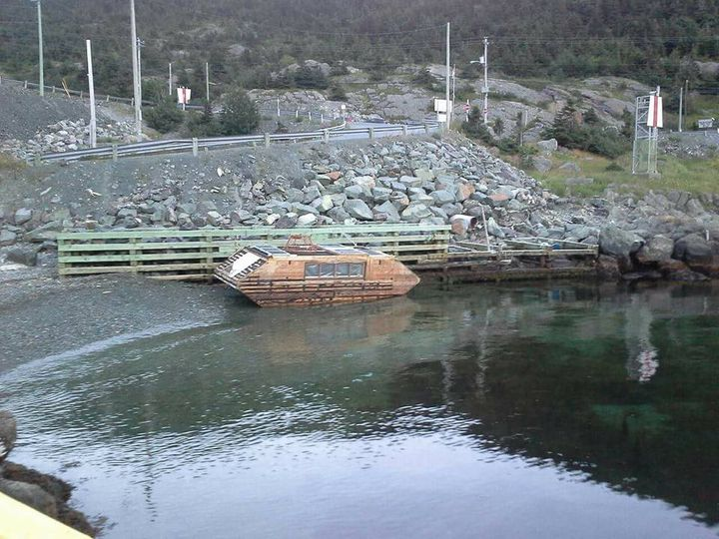
An Epic Journey
In case you are wondering why they dissuaded him, we’d like to remind you that the structure was not built for long sales. The journey is 4,000 miles and it really would not have been safe for Rick to travel, even though the boat did eventually reach the shore.
“The boat was last seen in Portugal Cove in Newfoundland during the summer, and it broke loose,” a spokesman for the Irish Coast Guard reported. “The Halifax authorities were amazed it made it to Ireland and was in one piece.”

Amazement
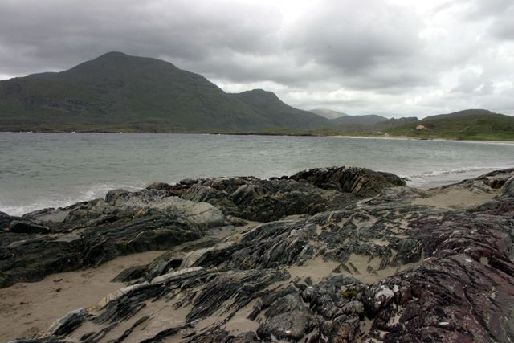
Many people in Canada were familiar with Rick Small’s mission. They had watched the boat drift away from his Canadian home and were shocked when they learned just how far it had travelled.
“It is amazing how it got here,” Hugh Gillespie shared on Facebook.
It turned out that no one was actually expecting it to make it across the Atlantic Ocean. Rick Small proved everybody wrong but nonetheless, we are relieved that he did not climb on board as the mission was still a dangerous one.

Colton McDonald
Others took to Facebook to share their shock at the remarkable journey. Colton McDonald wrote:
“I worked at a local lumber yard here in Newfoundland. I spent a lot of time helping Rick get the materials he purchased from the yard! Weird character but really interesting… Amazing how far the vessel got. I will have to just speculate on what happened to him!”
When Colton gave Rick the materials, he clearly had no idea what a success his idea would be.

Resilient
For the record, the houseboat was actually more resilient than everyone thought. Those who doubted it were obviously proved wrong but they could have predicted its success if they looked closely at the details.
Rick had coated the boat with tar so that the wooden exterior would be weatherproof. The boat was also believed to be fitted with an electric motor powered by a solar panel on the roof.
The BBC reported: "The boats steering system was only a piece of plywood bolted to a PVC pipe. And the motors barely had enough power to move."

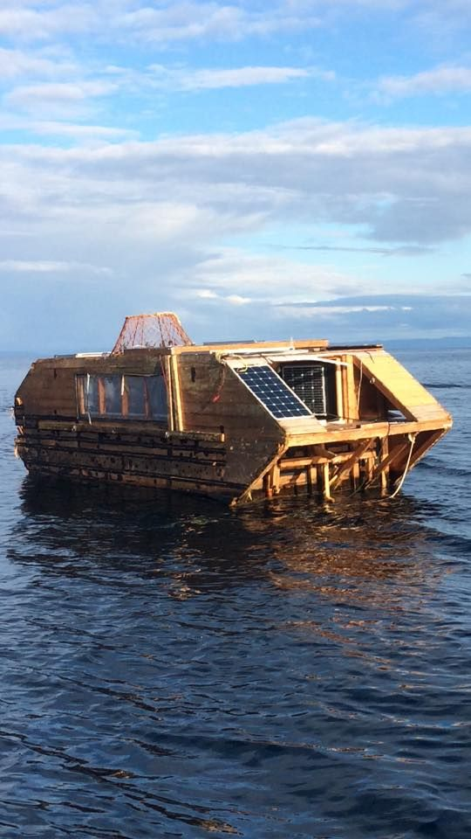
Receiver of the Wreck
Meanwhile in Ireland, Mayo County Council had an empty houseboat on its hands. They decided to place the vessel into a storage depot while they decided what to do with it.
An official known as a Receiver of Wreck was assigned the responsibility of looking after the boat. It was decided that they would wait a year for the rightful owner to claim it and after that, they would decide what to do with it.
Following the news that the boat had washed up on the Irish shore, however, Small did not contact the Mayo County Council.

The Elusive Rick Smalls
The council tried hard to reach Small so that they could return the boat to him or at least inform him that the boat had been found. Curiously though, Rick could not be reached.
The council was waiting for a year to pass so that they could decide what to do with the boat. Many groups have expressed interest in taking ownership of it. The boat was in such good condition inside and would only be in need of some minor refurbishments. What’s more, Small’s message indicated that he fully intended to give the boat away.

What Next?
One of the interested partied were the non-profit group “Men’s Sheds”. They offered to work on restoring the vessel.
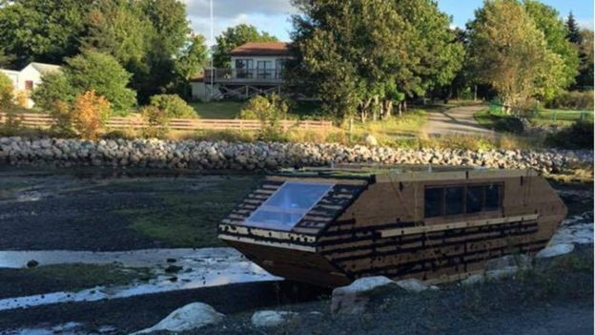
Another group hoped that the boat would become a tourist attraction on Ireland’s Wild Atlantic Way.
Many people had flocked to the beach to see the curious vessel and people hoped that if it became a permanent attraction, there would be a boost in local tourism.
But would people really come from far and wide to get a look at Rick Small’s creation?

Keeping It Local
Everybody seemed to want different things but one thing everyone seemed to agree on was that they wanted the boat to remain in Mayo as this is where it had ended up.
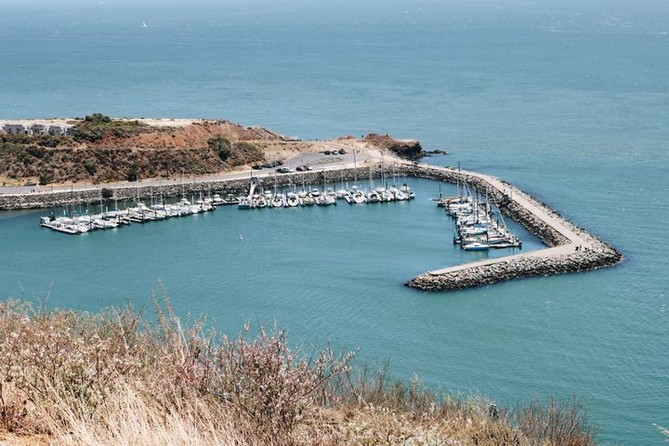
Hurst explained to Metro News: “If the vessel is not claimed and it remains in Ireland, we would like to see it kept locally,”
He added: “There has been a lot of interest in it. And the feeling locally is that because it came ashore here, it should remain here.”

Eco-Homes
The idea that Rick Smalls had for the boat was definitely a wonderful one. Homelessness remains a real problem in Ireland and the UK, even if this was not where Rick intended for his boat to end up.
There has been a recent rise in "Eco-Homes" which use little to no energy. Living on a boat is also a way to avoid rising house prices and Rick's creation had the potential to house a homeless person in need of shelter.

Where is Rick Smalls?
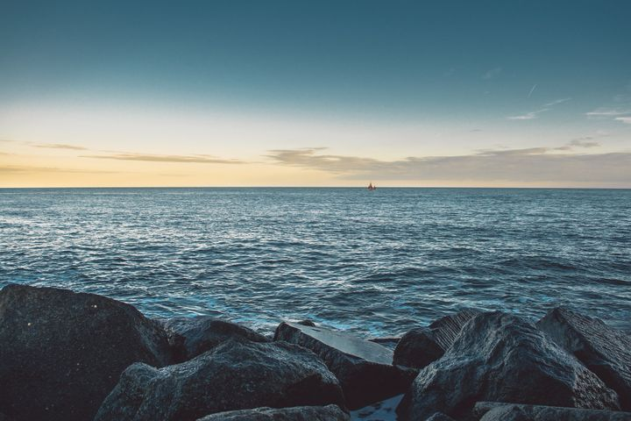
The remaining mystery is what happened to Rick Smalls. Timothy John Ewart, a fellow sailor, spotted the boat before it made its journey and asked Smalls about his intentions.
"The boats steering system was only a piece of plywood bolted to a PVC pipe," he explained. "And the motors barely had enough power to move."
Naturally, Timothy was astounded to learn that the board had made it. He would have congratulated Rick on his success, only he was nowhere to be found.

Never Seen Again
"I never saw him again," Timothy said of their last encounter.
The last time he saw Mr. Smalls was in 2015. He recalled: "When he left our area, he was standing on top using a long 2X4 (piece of wood) to push his way out because the current was stopping the boat."
It therefore seems to be the case that Rick ignored the Canadian official's advice and decided to cross the Atlantic in his boat. It still remains a mystery where he is today, especially given that his boat washed up on shore unscathed.

A Legend
We can only hope that Rick Smalls is somewhere safe, working on another crazy invention.
Wherever he is and whatever he is doing, he is now the legend who built the floating caravan that sailed the Atlantic Ocean. The boat still remains in Maya where it is a symbol of adventure.
The boat has been taken ashore to Cross Beach in County Mayo where it remains today. As well as being a symbol of adventure, Rick's message of sharing with those in need is prominent.

