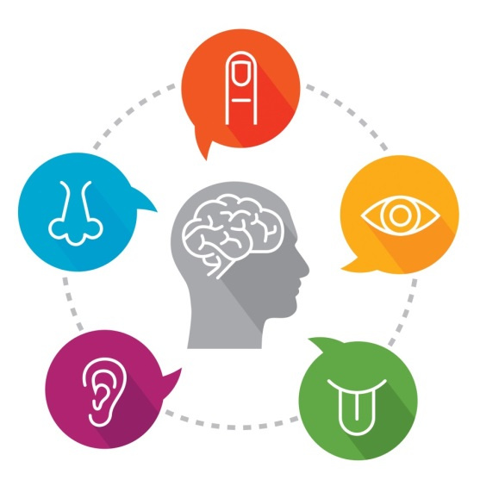
Prosopagnosia, or face blindness is the inability to recognize familiar faces.

Face blindness makes it difficult for people to recognize the faces of others they have met before. In extreme cases, a person with face blindness may not even recognize family members. Furthermore, sufferers can’t easily imagine people’s appearance in their minds. Focusing on non-facial clues, such as hairstyles and voices, help them to recognize others. One problem often experienced by these people is the inability to distinguish one actor from another in movies, making it difficult to follow the plot. Face blindness often follows brain damage such as a stroke. Some cases, however, seem to be genetic.

- How does face blindness affect sufferers?

- How can sufferers recognize people?

- Why do sufferers have a difficult time following the plot of movies?

- What is a common way to get face blindness?

