LISTENING II
Tim Schilstra
www.esltoybox.com
Goals of Listening
- To increase listening comprehension and retention
- To develop active listening skills
- To expand the teacher’s repertoire of listening activities
Description of Units
Listening Comprehension ………………………………………………………. 10 hours
Audio Illusions
Prosopagnosia
Eyewitness Testimony
Detective Games
3D Escape Room
You vs Wild

Active Listening …………………………………………………………………….. 6 hours
Listening to Body Language
Simple Verbal Responses
Reflective Listening
The Verbal Component
NPR Conversations

New Technologies in the Classroom ……………………………………………… 6 hours
Google Cardboard
Smartphones
Internet Sites
Artificial Intelligence

Student Needs ………………………………………………………….……..…… 8 hours
The Silent Period
Listening without Speaking
Music and Dance
Adapting a Textbook

Listening for Fun ……………………………………….…………………………… 5 hours
Barbara Streisand Coloring Book
Whose Line is it Anyways?
Would I Lie to You?
War of the Worlds
Active Listening
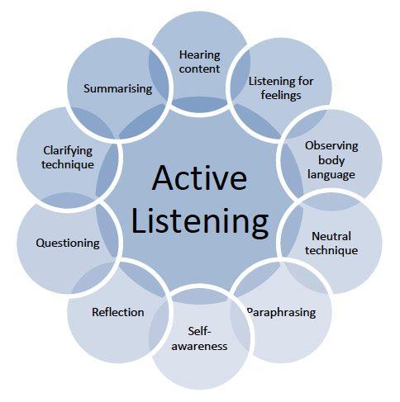
In this course we will be learning about active listening. Active listening is a skill that can be applied when having a conversation in any language. Our goal is to use active listening to increase our English awareness and thus increase our retained comprehension of information in English. Active listening requires that the listener fully concentrates, understands and remember what is being said. The goal of active listening is to make the other person feel heard and valued. It is a very important skill for having a successful conversation.
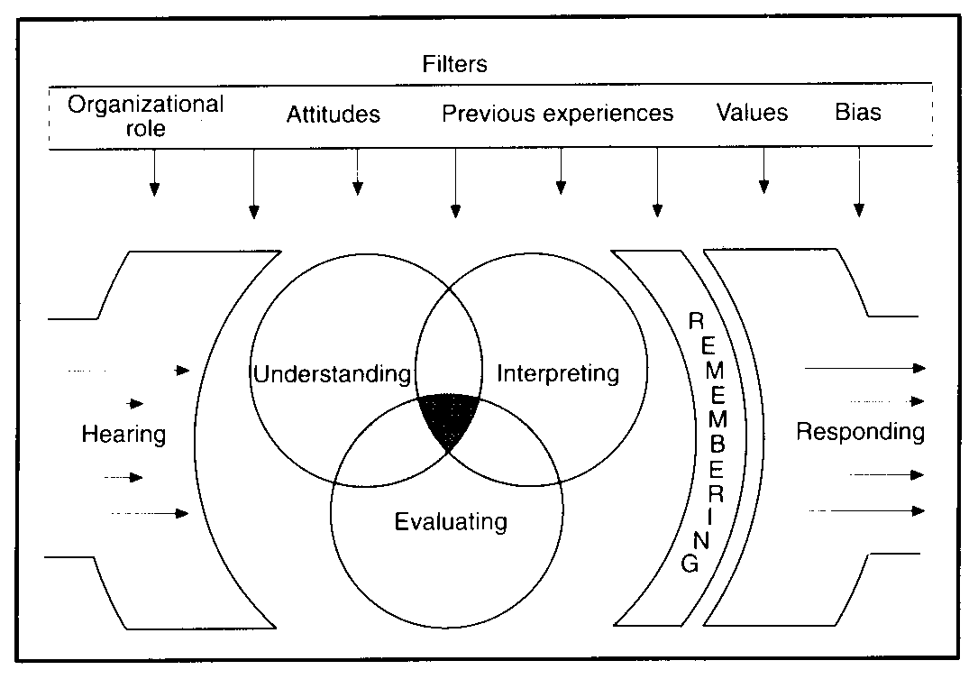
The first thing that we must understand about active listening is that is not just hearing someone speak. Often times, when we are having a conversation, we are just waiting for our turn to speak. Hearing doesn’t require that you engage with the other person’s ideas or even understanding. Active listening involves many techniques including (Cuncic 2019):
- Being neutral and nonjudgmental
- Being patient (periods of silence are not "filled")
- Verbal and nonverbal feedback to show signs of listening (e.g., smiling, eye contact, leaning in, mirroring)
- Asking questions
- Reflecting back what is said
- Asking for clarification
- Summarizing
Active listening my come naturally when you are talking to a loved one or when you are really interested in what the other person has to say. It clearly benefits all kinds of relationships. You can have deeper friendships, get along with coworkers better, and turn acquaintances into friends. One of the best people at this skill is Oprah Winfrey. Her body language and listening skills, along with knowing how to ask the right questions allows her to make an emotional connection quickly to anyone she meets (Cordon and Winfrey 2018). In this section of the course, we will improve our active listening skills by focusing on body language, reflective listening, and other skills inherent in good active listening.

Non-Verbal Cues
Non-verbal communication, including body language, is a key part of communication. It is estimated that 93% of communication is non-verbal (Mehrabian and Ferris 1967). This includes 38% vocal (but not language) and 55% visual. While the exact numbers may be misleading and wide-spread (Lapakko 2007), it does show an importance on non-verbal communication. In class, we will be looking at how the lack of this (non-verbal) information affects people and how we can use sensory deprivation to enhance the listening skills of students. While we are more concerned about the active listening implications of non-verbal communication, we can also use these skills as teachers. Our body language can be used for classroom management or to give students visual clues when trying to teach a second language.
Since the goal of active communication is to engage in meaningful conversation. We want to express openness and receptiveness with our body posture. One of the most important ways that Westerners convey receptiveness is through eye contact. Korean culture dictates that eye contact is less prevalent, but you should still try to make direct eye contact for a few seconds at a time often during a conversation. The direction of your eyes shows your partner where your interest is. If you are looking towards the door or away from them, you are secretly telling them that you would rather be outside of the door or somewhere else. Good eye contact is important.
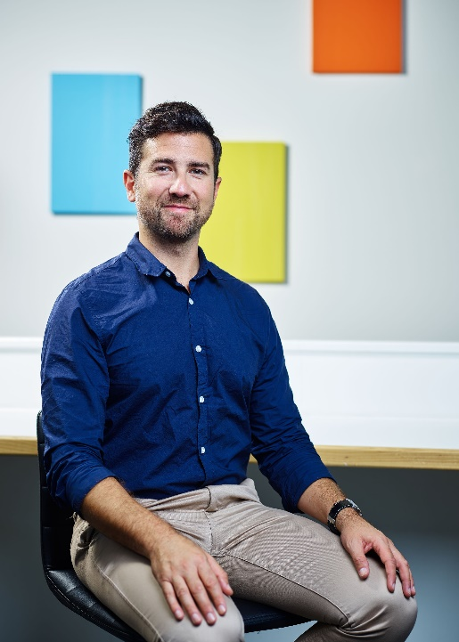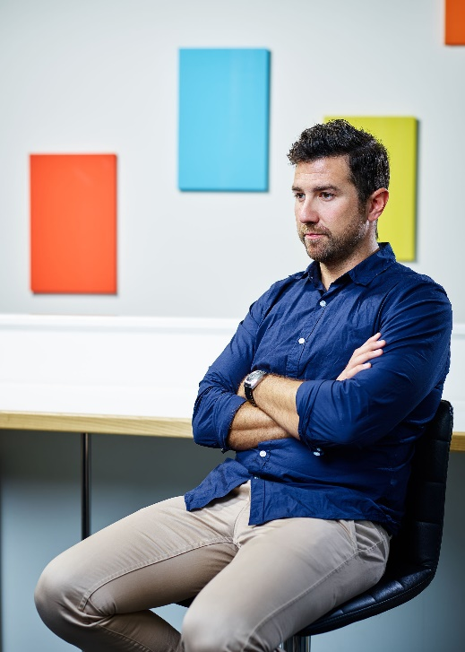
Your body position should be directed towards the person you are listening to. Avoid crossing your legs or (especially) your arms as this communicates disinterest. Instead, have your legs slightly open (with exceptions for dresses and skirts) with your hands in front of you on your lap if you are sitting. If you are standing, have your hands at your side and not in your pockets. The palms of your hands and arches of your foot can also tell your communication partner your level of interest. The more that your partner can see, the more open you appear. Avoid using your hands to write, draw or fidget with items around you. Touching your face (in particular your mouth or nose) is often considered a sign that you are lying, so try to avoid that. Also, hiding your hands can be seen as a sign of deceit. If you are talking across a table or desk, put your hands in a visible position. You should also be sitting upright with a slight lean towards your partner. This shows an interest in what they are saying.
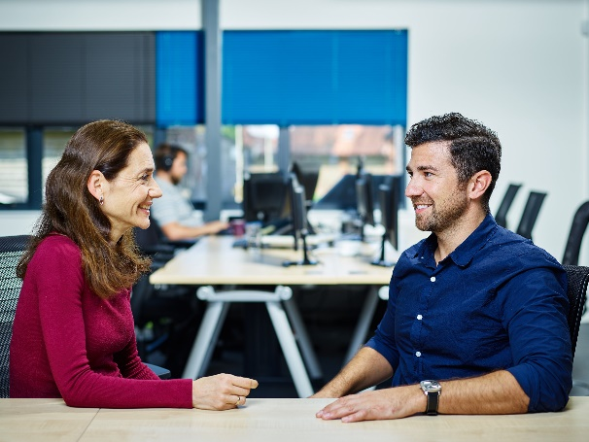
Can you spot the good and bad body language?
Body language is important in communicating mood but you can add more information through your facial expressions. We have already talked about the value of eye contact, but there are other things to consider. A nice, warm, genuine smile encourages people to be open. However, it might not be appropriate if you are listening to a story of something bad that happened to your partner. Instead, we need to employ the use of mirroring. Mirroring is when you change your body language to match that of your partner. If their eye brows furrow, showing distress, you should also furrow your brow. Finally, you should occasionally nod your head. This shows interest, agreement, and understanding with your partner. In class we will take an Emotional Quotient (EQ) test to see how well we can identify body language. EQ is similar to IQ in that it tests your level of emotional awareness like IQ tests your intelligence. Here are some examples from Memorado (2019):
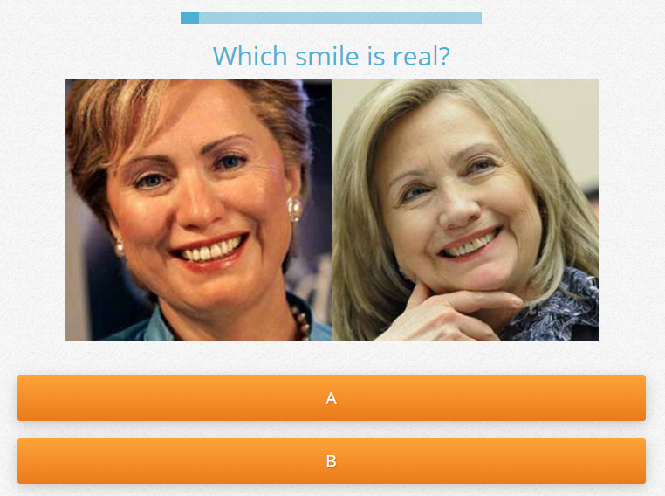
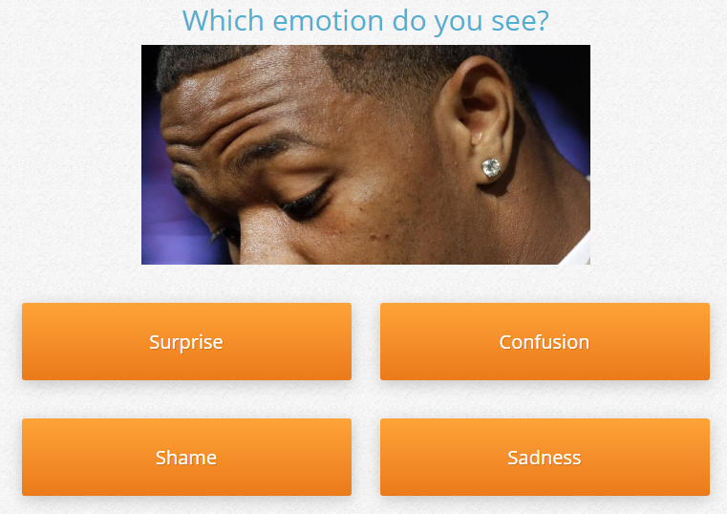

Vocal utterances are also useful in encouraging your partner to continue speaking. Simple phrases like ‘uh huh’ and ‘uh oh’ are a great way to show that you are listening without interrupting the speaker. Acknowledgement responses are on the borderline between verbal and non-verbal focalizations. These phrases include, but are not limited to: yes, ok, oh ya?, really?, and?, sure and right. Asking one of the W’s is also a good idea. Probably the most powerful word in active listening is “why?” Children learn this at an early age. Sometimes they overuse it to the point of annoyance, but it is very effective in continuing a conversation. Children may not be able to effectively communicate in conversations, but learn that asking ‘why?’ is like a life hack to get adults to talk to them longer. This simple word can be used much the same way when practicing active listening.

Reflective Listening
Reflective listening involves understanding the speaker’s idea and to repeat it back to confirm that it was understood correctly. This is especially important in active listening as it shows that you are listening, you understand and you are interested in what they are saying. It is essentially the verbal equivalent of mirroring. Reflective listening is rooted in empathy. According to Dalmar Fisher, reflective listening involves:
- Focusing upon the conversation by reducing or eliminating any kind of distraction.
- Genuinely embracing the speaker’s perspective without necessarily agreeing with it. By engaging in a non-judgmental and empathetic approach, listeners encourage the others to speak freely.
- Mirroring the mood of the speaker, reflecting the emotional state with words and nonverbal communication. This requires the listener to quiet his mind and focus fully upon the mood of the speaker. This mood will becomes apparent not just in words used but in the tone of voice, posture and other nonverbal cues given by the speaker. The listener will look for congruence between words and mood.
- Summarizing what the speaker said, using the speaker’s own words rather than merely paraphrasing words and phrases, thereby mirroring the essential concept of the speaker.
- Responding to the speaker’s specific point, without digressing to other subjects.
- Repeating the procedure for each subject, and switching the roles of speaker and listener, if necessary.
- During the reflective listening approach, both client and therapist embrace the technique of thoughtful silence, rather than to engage in idle chatter.
Perhaps an example will highlight how reflective listening is used. Let’s say that your friend was telling you about a bad breakup with her boyfriend. She explains that he cheated on her with someone from his job. A reflective listener might respond by saying, “I can’t believe that! He cheated on you with someone from work?!” The listener shows that they understand the content of the story, while inviting the speaker to confirm and expand on the story. They also express empathy with the speaker by expressing their shock. This empathy allows the speaker to feel a connection to the listener and make them more comfortable in adding detail to the story.
It is important to note that in active listening, we don’t want to become the speaker. Our goal is to make the speaker feel comfortable and to continue telling us their story. Reflective listening can provide opportunities for the speaker to elaborate, and is a great tool. But there is a temptation to make our own lives related to the stories we are listening to. In active listening, we must suppress this urge. For example, consider if the previous listener had responded by saying, “That sucks. I had someone cheat on me as well.” While the listener is showing understanding and empathy, the focus has changed to the listener, thereby making the speaker less important.
According to Neil and McNulty (1994), reflective listening is comprised of three parts: Reflecting content, reflecting feelings, reflecting meaning. Reflecting content focuses on what the speaker is saying to you, including thoughts, ideas, beliefs, facts, data, etc. Reflecting feelings refers to being empathetic to the speaker. You can use phrases like; you feel… You sound… You look… etc. This requires the listener to be able to identify more complex emotions. Finally, reflecting meaning is when you combine content and meaning reflection in a single response. Often this means making inferences into the speaker’s story. “You feel ____________ because ____________.” Mastering reflective listening is most of the way to active listening.

Verbal Component
Active listening builds on reflective listening by being more than just a conversational mirror. Active listening encourages the speaker to continue with their story by asking for more details and to expand their story. This is the active part, the verbal component, of active listening. In addition to reflecting, you can also keep the conversation going by using paraphrasing, summarizing, and repeating. Paraphrasing is taking what the speaker has said to you and repeating that back to them but in a slightly different way. You can also use summarizing to make show the speaker that you understand what they are saying and that you are listening to the whole story. It is also a good chance to find out how much you comprehended.
It is also important to show your empathy in the conversation. Sometimes, people just want someone to say, “That sucks.” Active listening is not about offering advice. Most of the time, the speaker just wants someone to listen to them, not to tell them what to do. Of course, if they ask for advice, be kind and try to understand the story from their perspective. It is just about being a good listener. Adding quick empathetic responses help to validate the feelings being experienced by the speaker. This also works for happy stories. Just saying, “That’s great.” Or “I’m happy for you.” Can really make someone feel good. I think that people act self-centered unintentionally in a lot of conversations. The way someone else feels should not affect us, but it sometimes does. It is important to realize this and to follow the emotional path of the speaker. If they get sad, you can get sad with them. If the story has a surprising ending, be surprised. Do not make the conversation about you. It is the speaker’s story.
It is important to stay non-judgmental in conversation. You are a neutral observer of the story. My final piece of advice is to ask questions you are genuinely interested in. Your genuine interest will always come across and be appreciated.
Active listening is a technique used in counseling, training, community organizing, tutoring, medical workers talking to patients, helping suicidal persons, management, journalism and for resolving conflicts. It is a useful technique that you can use to have more insightful and deep conversation as well. We all just want to be listened to.

6 Phrases That Demonstrate Active Listening (Zantal-Wiener 2018)
- Do you mean…?
  - I’m not sure I understand.
  - Could you tell me a bit more about that?
- It sounds like…
  - What I’m hearing is…
  - You seem a bit…
- Really?
  - When?
  - How?
  - You’re kidding.
- I’ve noticed that…
- Let me make sure I’ve got this right.
  - These are the main points I’ve heard you make so far.
  - Let’s make sure I’m hearing you correctly.
  - Let’s pause to make sure we’re on the same page.
- I’m sorry. That really sucks.
  - I’m sorry you’re going through that.
  - What a crappy situation to be in. I’m sorry.
  - That’s rough. How can I help.

5 Ways to Listen Better – transcript
https://www.ted.com/talks/julian_treasure_5_ways_to_listen_better/transcript
We are losing our listening. We spend roughly 60 percent of our communication time listening, but we're not very good at it. We retain just 25 percent of what we hear. Now -- not you, not this talk, but that is generally true.
Let's define listening as making meaning from sound. It's a mental process, and it's a process of extraction.
We use some pretty cool techniques to do this. One of them is pattern recognition. (Crowd noises) So in a cocktail party like this, if I say, "David, Sara, pay attention" -- some of you just sat up. We recognize patterns to distinguish noise from signal, and especially our name. Differencing is another technique we use. If I left this pink noise on for more than a couple of minutes, (Pink noise) you would literally cease to hear it. We listen to differences; we discount sounds that remain the same.
And then there is a whole range of filters. These filters take us from all sound down to what we pay attention to. Most people are entirely unconscious of these filters. But they actually create our reality in a way, because they tell us what we're paying attention to right now. I'll give you one example of that. Intention is very important in sound, in listening. When I married my wife, I promised her I would listen to her every day as if for the first time. Now that's something I fall short of on a daily basis.
But it's a great intention to have in a relationship.
But that's not all. Sound places us in space and in time. If you close your eyes right now in this room, you're aware of the size of the room from the reverberation and the bouncing of the sound off the surfaces; you're aware of how many people are around you, because of the micro-noises you're receiving. And sound places us in time as well, because sound always has time embedded in it. In fact, I would suggest that our listening is the main way that we experience the flow of time from past to future. So, "Sonority is time and meaning" -- a great quote.
I said at the beginning, we're losing our listening. Why did I say that? Well, there are a lot of reasons for this. First of all, we invented ways of recording -- first writing, then audio recording and now video recording as well. The premium on accurate and careful listening has simply disappeared. Secondly, the world is now so noisy, (Noise) with this cacophony going on visually and auditorily, it's just hard to listen; it's tiring to listen. Many people take refuge in headphones, but they turn big, public spaces like this, shared soundscapes, into millions of tiny, little personal sound bubbles. In this scenario, nobody's listening to anybody.
We're becoming impatient. We don't want oratory anymore; we want sound bites. And the art of conversation is being replaced -- dangerously, I think -- by personal broadcasting. I don't know how much listening there is in this conversation, which is sadly very common, especially in the UK. We're becoming desensitized. Our media have to scream at us with these kinds of headlines in order to get our attention. And that means it's harder for us to pay attention to the quiet, the subtle, the understated.
This is a serious problem that we're losing our listening. This is not trivial, because listening is our access to understanding. Conscious listening always creates understanding, and only without conscious listening can these things happen. A world where we don't listen to each other at all is a very scary place indeed. So I'd like to share with you five simple exercises, tools you can take away with you, to improve your own conscious listening. Would you like that?
Good. The first one is silence. Just three minutes a day of silence is a wonderful exercise to reset your ears and to recalibrate, so that you can hear the quiet again. If you can't get absolute silence, go for quiet, that's absolutely fine.
Second, I call this "the mixer." (Noise) So even if you're in a noisy environment like this -- and we all spend a lot of time in places like this -- listen in the coffee bar to how many channels of sound can I hear? How many individual channels in that mix am I listening to? You can do it in a beautiful place as well, like in a lake. How many birds am I hearing? Where are they? Where are those ripples? It's a great exercise for improving the quality of your listening.
Third, this exercise I call "savoring," and this is a beautiful exercise. It's about enjoying mundane sounds. This, for example, is my tumble dryer.
It's a waltz -- one, two, three; one, two, three; one, two, three. I love it! Or just try this one on for size.
Wow! So, mundane sounds can be really interesting -- if you pay attention. I call that the "hidden choir" -- it's around us all the time.
The next exercise is probably the most important of all of these, if you just take one thing away. This is listening positions -- the idea that you can move your listening position to what's appropriate to what you're listening to. This is playing with those filters. Remember I gave you those filters? It's starting to play with them as levers, to get conscious about them and to move to different places. These are just some of the listening positions, or scales of listening positions, that you can use. There are many. Have fun with that. It's very exciting.
And finally, an acronym. You can use this in listening, in communication. If you're in any one of those roles -- and I think that probably is everybody who's listening to this talk -- the acronym is RASA, which is the Sanskrit word for "juice" or "essence." And RASA stands for "Receive," which means pay attention to the person; "Appreciate," making little noises like "hmm," "oh," "OK"; "Summarize" -- the word "so" is very important in communication; and "Ask," ask questions afterwards.
Now sound is my passion, it's my life. I wrote a whole book about it. So I live to listen. That's too much to ask for most people. But I believe that every human being needs to listen consciously in order to live fully -- connected in space and in time to the physical world around us, connected in understanding to each other, not to mention spiritually connected, because every spiritual path I know of has listening and contemplation at its heart.
That's why we need to teach listening in our schools as a skill. Why is it not taught? It's crazy. And if we can teach listening in our schools, we can take our listening off that slippery slope to that dangerous, scary world that I talked about, and move it to a place where everybody is consciously listening all the time, or at least capable of doing it.
Now, I don't know how to do that, but this is TED, and I think the TED community is capable of anything. So I invite you to connect with me, connect with each other, take this mission out. And let's get listening taught in schools, and transform the world in one generation to a conscious, listening world -- a world of connection, a world of understanding and a world of peace.
Thank you for listening to me today.

10 Ways to Have a Better Conversation – summary
https://www.youtube.com/watch?v=R1vskiVDwl4

1. Don't multitask. (4:27)
2. Don't pontificate. (4:50)
3. Use open ended questions. (6:02)
4. Go with the flow. (6:39)
5. If you don't know, say that you don't know. (7:26)
6. Don't equate your experience with their. (7:46)
7. Try not to repeat yourself. (8:26)
8. Stay out of the wits. (8:46)
9. Listen. (9:08)
10. Be brief. (10:29)

Student Activities
Sensory Deprivation
One of the fun ways to help students with their listening skills is through sensory deprivation. Take away one of their senses (sight) will allow them to focus on their listening. There is of course a real world equivalent, blindness. But there are more types of blindness than you may be aware of. In class we will look at color blindness, prospagnoisia and aphantasia. Color blindness is the inability to distinguish colors. Prospagnosia is the inability to recognize faces. And aphantasia is the inability to create images in your mind’s eye (imagination).
Three blind mice. Three blind mice.
See how they run. See how they run.
They all ran after the farmer's wife,
Who cut off their tails with a carving knife,
Did you ever see such a sight in your life,
As three blind mice?

We can simulate full blindness with blindfolds, a blacked out screen, or information that can only be seen by some students. A fun game for learning adjectives or basic question formation is to have one student come to the front. The other students must ask questions to guess what is on the computer screen. I have used this many times in class. I would advise you to make sure students can’t see the reflection of the computer screen though as it ruins the game. The opposite of this game is Hot Seat. In Hot Seat, one student sits at the front of the class with their back to the television screen. The others students must give clues, or describe what is on the TV screen and the person in the hot seat must guess what it is.
Another useful type of activity that uses blindness is having students describe a scene. In class we will play the Police Sketch Artist game together. In this game, students are separated into partners with one facing the TV and one facing away from the TV. Students are shown a picture of a person that they must describe to the police sketch artist (with their back towards the TV). The police sketch artist then has to use that information to draw the person. The closest to the correct answer wins.
We can play other games with visual deprivation. For example, you could play some video clips with the screen blacked out. Then have students try to guess what is happening in the picture. Another common game I used is partial pictures. With some games, I only showed parts of a picture, or slowly revealed the image. Students race to guess that answer first.

Audio Description
A carrot-nosed snowman shuffles up to a purple flower peeping out of deep snow.
He takes a deep sniff.
Achoo!
His nose lands on a frozen pond.
A reindeer look up and pants like a dog.
Seeing the reindeer slip on the ice, the snowman smiles and moves towards him. Actually, he is running on the spot.
The reindeer falls on his chin.
The snowman uses his arm as a crutch.
The reindeer paddles his front legs.
Head over heels first, snowman crawls along the ice.
The reindeer does the breaststroke.
The snowman rolls his body, but flips onto his back.
The reindeer’s tongue sticks to the ice.
The snowman hurls his head.
Twig arm and reindeer lips tug at the carrot.
The carrot flies off and lands in soft snow.
The reindeer goes after it with snowman and his body parts hanging on his tail.
The snowman puts himself back together again and glumly contemplates his noseless state.
The reindeer jams the carrot back in place and pants like a proud puppy.
The snowman pats him with a stick then arm.
He goes to sneeze.
He grabs his nose with two hands.
His head shoots off.

Face Blindness
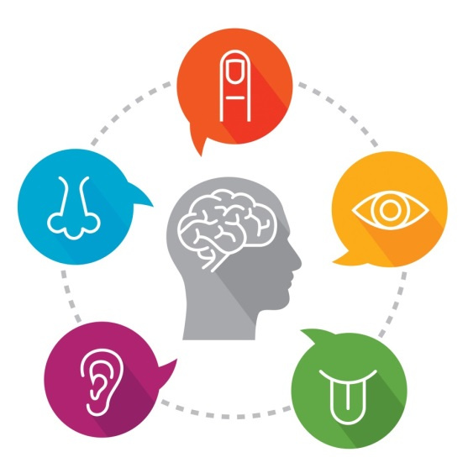
Prosopagnosia, or face blindness is the inability to recognize familiar faces.

Face blindness makes it difficult for people to recognize the faces of others they have met before. In extreme cases, a person with face blindness may not even recognize family members. Furthermore, sufferers can’t easily imagine people’s appearance in their minds. Focusing on non-facial clues, such as hairstyles and voices, help them to recognize others. One problem often experienced by these people is the inability to distinguish one actor from another in movies, making it difficult to follow the plot. Face blindness often follows brain damage such as a stroke. Some cases, however, seem to be genetic.

- How does face blindness affect sufferers?

- How can sufferers recognize people?

- Why do sufferers have a difficult time following the plot of movies?

- What is a common way to get face blindness?

The Silent Period
The silent period in second language acquisition is the phase when a learner is not producing language yet, but is actively processing it. Each student’s silent period is different. As teachers, we like to have feedback and responses from students to know their English level. But if a student is not trying to talk, it can be difficult to know what level they are at. There may be many different reasons why a student does not want to try speaking yet. They may be worried about their skill level, are socially awkward, embarrassed or too shy to be using the second language. I have even had a student that could not speak (even in Korean). But these student may still be learning and should not be ignored. Since the silent period occurs at the start of learning an L2, we can make games focused on young students. Students sometimes need time to become comfortable speaking another language.
We can still check for comprehension and encourage students’ listening skills through pointing games. Students really seem to enjoy hidden picture games. They are given some items to find in the picture and search to find them. You can turn this activity into a game by giving a point to the first student who finds the item and seeing who has the most points at the end of the game. You can also take this one step farther by incorporating target language. For example, you could make a page with a lot of actions illustrated. The students have to ask you, “What is he doing” before you tell them the clue, “He is eating an ice cream.” The students then race to find the picture of the ice cream cone. One final example is counting. In one lesson, students are expected to state how many of a certain type of animal there are. So, I created a landscape with many animals in it. One student will ask the other, “How many _____ are there?” The other needs to count the animals and answer, “There are _______ ________.”
Coloring activities are also a great way to engage with young learners stuck in the silent period. In the Funny Fruit Basket game, students can color the fruit in one of a selected number of colors. They are encouraged to color the fruits in a different color than normal. After all of the student finish coloring, the teacher draws a fruit card and a color card (representing all the fruits and colors). “It is a pink banana,” the teacher might say. If a student had colored the banana pink, they get a point. The students that are past the silent period may also help you by drawing and saying the colors and fruits. The point of these activities is for the students to have fun, become comfortable with the language and to be actively learning even if they are not speaking yet.

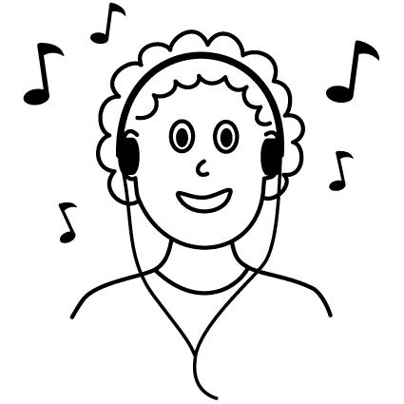
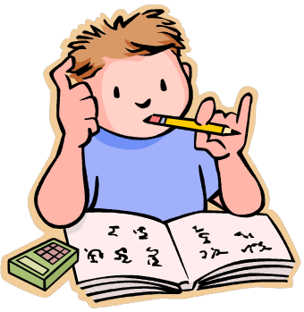
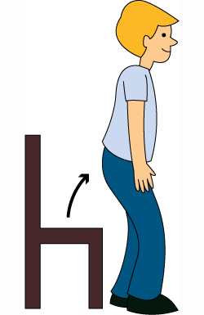
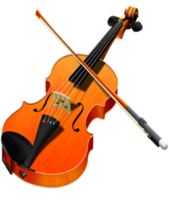
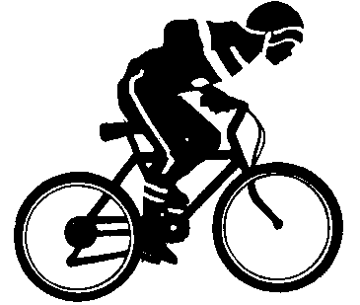
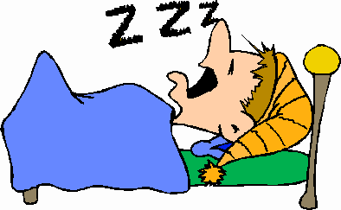
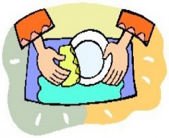
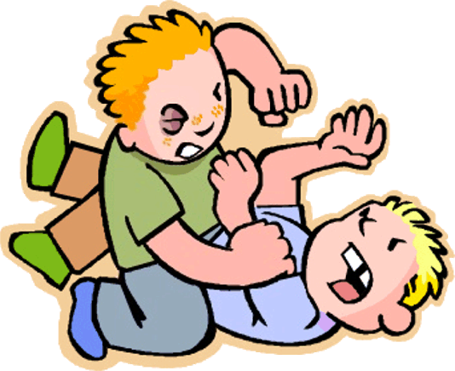
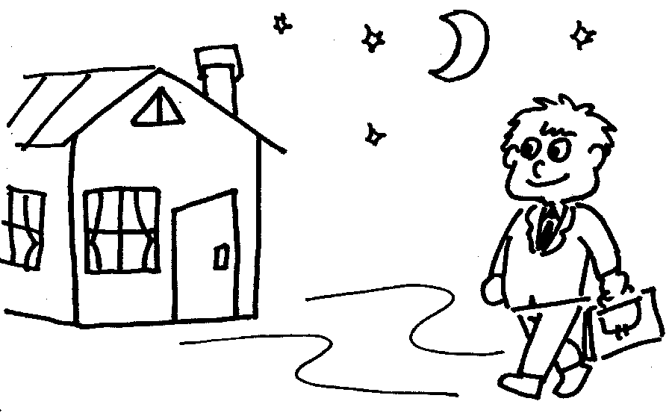
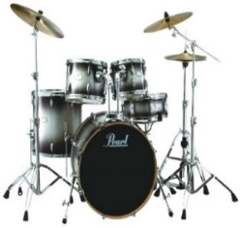
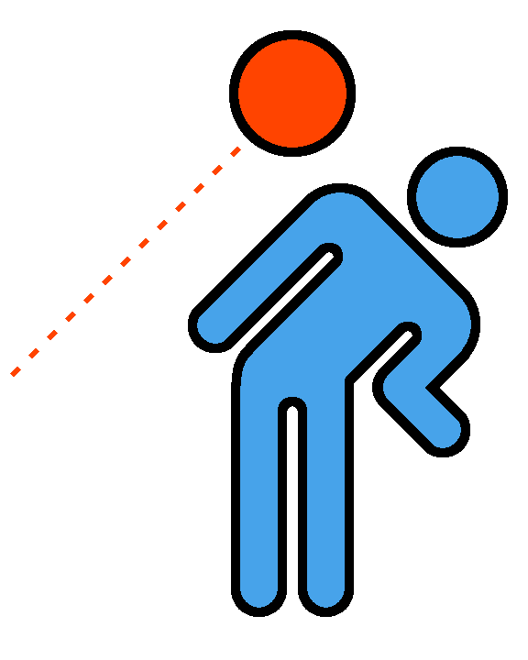
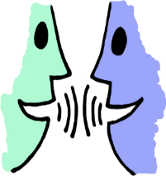

New Technology
In this course, we will also explore additional games and activities that take advantage of new technologies in the classroom. Most of us teachers are digital immigrants, while our students are digital natives. They may have a better understanding of new technologies than we do, which can be intimidating. But it is also a great opportunity for us. We can connect with students in new and interesting ways. If we can show them something they haven’t seen on a device before, they will be immediately interested in our lesson. It is my hope that we can explore new technology with some interesting games.
We will start by making our own VR devices through Google cardboard and try playing some games. Keep Talking and No One Explodes is a great listening and communication game. One student wears the VR device and can see a virtual bomb. They can manipulate the bomb, but don’t know how to defuse it. The other students have an instruction manual on how to diffuse the bomb and must communicate with the VR wearer to diffuse the bomb in time. This game is a lot of fun, but may be a little difficult for lower level students. I made a PowerPoint version of this game that we will also try in class. Another way that we will use the VR device is by describing a scene. For students this could just be a picture that they have to describe to the other member while they draw. But there are a lot of virtual real estate tours available on the interest. We will attempt to draw the blueprints of houses based on the VR tours.
We will also use our smartphones to play some listening games. In SpaceTeam, players must communicate with each other to keep their ship together. One person might have instruction for another, while another player has instructions for another player. The game is a lot of fun and gets loud very quickly. There is even an ESL version of this game. Another game that we will play is called SpyFall. In this game, players ask each other questions about the location. One player is not actually at the location and is, in fact, a spy. Players must be vague enough that the spy can’t guess where they are and the spy must do a good job of convincing the players that they know where the group is. It may not be a great game for students however. Coup is another hidden identity game that relies on listening skills. A similar game that students like is Werewolf. And of course there is an app for that too.
We will also be exploring some interesting websites and apps for teaching. Kahoot! is a fun way to involve students in the class. Students can send their responses to the server computer to be displayed on a larger screen. In Quizlet, students must work together to complete the quiz. We will even use Netflix in class together. In particular, we will watch / participate in an episode of You vs Wild. In this program, you can choose options for the actor (Bear Grylls) to do. Students will feel a sense of agency while and really enjoy making Bear do some gross stuff. Seussville.com gives students access to Dr. Seuss books as well as games and activities that are associated with the books. It’s great for student camps and extra classes.
There is an excellent list of useful websites on Parenting.com (Willets 2019):
- Curious world - Brought to you by Houghton Mifflin Harcourt, Curious World is designed to prepare kids for kindergarten. Tiny tots learn not only math and reading readiness skills, but also social skills. A super cool feature is the flashcards you can customize by your child’s age and subject area you want him to learn. Just select criteria from a pull down menu, and enjoy activities that can be done anywhere, any time.
- PBS Kids – You watched PBS as a kid, and now your little ones can hop online with some of the same friends you remember, like Elmo and Curious George. Of course, there are new friends, too, such as Peg + Cat. Select games by character, difficulty level or latest available. The site also has a huge library of printables for your child’s educational enrichment.
- National Geographic Kids – Has your child ever asked you a question like, “What are baby penguins called?” Well, National Geographic Kids has the answer! Kids can watch videos, play games, and best of all, learn about animals, nature and the world around them. You know, in case you don’t know everything!
- ABCmouse.com – ABCMouse.com calls itself the most comprehensive learning site on Earth for kids ages 2 to 7. Your kiddos can read or listen to books and music, play games and color as they accelerate through customizable learning levels designed by teachers and experts. The site even tracks your child’s progress as she learns. You can try out the site for free for a month; after that, the monthly subscription fee is $7.95.
- Funbrain – Kids in preschool through Grade 8 will love Funbrain, a site that makes developing math, reading and literacy skills fun. Check out games like Math Baseball and Grammar Gorillas. Kids can even read books on the go.
- Babytv.com - This site offers 24-hour television programming for little ones—because who hasn’t been up at 3 a.m. with a child? In addition to always accessible educational shows, kids can play games, listen to songs and more. There’s a monthly subscription fee that depends upon which platform your child will be viewing on—Kindle, iPad, etc.—and what features you plan to use.
- Agnitus – Agnitus is all about the tangible learning experience. In a world where kids are told not to touch things, the Agnitus app says, “Yes! Please touch!” Kids can trace numbers, learn about size relationships, colors, consonants, read books and more, all on a tablet. A free trial is available online.
- FarFaria – Are you sick of reading the same ol’ boring stories to your kids? Then check out FarFaria, an app that offers unlimited storybooks for bedtime or any time. You can buy a monthly or yearly subscription to the site and then read to your child’s heart’s content.
- BrainPOP – BrainPOP’s animation brings learning concepts to life for individuals or entire classrooms. Kids learn about historical events, science and even the stock market, all with the help of a plucky robot and his friends.
- Spatulatta - Learning takes place in the kitchen, too, according to Spatulatta. Kids can learn cooking basics and try out new recipes built around the type of meal and favorite ingredients. What better way is there to transform your picky eater into a budding chef?
Finally, we will use QR codes to get information. In our case, we will listen to some audio recordings that can only be accessed by QR code. But listen carefully to figure out the riddle.
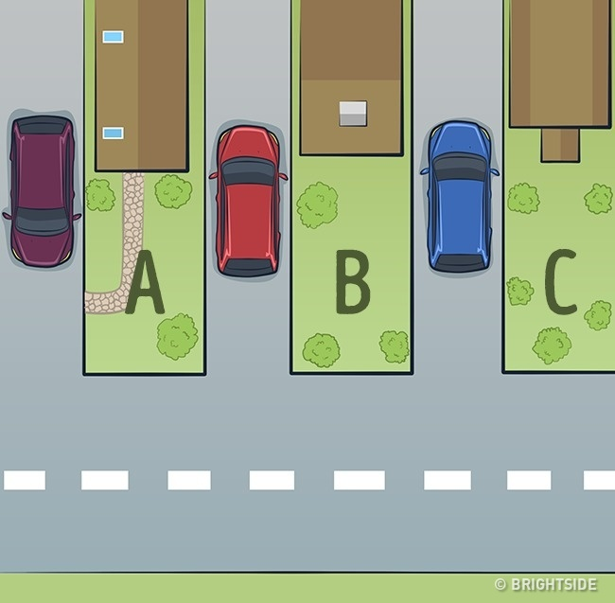
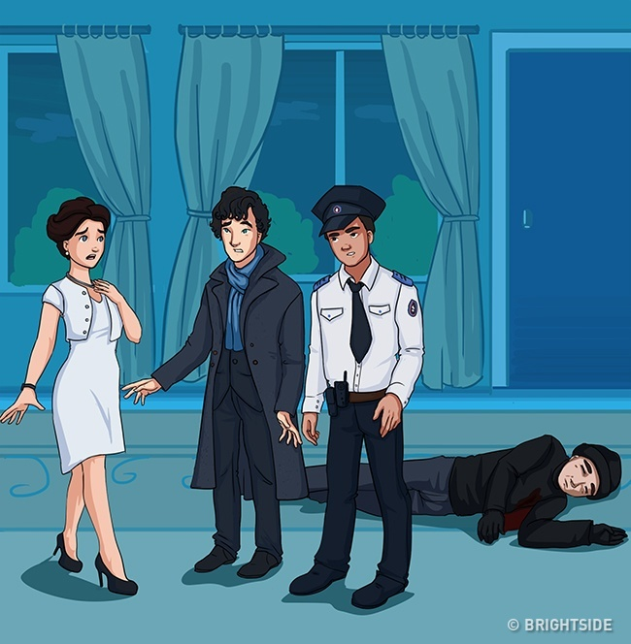

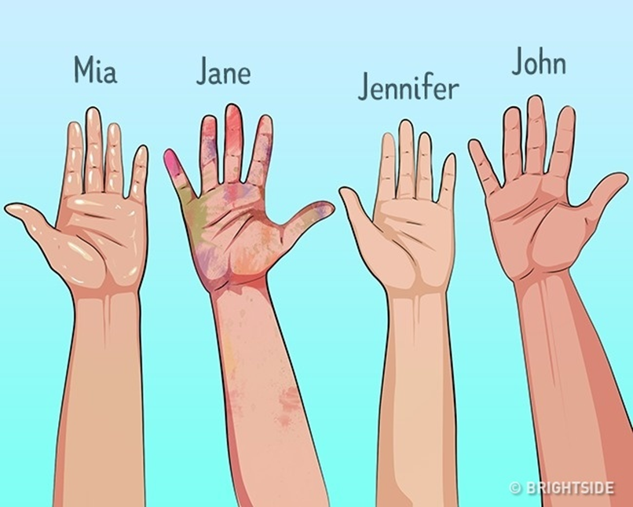
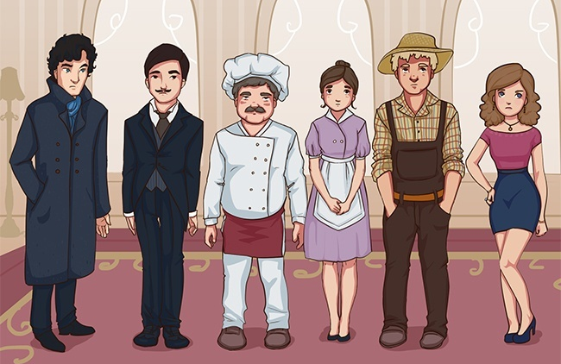

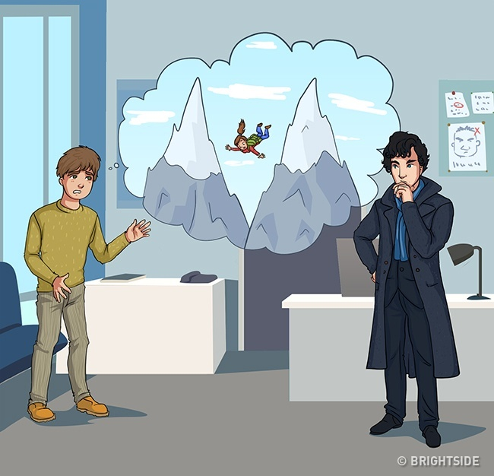
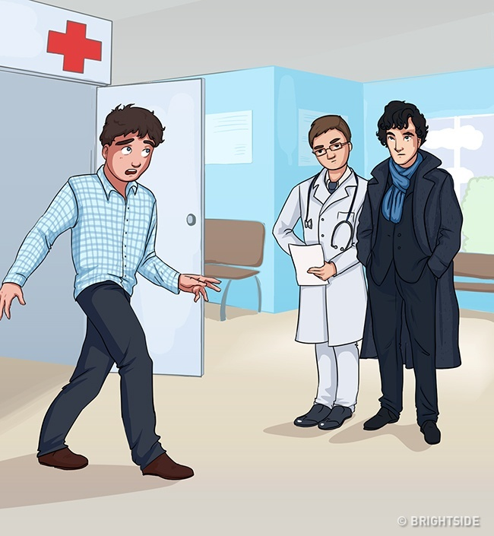
Adopting Textbooks
In our final section of the course, we will look at different ways to use the audio from our textbooks. Since we are responsible for teaching material from the textbooks, it is a good idea to look at the textbooks and find other ways to use the material. Most textbooks come with a CD that includes videos and audio. There are some things that we can do to create a better learning experience for our students. If you are consistent with your methodology, your students will recognize immediately what they are expected to do. In my case, one of the special needs kids got so upset at my coteacher for changing the format that we had to stop class and bring in his homeroom teacher. Of course, this is an extremely rare situation, but it shows how consistency can make a class run smoother. Let’s take a look at a normal textbook lesson from when I taught elementary students.
The first part of most lessons is knowledge activation. We want to elicit students’ background knowledge. This can be done with PowerPoint presentations, a quick game, or just a short conversation with students. I liked to highlight some of the keywords that they will hear in the video. Knowledge activation might also include looking at the pictures in the textbook and identifying things that the students see. This can be particularly helpful as it focuses the students on specific things from the video.
Next, I would usually play the video without sound. Most textbooks videos come with a mute feature but if they don’t the TV does. I would have the students watch the video without sound and guess what they say. It is a good idea to encourage students to make similar sentences. Our next step was to play the video clip with sound. The students listened to hear if their sentence was said. My coteachers liked to give stamps to students who guessed correctly. After the sentences had been taken up, we would often go through a series of comprehension check questions before listening again with the subtitles on. This was often followed by a listen and repeat section. In the last part of the lesson we would choose actors to read the characters’ parts. Depending on the level of your students, you could also add questions like, “Why did she do that?” “What do you think will happen next?” “What would you do in that situation?”
Since we followed this formatted for each lesson, there was little need to explain the rules each time. Students would often put up their hands before I even asked them to guess the lines. This process was streamlined to make time for a fun activity after finishing with the textbook for that day. The activity was a fun reward for doing well with the textbook section and was related to what we were studying.
What are some other ways to teach students using the textbook videos?

Barbara Streisand – Coloring Book
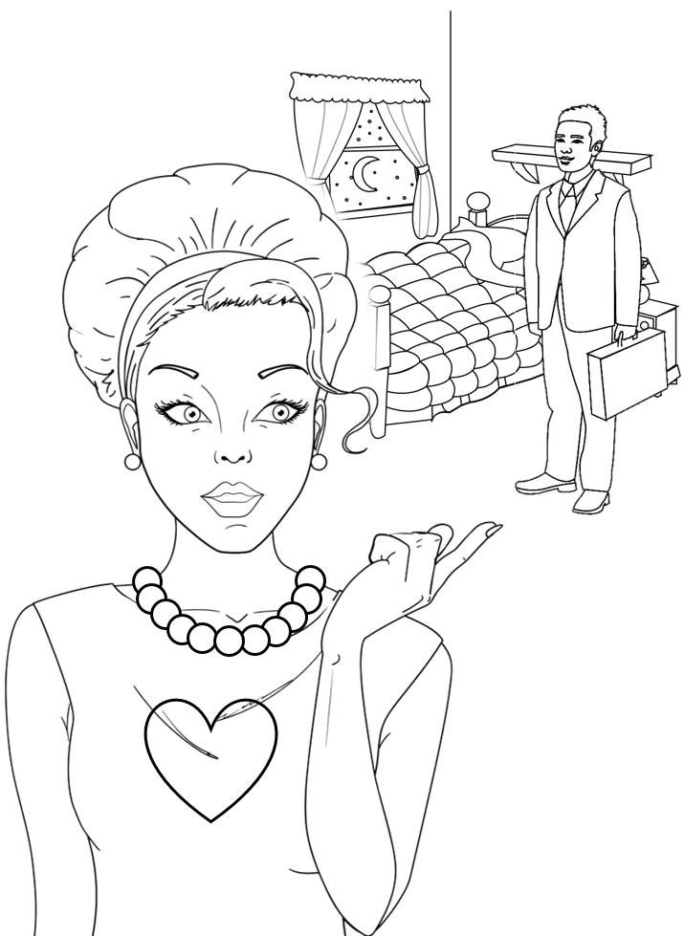

3-D Escape Room: Frequency (The Owl Field)
Abducted – 납치된
Backwards messages – 거꾸로 읽는 메시지
Belly – 배, 복부
Celestial - 천체의
Chronologically – 연대순으로, 시간순서대로
Comply - 응하다
Confirmation bias – 확증 편향
Cult – (기성 종교가 아닌 종교의) 광신적 종교 집단, 숭배
Cynic - 비꼬는 사람
Cynical – 냉소적인
Dangle a carrot - 동기를 부여하다
Digits - 자릿수
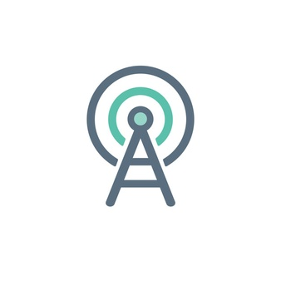
Elite - 상류층
Emotions are muted – 감정이 없는
Encounter - 교전
Exploited – 착취당하는
Exorcism – 퇴마, 퇴마의식
Hostile - 적의
Reel – (카세트나 영화필름을 감는)릴, 녹음
Revolution - 혁명
Trolling - 조업
TV evangelist - 텔레비전 전도사
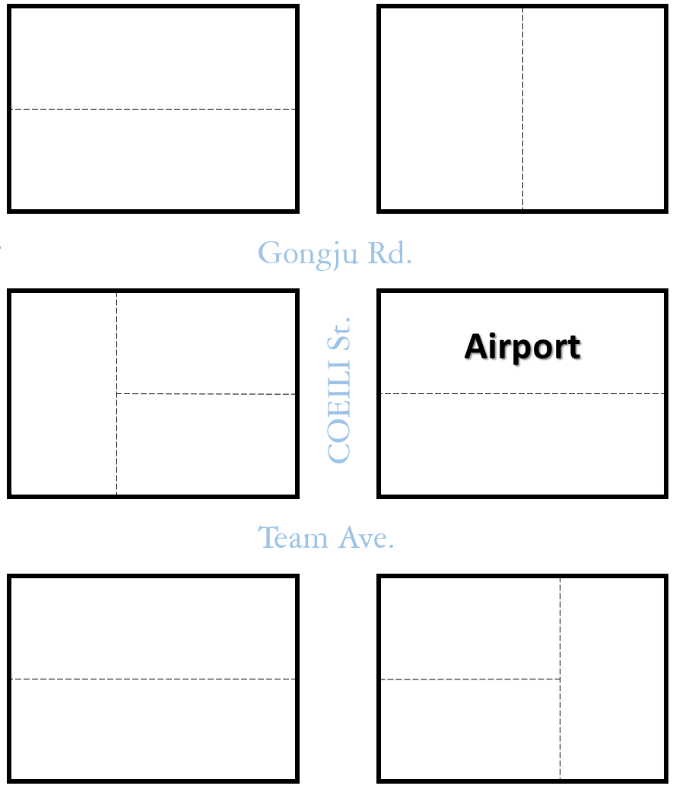

- The convenience store is behind the police station.
- The airport is across from the restaurant and theater.
- The hotel is behind the supermarket.
- The pharmacy is on the corner of COEILI St. and Gongju Rd.
- The restaurant is across from the hotel.
- The bank is across from the post office.
- The clinic is next to the bank.
- The gas station is to the left of the post office.
- The park is across from the library.
- The supermarket is across from the pharmacy.
- The post office is next to the pharmacy.
- The library is between the police station and the park.

References
Charisma on Demand. (2018, Jul.24). How to Make Someone Remember You for a Lifetime. [Video] Available at: https://www.youtube.com/watch?v=v-ps2nfkAiA&t=620s
Corden, O., and Winfrey, O. [The Late Show with James Corden]. (2018, Mar.13). Oprah Can Make Anyone Cry, Including James. [Video] Available at: https://www.youtube.com/watch?v=_GZlUextcAA
Craig, H. (2019, Mar.3). 17 Emotional Intelligence Tests and Assessments. [online] Available at: https://positivepsychology.com/emotional-intelligence-tests/
Cuncic, A. (2019, Sep.27). How to Practice Active listening. [online] Available at: https://www.verywellmind.com/what-is-active-listening-3024343
Headlee, C. [TED]. (2016, Mar.8). 10 ways to have a better conversation – Celeste Headlee. [Video] Available at: https://www.youtube.com/watch?v=R1vskiVDwl4
Katz, N., McNulty, k. (1994). Reflective Listening. [online] Available at: https://www.maxwell.syr.edu/uploadedfiles/parcc/cmc/reflective%20listening%20nk.pdf
Lapakko, D. (2007). Communication is 93% Nonverbal: An Urban Legend Proliferates. Communication and Theater Association of Minnesota Journal, 34, 7-19.
Mehrabian, A., & Ferris, S. R. (1967). Inference of attitudes from nonverbal communication in two channels. Journal of Consulting Psychology, 31(3), 248-252. http://dx.doi.org/10.1037/h0024648
Mind Tools Content Team. (accessed 2019, Oct. 14). Body Language –Picking Up and Understanding Nonverbal Signals. [online] Available at: https://www.mindtools.com/pages/article/Body_Language.htm
Treasure, J. (2011). 5 ways to listen better. [Video] Available at: https://www.ted.com/talks/julian_treasure_5_ways_to_listen_better/transcript
Wikipedia contributors. (2019, September 17). Active listening. In Wikipedia, The Free Encyclopedia. Retrieved 07:02, October 11, 2019, from https://en.wikipedia.org/w/index.php?title=Active_listening&oldid=916138724
Wikipedia contributors. Reflective listening. Wikipedia, The Free Encyclopedia. April 1, 2019, 14:06 UTC. Available at: https://en.wikipedia.org/w/index.php?title=Reflective_listening&oldid=890461557. Accessed October 14, 2019.
Willets, M. (2019). 10 Best Educational Websites for Kids. [online] Available at: https://www.parenting.com/child/10-best-educational-websites-kids/
Zantal-Wiener, A. (2018, Jan.23). 6 Phrases That Demonstrate Active Listening. [Blog] Available at: https://blog.hubspot.com/marketing/phrases-for-active-listening

Experience 3-D sounds from around the world:
The Sound Traveler. https://www.youtube.com/channel/UC0tq0g5u2bo-TErZt7SJM6w
3-D interactive choose your own adventures:
The Owl Field. https://www.owlfield.com/
Experience color blindness with:
Coblis - http://www.color-blindness.com/coblis-color-blindness-simulator/?fbclid=IwAR2_fv6TJgHa23c1kNBX3Bws9QmC9aRWl8togrKOSBaep0XrWYe_IKVakn8

