Lose Yourself
Eminem

Look
If you had
One shot
Or one opportunity
To seize everything you ever wanted
In one moment
Would you capture it
Or just let it slip?
Yo
His palms are sweaty, knees weak, arms are heavy
There's vomit on his sweater already, mom's spaghetti
He's nervous, but on the surface he looks calm and ready
To drop bombs, but he keeps on forgettin'
What he wrote down, the whole crowd goes so loud
He opens his mouth, but the words won't come out
He's chokin', how, everybody's jokin' now
The clocks run out, times up, over, blaow!
Snap back to reality, oh there goes gravity
Oh, there goes Rabbit, he choked
He's so mad, but he won't give up that easy? No
He won't have it, he knows his whole back city's ropes
It don't matter, he's dope, he knows that, but he's broke
He's so stacked that he knows, when he goes back to his mobile home,
that's when its
Back to the lab again yo, this whole rhapsody
He better go capture this moment and hope it don't pass him

You better lose yourself in the music, the moment
You own it, you better never let it go
You only get one shot, do not miss your chance to blow
This opportunity comes once in a lifetime you better

The souls escaping, through this hole that its gaping
This world is mine for the taking
Make me king, as we move toward a, new world order
A normal life is borin', but super stardom's close to post mortar
It only grows harder, only grows hotter
He blows us all over these hoes is all on him
Coast to coast shows, he's known as the globetrotter
Lonely roads, God only knows, he's grown farther from home, he's no father
He goes home and barely knows his own daughter
But hold your nose 'cause here goes the cold water
His hoes don't want him no mo, he's cold product
They moved on to the next schmo who flows, he nose dove and sold nada
So the soap opera is told and unfolds, I suppose it's old partna, but the beat goes on
Da da dumb da dumb da da
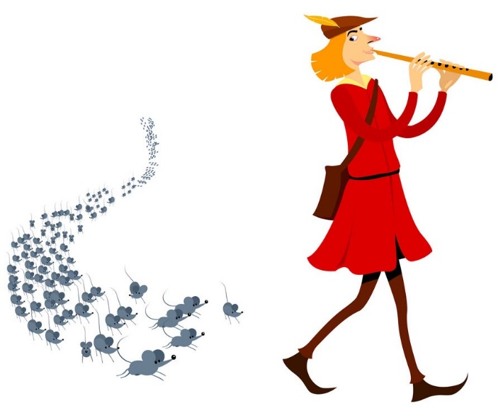
No more games, I'm a change what you call rage
Tear this motherfuckin' roof off like two dogs caged
I was playin' in the beginnin', the mood all changed
I been chewed up and spit out and booed off stage
But I kept rhymin' and stepwritin' the next cipher
Best believe somebody's payin' the pied piper
All the pain inside amplified by the
Fact that I can't get by with my nine to
Five and I can't provide the right type of
Life for my family 'cause man, these God damn food stamps don't buy diapers
And its no movie, there's no Mekhi Phifer
This is my life and these times are so hard
And it's getting even harder tryin' to feed and water my seed, plus
See dishonor caught up between bein' a father and a prima-donna
Baby mama drama screamin' on and too much
For me to want to say in one spot, another jam or not
Has gotten me to the point, I'm like a snail I've got
To formulate a plot fore I end up in jail or shot
Success is my only motherfuckin' option, failures not
Mom, I love you, but this trail has got to go, I cannot grow old in Salem's lot
So here I go is my shot
Feet fail me not 'cause maybe the only opportunity that I got

