Listening & Speaking
Tim Schilstra

Goals
- Trainees will increase their conversational competency through games and activities. We will study different aspects of active listening and practice our new skills.
- Trainees will gain proficiency in speaking through activities in congruence with active listening. Trainees will receive amble time to practice speaking in English.

Description of Activities
- Sensory Deprivation – Isolating listening skills is difficult, taking away other senses is one way to focus on listening. In this course we will look at different types of blindness and experience games that include sensory deprivation.
- Detective Games – In this section of the course, we will use our listening and speaking skills to analyze information. Trainees will share and collect information to solve crimes.
- Active Listening – Active listening is used for natural conversation. While the concept and methods can be used in any language, we will use active listening as a backdrop for English conversations. It involves things like body language, reflecting, identifying, summarizing, as well as a verbal component.
- Listening Better – We will watch a couple of TED talks about listening. Trainees will focus on comprehending what is being said and afterwards we will try the methods presented in the talk.
- Interest Theory – Interest theory deals with motivation. We will use examples of interest theory to practice our listening skills.
- You vs Wild – We will watch the Netflix TV show of the same name. During the video, the trainees will be asked to make a series of decisions that the will determine the fate of the protagonist. It is a fun way to finish off the course and is an excellent example of a listening game that can be used in the classroom.

Listening
Sensory Deprivation
One of the fun ways to help students with their listening skills is through sensory deprivation. Take away one of their senses (sight) will allow them to focus on their listening. There is of course a real world equivalent, blindness. But there are more types of blindness than you may be aware of. In class we will look at color blindness, prospagnoisia and aphantasia. Color blindness is the inability to distinguish colors. Prospagnosia is the inability to recognize faces. And aphantasia is the inability to create images in your mind’s eye (imagination).
Three blind mice. Three blind mice.
See how they run. See how they run.
They all ran after the farmer's wife,
Who cut off their tails with a carving knife,
Did you ever see such a sight in your life,
As three blind mice?

We can simulate full blindness with blindfolds, a blacked out screen, or information that can only be seen by some students. A fun game for learning adjectives or basic question formation is to have one student come to the front. The other students must ask questions to guess what is on the computer screen. I have used this many times in class. I would advise you to make sure students can’t see the reflection of the computer screen though as it ruins the game. The opposite of this game is Hot Seat. In Hot Seat, one student sits at the front of the class with their back to the television screen. The others students must give clues, or describe what is on the TV screen and the person in the hot seat must guess what it is.
Another useful type of activity that uses blindness is having students describe a scene. In class we will play the Police Sketch Artist game together. In this game, students are separated into partners with one facing the TV and one facing away from the TV. Students are shown a picture of a person that they must describe to the police sketch artist (with their back towards the TV). The police sketch artist then has to use that information to draw the person. The closest to the correct answer wins.
We can play other games with visual deprivation. For example, you could play some video clips with the screen blacked out. Then have students try to guess what is happening in the picture. Another common game I used is partial pictures. With some games, I only showed parts of a picture, or slowly revealed the image. Students race to guess that answer first.

Face Blindness
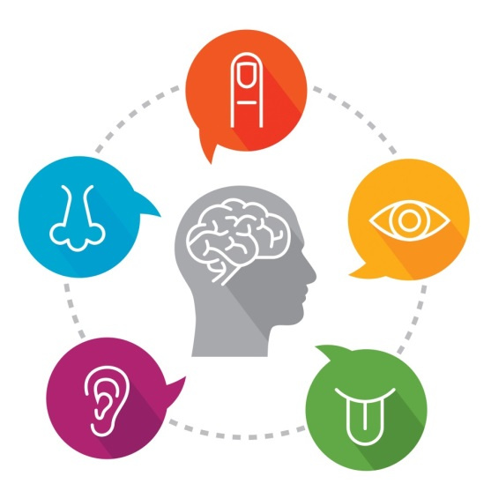
Prosopagnosia, or face blindness is the inability to recognize familiar faces.

Face blindness makes it difficult for people to recognize the faces of others they have met before. In extreme cases, a person with face blindness may not even recognize family members. Furthermore, sufferers can’t easily imagine people’s appearance in their minds. Focusing on non-facial clues, such as hairstyles and voices, help them to recognize others. One problem often experienced by these people is the inability to distinguish one actor from another in movies, making it difficult to follow the plot. Face blindness often follows brain damage such as a stroke. Some cases, however, seem to be genetic.

- How does face blindness affect sufferers?

- How can sufferers recognize people?

- Why do sufferers have a difficult time following the plot of movies?

- What is a common way to get face blindness?

Police Sketch Artist

Police Sketch Artist

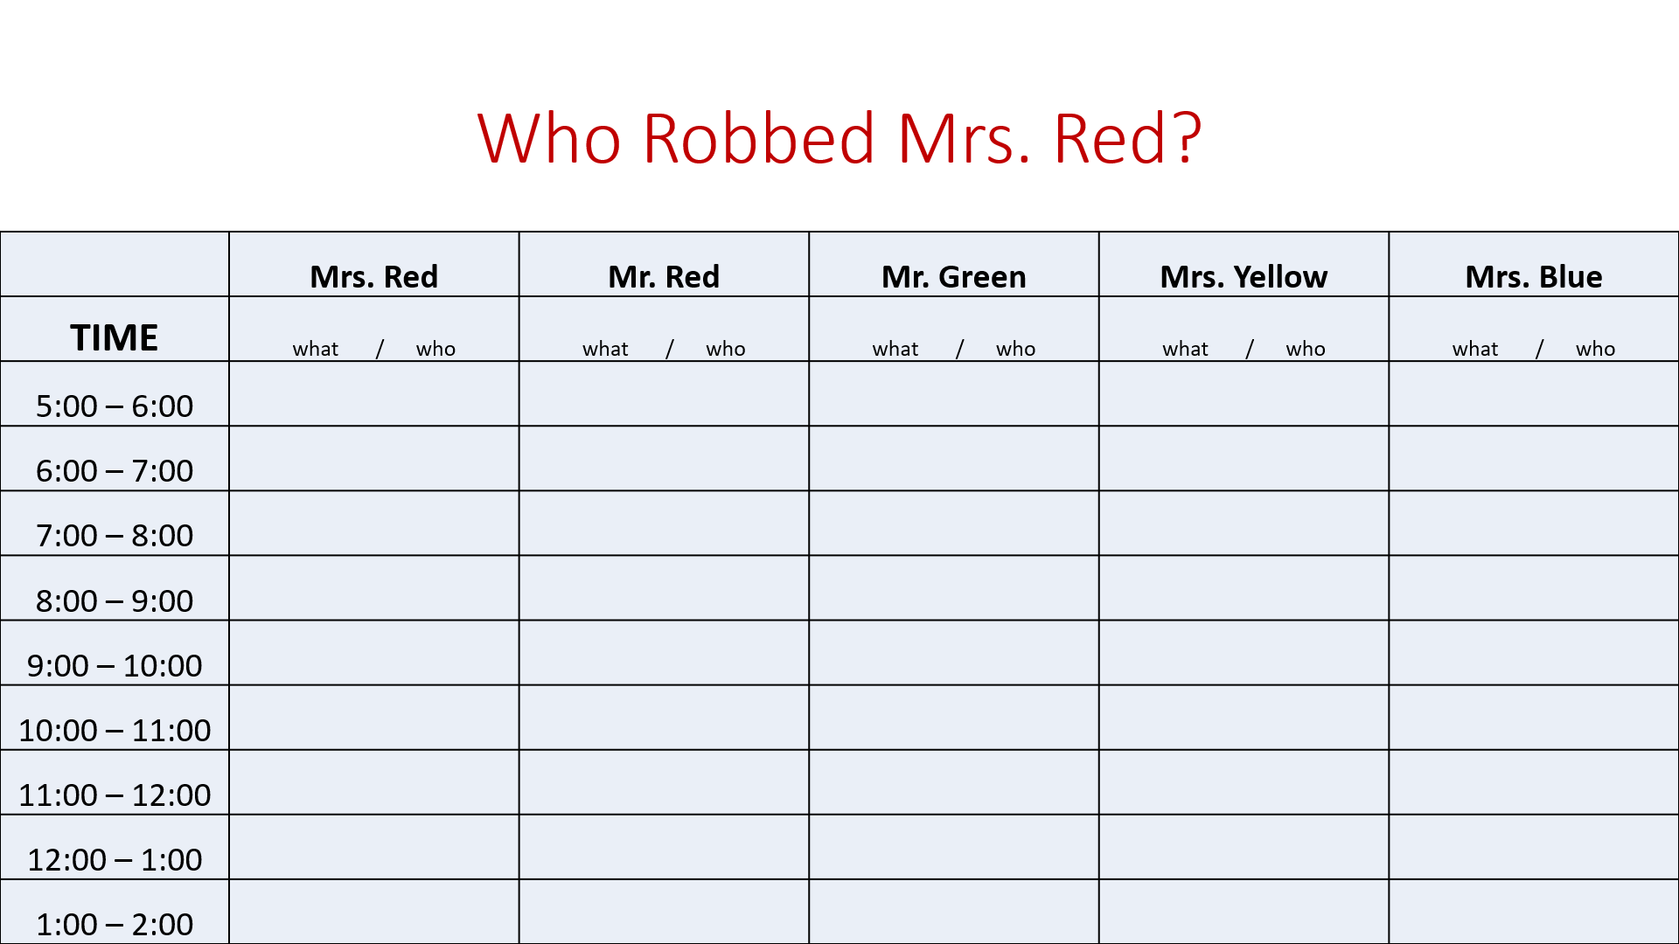
Active Listening
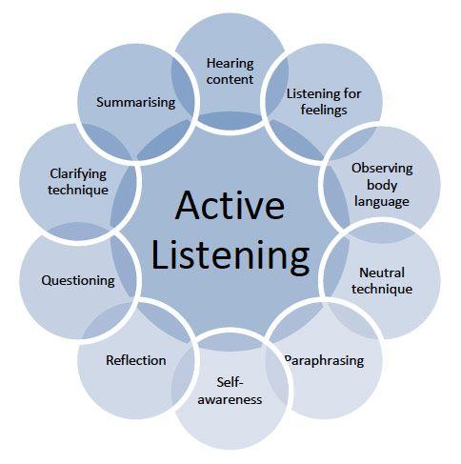
In this course we will be learning about active listening. Active listening is a skill that can be applied when having a conversation in any language. Our goal is to use active listening to increase our English awareness and thus increase our retained comprehension of information in English. Active listening requires that the listener fully concentrates, understands and remember what is being said. The goal of active listening is to make the other person feel heard and valued. It is a very important skill for having a successful conversation.
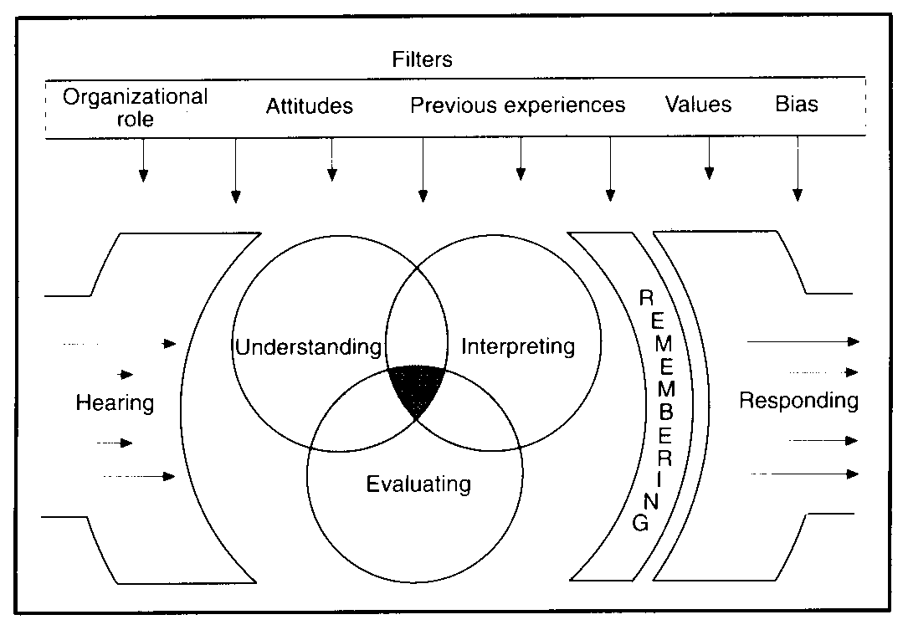
The first thing that we must understand about active listening is that is not just hearing someone speak. Often times, when we are having a conversation, we are just waiting for our turn to speak. Hearing doesn’t require that you engage with the other person’s ideas or even understanding. Active listening involves many techniques including (Cuncic 2019):
- Being neutral and nonjudgmental
- Being patient (periods of silence are not "filled")
- Verbal and nonverbal feedback to show signs of listening (e.g., smiling, eye contact, leaning in, mirroring)
- Asking questions
- Reflecting back what is said
- Asking for clarification
- Summarizing
Active listening my come naturally when you are talking to a loved one or when you are really interested in what the other person has to say. It clearly benefits all kinds of relationships. You can have deeper friendships, get along with coworkers better, and turn acquaintances into friends. One of the best people at this skill is Oprah Winfrey. Her body language and listening skills, along with knowing how to ask the right questions allows her to make an emotional connection quickly to anyone she meets (Cordon and Winfrey 2018). In this section of the course, we will improve our active listening skills by focusing on body language, reflective listening, and other skills inherent in good active listening.

Non-Verbal Cues
Non-verbal communication, including body language, is a key part of communication. It is estimated that 93% of communication is non-verbal (Mehrabian and Ferris 1967). This includes 38% vocal (but not language) and 55% visual. While the exact numbers may be misleading and wide-spread (Lapakko 2007), it does show an importance on non-verbal communication. In class, we will be looking at how the lack of this (non-verbal) information affects people and how we can use sensory deprivation to enhance the listening skills of students. While we are more concerned about the active listening implications of non-verbal communication, we can also use these skills as teachers. Our body language can be used for classroom management or to give students visual clues when trying to teach a second language.
Since the goal of active communication is to engage in meaningful conversation. We want to express openness and receptiveness with our body posture. One of the most important ways that Westerners convey receptiveness is through eye contact. Korean culture dictates that eye contact is less prevalent, but you should still try to make direct eye contact for a few seconds at a time often during a conversation. The direction of your eyes shows your partner where your interest is. If you are looking towards the door or away from them, you are secretly telling them that you would rather be outside of the door or somewhere else. Good eye contact is important.
Your body position should be directed towards the person you are listening to. Avoid crossing your legs or (especially) your arms as this communicates disinterest. Instead, have your legs slightly open (with exceptions for dresses and skirts) with your hands in front of you on your lap if you are sitting. If you are standing, have your hands at your side and not in your pockets. The palms of your hands and arches of your foot can also tell your communication partner your level of interest. The more that your partner can see, the more open you appear. Avoid using your hands to write, draw or fidget with items around you. Touching your face (in particular your mouth or nose) is often considered a sign that you are lying, so try to avoid that. Also, hiding your hands can be seen as a sign of deceit. If you are talking across a table or desk, put your hands in a visible position. You should also be sitting upright with a slight lean towards your partner. This shows an interest in what they are saying.
Can you spot the good and bad body language?
Body language is important in communicating mood but you can add more information through your facial expressions. We have already talked about the value of eye contact, but there are other things to consider. A nice, warm, genuine smile encourages people to be open. However, it might not be appropriate if you are listening to a story of something bad that happened to your partner. Instead, we need to employ the use of mirroring. Mirroring is when you change your body language to match that of your partner. If their eye brows furrow, showing distress, you should also furrow your brow. Finally, you should occasionally nod your head. This shows interest, agreement, and understanding with your partner. In class we will take an Emotional Quotient (EQ) test to see how well we can identify body language. EQ is similar to IQ in that it tests your level of emotional awareness like IQ tests your intelligence. Here are some examples from Memorado (2019):
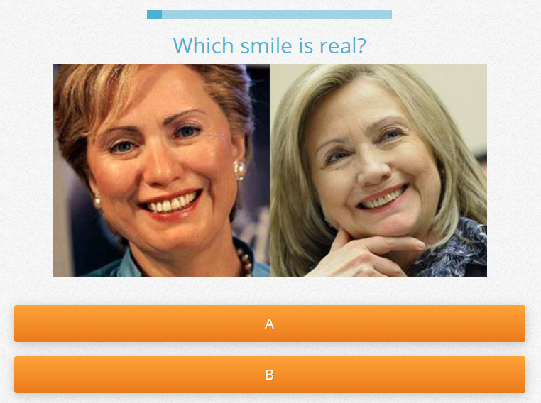
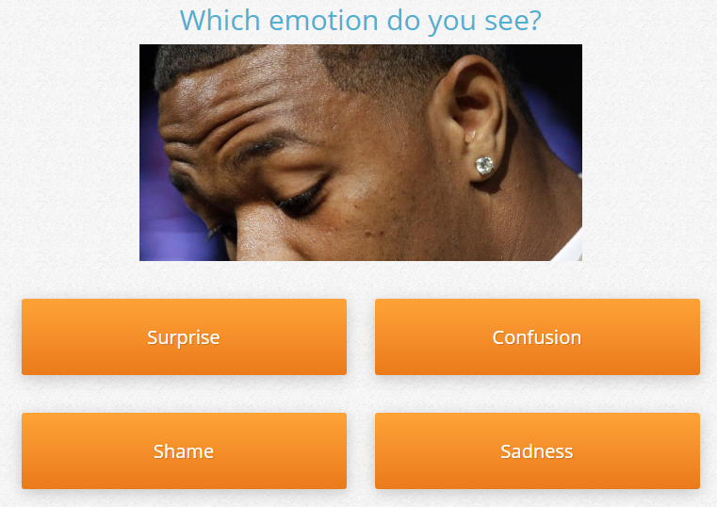

Vocal utterances are also useful in encouraging your partner to continue speaking. Simple phrases like ‘uh huh’ and ‘uh oh’ are a great way to show that you are listening without interrupting the speaker. Acknowledgement responses are on the borderline between verbal and non-verbal focalizations. These phrases include, but are not limited to: yes, ok, oh ya?, really?, and?, sure and right. Asking one of the W’s is also a good idea. Probably the most powerful word in active listening is “why?” Children learn this at an early age. Sometimes they overuse it to the point of annoyance, but it is very effective in continuing a conversation. Children may not be able to effectively communicate in conversations, but learn that asking ‘why?’ is like a life hack to get adults to talk to them longer. This simple word can be used much the same way when practicing active listening.

Reflective Listening
Reflective listening involves understanding the speaker’s idea and to repeat it back to confirm that it was understood correctly. This is especially important in active listening as it shows that you are listening, you understand and you are interested in what they are saying. It is essentially the verbal equivalent of mirroring. Reflective listening is rooted in empathy. According to Dalmar Fisher, reflective listening involves:
- Focusing upon the conversation by reducing or eliminating any kind of distraction.
- Genuinely embracing the speaker’s perspective without necessarily agreeing with it. By engaging in a non-judgmental and empathetic approach, listeners encourage the others to speak freely.
- Mirroring the mood of the speaker, reflecting the emotional state with words and nonverbal communication. This requires the listener to quiet his mind and focus fully upon the mood of the speaker. This mood will becomes apparent not just in words used but in the tone of voice, posture and other nonverbal cues given by the speaker. The listener will look for congruence between words and mood.
- Summarizing what the speaker said, using the speaker’s own words rather than merely paraphrasing words and phrases, thereby mirroring the essential concept of the speaker.
- Responding to the speaker’s specific point, without digressing to other subjects.
- Repeating the procedure for each subject, and switching the roles of speaker and listener, if necessary.
- During the reflective listening approach, both client and therapist embrace the technique of thoughtful silence, rather than to engage in idle chatter.
Perhaps an example will highlight how reflective listening is used. Let’s say that your friend was telling you about a bad breakup with her boyfriend. She explains that he cheated on her with someone from his job. A reflective listener might respond by saying, “I can’t believe that! He cheated on you with someone from work?!” The listener shows that they understand the content of the story, while inviting the speaker to confirm and expand on the story. They also express empathy with the speaker by expressing their shock. This empathy allows the speaker to feel a connection to the listener and make them more comfortable in adding detail to the story.
It is important to note that in active listening, we don’t want to become the speaker. Our goal is to make the speaker feel comfortable and to continue telling us their story. Reflective listening can provide opportunities for the speaker to elaborate, and is a great tool. But there is a temptation to make our own lives related to the stories we are listening to. In active listening, we must suppress this urge. For example, consider if the previous listener had responded by saying, “That sucks. I had someone cheat on me as well.” While the listener is showing understanding and empathy, the focus has changed to the listener, thereby making the speaker less important.
According to Neil and McNulty (1994), reflective listening is comprised of three parts: Reflecting content, reflecting feelings, reflecting meaning. Reflecting content focuses on what the speaker is saying to you, including thoughts, ideas, beliefs, facts, data, etc. Reflecting feelings refers to being empathetic to the speaker. You can use phrases like; you feel… You sound… You look… etc. This requires the listener to be able to identify more complex emotions. Finally, reflecting meaning is when you combine content and meaning reflection in a single response. Often this means making inferences into the speaker’s story. “You feel ____________ because ____________.” Mastering reflective listening is most of the way to active listening.

Verbal Component
Active listening builds on reflective listening by being more than just a conversational mirror. Active listening encourages the speaker to continue with their story by asking for more details and to expand their story. This is the active part, the verbal component, of active listening. In addition to reflecting, you can also keep the conversation going by using paraphrasing, summarizing, and repeating. Paraphrasing is taking what the speaker has said to you and repeating that back to them but in a slightly different way. You can also use summarizing to make show the speaker that you understand what they are saying and that you are listening to the whole story. It is also a good chance to find out how much you comprehended.
It is also important to show your empathy in the conversation. Sometimes, people just want someone to say, “That sucks.” Active listening is not about offering advice. Most of the time, the speaker just wants someone to listen to them, not to tell them what to do. Of course, if they ask for advice, be kind and try to understand the story from their perspective. It is just about being a good listener. Adding quick empathetic responses help to validate the feelings being experienced by the speaker. This also works for happy stories. Just saying, “That’s great.” Or “I’m happy for you.” Can really make someone feel good. I think that people act self-centered unintentionally in a lot of conversations. The way someone else feels should not affect us, but it sometimes does. It is important to realize this and to follow the emotional path of the speaker. If they get sad, you can get sad with them. If the story has a surprising ending, be surprised. Do not make the conversation about you. It is the speaker’s story.
It is important to stay non-judgmental in conversation. You are a neutral observer of the story. My final piece of advice is to ask questions you are genuinely interested in. Your genuine interest will always come across and be appreciated.
Active listening is a technique used in counseling, training, community organizing, tutoring, medical workers talking to patients, helping suicidal persons, management, journalism and for resolving conflicts. It is a useful technique that you can use to have more insightful and deep conversation as well. We all just want to be listened to.

6 Phrases That Demonstrate Active Listening (Zantal-Wiener 2018)
- Do you mean…?
  - I’m not sure I understand.
  - Could you tell me a bit more about that?
- It sounds like…
  - What I’m hearing is…
  - You seem a bit…
- Really?
  - When?
  - How?
  - You’re kidding.
- I’ve noticed that…
- Let me make sure I’ve got this right.
  - These are the main points I’ve heard you make so far.
  - Let’s make sure I’m hearing you correctly.
  - Let’s pause to make sure we’re on the same page.
- I’m sorry. That really sucks.
  - I’m sorry you’re going through that.
  - What a crappy situation to be in. I’m sorry.
  - That’s rough. How can I help.

5 Ways to Listen Better – transcript
https://www.ted.com/talks/julian_treasure_5_ways_to_listen_better/transcript
We are losing our listening. We spend roughly 60 percent of our communication time listening, but we're not very good at it. We retain just 25 percent of what we hear. Now -- not you, not this talk, but that is generally true.
Let's define listening as making meaning from sound. It's a mental process, and it's a process of extraction.
We use some pretty cool techniques to do this. One of them is pattern recognition. (Crowd noises) So in a cocktail party like this, if I say, "David, Sara, pay attention" -- some of you just sat up. We recognize patterns to distinguish noise from signal, and especially our name. Differencing is another technique we use. If I left this pink noise on for more than a couple of minutes, (Pink noise) you would literally cease to hear it. We listen to differences; we discount sounds that remain the same.
And then there is a whole range of filters. These filters take us from all sound down to what we pay attention to. Most people are entirely unconscious of these filters. But they actually create our reality in a way, because they tell us what we're paying attention to right now. I'll give you one example of that. Intention is very important in sound, in listening. When I married my wife, I promised her I would listen to her every day as if for the first time. Now that's something I fall short of on a daily basis.
But it's a great intention to have in a relationship.
But that's not all. Sound places us in space and in time. If you close your eyes right now in this room, you're aware of the size of the room from the reverberation and the bouncing of the sound off the surfaces; you're aware of how many people are around you, because of the micro-noises you're receiving. And sound places us in time as well, because sound always has time embedded in it. In fact, I would suggest that our listening is the main way that we experience the flow of time from past to future. So, "Sonority is time and meaning" -- a great quote.
I said at the beginning, we're losing our listening. Why did I say that? Well, there are a lot of reasons for this. First of all, we invented ways of recording -- first writing, then audio recording and now video recording as well. The premium on accurate and careful listening has simply disappeared. Secondly, the world is now so noisy, (Noise) with this cacophony going on visually and auditorily, it's just hard to listen; it's tiring to listen. Many people take refuge in headphones, but they turn big, public spaces like this, shared soundscapes, into millions of tiny, little personal sound bubbles. In this scenario, nobody's listening to anybody.
We're becoming impatient. We don't want oratory anymore; we want sound bites. And the art of conversation is being replaced -- dangerously, I think -- by personal broadcasting. I don't know how much listening there is in this conversation, which is sadly very common, especially in the UK. We're becoming desensitized. Our media have to scream at us with these kinds of headlines in order to get our attention. And that means it's harder for us to pay attention to the quiet, the subtle, the understated.
This is a serious problem that we're losing our listening. This is not trivial, because listening is our access to understanding. Conscious listening always creates understanding, and only without conscious listening can these things happen. A world where we don't listen to each other at all is a very scary place indeed. So I'd like to share with you five simple exercises, tools you can take away with you, to improve your own conscious listening. Would you like that?
Good. The first one is silence. Just three minutes a day of silence is a wonderful exercise to reset your ears and to recalibrate, so that you can hear the quiet again. If you can't get absolute silence, go for quiet, that's absolutely fine.
Second, I call this "the mixer." (Noise) So even if you're in a noisy environment like this -- and we all spend a lot of time in places like this -- listen in the coffee bar to how many channels of sound can I hear? How many individual channels in that mix am I listening to? You can do it in a beautiful place as well, like in a lake. How many birds am I hearing? Where are they? Where are those ripples? It's a great exercise for improving the quality of your listening.
Third, this exercise I call "savoring," and this is a beautiful exercise. It's about enjoying mundane sounds. This, for example, is my tumble dryer.
It's a waltz -- one, two, three; one, two, three; one, two, three. I love it! Or just try this one on for size.
Wow! So, mundane sounds can be really interesting -- if you pay attention. I call that the "hidden choir" -- it's around us all the time.
The next exercise is probably the most important of all of these, if you just take one thing away. This is listening positions -- the idea that you can move your listening position to what's appropriate to what you're listening to. This is playing with those filters. Remember I gave you those filters? It's starting to play with them as levers, to get conscious about them and to move to different places. These are just some of the listening positions, or scales of listening positions, that you can use. There are many. Have fun with that. It's very exciting.
And finally, an acronym. You can use this in listening, in communication. If you're in any one of those roles -- and I think that probably is everybody who's listening to this talk -- the acronym is RASA, which is the Sanskrit word for "juice" or "essence." And RASA stands for "Receive," which means pay attention to the person; "Appreciate," making little noises like "hmm," "oh," "OK"; "Summarize" -- the word "so" is very important in communication; and "Ask," ask questions afterwards.
Now sound is my passion, it's my life. I wrote a whole book about it. So I live to listen. That's too much to ask for most people. But I believe that every human being needs to listen consciously in order to live fully -- connected in space and in time to the physical world around us, connected in understanding to each other, not to mention spiritually connected, because every spiritual path I know of has listening and contemplation at its heart.
That's why we need to teach listening in our schools as a skill. Why is it not taught? It's crazy. And if we can teach listening in our schools, we can take our listening off that slippery slope to that dangerous, scary world that I talked about, and move it to a place where everybody is consciously listening all the time, or at least capable of doing it.
Now, I don't know how to do that, but this is TED, and I think the TED community is capable of anything. So I invite you to connect with me, connect with each other, take this mission out. And let's get listening taught in schools, and transform the world in one generation to a conscious, listening world -- a world of connection, a world of understanding and a world of peace.
Thank you for listening to me today.

10 Ways to Have a Better Conversation – summary
https://www.youtube.com/watch?v=R1vskiVDwl4

1. Don't multitask. (4:27)
2. Don't pontificate. (4:50)
3. Use open ended questions. (6:02)
4. Go with the flow. (6:39)
5. If you don't know, say that you don't know. (7:26)
6. Don't equate your experience with their. (7:46)
7. Try not to repeat yourself. (8:26)
8. Stay out of the wits. (8:46)
9. Listen. (9:08)
10. Be brief. (10:29)

5 Levels of Difficulty
How would you change your language to speak to various age groups / levels?

Here are some considerations:
- Issues related to Listening
  - Physical limitations
  - Non-verbal cues
  - Panic if they don’t know a words
  - Literacy
- 3 Ways to increase listening skills and confidence
  - Limit the use of translation
  - Avoid confusing listening skills with literacy skills
  - Use videos because students can also watch
- Strategies for teaching listening
  - Gestures
  - Comprehension Check Questions
  - Explain it back
  - Prediction
  - Background knowledge
  - Analogies to things they already know
  - Examples
  - Familiar words/sentence structures
  - Visuals

Interest Theory
Interest theory is concerned with how student interest affects their behavior. In particular, greater interest leads to higher motivation, persistence, attendance, attention, engagement and processing of information. But interest is a very large concept that can be influenced by a number of factors:
- Content, objects, or events
- Interaction with the environment
- Cognitive (paying attention) and Affective (feelings) components
- Unaware of their interests
- Physiological / Neurological
  - Looks like a reward in MRI

Being aware of how interest affects students can lead to a better classroom experience for your students. In class, we will examine the key points about Interest Theory and how they can be applied to the classroom. We will also experience examples of interesting listening stories.
There are two basic types of interest: Situational and Individual. Situational interest is temporary and is influenced by the environment. These factors may include task instructions, an exciting atmosphere or an engaging text. Individual interest is longer lasting, ongoing and tends to be more affective. Here the student has internalized the interest beyond what was required. For example, hobbies are often considered individual interest because it is something that an individual is engaged with over a long period of time.
Individual interest can be outcome of a series of interest stages. The lines are not clearly drawn, but interest seems to develop in a predictable way. Hidi and Renninger (2006) further divide situational and individual interest into:
- Situational
  - Triggered Situational Interest
  - Maintained Situational Interest
- Individual
  - Emerging Individual Interest
  - Well-developed Individual Interest

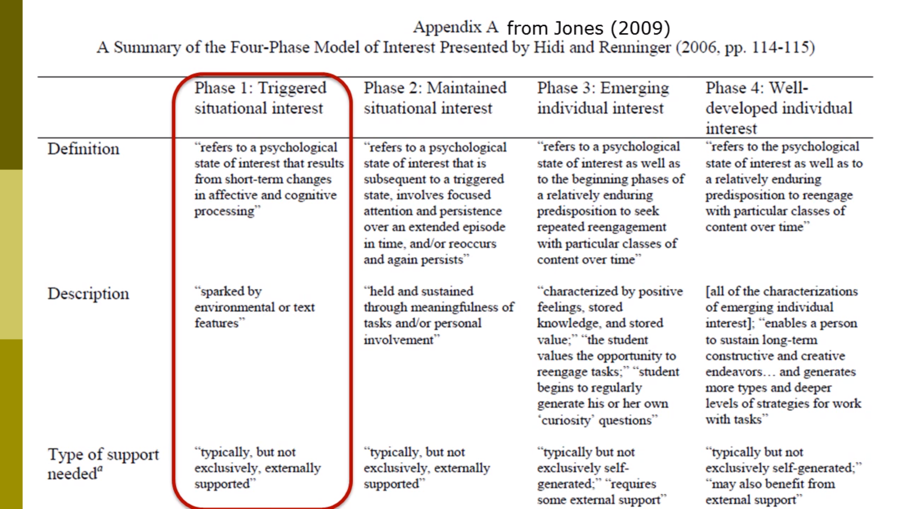
The relationship between these different types of interest and sources of stimulation can vary. Overall it is important to note that interest can be developed in many different ways.
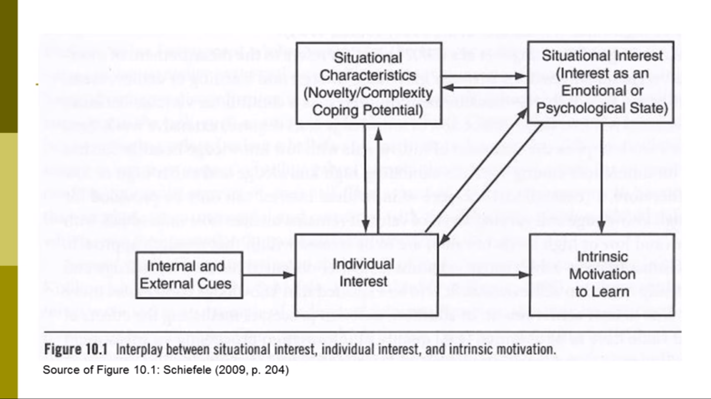

Bergin (1999) suggests a list of things that can incite interest. These can act as topic suggestions when designing a lesson (though I would avoid the last one for younger students):
- Novelty
- Food
- Humor
- Social Interactions
- Games
- Puzzles
- Fantasy
- Narrative
- Physical Activities
- Content Related to Injury, sex, or scandal

Applying interest theory to class may seem difficult, but it really isn’t. Even though we are often forced to teach directly from the textbook or in a certain manner, there are things we can do to make class more interesting. For one, we can provide content related to our students’ background knowledge and interest. If we cater our language to include the things that they are already interested in, it is a short cut to getting them interested in English. Secondly, the activities that we use can have an emotional component. Talking about relationships and letting the students share their opinions are just two ways to make the lesson more emotionally driven. You can also vary your presentation style. Sometimes a little change will captivate interest in students. If you normally use PowerPoint games, try doing a hands on activity. Perhaps change the order of your lesson. You could start with a game and finish by studying the textbook. Finally, finding new or surprising interest can increase interest amongst students. The human brain responds very favorably to learning new information. It gives us a good feeling to learn something new. In conclusion, interest leads to positive outcomes and finding ways to increase interest can only enhance the learning experience.

Monsieur Mangetout / “Mr. Eat-All”

(http://nothingnormalhere.com/obscure-episode-25-michel-lotito/

Have you ever been too hungry? I bet that hunger never quite made you think about eating a bicycle or an airplane. Though I am unsure why Michel Lotito, also known as Monsieur Mangetout or ”Mr. Eat-All”, began chomping on items such as these, he became famous for it nonetheless.

Born June 15, 1950, this bizarre performer’s feats involved eating bits of metal, glass, rubber, and other materials. Michel claimed that he began eating unusual material around 16 years old, and performed publicly beginning in 1966.

There was a method to his madness. Lotito would obviously break the large bits of whatever he was eating into smaller pieces. He did not just randomly take chomps out of passing vehicles. He drank mineral oil to prepare himself to pass bits of this nonsense, and drank water during his “meals”. The oils acted as a lubricant, helping objects go down his throat, and also assisted in the “passing” of the materials later on.

Michel claimed he had no problem “passing” his unusual diet, and claimed not to suffer any ill effects from consuming materials usually considered poisonous.
via GIPHY

In his time as a performer, he consumed around 1 kilogram (2.2 lbs.) of material daily, and the list of unusual items that he had eaten is almost unbelievable.

Some of the more well-known items he consumed include 1 pair of skis, 1 computer, 1 coffin, 2 beds, 6 chandeliers, 7 televisions, 12 teaspoons, 15 shopping carts, 18 bicycles, and countless light bulbs, glasses, and other small items.

Not bizarre enough? Well, Michel also cut-up and digested an entire Cessna 150 aircraft, which took him roughly two years; from 1978 to 1980.

That’s right, Michel ate an entire plane.

Though it would seem that Michel could eat just about anything you offered him, he wasn’t a fan of hard-boiled eggs, and found a food-nemesis that he absolutely would not eat, bananas.

(Translation) “When I eat a banana and I have metal in my stomach it causes heartburn, and as soft, I hate pain, so unfortunately I can’t eat bananas”. Source

Many doctors examined Michel’s strange behavior, using all manner of investigative procedures, but none explained how it was possible. Doctors worried that even though he could pass the items he would become sick or damage his internal organs, but he continued for years.

Having such a strange lifestyle, Lotito passed away of natural causes on June 25, 2007, ten days after his 57th birthday. Today, he is buried at Grenoble Cemetery.

Michel Lotito was a naturally bizarre individual, so it’s no surprise I was drawn to investigate his tale. Though he has passed, his incredible feats still bring amazement to those who come across them, and I hope in sharing this that his memory lives on!

Roads becoming unsafe for senior citizens in S. Korea
(http://www.koreaherald.com/view.php?ud=20191118000797)

As senior citizens increasingly make up a higher proportion of the population, roads here are becoming ever more dangerous for older people.
Around 7 p.m. on Sunday, an 82-year-old man was hit consecutively by a taxi and a sedan making a right turn at an intersection in Chungju, North Chungcheong Province. He was taken to a hospital, but died within an hour. The police investigation showed the man was jaywalking when the first collision occurred.
Last month, an 82-year-old on a bicycle was crushed by a dump truck outside a construction site in Incheon. The driver, who claims to have been following a signalman’s order, said he had not seen the cyclist approaching from the side as he was making an exit from the site. A woman in her 70s in Gwangju is reportedly suffering from severe injuries after being hit by a sedan when she was jaywalking.
According to the police agency’s Road Traffic Authority -- otherwise known as KoRoad -- although the overall number of pedestrian deaths in South Korea has dropped every year, the proportion of victims over 65 is rising steadily. Among the 1,487 pedestrians killed as a result of car crashes last year, seniors comprised 56.6 percent, an increase of 2 percentage points from the previous year and almost 9 percentage points from 2014, KoRoad data showed.
“Seniors crossing the road ignoring traffic signals take up more than two-thirds of the senior pedestrian accidents,” an official at KoRoad’s policy research department said. “Seniors are unaware of or insensitive to the modern traffic rules and often ignore them. The government is making efforts to expand education about traffic regulations to the older generation.”
Meanwhile, drivers over the age of 65 are a rising threat on the road. KoRoad data showed that between 2014 and 2018, the number of collisions caused by drivers in the senior age group jumped 48 percent, exceeding 30,000 last year for the first time in history.

SHIP WASHES UP ON SHORE AND REVEALS INCREDIBLE MYSTERY
By Abigail P
-
2019-06-04
Article was originally published on our site omgcheckitout.com

When the residents of the coastal County Mayo saw a ship approaching their shores, slowly making its way over the Atlantic Ocean's horizon, they tried to hail it on all possible radio frequencies. When the ship remained unresponsive, they did what any responsible seaside community would do, and called the local coast guard - but what the officials found when they finally boarded the ship was only the start of a story which would lead them to piece together an answer to an incredible mystery.

A Surprise Phone Call
As the boat got closer and closer to shore, the onlookers could tell something was wrong.
Not only was its design odd - it seemed abandoned… or perhaps, they thought, its passengers could be trapped inside, without any way to communicate with shore.
The local authorities were called up, and sent a boat in to investigate the strange seafaring vessel.

Choppy Waters
The west coast of Ireland is known for its rough and choppy waters. When the boat was found, the first thought people had was to check to see if any passengers were trapped inside. Onlookers were concerned that the boat had been washed up in a storm and that the people inside were unable to call for help.
Consequently, the first thing locals did was to call for a rescue crew to check if anybody was stuck on board. When they stepped inside, however, they found the ship to be totally empty.

A Little Context
For a little context, County Mayo is one of the biggest counties in Ireland and has a population of 130,000 people. The area is surrounded by sea cliffs which are known for being some of the biggest and most impressive in Europe.
The coastal views surrounding Mayo are certainly beautiful but people generally express more interest in the strange items that are washed up on the shore. Keep reading to find out some of the unusual items people have found on Mayo’s shores.

Objects Are Washed Up Frequently
In June 2017, an American tourist stumbled across a kilogram of the illegal drug, cocaine. A few months later, a helmet and life jacket wound up on the shore with no owner in sight.
It was later concluded that the two items must have belonged to Paul Ormsby or Ciarán Smith. These are the names of the two coastguards who disappeared earlier that year after their helicopter crashed. That is not all that people have found on the mysterious beaches of Maya.

Shipwrecks
In 1917, the British sailing ship SV Arethusa sank during an attack led by German troops. The remains of the ship washed up on the Maya shore and the remains of enough wreck were discovered in 2017.
Shipwrecks don’t really come as much of a shock to the Irish people, who are used to them washing up on their shore. In 2016, however, the boat that washed up contained a hefty surprise which would catch everybody involved off guard.

Where Was the Crew?
It was a typical day in fall when locals spotted an unfamiliar boat washed up near Cross Beach. The boat was a houseboat only it did not belong to any of the locals.
Anxious to make sure there was no one trapped on board, they phoned the Coast Guard who hurried out to check if anyone was left inside. They secured the vessel with ropes and clambered anxiously inside to check if anybody was in need of assistance.
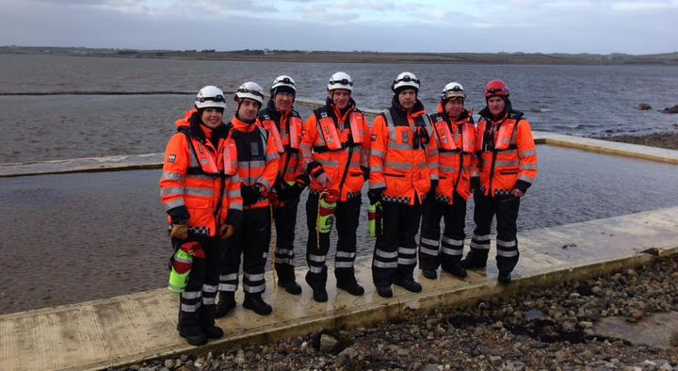
They were very surprised, however, to discover that the boat was completely empty.

Michael Hurst
Michael Hurst from the Ballyglass Coast Guard Unit was one of the first people on the scene. He recalled rushing to the beach, expecting to find people in need of their assistance. When he discovered the boat was empty, he had no idea what to think.
“I didn’t know what to think; I was just concerned about safety and securing it,” he told The Daily Telegraph. “Then I thought: where in the name of God did this come from, and who built it?”

Makeshift Vessel
The situation was made even more unusual by the vessel itself, which was a unique specimen.
It had been made from off-cuts of timber, spray foam and polystyrene. The makeshift boat also had Perspex windows and solar panels.
It had clearly been a makeshift job which makes it even stranger that the person who built the boat was not on board. Why would somebody abandon a ship that they had taken the time and effort to build from scratch?

A Floating Caravan
What’s more, the boat was not really fit for crossing the ocean. It was fairly small and was only about 12 feet wide and 20 feet long. It really wasn’t made for long journeys. Hurst commented that the boat was more of a “floating caravan.”
It was not in good condition and did not look particularly safe. This just made it even more surprising that the boat had ended up on a shore in Ireland, when no one in the town claimed to be responsible for the boat.

A Secret Castle
Inside, however, the boat was in pretty impressive condition. It had clearly been well maintained, which just begs even more questions about the owner.
“I wouldn’t like to go out on it. But if you were homeless, it would be like a castle,” Hurst commented.
Why would somebody take such great care of the inside of the boat only to send it sailing with no one on board? Had they expected it to sink? Or worse, had they been on board and got lost out at sea? More investigation was needed.

One Short Message
The Coast Guard decided that more thorough investigation was needed. They clambered inside the vessel and started to look closer at the details. They found something rather curious written on the walls…
“I, Rick Small, donate this structure to a homeless youth to give them a better life that Newfoundlanders choose not to do!” the message read. “No rent, no mortgage, no hydro.”
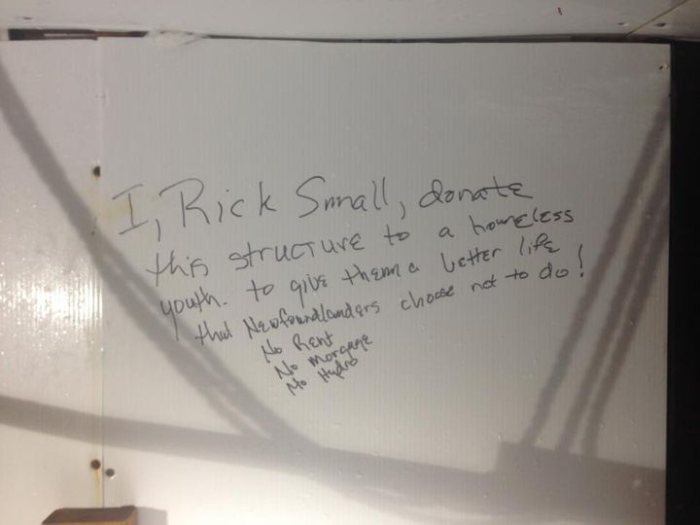
With one short message, the maker of the boat had answered the bulk of questions that everybody had about the vessel.

Rick Small
After reading this message, the investigators discovered that Rick Small is an eco-adventurer based in Ontario, Canada. After all, the Canadians have an impressive reputation for crossing the country in unique and adventurous ways, so that shouldn’t come as a big surprise.
If you don’t believe us, just look at the man who made the boat. Rick Small had in fact travelled the 4,375 miles from British Columbia to Newfoundland on a tricycle powered by solar energy. It doesn’t get more hardcore than that!

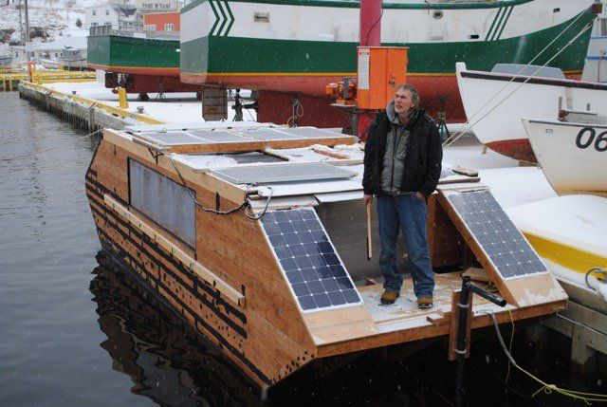

Contacting Canada
Once the mystery was sussed, the Irish Coast Guard reached out to the authorities in Halifax, Canada. They wanted to inform them of the discovery and were excited to let them know just how far the boat had travelled before it washed up.
The Canadian officials were just as surprised as they were. They could not believe that the boat had made it so far! Reportedly, Small originally intended to sail his boat across the Atlantic himself. It was actually the Canadian authorities who managed to discourage him from making the journey.

An Epic Journey
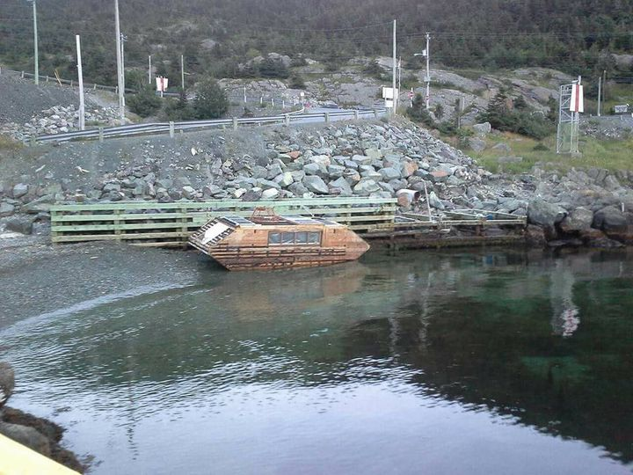
In case you are wondering why they dissuaded him, we’d like to remind you that the structure was not built for long sales. The journey is 4,000 miles and it really would not have been safe for Rick to travel, even though the boat did eventually reach the shore.
“The boat was last seen in Portugal Cove in Newfoundland during the summer, and it broke loose,” a spokesman for the Irish Coast Guard reported. “The Halifax authorities were amazed it made it to Ireland and was in one piece.”

Amazement
Many people in Canada were familiar with Rick Small’s mission. They had watched the boat drift away from his Canadian home and were shocked when they learned just how far it had travelled.
“It is amazing how it got here,” Hugh Gillespie shared on Facebook.
It turned out that no one was actually expecting it to make it across the Atlantic Ocean. Rick Small proved everybody wrong but nonetheless, we are relieved that he did not climb on board as the mission was still a dangerous one.

Colton McDonald
Others took to Facebook to share their shock at the remarkable journey. Colton McDonald wrote:
“I worked at a local lumber yard here in Newfoundland. I spent a lot of time helping Rick get the materials he purchased from the yard! Weird character but really interesting… Amazing how far the vessel got. I will have to just speculate on what happened to him!”
When Colton gave Rick the materials, he clearly had no idea what a success his idea would be.

Resilient
For the record, the houseboat was actually more resilient than everyone thought. Those who doubted it were obviously proved wrong but they could have predicted its success if they looked closely at the details.
Rick had coated the boat with tar so that the wooden exterior would be weatherproof. The boat was also believed to be fitted with an electric motor powered by a solar panel on the roof.
The BBC reported: "The boats steering system was only a piece of plywood bolted to a PVC pipe. And the motors barely had enough power to move."

Receiver of the Wreck
Meanwhile in Ireland, Mayo County Council had an empty houseboat on its hands. They decided to place the vessel into a storage depot while they decided what to do with it.
An official known as a Receiver of Wreck was assigned the responsibility of looking after the boat. It was decided that they would wait a year for the rightful owner to claim it and after that, they would decide what to do with it.
Following the news that the boat had washed up on the Irish shore, however, Small did not contact the Mayo County Council.

The Elusive Rick Smalls
The council tried hard to reach Small so that they could return the boat to him or at least inform him that the boat had been found. Curiously though, Rick could not be reached.
The council was waiting for a year to pass so that they could decide what to do with the boat. Many groups have expressed interest in taking ownership of it. The boat was in such good condition inside and would only be in need of some minor refurbishments. What’s more, Small’s message indicated that he fully intended to give the boat away.

What Next?
One of the interested partied were the non-profit group “Men’s Sheds”. They offered to work on restoring the vessel.
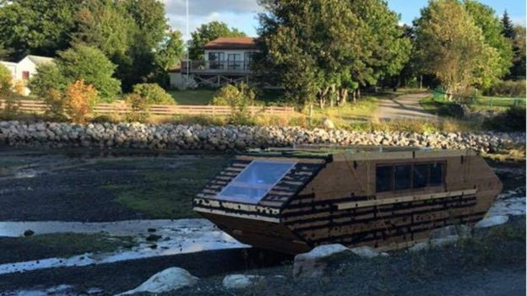
Another group hoped that the boat would become a tourist attraction on Ireland’s Wild Atlantic Way.
Many people had flocked to the beach to see the curious vessel and people hoped that if it became a permanent attraction, there would be a boost in local tourism.
But would people really come from far and wide to get a look at Rick Small’s creation?

Keeping It Local
Everybody seemed to want different things but one thing everyone seemed to agree on was that they wanted the boat to remain in Mayo as this is where it had ended up.
Hurst explained to Metro News: “If the vessel is not claimed and it remains in Ireland, we would like to see it kept locally,”
He added: “There has been a lot of interest in it. And the feeling locally is that because it came ashore here, it should remain here.”

Eco-Homes
The idea that Rick Smalls had for the boat was definitely a wonderful one. Homelessness remains a real problem in Ireland and the UK, even if this was not where Rick intended for his boat to end up.
There has been a recent rise in "Eco-Homes" which use little to no energy. Living on a boat is also a way to avoid rising house prices and Rick's creation had the potential to house a homeless person in need of shelter.

Where is Rick Smalls?
The remaining mystery is what happened to Rick Smalls. Timothy John Ewart, a fellow sailor, spotted the boat before it made its journey and asked Smalls about his intentions.
"The boats steering system was only a piece of plywood bolted to a PVC pipe," he explained. "And the motors barely had enough power to move."
Naturally, Timothy was astounded to learn that the board had made it. He would have congratulated Rick on his success, only he was nowhere to be found.

Never Seen Again
"I never saw him again," Timothy said of their last encounter.
The last time he saw Mr. Smalls was in 2015. He recalled: "When he left our area, he was standing on top using a long 2X4 (piece of wood) to push his way out because the current was stopping the boat."
It therefore seems to be the case that Rick ignored the Canadian official's advice and decided to cross the Atlantic in his boat. It still remains a mystery where he is today, especially given that his boat washed up on shore unscathed.

A Legend
We can only hope that Rick Smalls is somewhere safe, working on another crazy invention.
Wherever he is and whatever he is doing, he is now the legend who built the floating caravan that sailed the Atlantic Ocean. The boat still remains in Maya where it is a symbol of adventure.
The boat has been taken ashore to Cross Beach in County Mayo where it remains today. As well as being a symbol of adventure, Rick's message of sharing with those in need is prominent.

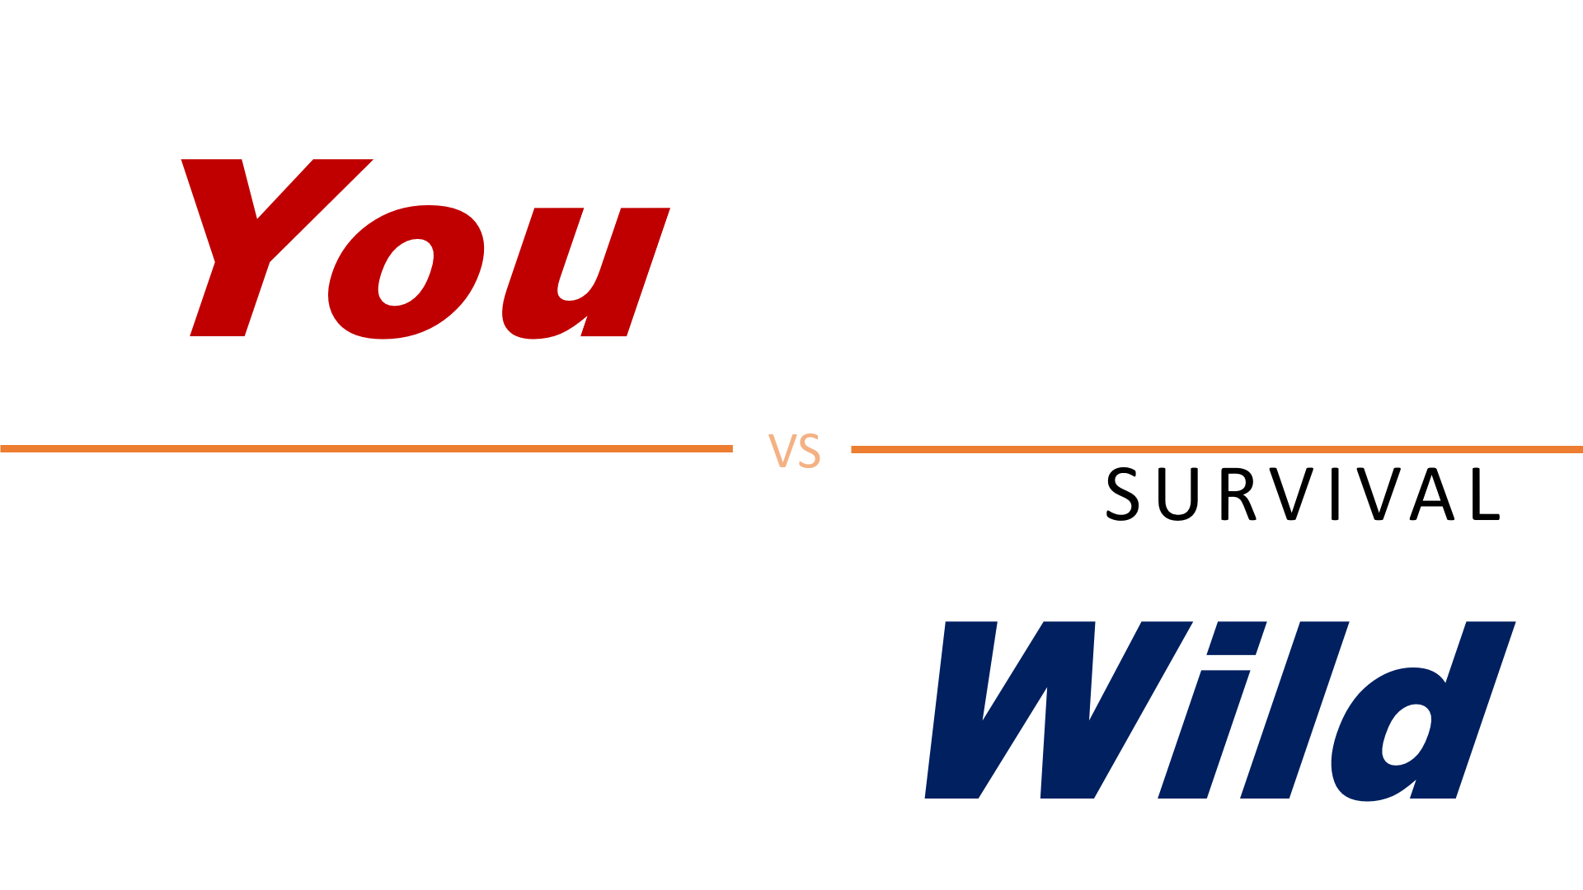
Your Mission:
- Search for wreckage
- Find the anti-venom

Dangerous Terrain:
- Scorching valleys
- Sandstone cliffs
- Slot canyons

What are some dangers in the desert?

Rappel =

Kilometers :
Meters :
Celsius :
References
David A. Bergin (1999) Influences on classroom interest, Educational Psychologist, 34:2, 87-98, DOI: 10.1207/s15326985ep3402_2
Charisma on Demand. (2018, Jul.24). How to Make Someone Remember You for a Lifetime. [Video] Available at: https://www.youtube.com/watch?v=v-ps2nfkAiA&t=620s
Corden, O., and Winfrey, O. [The Late Show with James Corden]. (2018, Mar.13). Oprah Can Make Anyone Cry, Including James. [Video] Available at: https://www.youtube.com/watch?v=_GZlUextcAA
Craig, H. (2019, Mar.3). 17 Emotional Intelligence Tests and Assessments. [online] Available at: https://positivepsychology.com/emotional-intelligence-tests/
Cuncic, A. (2019, Sep.27). How to Practice Active listening. [online] Available at: https://www.verywellmind.com/what-is-active-listening-3024343
Harackiewicz, J. M., Smith, J. L., & Priniski, S. J. (2016). Interest Matters: The Importance of Promoting Interest in Education. Policy insights from the behavioral and brain sciences, 3(2), 220–227. doi:10.1177/2372732216655542
Headlee, C. [TED]. (2016, Mar.8). 10 ways to have a better conversation – Celeste Headlee. [Video] Available at: https://www.youtube.com/watch?v=R1vskiVDwl4
Hidi, S. & Renninger (2006) The Four-Phase Model of Interest Development, Educational Psychologist, 41:2, 111-127, DOI: 10.1207/s15326985ep4102_4
Katz, N., McNulty, k. (1994). Reflective Listening. [online] Available at: https://www.maxwell.syr.edu/uploadedfiles/parcc/cmc/reflective%20listening%20nk.pdf
Krapp, Andreas. (2002). An educational-psychological theory of interest and its relation to SDT. The handbook of self-determination research. 405-427.
Lapakko, D. (2007). Communication is 93% Nonverbal: An Urban Legend Proliferates. Communication and Theater Association of Minnesota Journal, 34, 7-19.
Mehrabian, A., & Ferris, S. R. (1967). Inference of attitudes from nonverbal communication in two channels. Journal of Consulting Psychology, 31(3), 248-252. http://dx.doi.org/10.1037/h0024648
Mind Tools Content Team. (accessed 2019, Oct. 14). Body Language –Picking Up and Understanding Nonverbal Signals. [online] Available at: https://www.mindtools.com/pages/article/Body_Language.htm
Schiefele, U. (2009). Situational and individual interest. In K. R. Wenzel & A. Wigfield (Eds.), Educational psychology handbook series. Handbook of motivation at school (p. 197–222). Routledge/Taylor & Francis Group.
Treasure, J. (2011). 5 ways to listen better. [Video] Available at: https://www.ted.com/talks/julian_treasure_5_ways_to_listen_better/transcript
Wikipedia contributors. (2019, September 17). Active listening. In Wikipedia, The Free Encyclopedia. Retrieved 07:02, October 11, 2019, from https://en.wikipedia.org/w/index.php?title=Active_listening&oldid=916138724
Wikipedia contributors. Reflective listening. Wikipedia, The Free Encyclopedia. April 1, 2019, 14:06 UTC. Available at: https://en.wikipedia.org/w/index.php?title=Reflective_listening&oldid=890461557. Accessed October 14, 2019.
Willets, M. (2019). 10 Best Educational Websites for Kids. [online] Available at: https://www.parenting.com/child/10-best-educational-websites-kids/
Zantal-Wiener, A. (2018, Jan.23). 6 Phrases That Demonstrate Active Listening. [Blog] Available at: https://blog.hubspot.com/marketing/phrases-for-active-listening

