SPEAKING II (Writing) / Practical Teaching
Tim Schilstra
Goals of Class
In the speaking part of this session we will be focusing on improving your English skills through practice. You will be given ample opportunity to practice the skills learned in class. Additionally, we will be trying some games and activities that can be used in the classroom. The main goal of this speaking session is to become more confident and competent in speaking English. We will also be incorporating writing skills into this session. Additionally, in practical teaching, we will investigate microteaching. We will learn what it is, how to use it and participate in a microteaching session. The goal of microteaching is to share our best ideas and to refine our teaching skills. There are some more specific goals that include:
- Using English creatively to explain, discuss or argue
- How to incorporate new technology in the classroom
- How to use your hands to be a more effective speaker and teacher
- Making your speech sound more natural
- Being able to adjust language for small talk and opening up
- Using English in the classroom
- How to provide useful feedback
- To learn from the other trainees through microteaching

Description of Unit
Speaking II
Trainees will be given many opportunities to practice their English skills through a variety of activities, games and challenges. Throughout this course, they will learn some specific speaking skills and then apply them in practice. We will examine the video, “I Hired a Speech Therapist to Fix My Boring Voice.” We will follow the skills he acquires in the video and try the activities he tries while expanding on the skills he is developing.
Writing
The writing component of this session will be mostly incorporated into the various games and activities we will be doing in the speaking part. Additionally, trainees will be writing a speech, cards, lesson plans, and giving feedback.

Practical Teaching
We will focus on microteaching during this section of the course. Trainees will create their own sample lessons to show the class. Trainees will be encouraged to focus on their best attributes as a teacher.
Conversation
In conversation class we will have an opportunity to discuss many things. We will play some board games designed to get people talking. Another big part of conversation class is the use of conversation starters. Trainees will also have the opportunity to lead conversations.

Introduction
Hello everyone. My name is Tim and I will have the honor of teaching you ‘speaking’ in session 2. In this course, we will use various activities and games to practice our speaking and writing skills. Some of the activities will be useful for your level, while others are meant as example games for students. Through these activities, I hope you will become more comfortable and confident in you speaking skills while learning new ways to use the English language.
In addition to the regular activities and games, we will also try some new technology. One day will be spent trying some remote-play games. Another day we will use some smartphone apps. The world is changing, and it is good to keep up with resources that are available to teachers.
We will also work through a unit based on the YouTube video, “I Hired a Speech Therapist to Fix My Boring Voice.” The video follows Kane Diep as he prepares to give a speech. Through his journey he learns some speaking and conversation skills. We will try the exercises he uses and go into more depth on the skills he learns. Through this journey, we will also touch on some English points as well. Kane’s journey was unexpectedly deep and emotional. He said that it was the most life-changing video he has ever made. I hope it will be just as beneficial to us.
I am looking forward to spending some time with all of you.

Course Outline
Lesson 1 – Introduction (+Zoom, Re-Zoom)
Lesson 2 – Cat Crimes
Lesson 3 – Explain the Map
Lesson 4 – The Capital of the World
Lesson 5 – Portmanteau + Anagrams
Lesson 6 – Ranking
Lesson 7 – Solve the Problem
Lesson 8 – Euphemisms
Lesson 9 – Choosing the Right Words
Lesson 10 + 11 – Web-based Games
Lesson 12 + 13 – Smartphones + QR Codes
Lesson 14 – Snake Oil Salesman
Lesson 15 – Say Anything
Lesson 16 – Speaking with Hands
Lesson 17 - First Impressions
Lesson 18 + 19 – The Musicality of English
Lesson 20 – Compliments
Lesson 21 – Gift Giving
Lesson 22 – Small Talk
Lesson 23 – Opening Up
Lesson 24 – Getting What You Want
Lesson 25 + 26 – Best Place to Visit in Korea
Lesson 27 – Metaphors
Lesson 28 – Power of Three
Lesson 29 + 30 – Best Place to Visit in Korea (speeches)
Lesson 31 – British Game Shows
Lesson 32 – Two Rooms and a Boom
Lesson 33 – Role Play
Lesson 34 – Introduction to Microteaching
Lesson 35 – 38 – Lesson Preparation
Lesson 39 – Giving Feedback
Lesson 40 – 43 – Microteaching Demonstrations
Lesson 44 – Christmas Cards

Speaking (writing)
P is for Pterodactyl (The WORST alphabet book ever)
A is for Aisle – The bread aisle has not been cleaned in aeons, and nine tiny beasts meet to have a feast.
B is for Bdellium – We doubt anyone knows what bdellium is, but it’s the only word dumb enough to begin with a silent B.
C is for Czar – Shhh! The fascinating czar is secretly part Czech.
D is for Djibouti – The boat race begins when the handsome judge from Djibouti drops his handkerchief from the bridge.
E is for Ewe – Eileen the ewe was so euphoric the wolves were eaten, she even gave the eulogy.
F is not for Photo, phlegm, phooey, or phone – F is only for “foto” when you speak fluent Spanish at home!
G is for Gnocchi – The gnome yells, “Waiter! There’s a bright white gnat nibbling on my gnocchi!”
H is for Heir – The honest heir admits that herbalism isn’t his cup of tea.
I is not for Eye – We asked the pirate if he has two eyes, and he said, “aye, aye!”
J is for Jai Alai – Juanita and Bjorn happily played jai alai before eating fajitas in Juarez.
K is for Knight – The noble knight’s knife nicked the knave’s knee.
L is not for Elle – An elephant named Elle rode the el train halfway to El Paso and dined on hearts of palm with her folks.
M is for Mnemonic – But now Mr. M can’t remember why.
N is not for Knot – N is for naughty children who will sing a solemn hymn when autumn comes to an end.
O is for Ouija – The French leopard says, “Oui! We’d love to play Ouija with the wee witch from Oaxaca.”
P is for Pterodactyl – Ptolemy the psychic pterodactyl struggles with psoriasis.
Q is for Quinoa – We can enjoy quinoa and quiche by the quays of Qatar.
R is not for Are – In England, the Queen proclaims, “We aren’t saying the r’s in butterfly, shark, or lizard!”
S is for Seas – Cee Cee swam through the debris in the seas to see the imaginary isle of New Arkansas.
T is for Tsunami – The charging tsunami washed away all of the Tchaikovky’s tchotchkes.
U is not for You – You never could have guessed that the wolf was disguised as the ewe!
V is for Five – How Roman-tic!
W is for Wren – The wren wrapped the rabbit’s gift in red, but forgot to write a note.
X is for Xylophone – Xavier’s extra arm made him an exceptional xylophone player.
Y is not for Why – But Yves, who is wearing yellow shorts, yells, “Why is the Eiffel Tower upside down?”
Z is for Zhivago – Goodnight, Zhivago the Zebra! I’ve enjoyed our rendezvous. Zzzz…

Explain the Map

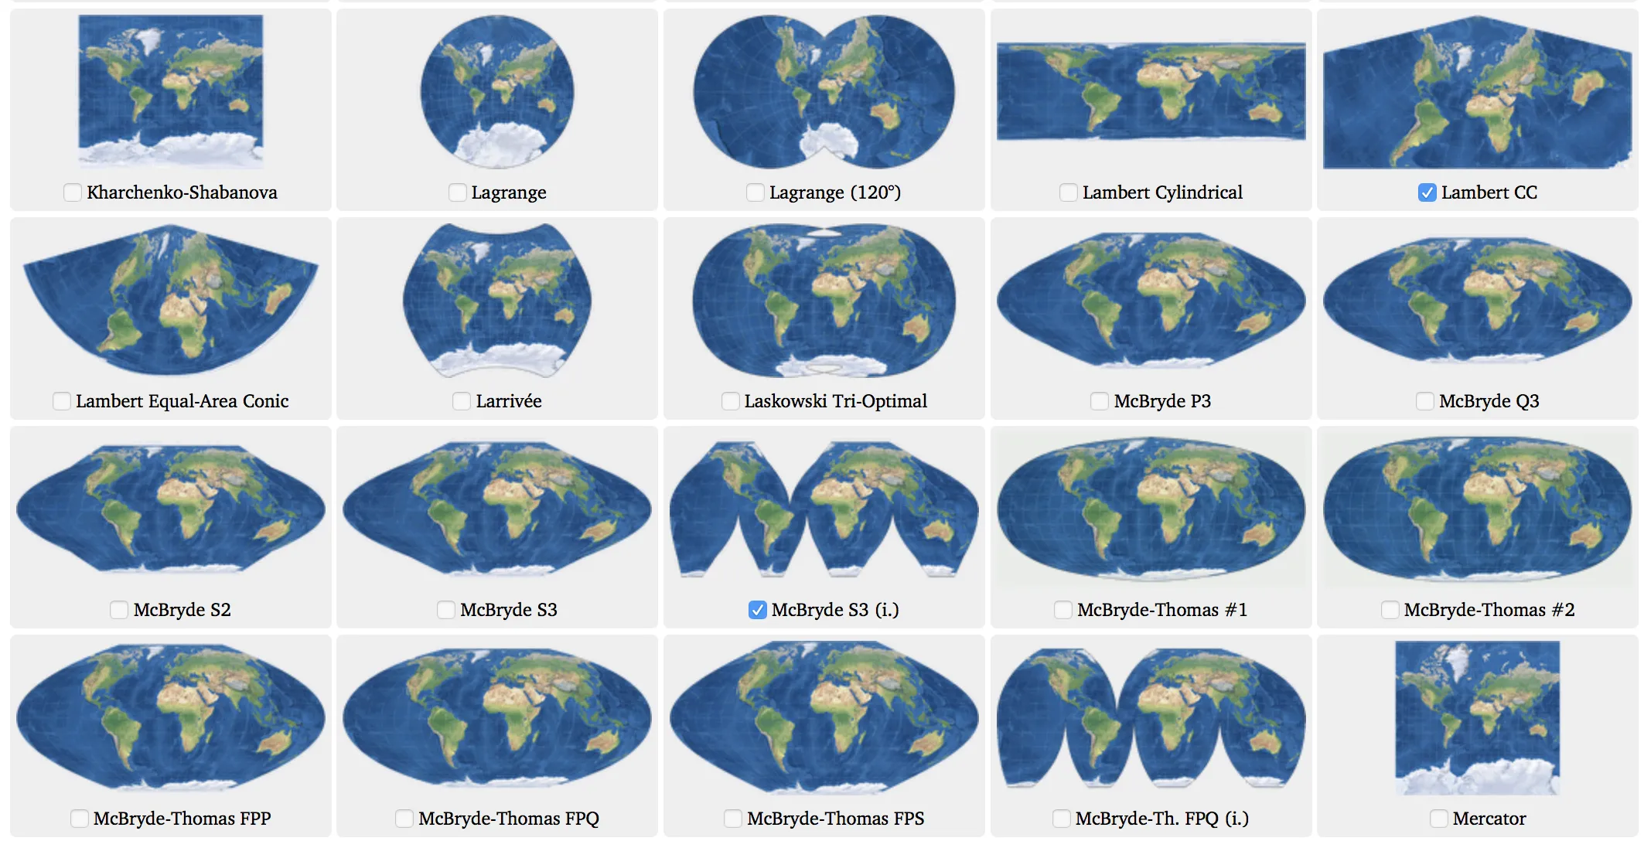

#3
#9
#12
#52
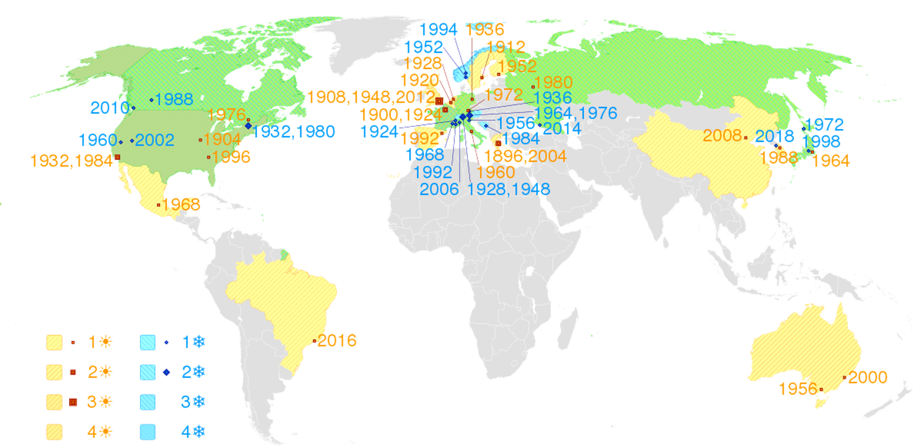
#33
#31
#30
#29
Portmanteau
Breakfast + Lunch =
Electronic + Mail =
Smoke + Fog =
Spiced + Ham =
Hungry + Angry =
Costume + Play =
Motor + Hotel =
Education + Entertainment =
Spoon + Fork =

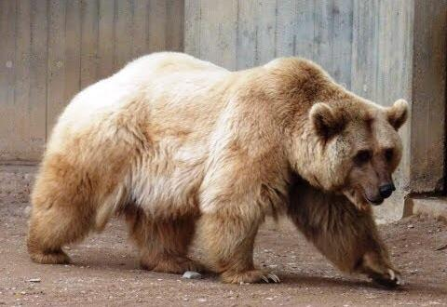

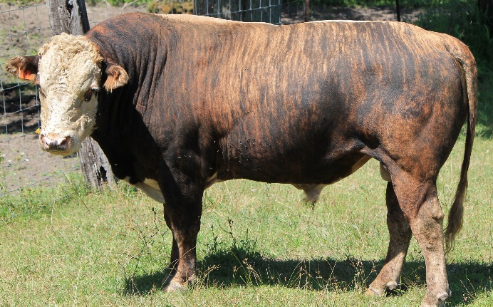

Blasts from the past: The Soviet ape-man scandal
LIFE 20 August 2008
By Stephanie Pain
In February 1926, Russian biologist Ilia Ivanov set out for Guinea in French West Africa, where he planned to perform one of the world’s most sensational experiments. Ivanov was an expert in artificial insemination and had used his ground-breaking methods to create an assortment of hybrid animals. Now he was going to try something even more radical – crossing an ape and a human. His trip to Africa was expensive and its purpose highly questionable, yet the Bolshevik government not only sanctioned it but also financed it at a time when few Russians were allowed to leave the country. Why would so eminent a scientist risk his reputation? And why did the Bolsheviks back him?
IT WAS the story with everything: secret papers, an evil Soviet dictator and a zealous zoologist hell-bent on breeding a creature that was half man, half ape. When details of Ilia Ivanov’s attempts to create an ape-human hybrid emerged in the 1990s from the newly opened Russian archives, they prompted a rash of lurid headlines. Ivanov became the “Red Frankenstein”. His proposed liaisons were invariably dangerous. There was even the suggestion that he had been ordered to breed super-strong hairy warriors for what The Sun in London dubbed “Stalin’s mutant ape army”.
Yet Ivanov’s efforts during the 1920s to create an ape-human hybrid had been anything but secret, according to Alexander Etkind, a Soviet-born specialist in Russian history now at the University of Cambridge. Ivanov’s project was a sensation at the time and generated almost as many headlines as it would later on, but when no ape-man materialised the fuss died down and his research was forgotten. Some 60 years later, scholars reconstructed events from scattered letters, notebooks and diaries held in assorted government archives. Despite years of digging, however, one vital part of the story remains elusive. “None of these documents reveals why he did it,” says Etkind. After examining the available evidence, he thinks he has an answer (Studies in History and Philosophy of Biological and Biomedical Sciences, vol 39, p 205).
At the start of the 20th century, Ivanov was internationally acclaimed for his pioneering work in artificial insemination (AI), and having perfected his methods he was keen to see how they could be applied. His first big project was aimed at improving imperial Russia’s bloodstock, using sperm from the best stallions. Before long, he was pondering the possibilities of hybridisation: with AI, he reckoned he might be able to create novel types of domestic animal by crossing closely related species. Soon he had produced a zeedonk (zebra-donkey hybrid), a zubron (European bison-cow cross) and various combinations of rats, mice, guinea pigs and rabbits. In 1910, he told a gathering of zoologists that it might even be possible to create hybrids between humans and their closest relatives.
At that stage, Ivanov was simply speculating, but a decade and a revolution later, he was making plans to put theory into practice. In 1924, he put his proposals to the government. Despite the disapproval of the scientific establishment Ivanov got the go-ahead – and the funds to mount an expedition to Africa to collect apes. Documents show that the decision was pushed through by leading members of the Bolshevik government.
In February 1926, Ivanov set off for Africa. His first stop was Paris, where he won the enthusiastic support of the directors of the Pasteur Institute and the promise of access to the chimps at its new primate centre in Guinea, then part of French West Africa. He reached Guinea in late March only to discover none of the chimps was mature enough to breed. He would have to return later in the year to capture some chimps of his own.
Ivanov passed the summer in Paris, where he spent some of his time at the Pasteur Institute working on ways to capture and subdue chimps, and some with the celebrated surgeon Serge Voronoff, inventor of an increasingly fashionable “rejuvenation therapy”. In a now notorious operation, Voronoff grafted slices of ape testes into those of rich and ageing men hoping to regain their former vigour. That summer, he and Ivanov made headlines by transplanting a woman’s ovary into a chimp called Nora and then inseminating her with human sperm. While the press waited for the outcome, reporters turned their attention to Ivanov’s unusual project. The idea of an ape-human hybrid was both shocking and fascinating. Was it possible? Were humans really that closely related to apes? What would the result be like? And what were the Soviets up to?
In November, Ivanov returned to Guinea, captured his chimps and with considerable difficulty eventually inseminated three of them. By now, he had a second experiment in mind: to inseminate women with chimp sperm. Knowing that no local woman would agree, he planned to do this under the pretext of a medical examination, but the French governor forbade it.
None of the three chimps conceived. Disappointed, Ivanov headed home with 20 chimps to stock a new ape nursery in the subtropical Soviet republic of Abkhazia. He knew now that his best chance of creating his hybrid was to find Soviet women willing to carry half-ape babies in the interests of science. In the event, only four chimps made it to Abkhazia and so while the nursery set about acquiring more apes, Ivanov looked for volunteers.
At least five women volunteered. But although the nursery did get hold of an assortment of apes, they never flourished, and by the time Ivanov was ready to proceed the only adult male left was Tarzan, a 26-year-old orang-utan. Ivanov pressed on until fate dealt his project a fatal blow. Tarzan had a brain haemorrhage. “The orang has died, we are looking for a replacement,” Ivanov cabled the woman he had lined up to receive Tarzan’s sperm. More chimps arrived in 1930 – but Ivanov fell victim to the widespread purge of scientists and was exiled to Kazakhstan. He was released the next year but died soon after.
“Five women offered to carry half-ape babies in the interests of science”
So why did Ivanov want so badly to produce a baby that was half-ape, half-human? And why did the Bolsheviks encourage him?
When Ivanov put his proposal to the Academy of Sciences he painted it as the experiment that would prove men had evolved from apes. “If he crossed an ape and a human and produced viable offspring then that would mean Darwin was right about how closely related we are,” says Etkind. When Ivanov approached the government, he stressed how proving Darwin right would strike a blow against religion, which the Bolsheviks were struggling to stamp out. Success would not only bolster the reputation of Soviet science but provide useful anti-religious propaganda to boot.
That might seem motive enough, yet as Etkind points out, some have suggested that the ageing Bolshevik leaders had something less intellectual in mind. “There is conjecture that Ivanov was sent to Africa to bring back apes in order to provide them with glands for rejuvenation.” The Kremlin’s doctors certainly dabbled in rejuvenation treatments and Ivanov did have links to Voronoff, but Etkind is not convinced. “If you want to cover up a bizarre scheme to rejuvenate ageing politicians then you wouldn’t choose an even more bizarre project that’s going to attract a lot of publicity.”
There is a third possible motive – that Ivanov’s research was part of an ambitious plan to transform society. The high-ranking Bolsheviks who backed Ivanov were intellectuals who saw science as a means of realising their dream of a socialist utopia. “Politicians could change the political system, nationalise industries and turn farms into vast collectives – but the task of transforming people was entrusted to scientists,” says Etkind. “The aim was to match people to the socialist design of Soviet society.”
One way to do that was through “positive eugenics”, using AI to speed up the spread of desirable traits – a willingness to live and work communally, for instance – and to get rid of “primitive” traits such as competitiveness, greed and the desire to own property. “There were many projects aimed at changing humanity,” Etkind says. “Ivanov’s was the most extreme but if he succeeded then that would show that humans could be changed in radical and creative ways.”
Etkind believes this is the most likely reason why the Bolsheviks backed the project and that it was also what motivated Ivanov, at least in part. Like many others, Ivanov was swept along by the Bolshevik dream, he says. “He had proved that AI had the capacity to change nature, and testing its limits was perfectly in tune with the revolutionary times.” At the end of the day, Ivanov was a typical Russian intellectual. “His ends and means today sound truly radical. But if you think about it, a successful hybridisation with apes is no more fantastic than a happy life in a communal apartment.”
Read more: https://www.newscientist.com/article/mg19926701-000-blasts-from-the-past-the-soviet-ape-man-scandal/#ixzz6NhAZp7Jk

Crew Selection
Name: Bob Thornton
Gender: Male
Age: 57
Job: CEO

Bio: Since he was young, Bob has always wanted to go to Mars. He started an electronics company and became rich. He destroyed his competition. He is aggressive. He does not like being told what to do. But, he will give you some extra money if you select him for the crew.

Name: George Stamford
Gender: Male
Age: 15
Job: Buddhist Monk

Bio: George is young and religious. He believes that everyone should be kind to one another. It is his job to suffer for the rest of the crew. He doesn’t have many skills and he is not strong. But, he will do anything to help other people.

Name: Frank Rivers
Gender: Male
Age: 45
Job: Farmer

Bio: Frank is a quiet person. He is a hard worker and is strong despite his age. He has a good knowledge of how to grow crops in various soils. He likes working alone.
Name: Lisa Angle
Gender: Female
Age: 39
Job: Engineer

Bio: Lisa was always one of the top students in her class. She decided to become an engineer. She is really good at designing buildings and has some knowledge about machines as well. She does not like to do physical work, but she will do it if you select her for the crew.

Name: Sarah Borland
Gender: Female
Age: 29
Job: Teacher

Bio: Sarah is an elementary school teacher. She is very interested in Mars and thinks it will be an exciting opportunity. She is really good at getting people to cooperate. She can take on the role of a leader or be a good team player. She is willing to help any way she can. Unfortunately, she does not have much special knowledge.
Name: Samantha Fox
Gender: Female
Age: 62
Job: Doctor

Bio: Samantha has many years of experience as a doctor. She can diagnose any disease and knows how to treat them. She even spent some time as a military doctor. She is surprisingly strong. But she does not want to be a leader. She would rather just do her job.

Name: Simon Skinner
Gender: Male
Age: 26
Job: Construction Worker

Bio: Simon is a team player. He cooperates well and is very strong. He has experience building and can operate machine. He has some engineering knowledge, but mostly he is valuable as a worker. He gets along with everyone.

Name: Hal Ragnow
Gender: Male
Age: 37
Job: Chef

Bio: Hal has a lot of experience as a chef. In his restaurant he serves many customers every night. He also loves to experiment with new recipes. He is used to being a leader, but he can cooperate with others. Don’t count on him to do much physical work around the base though.
Name: Brain Holler
Gender: Male
Age: 48
Job: Scientist

Bio: Brian has a broad understanding of the physical sciences (physics, biology, chemistry). But he focused mostly on plant biology. He is a genius and has knowledge about many things. He can also help with physical work, but his brain is his biggest advantage.

Name: Michelle Lee
Gender: Female
Age: 44
Job: Lawyer

Bio: Michelle graduated from a top law school and is a defense attorney. One of her best skills is negotiation. She knows how to get people to work out their problems together. She is a natural leader, but probably won’t do much physical work.

Name: Elizabeth Walker
Gender: Female
Age: 31
Job: Police Officer

Bio: Elizabeth did not do too well in school. She became a police officer because she wanted to protect and help other people. She is strong and will help anyone.

Name: Maria Stansfield
Gender: Female
Age: 24
Job: Politician

Bio: Maria is opinionated. She loves to argue. She fights for less fortunate (or weaker) people. She is quite smart but thinks she is always right. She would rather use her words than her muscles.

Name: Derk Manley
Gender: Male
Age: 52
Job: Army Captain

Bio: Derk is a natural leader. He has been leading men for a long time. He knows how to get the most out of people. He is strong and takes orders well. He obeys the rules and does what he is told. His main advantage is his leadership.

Name: Amelia Stinger
Gender: Female
Age: 34
Job: Pilot

Bio: Amelia is a skilled pilot. She has flown fighter jets and passenger planes. She knows how to navigate and is fairly smart. She also has a lot of technical knowledge about machine, especially aircraft.

Name: Port Maitland
Gender: Male
Age: 42
Job: Mechanic

Bio: Port has a lot of experience with machines. He instinctively knows what is wrong with cars and other machines. He is also strong and can help the crew with physical work. He has a great sense of humor and everyone loves him. He is overweight and requires more food than the rest of the crew.
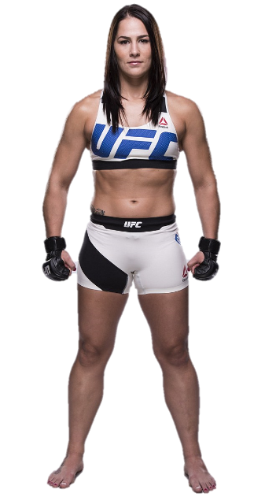
Name: Terrassa Kyle
Gender: Female
Age: 30
Job: Athlete

Bio: Terrassa is a UFC fighter. She is physically gifted. She can help the crew with anything physical. She doesn’t have much scientific or mechanical knowledge. Because she is physically talented she expects people to treat her better than everyone else.

Who should go to Mars?
Here’s what it takes to survive the mission
By Angela Chen@chengela Sep 30, 2016, 9:01am EDT
Elon Musk laid out his plan to colonize Mars at a conference on Tuesday, but it was during the Q&A session that a woman asked one of the key questions: who will be chosen to embark on a risky trip to colonize a harsh planet?
“If normal people want to travel to Mars, do we need some specific requirements?” she asked. “Can normal people go?"
The SpaceX CEO had two answers to this line of questioning. "We're trying to make it such that anyone can go,” he said, with "maybe a few days of training.” However, the trip will be dangerous. “The risk of fatality will be really high. There’s no way around it,” he later said. "It would be basically, are you prepared to die? If that okay, then you’re a candidate for going."
But choosing a candidate for a mission to Mars might require a bit more than that, and sending “anyone” to space sounds like a recipe for disaster. Astronauts who go into low Earth orbit have to pass a strict vetting process. Living in space, in a confined environment under high-stress situations, takes both physical and mental tolls. So, we’re left wondering: how much training do you really need? What personality traits should these SpaceX-sponsored Mars colonists have? Should the crews be all-male or all-female? The Verge spoke to experts to try to fill in the holes in Musk’s plan and figure out who would be the perfect candidates for this mission.
First off, is it true that “anyone with a few days of training” can undertake a trip through deep space?
Let’s break this down. On a purely physical level, it’s true that you don’t need to be a world-class athlete to be selected. A reasonably fit person without health complications could be cleared, according to Sheryl Bishop, a researcher who has worked at the Mars Desert Research Station, which simulates life on Mars for scientific purposes.
SELECT PEOPLE WHO ARE EXCITED AND CAN LIVE WITH OTHERS WITHOUT GETTING INTO FIGHTS
NASA requires astronaut hopefuls to pass a “space physical” that is basically a military physical. It also requires good vision, good blood pressure, and a certain height range. None of this is out of the realm of possibility for most people. NASA doesn’t require extraordinary strength or speed.
Physical fitness, however, is only one part of selection, and it’s arguably the easiest part. For NASA, you also need to have a technical degree (math, engineering, etc.) and at least three years of relevant work experience says Anne Roemer, the agency’s manager for astronaut selection. Technical skills and personality traits will limit who gets chosen, much more so than physical requirements. Since 1959, only about 338 astronauts have been selected.
Barry Wilmore, for example, first applied to be an astronaut in 1992. He wasn’t chosen until 2000, despite having two master's degrees in technical fields and having worked as a Navy pilot. Wilmore says he was challenged by how rigorous and stressful the technical training was — training could have five major systems on the simulation shuttle failing all at once.
What kind of personality traits are important? Will all Mars colonists have to be gung ho “adventurer” types?
Not exactly. Of course, all candidates need to be cool under pressure. A lot of NASA astronauts come from the military, and have flying or combat experience. Wilmore, for example — who has spent 178 days in space, mostly on the ISS — flew in Operation Desert Storm during the Gulf War, so it was clear that he could perform well under high-stress situations. “When you are flying, you gotta minimize being within your own mind,” says Wilmore. “You can get flustered and you gotta push that back and be able to clear-minded because your life and that of the crew hangs in the balance.”
Good astronauts have an adventurous spirit, but they also need to be disciplined and able to work well with others. Life on a space station, or a spaceship, can be boring. People live in a tiny confined space and need to figure out things like how to divide up the housework. When it comes to putting together a crew, a mix of technical skills is also important. You need doctors to keep everyone healthy, engineers that really understand how the ship works, and scientists who can conduct research experiments.
ALL-MEN GROUPS AREN’T A GOOD IDEA
This has changed since the early days of spaceflight. The first astronauts we had were stereotypical explorers, the kind of people who want to walk across glaciers and do fieldwork, Bishop says. But those first space trips were short, so it was okay to have “personalities that don’t play well with people over prolonged periods of time,” Bishop says.
Going to Mars, however, will take months, so it’ll be important to select people who are excited and can live with others without getting into fights.
Do any past expeditions resemble what a trip to Mars would be like and what can we learn from them?
Mars trips resemble expeditions to Antarctica. These explorers have the drive to survive a punishing environment, but can still collaborate with a few people in a remote area for a long time. They might make some of the best possible recruits for a mission to Mars.
Life in the South Pole, for example, can be highly regimented, says Lauren Wise, a laboratory specialist who investigates the contaminated areas of Antarctica. She gets up around 6:15AM every day. There are set meal times, she had to write on a board when she was leaving station limits, and pay very close attention to instructions.
Life can also be physically and mentally challenging, says Wise. She’s a small person and “sometimes walking in the stronger winds can be quite difficult,” she says. She misses activities back home (like yoga and swimming) and the lack of fresh fruit is a challenge. Sharing the small, remote research station with different types of people also requires her to be tolerant — and prepared for anything.
“The ever-changing conditions mean that sometimes what you have planned doesn’t always occur or happen in the way which you would like it to,” she says. “You also have to be able to think a little outside the box as you can’t just pop down to the hardware store or shop if you need something.”
So, SpaceX wants to send 100 people on the first trip. What kind of group is ideal? All one gender? Coed?
All-men groups aren’t a good idea. Women typically are more supportive than men in their interactions with other group members, and all-male groups can be more competitive, says Namni Goel, a researcher at the University of Pennsylvania who has written about sex and gender in space adaptation. Other studies show that mixed-gender crews do better than all men because adding women to an all-male crew can make men less territorial and rude.
There’s less research on all-female groups, and studies from space and other isolated and confined environments often use small sample sizes. It is also important to consider individual differences when thinking about group composition for space missions, adds Goel. According to Bishop, it’s possible that all-female groups aren’t as good as mixed-gender groups because women tend to focus very much on building interpersonal relationships, and having men around might make them focus more on the specific task at hand.
There should be a range of ages too because younger people tend to be more flexible in their thinking, while older ones have more experience and perspective, according to Bishop. Skillset diversity is also important, though large groups of more than 30 people tend to break off into small groups, she adds. This creates an “us and them” mentality — for example, “us scientists versus everyone else” or “us engineers versus everyone else.” Leaders will need to be wary of this situation and make sure people feel a strong sense of common purpose.
What about the psychological challenges?
Space is beautiful, but it is also lonely. When you’re stuck on a spaceship, you can’t just go visit friends and family. Wise, the scientist working in Antarctica, has some experience with homesickness. Her grandmother died while she was stationed, and that was a hard time for her, she says. But she could call her family at least once a week and keep in touch by email.
SPACEFLIGHT IS “FAR MORE THAN YOU CAN IMAGINE”
During a trip to Mars, communication with Earth would probably have a 20- to 40-minute delay. Not only does this mean no more immediate communication with mission control in emergency situations, weekly calls to loved ones are also out. The people who go will need to be extra resilient to loneliness.
There’s a lot we still don’t know in terms of the psychological challenges of a mission to Mars. On the International Space Station, for example, astronauts can gaze out the window and look at the Earth. On a trip to Mars, there’ll be a time when our planet will look like a tiny star. No one knows how people might react to that.
But flying in space can also be a positive experience, of course. Astronauts who have viewed the Earth from space have reported deep psychological changes, which is often called the “overview effect.” It’s been described as a sense of mental clarity and a feeling of a new kind of perspective and self-awareness. “Looking out at the Earth over the course of a year and seeing the impacts that our presence has on the environment, especially on some parts of Asia, you know makes me feel like there’s more that everyone can do, including myself, to make Earth a better place for the future inhabitants,” says Scott Kelly, who spent 340 days on the ISS — the longest any American has lived in space.
Wilmore, another NASA astronaut, says that spaceflight is “far more than you can imagine.” Think about leaving the planet and circling the entire globe in 90 minutes: “You see how it changes and it’s just amazing,” he says. “There’s a weightless feeling — you feel like Superman because you can fly and move heavy objects. It’s truly thrilling.”

Solve the Problem
The Goalie Problem
- There are no more goalies, but the game must continue.
- What should they do?

Porch Pirates
- 1.7 Million packages stolen daily in America.
- Some porch pirates follow delivery trucks and steal when they go.
- What would you do? Nothing illegal.

Penguin Tracker
- It’s hard to see individuals with a plane
- Tracking chips cause death
- Far from humans
- How can you track them?

Waiting in Line
- 1990s
- Customers complained about waiting for baggage
- They tried hiring extra staff.
- They were within industry standards (8 Minutes)
- People continued to complain
- Find a solution so customers stop complaining

Trapped Americans
- Due to the agreement between Britain and America, there is a small American town trapped in Canada.
- The town is too small for a high school.
- How do these high school students receive their education?

LA Reservoir
- Bromide is safe (natural in saltwater) but when it
reacts with ozone, it becomes bromate (carcinogen)
- The reservoir was the problem
- Bromide + Chlorine + Sunlight = Bromate
- Your task is to block the sun over LA Reservoir

A Famous Actor
- Your task is to get a famous actor in your movie.

Metaphors
We use about 6 metaphors per minute. Metaphors can be “novel” or “frozen”. We use novel metaphors every 1.80 minutes and frozen metaphors every 4.08 minutes.
Frozen Metaphors:
- I was frozen in fear
- Her heart was frozen
- We had to freeze the salaries.
- The bank froze his assets until he paid his debt.
Taste Metaphors:
- She was always sweet to me.
- Don’t be bitter. There’s always next time
- That’s a bland statement.
- Just because you lost doesn’t mean you should be salty.
- She has impeccable taste.
- She is always so fashionable.
- That’s a delicious suit you’re wearing.
- I want you to tell me some spicy rumors.
- Her punching him was a tasteless act.
- Why is he going out with her? He has no taste.
- Stop complaining. Stop being so sour.
Food Idioms:
- I’ll make you eat your words
- That kid is a bad apple.
- It’s gone pear shaped
- No problem. It was a piece of cake.
- It’s just not my cup of tea.
- I’m going nuts.
- Comparing apples to apples.
- He’s cherry picking information.
- You’ve got egg on your face.
- You better butter up to the boss.
- Don’t sugarcoat it.
- Something is fishy here.
- Take what he says with a grain of salt.
- She’s got a bun in the oven.
- It was a fruitful investment.
- You can have your cake and eat it too.
- English is my bread and butter.
- We’re in a pickle now.
- Don’t cry over spilled milk.
- Food for thought.

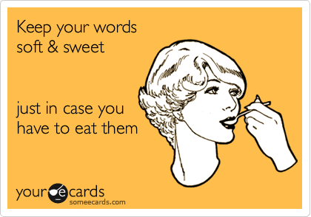

Euphemisms
Usually an inoffensive or polite way to say something uncomfortable or rude.

Bit the dust
Bought the farm
Kicked the bucket
She’s in a better place
Departed
Croaked
Passed away

Cut the cheese
Breaking wind
Ripped a big one
Lay an egg
Flatulence
Pass gas

Well-seasoned
Over the hill
Experienced
Senior citizen
Geriatric

Big-boned
Rotund
Plump
Portly
Chubby
Overweight
“dad bod”

Less able
Aloof
Slow
Simple
Affable
Dimwitted

Not the brightest bulb
Not the sharpest knife in the drawer
Not the sharpest tool in the shed
Not playing with a full deck of cards
A few sandwiches short of a picnic
Dumber than a bag of rocks

I’m late
Eating for two
A bun in the oven
Knocked up
In the family way
Prego

Laid off
Let go
A victim of downsizing
Sacked

Choose the best idiom:
1. One of our employees spent some time in prison when he was younger.
2. Martin’s uncle died in World War II.
3. Chelsea was an advertising executive, but now she’s a housewife.
4. George works as a trash man, but is currently looking for work as a janitor.
5. Sally’s dog had to be killed. It had cancer.
6. Sir, I’m very sorry but there is a problem with your order. It looks like it won’t be shipped until Thursday.
7. Did the doctor recommend getting an abortion?
8. The job offer sounds great, but I was hoping for better pay.
9. I think it’s great that our company provides employment opportunities to the mentally retarded.
10. You owe our company some money. Please pay us as soon as possible.
11. A local teacher was removed from duty due to his drug addiction.
12. I wouldn’t show that movie to your child. There is a lot of sexual content.
13. Give me a couple minutes to go to the bathroom, and then we can continue the conference call.
14. Let’s buy some used furniture instead of spending a fortune on a new bedroom set.
15. I heard a rumor that our company is planning on firing several salespeople on Friday.
16. Mrs. Smith’s secretary will arrange the meeting and send out a schedule.
17. Poor children are more at risk to drop out of high school.
18. Karl is the fat man who sits next to Angela in Accounting.
19. I had to pick up my friend from a party last night. He was drunk and unable to drive.
20. Several students in my English class are from third world countries.
21. I’m unemployed right now, but I hope to find something soon.
22. Is the death penalty a possibility in this trial?
23. I was very sorry to hear about your grandfather’s death.
24. We can’t give specifics on the case, but we can inform you that we have arrested someone.
25. Several prisons are hiring. You should apply.
26. Are there many illegal immigrants in this industry?
27. Some old people are upset about the government cuts.
28. The war has been controversial because of the accidental civilian deaths.

The Right Words (Word Choice Matters)
Oxymoron – Words that are contradictory
Tautology – Words that are redundant
 | Oxymoron | Tautology
Repeat that again.
It’s a bitter sweet moment
He is the only honest thief
Shout it loudly
Remember when 4G was a new innovation?
A small crowd appeared
There’s a lot of frozen ice on the road
Now is a good time to act naturally
In my opinion, I think he is wrong

A tautology, or repetition, is used to help students understand what is being said.
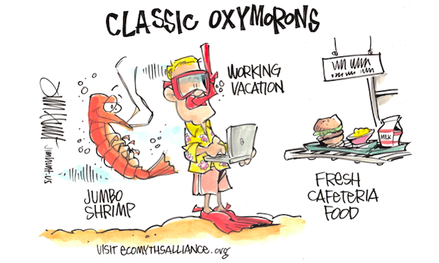

George Carlin:
Toilet Paper –
Sneakers –
False Teeth –
Medicine –
Information –
Dump –
Car Crash –
Partly Cloudy –
Motels –
House trailer –
Used Cars –
Room Service –
Constipation –
War –
Pandemic –

          - Apple genius
          - Between jobs
          - Sandwich artist
          - Retail associate
          - Spin doctor
          - Pugilist
          - Influencer
          - Administrative assistant
          - Law enforcement officer
          - Patient care provider
          - Waste removal engineer
          - Underwater ceramic technician
          - Director of First Impressions

I Love… - Tom T. Hall
I love little baby ducks, old pickup trucks
Slow-movin' trains and rain
I love little country streams, sleep without dreams
Sunday school in May and hay
And I love you, too
I love leaves in the wind, pictures of my friends
Birds of the world and squirrels
I love coffee in a cup, little fuzzy pups
Bourbon in a glass and grass
And I love you, too
I love honest, open smiles, kisses from a child
Tomatoes on the vine and onions
I love winners when they cry, losers when they cry
Music when it's good and life
And I love you, too.

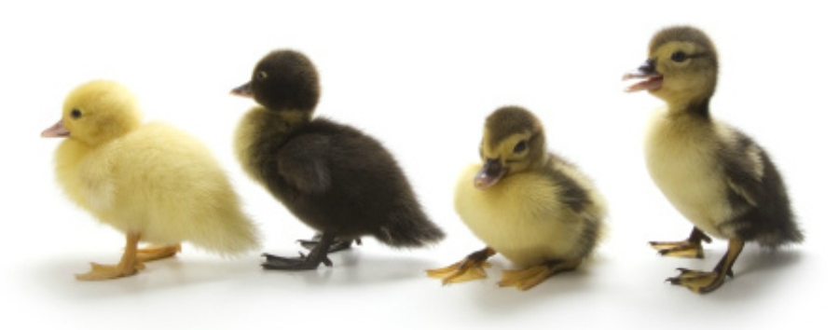

Role Play
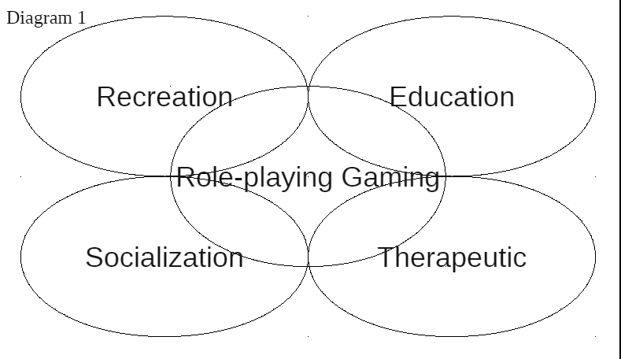
- Grab Bag Skits
- Game of Possibilities
- Real World Situations (Restaurant)
- Build a Business (students run an English ‘Subway’)
- DnD
- Dread
- LARP
- Edularp (Denmark)
- Mini UN
- Murder Mystery
- Gamifying the Classroom (Classcraft, rewards systems)

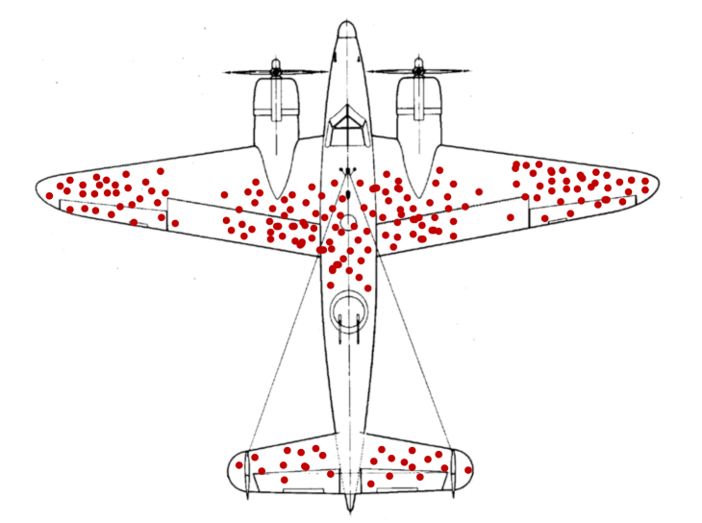
Biases

Survivor Bias

Survey Bias
Volunteer Bias
Only information from when people fill out the form
- Restaurant reviews – only people hate or love it.
- Research surveys
- Political Polling
Who are taking the surveys?
- Someone with time
- Usually socio-economically advantaged
- University students
- Who the researcher has access to
Confirmation Bias
- We only seek information that agrees with our beliefs
  - It is more useful to find information that disagrees with us.

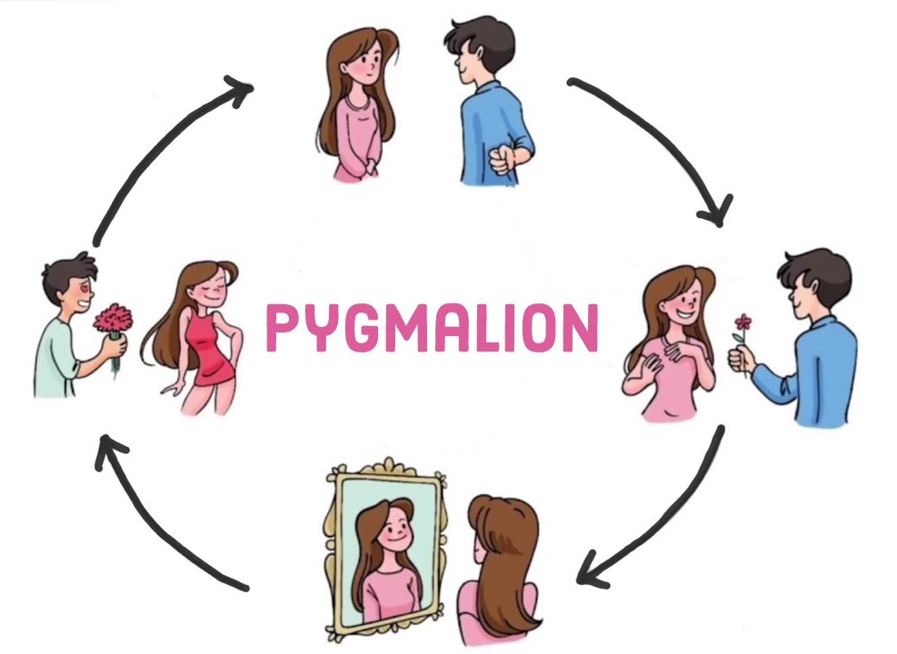
Pygmalion Effect
Self-fulfilling prophecy
Two students with the same intelligence:
- Treat one student better, they have a better experience, they try harder, and they do better
- Treat one student worse, they have a bad experience, they don’t want to try, their lack of studying leads to failure.

Heuristics
Cognitive shortcuts (rules of thumb)
  - Don’t have time or energy to examine ALL of the information
See relationships that are not actually there.
  - Coincidence
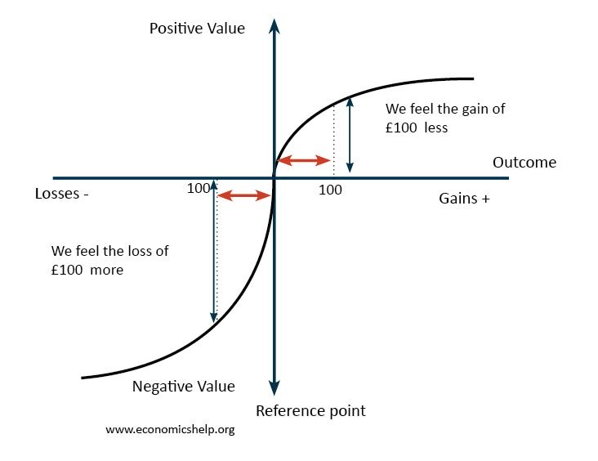
Loss Aversion
Losses are felt more strongly than gains.

Sunk Cost Fallacy
Bias Blind Spot
- 661 Americans were asked if they thought they were more or less biased than average:
  - 85% of Americans think they are less biased than average.
    - Not possible
  - Only one participant believed that he or she was more biased than the average American
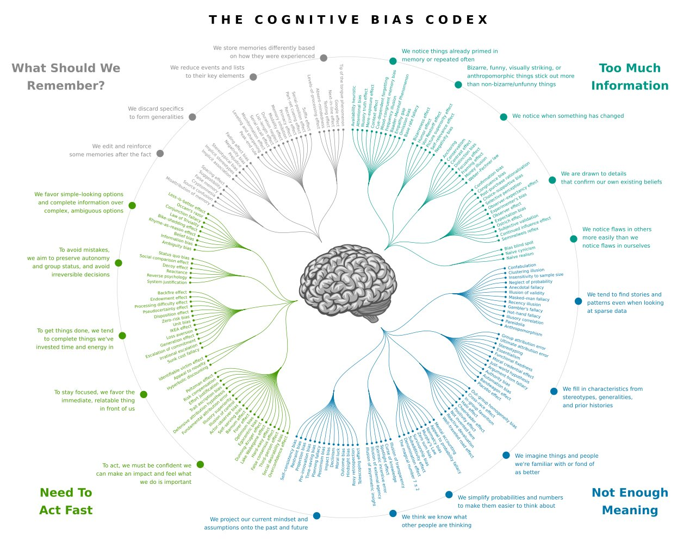

I Hired a Speech Therapist to Fix My Boring Voice
What is wrong with his voice?

Monotone
- Mono-pacing, mono-volume, mono-rhythm, mono-style
- Give the impression that you don’t care.
- Intonation is 38% of impression.
- Our voice has a ~30 note range. Most people only use 1 and 2 notes

The 4 Ps
- Pace
  - Slow at key moments
- Pitch
  - Variety of emotion
- Power
  - “Speak softly and carry a big stick.” – Theodore Roosevelt
- Pauses
  - Awkwardness is 0.7 seconds
“If you stop… and you think exactly what you want to say, your point can come across much more poignantly.”

What are his hands saying?

Talking with Our Hands
Our hands mimic the story we are telling. Often will subconsciously act out parts of our stories.
Hand gestures have also been linked to popularity. Someone who uses a lot of hand gestures is more likely to be popular.
Since gestures add to stories, we can also use them to help understand people
Our reactions follow a pattern. First is our emotional response. This is how the stimulus makes us feel. Then our body responds. Our body might reflexively jump back, tense up or relax depending on the situation. We don’t always have complete control over our body response. However, we do have control over what we say. Our verbal response is the last of the three responses. What we say is normally a conscious act. We have to think about what we are going to say which gives us the opportunity to create a preferred response. We might alter what we say (lie) or how we say it to appease our audience. Since the body response comes before the verbal response and we don’t have much control over it, it can be used to see the true underlying emotion.
Our body response reveals things that are missing in our speech. Gestures can enhance or undermine our message. If someone’s body movements don’t match their verbal response, we will become suspicious. Are they lying? This is called congruence and it is used by body language experts to judge the truthfulness of the statement.

Teaching with Our Hands
Hand gestures are also used in the classroom. They can help accelerate learning and guide the learner to important information. You have also probably heard about TPR (Total Physical Response) where body gestures are prominently used. Teachers also can use hand gestures to keep students interested, follow their actions and to organize (put your hand up) students.

In the video, Amy Chapman suggests using your hands to end sentences. Sentences should be ended with a downward inflection. Some people have issues with this, so Amy recommends tapping your leg at the end of the sentence to remind yourself to lower your pitch. This worked very well for Kane. Hand gestures are quite important and can be used to enhance speech.

First Impressions
Your first impression is usually established within the first 7 to 17 seconds of meeting someone. That is not a lot of time. Your first impression can include what you wear, how you walk and act, the quality of your voice (including tone and grammar) and the actual words you use.
First impressions are persistent. This means that they will last a long time. In psychology, this is known as the primacy effect. It means that we remember the first thing more than things from the middle. Our first exposure to a situation will be vividly remember, while the 23rd time might be completely forgotten.
First impressions are also subconscious. We get a feeling about someone without a lot of logical reasoning. Have you ever met someone and immediately liked them? Has the opposite occurred? As we talked about in the previous lesson, body gestures can affect how we feel about someone. Since first impressions are short, using all of our resources is a good idea.
How you feel about someone in the initial interaction has predictive power. This means that we can use it to predict future relationships. Predicted Outcome Value Theory (POVT) suggests that we make value judgments during our first impressions that will affect long term relationships. We predict what kinds of outcomes our potential relationship would have and act accordingly. In the experiments conducted, outcome value was a very strong predictor of future relations.

Qualities
What are the first things you notice about someone?

What do you want people to ask you?

Musicality of English
Verbal components: Individual sounds vs English rhythm
Intonation – Our voices can go up or down. The recognized intonation patterns include: rising, falling, high, low, flat, rising-falling, falling-rising. We are not going to cover too many of these, but will look at Rising and Falling intonation.
Rising intonation is mostly used at the end of questions. It can also be used in the middle of a sentence to show that you are not finished speaking. For these reasons, improper use of the rising intonation can be confusing to the listener.
Falling intonation is mostly used at the end of sentences to show that you have completed your thought. People sound more knowledgeable and confident when they end sentences with falling intonation.

Stress – We can put emphasis on certain syllables or words by using stress.
In each word there is one syllable that has strong and clear pronunciation. Stressed syllables are higher, louder, and longer. There are a few rules, but there are a lot of exceptions. Syllable stress can be difficult to figure out and is often acquired through interaction with the native speaker. In the dictionary, there is a ‘ before the stressed syllable in the word. This can help you pronounce new words.

Rules:
Nouns (and adjectives) with two syllables, usually have stress on the first syllable.
Verbs with two syllables usually have stress on the last syllable.
Three syllable words can have stress anywhere, but usually first or middle syllable.
Four syllable words are usually stressed in the middle.
If a word ends in -tion, -sion, or -cian; the stress is usually on the second to last syllable (before the -tion, -sion, or -cian)

How many syllables?

Banana –
Truck –
Beautiful –
Time –
Apple –
Study –
Special –
University –
Honorable –
Contagious –

Words can also be stressed in a sentence in addition to the stress we put on syllables. In general, content words are stressed and grammar words are unstressed. Grammar words are more for organization and clarity than for providing important information. However, word stress is quite flexible. The meaning and intention of your sentence can change based on which words you stress.
Highlight the content words:
- How about we go for a coffee this afternoon?
- My phone is broken, so I am going to buy a new one.
- Could you get some bread from the bakery on the way here?
- I heard the weather will be bad tomorrow.
- He has no idea what he wants to do after he graduates.
Finally, when making corrections, we commonly put exaggerated stress on the words that are being corrected.

Juncture – Juncture is how sounds are mixed or how they transition.
Open juncture – pauses show the boundaries or words and phrases.
He lies / Heal eyes
My turn / Might earn
Play nice / Plain ice
Closed juncture – Syllables are connected to show a shared meaning.
Night trait / nitrate
A corn / acorn

Where is the juncture?

Super
Dinner
Hello
Paper
Supper
Diner
Happy
Open

Mad Gab – Move the junctions and change pronunciation
WANDER HER WOMB HEN
TEAM OATH HE
MAY PULL SIR UP
BEYOND SAY
ACHE UP PUCK OFF HEE
ACORN REHAND REST
TREE COURT WREATH
PILL EAST OPERA NING
DEPOT STALL FIZZ
AIM US KEY TUB HEIGHT
DUNE HOT FEED THAN HYMN HULLS
CREASED MY SIEVE
ACE HECK HUNCH ANTS

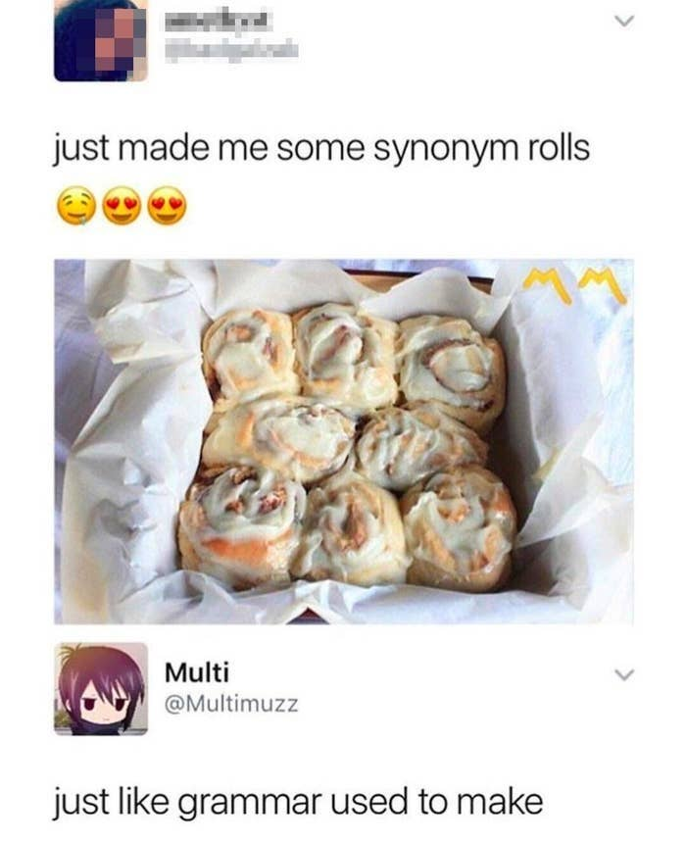

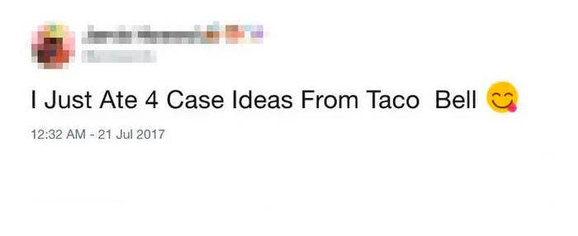
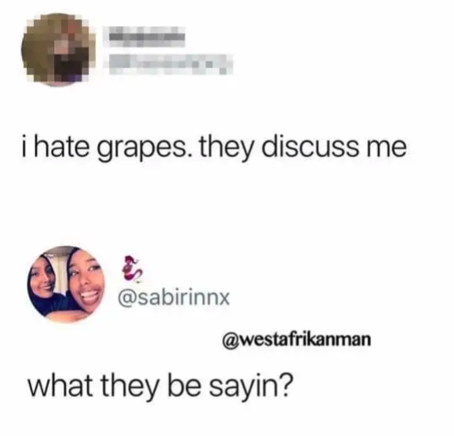

Pitch – The high and low sounds help in communication.

Speed (Pace) – The speed of language adds emotion to what you are saying.
The speed that you are talking also has an impact on the listener. The overall speed is not as important as the contrasts within your speech. You can speed up when you want to show nervousness or excitement. Or you can slow down to highlight key moments. Slow sentences are also more dramatic and serious.

Compliments
What makes a compliment good?

Which is the better compliment?

You are so smart.
or
Your essay was well-written.

I love how you styled you hair today.
or
You have a pretty smile.

You are my favorite teacher of all time!
or
I appreciate you explaining the question to us.

Congratulations on winning the writing contest. You must have worked really hard
or
Congratulations on turning 30 years old. Happy birthday!

You are amazing.
or
I like that you helped him carry his bags. It shows that you are kind.

I appreciate that you are all attentive listeners. I like that.
or
I appreciate you listening to me.

Complimenting Students
Praise for – accomplishments, working hard

Compliment Sandwich
Positive feedback
Negative feedback
Positive feedback

Most Common Sentences
“I like…”
“What is this?”
“That’s great!”
*High Five*

Amy’s Advice
- Thing
- Like
- Change

Gift Giving
Make a Wish list: drawnames.com
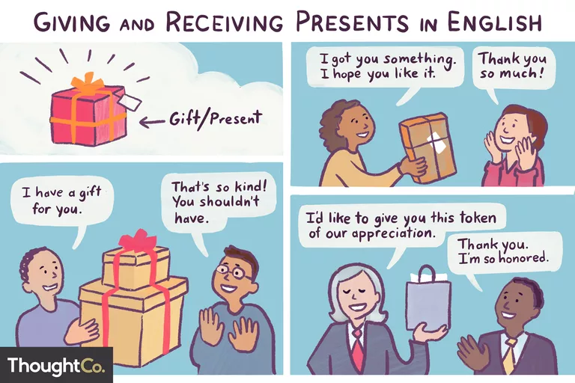

What to Say When GIVING a gift:
Informal
- I got you something. I hope you like it.
- Look what I have for you!
- I thought you might like this for…
- Happy Birthday! Here’s a little (gift/present) for you.
- Enjoy!
- It’s only something small, but I hope you like it.
- Here’s a little present for you.
- Guess what I bought you!

Formal
- ___________, I’d like to give you this (gift/present).
- ___________, this is a present that (I/we/the staff) got for you.
- I’d like to present you with this…
(very formal, used when giving an award or special gift)
- In the name of __________, I like to give you this present.
(also very formal)
- Here is a token of our appreciation.

Compliments
- You are looking for that one piece of truth.

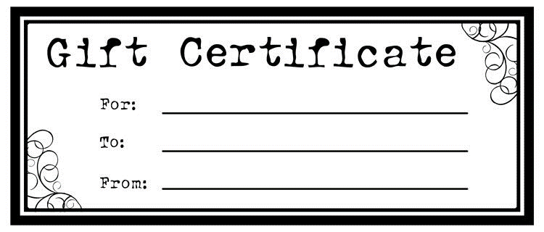
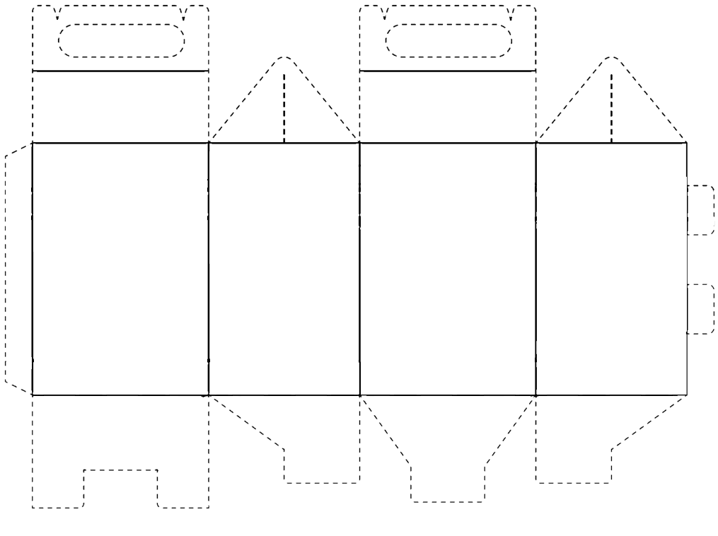
Small Talk
Small talk is polite conversation about unimportant or uncontroversial matters. We use small talk in a lot of situations: at work, meeting new people, friends that you are not close to, talking to strangers, etc. It is a very useful skill to acquire.
One of the most important parts of small talk is topic choice. Again, in small talk we want to talk about unimportant or uncontroversial topics. A classic example is talking about the weather or sports. Can you think of some more safe topics?

Make a list of safe small talk topics:

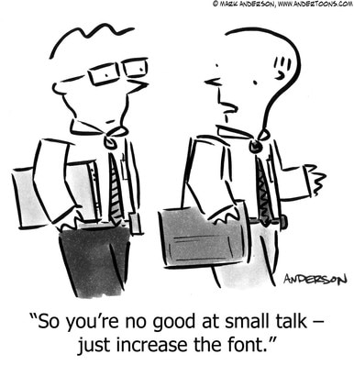

As you can imagine, we want to avoid personal questions at this time. Personal questions can be influenced by culture as well. Some small talk questions in Korea would be considered rude in Canada. For example, asking someone about their relationships is personal. Foreigners sometimes feel culture shock or feel embarrassed when asked questions like:
- How tall are you?
- How old are you?
- Where do you live?
- What is your blood type?
Check the list of topics you created earlier and cross out the ones that are personal.
What are some more personal questions?

It’s difficult to start up a conversation. One thing you may want to consider is making an observation. You can use sentences like:
- I see you are….
- That looks / sounds…
Making an observation shows the listener that you have taken an interest in them. Also, it helps the other person in the conversation by giving them a topic to start from.
Additionally, asking someone for their opinion is a good way to advance a conversation. “What do you think about…” is a great way to start a dialogue with a stranger. But it can also be used in the middle of a conversation after someone tells you something. Perhaps you are unsure what to say next. Asking their opinion on what they said or what you said is a good way to continue the conversation.
Another way to continue the conversation is by using turn-around questions. A turn-around question is when you ask someone what they just asked you. One way to do this is by using questions like:
- What about you?
- How about you?
- And you?
Another way to make a turn-around question is to repeat the questions that was asked of you, but place added stress on “you”. In the following questions, the stressed word is underlined:
- How are you doing?
- I’m good. How are you doing?

Opening UP
Small talk is great in a lot of situations, but you can’t get close to someone using just small talk. In this lesson we will look at ways to have a more intimate conversation with someone. To get someone to open up they need to trust you, feel comfortable with you and have a good reason to be open.

Who are you open with?

Why are you open with them?

What do you talk about with them?

Open-Ended Questions
An open-ended question is one that doesn’t have a specific answer. It allows your conversational partner to be creative in their answer. Their freedom will create an opportunity to bring up something more intimate than small talk. With open-ended questions we want to avoid single word responses. Some common open-ended questions include:
- Tell me about ______.
- How does that make you feel?
- What do you think?
When you ask an open-ended question, you must be prepared to listen. Let your partner talk. Follow the conversation wherever they want to take it. If you don’t force the conversation, they will feel more comfortable.

Try writing your own open-ended question:

Assumption Questions
Another technique you might want to try is the use of an assumption question. You might notice a particular behavior during your conversation. For example, someone might not be making eye contact with their head down when talking about their relationship. You could make the assumption that they are having troubles with their relationship. Ask them about this. “I have to be honest. You don’t seem to be happy about your relationship. Is there something bothering you?”
An assumption question shows that you are really paying attention to what they are saying. You must have picked up on what they are saying, how they are saying it, or by reading body language. Asking an assumption question will cause a reaction.
If you are wrong, the other person will instinctually want to correct you. “No, I am just tired from a long day at work.” You can use this opportunity to follow the conversation down another road. You can ask about what is happening at their job or talk about strategies to reduce tiredness. The road to an intimate conversation can have a lot of turns.
If you are correct, it tells the other person that you are the perfect person to talk to about their problems. I think most people want to talk through their issues, but don’t know WHO to talk to about it. By identifying the underlying issue, you have shown that you care, are interested and have at least some understanding of them.

Visual / Verbal Cues

Assumption

YES
NO

Open Up
Correction

Labeling
Labeling is similar to assumption questions. Simply by stating how you think they feel can get someone to open up. In labeling you are trying to identify how someone is feeling about the story they are telling you. Paying close attention to body language is a great place to start.
- You must feel…
- You must be…
- It sounds like you are…
- You’re feeling _________ about this.

Open Body Language

Clarification Questions
Yet another strategy for getting someone to open up is to ask clarification questions. These questions are designed to get more details. Sometimes we will quickly tell our story to people we are not close to. Asking these clarification questions will slow down the conversation and give the other person a chance to tell you more about their story. The details can lead to a deeper conversation. Your connection will grow as your partner sees you are interested in them, their story and learning more.
- What do you mean?
- Tell me more about…
- Can you explain that?

Affirmation Responses + Continuation Questions
These are both simple, short things you can say to continue the conversation. They show the other person that you are listening and paying attention. They might not mean much contextually, but have a dramatic effect on someone’s willingness to open up.

Oh..
Ok
Sure
Yes
I see
I agree
Yeah?
Interesting
Right
Uh huh
Oh really?
Go on

Really?
And then?
Go on
Oh ya?
Tell me more

“Rules”
- It’s not about you
- Try not to judge
- Reflect their emotions
- Be open

Asking for Help
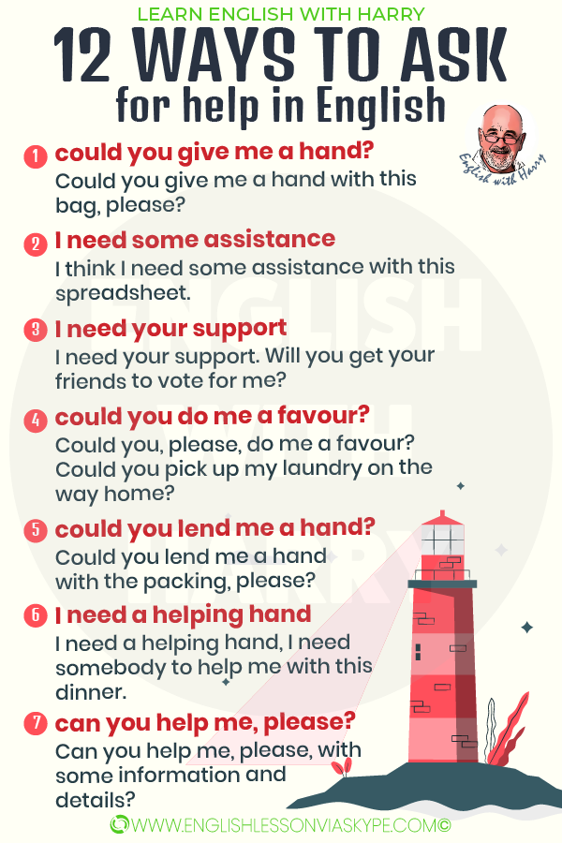

The Ben Franklin Effect
The Ben Franklin Effect is an example of cognitive dissonance. It doesn’t make logical sense, but asking someone for help will make them more likely to help you later. The reason it is called the Ben Franklin effect is because he said:
“He that has once done a kindness will be more ready to do you another, than he whom you yourself have obliged.”
Basically he was saying that someone is more likely to do a favor for you if they have done it before THAN IF YOU did the favor for them. This behavior has been studied numerous times thereafter and so far it holds true. Furthermore, it has been shown that asking for help will make the person feel more attached to you or personally connected. So, you can build a relationship by asking for favors.
In the classroom, we can use this information to build better relationships with our students. What are some favors that you can ask students for?

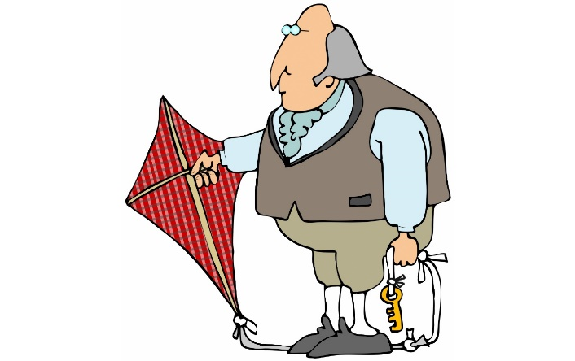

Autonomy
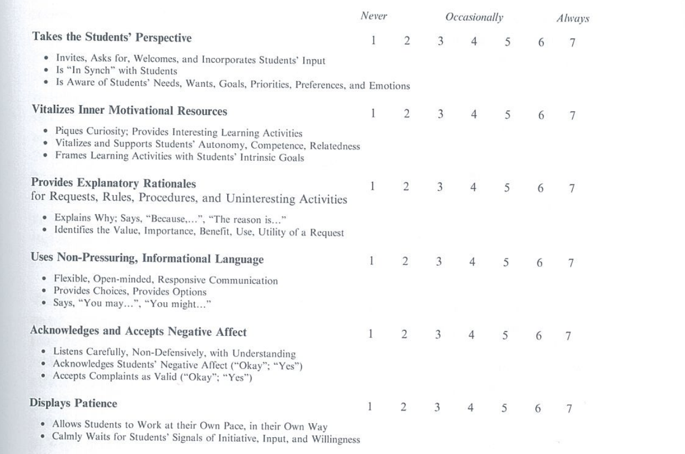

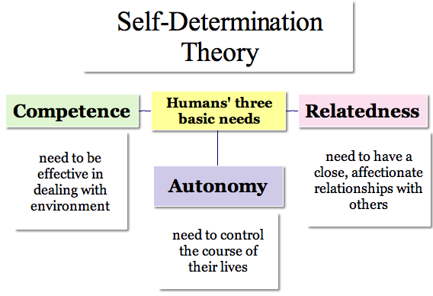

Giving Advice (Key Phrases)
If I were in your place...
This page lists useful expressions for the language function of giving advice and recommendations to other people.
- (I think/I really think) you need to/must/should ...
- How about ...?
- It is usually a good idea to ...
- My suggestion/advice is (to) ...
- Why don't you ...?
- You could (try) ...
- You probably/definitely/really should ...
- Have you tried ...?
- I (would) (strongly) suggest/advise that ...
- If I was/were you, I'd ...
- In my experience, ... works really well.
- It's generally best/a good idea to...
- One idea is to ...
- One thing you could/should/have to do is ...
- The best/most important thing (to do) is to ...
- ... might work.
- ... would probably work.
- ... (always) works for me.
- If I was/were in your place, I'd ...
- If that happened to me/In that case/If I had that problem, I'd ...
- My (main/personal) recommendation is/would be ...
- You'd better ...
- In this (kind of) situation, I (would) always recommend/advise ...

- (If I was/were) in that (that kind of) situation, I'd ...
- Have you thought about ...?
- If it was/were me, I'd ...
- Make sure you (don't) ...
- The sooner you ... the better.
- Whatever you do, ...
- Your only option is to ...
- You have no choice but to ...

Advanced
- ... is worth a try.
- A (self-help) book I read recommends ...
- A piece of advice from ... that I'd like to pass on is to ...
- A wise man once said ...
- As the proverb says, ...
- I can't recommend ... strongly enough.
- You should ..., no doubt about it.
- It might be an old wives' tale, but ...
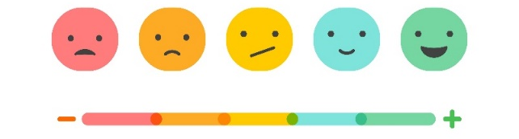

Technology
Here are a list of some of the games we are going to try in class. This is for your reference if you want to try them later with friends or students.
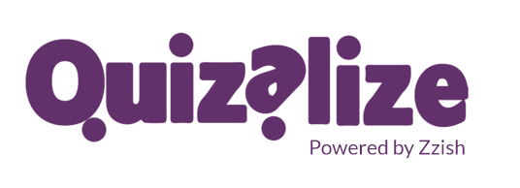

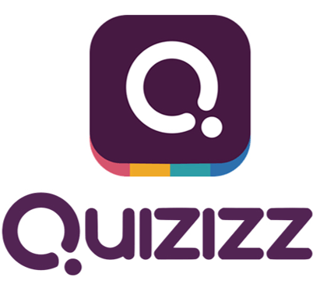
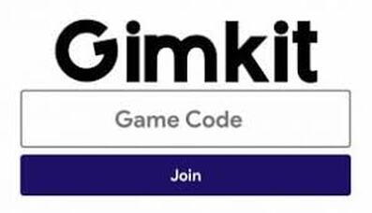

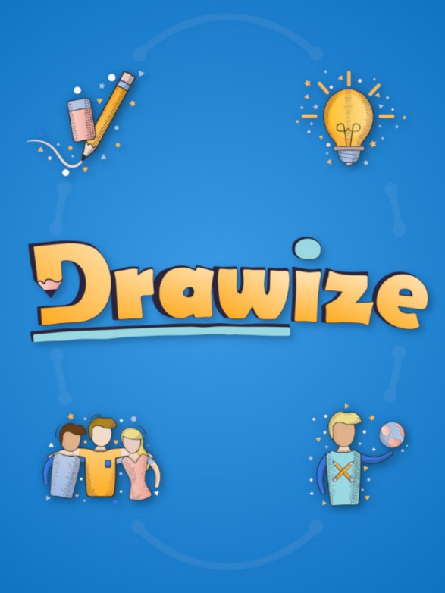
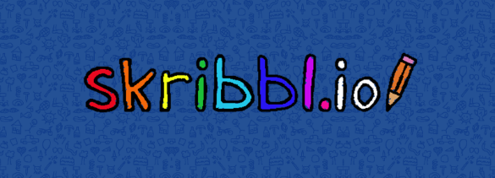

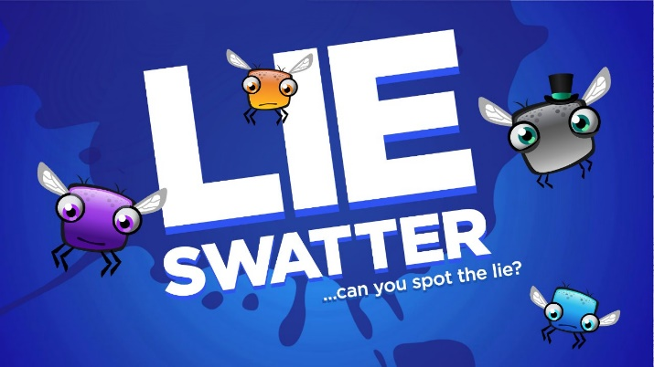
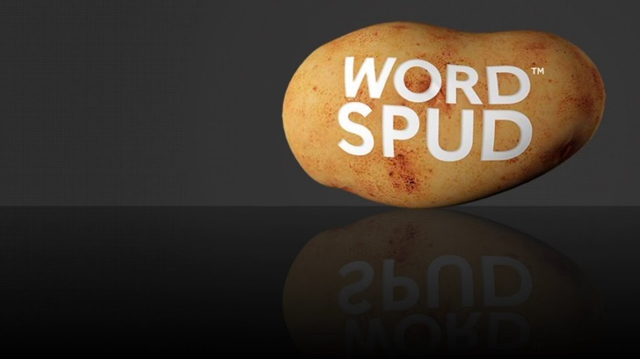
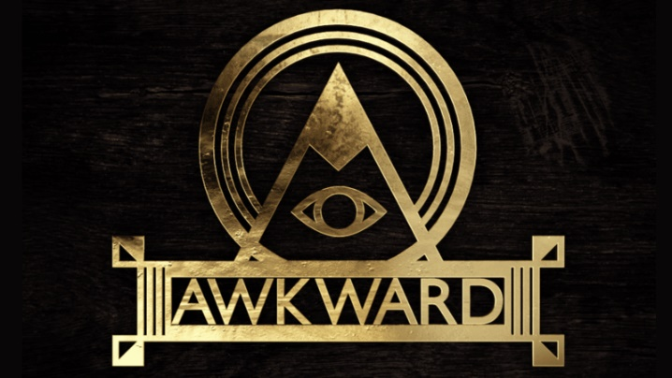
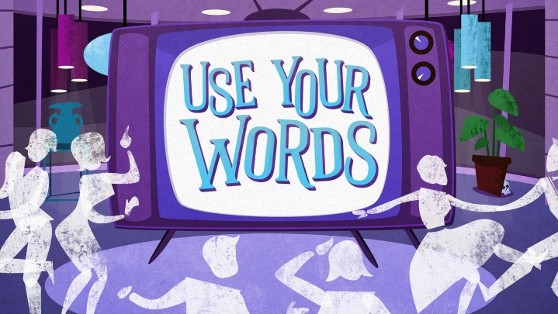

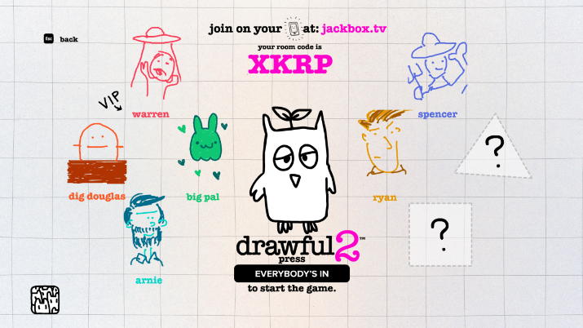

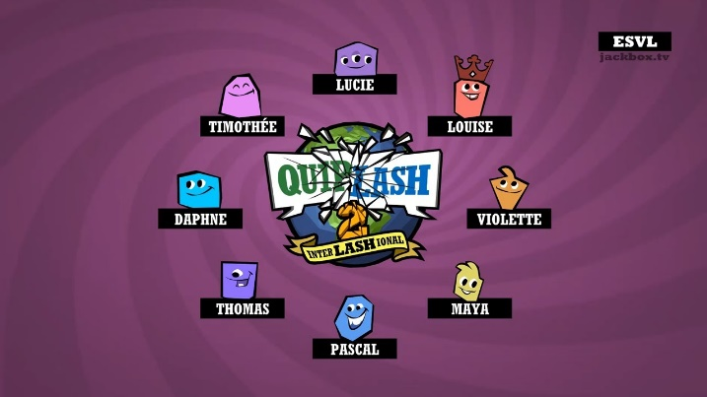

Smartphone can also be used to learn English. There are many apps like:

Duolingo

Busuu

Improve English: Word Games

LingQ

Memrise

Babbel

Rosetta Stone

Learn English Grammar

LingoDeer

Beelinguapp

ELSA Speak

Speak English Conversation

In addition to language learning apps, there are a number of other resources you can access through your phone:

Spaceteam ESL
Spyfall
Mafia Online
Heads Up
Guess Up
Charades
Psych! Outwit Your Friends

Words with Friends
Draw It
Coup
Battle Text
Scattergories
Taboo
Would You Rather
Hangman Free
Scrabble
Boggle with Friends

2 Pictures 1 Word

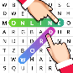
Word Search Online
Just Riddles
Match-UP Learn English

Wheel of Fortune
Epic!
Draw a Stickman EPIC

Selfie Games: Group TV Party
Far Faria
Curious World
Triple Agent
Escape Team

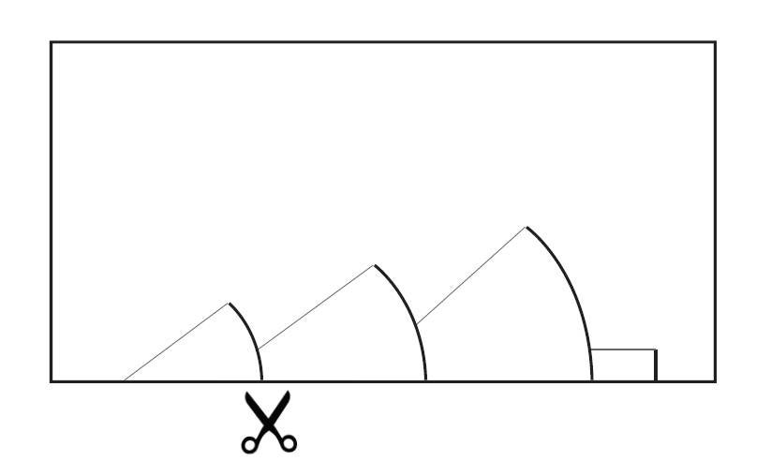
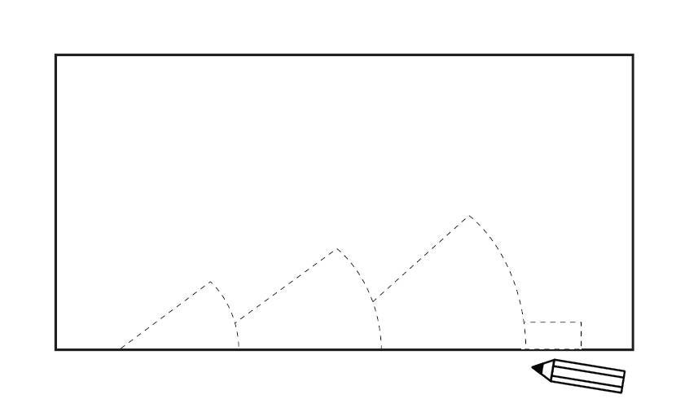

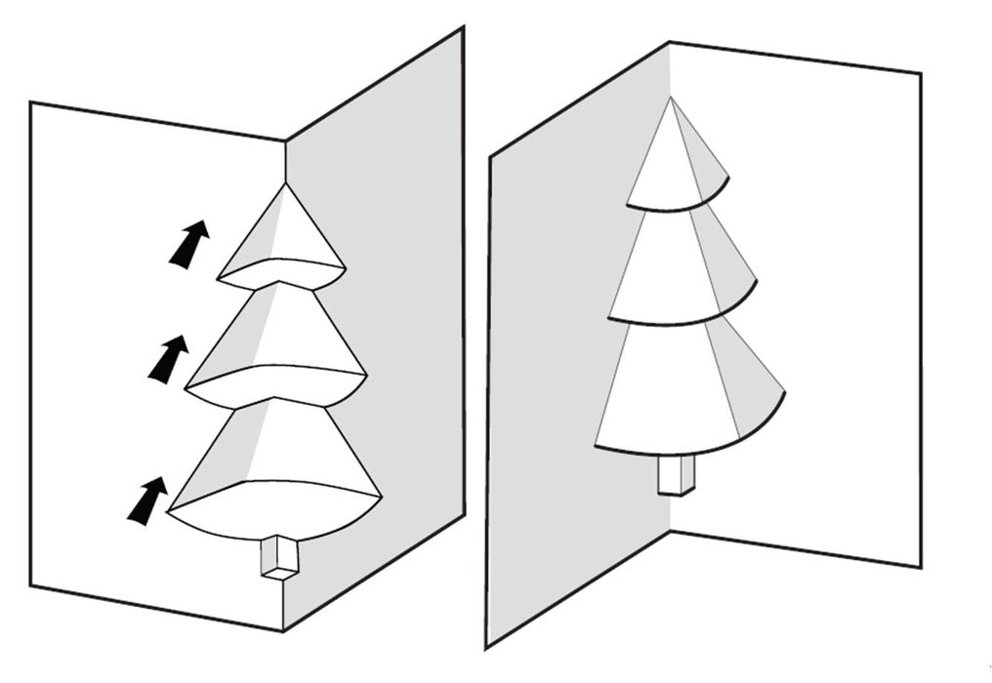
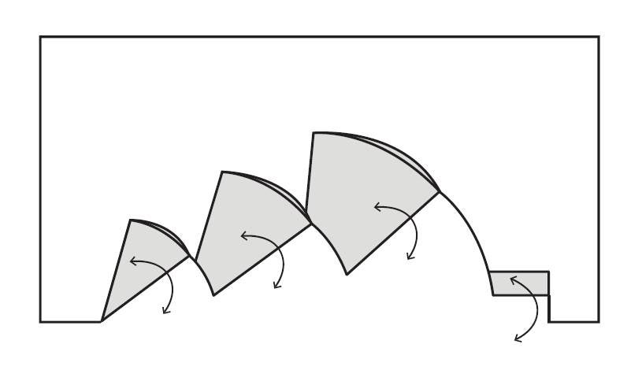

Bibliography and Further Reading
90+ Metaphor Examples in Literature That You Need to Know. (2018, October 19). Retrieved June 01, 2020, from https://blog.reedsy.com/metaphor-examples/?fbclid=IwAR1rkgCQ0j-p3ePC5k0estc6uqz-xXRZ4FYXkXOFkoB8ZGztkcqcZ1fCZQ4

해외현장학습-충남외국어교육원. (2020. May 13). Lesson 3: Small Talk (잡담). [video file]. Retrieved from https://youtu.be/uUJpDRHkZfc
Anne. (2012, October 29). Useful English expressions – Asking for and giving advice. Retrieved October 19, 2020, from https://blog.maltalingua.com/useful-expressions-english-lesson-advice/
Banyai, I. (1998). Zoom. New York, NY: Puffin.
Banyai, I. (1998). Re-zoom. New York, NY: Puffin.
Beare, K. (2020, August 28). Learn What to Say in English When You Give or Receive a Gift. Retrieved October 19, 2020, from https://www.thoughtco.com/giving-and-receiving-presents-in-english-1212057
Because Kids Love Games. (n.d.). Retrieved June 02, 2020, from https://www.classcraft.com/
Blank, L. (2016, April 20). Point Roberts. Retrieved June 01, 2020, from https://www.atlasobscura.com/places/point-roberts
Blenheim. (n.d.). Saving 'The Finest View in England'. Retrieved June 01, 2020, from https://www.blenheim.org/restoration/savingthefinestview/
Bright Side. (2019, May 9). Scientists Removed Water from an Old British Bridge But Couldn’t Believe Their Eyes. [video file]. Retrieved from https://youtu.be/g5sXawX5oLw
BuzzFeedVideo. (2019. January 5). I Hired A Speech Therapist to Fix My Boring Voice [video file]. Retrieved from https://youtu.be/nLDRQYeYQJg
Cantero-Gomez, P. (2019, June 18). The Top 10 Characteristics Of Highly Admired People. Retrieved October 19, 2020, from https://www.forbes.com/sites/palomacanterogomez/2019/06/18/the-top-10-characteristics-of-highly-admired-people/
Centeno, A. (2017, September 22). First Impressions and Predicted Friendship Value: Making Friends through Good Impressions. Retrieved October 19, 2020, from https://www.realmenrealstyle.com/first-impressions-friendship-value/
Chen, A. (2016, September 30). Who should go to Mars? Retrieved June 01, 2020, from https://www.theverge.com/2016/9/30/13099134/space-x-elon-musk-mars-mission-colonists-personality-fitness-health-requirements
Chiou, W., Yang, C., & Wan, C. (2011). Ironic Effects of Dietary Supplementation. Psychological Science, 22(8), 1081-1086. doi:10.1177/0956797611416253
Clark, B., Mike, Clark, B., Lytle, L., Ionescu, A., Russ, . . . Kek. (2019, April 02). How to Use the 'Rule of Three' to Create Engaging Content. Retrieved June 01, 2020, from https://copyblogger.com/rule-of-three/
@Copyright skillsyouneed.com. (n.d.). Effective Speaking. Retrieved October 19, 2020, from https://www.skillsyouneed.com/ips/effective-speaking.html
Cosmic Joke UK. (2013, October 10). PanoptiCorp Mini Documentary 2013. [video file]. Retrieved from https://youtu.be/mifzvxepjOA
Cousins, B. (2020, February 28). Zamboni driver turned NHL goalie David Ayres given his own hockey card. Retrieved June 01, 2020, from https://www.ctvnews.ca/canada/zamboni-driver-turned-nhl-goalie-david-ayres-given-his-own-hockey-card-1.4832575
Create Custom Map. (n.d.). Retrieved June 01, 2020, from https://mapchart.net/
Cuncic, A. (2020, May 25). Practicing Active Listening in Your Daily Conversations. Retrieved October 19, 2020, from https://www.verywellmind.com/what-is-active-listening-3024343
Dodge, K. (2020, May 22). Turn the Question Around By Asking What About You?: Repeat Questions Back with Stress & Intonation • English with Kim. Retrieved October 19, 2020, from https://englishwithkim.com/turn-questions-around-what-about-you/
Donohue, W., & Donohue, W. (2019, September 24). 7 Lessons on Survivorship Bias that Will Help You Make Better Decisions. Retrieved June 02, 2020, from http://blog.idonethis.com/7-lessons-survivorship-bias-will-help-make-better-decisions/
Dillinger, S. (2020, February 20). The Best Qualities in a Person. Retrieved October 19, 2020, from https://www.ranker.com/list/best-qualities-in-a-person/samantha-dillinger
DrawNames.com ~ Gift Exchange: Secret Santa Generator. (n.d.). Retrieved October 19, 2020, from https://www.drawnames.com/
Effectiviology. (n.d.). The Benjamin Franklin Effect: How to Build Rapport by Asking for Favors. Retrieved October 19, 2020, from https://effectiviology.com/benjamin-franklin-effect/
Foer, J., Thuras, D., & Morton, E. (2019). Antarctica. In Atlas obscura: An explorer's guide to the world's hidden wonders (p. 452). New York, NY: Workman Publishing.
Freeman, D. (2051). Tricolon. Retrieved June 01, 2020, from https://www.vernaculardiscourse.com/tricolon.html
Gotthardt, T., Henning, B., Humberg, K., Haq, M., Ydo, I., & Ballas, D. (2018, April 26). Maps. Retrieved June 01, 2020, from https://worldmapper.org/maps/
Haldar, R. (2018). P is for pterodactyl: The worst alphabet book ever. Naperville, IL: Sourcebooks Jabberwocky, an imprint of Sourcebooks
Harry. (2020, October 18). 12 Other Ways to Ask for Help in English - Learn English with Harry 👴. Retrieved October 19, 2020, from https://www.englishlessonviaskype.com/12-other-ways-to-ask-for-help-in-english/
Hawkes-Robinson, William. (2008). Role-playing Games Used as Educational and Therapeutic Tools for Youth and Adults. Rpgresearch.com
Hu, W., & Haag, M. (2019, December 02). 90,000 Packages Disappear Daily in N.Y.C. Is Help on the Way? Retrieved June 01, 2020, from https://www.nytimes.com/2019/12/02/nyregion/online-shopping-package-theft.html
Hyun-ju, O. (2016, March 22). Koreans ignore scattered cash in downtown square. Retrieved June 01, 2020, from http://m.koreaherald.com/view.php?ud=20160322000995
Ibx2cat. (2018, January 9). Canada & How Borders Define A Country. [video file]. Retrieved from https://youtu.be/gr3UVG-Ocyg
Improvement Pill. (2019. August 14). How to Get People to Open Up. [video file]. Retrieved from https://youtu.be/uKO6MidWggs
Jackson, T. (2019, December 09). Turducken, Cooking with Fire Podcast: The Sauce by All Things Barbecue. Retrieved June 01, 2020, from https://www.atbbq.com/thesauce/cooking-with-fire-episode-35-turducken/
James, N. (2015). Fancy-pants job titles. [PDF file] Plain English Foundation. Retrieved from https://www.plainenglishfoundation.com/documents/10179/73292/Fancy-pants_job_titles.pdf
Jaques, Rafael & Bisol, Claudia. (2019). Role-Playing Games for Common Well-Being in High School — Notes from a Study Developed in Southern Brazil. 9. 498. 10.18178/ijiet.2019.9.7.1253.
Jones, B. (2017, July 09). 100+ Common Euphemisms You Need to Know. Retrieved June 01, 2020, from http://getmorevocab.com/common-euphemisms-you-need-know/
Ke, Q., & Wang, W. (2013). The Adjective Frequency in Advertising English Slogans. Theory and Practice in Language Studies, 3(2). doi:10.4304/tpls.3.2.275-284
Keycha1n. (2020). Top Ten Most Admirable Qualities In a Person. Retrieved October 19, 2020, from https://www.thetoptens.com/admirable-qualities-person/
Lazzeri, A. (2016, April 06). Guess what these ludicrous PC job titles REALLY mean. Retrieved June 01, 2020, from https://www.thesun.co.uk/archives/news/48628/guess-what-these-pc-job-titles-really-mean/
Leith, S. (2014, July 07). A classic way to give public speakers rhythm. Retrieved June 01, 2020, from https://www.ft.com/content/a731822a-0373-11e4-817f-00144feab7de
Levy, Colin. (2019, December 8). How to Get a World-Famous Actor in your Short Film. [video file]. Retrieved from https://youtu.be/sZpvVggtwyk
Madzdad, Larry BobJoe Larry BobJoe, Luis Milian Luis Milian, Rory, R., Sarah, S., Francie Patton Francie Patton, . . . Jilltdcatlady Jilltdcatlady Community. (January). 52 Terrible Maps That Are So Bad They're Good. Retrieved June 01, 2020, from https://www.boredpanda.com/funny-terrible-maps/?utm_source=google
MAKE_Publishing. (2017, October 30). How to Make a Pop-up Christmas Tree Card. Retrieved October 20, 2020, from https://www.instructables.com/How-to-make-a-pop-up-Christmas-tree-card/
Malmgren, H., & Renato. (n.d.). ANIMATION : Learning Through Role-Play: Edu-Larp. Retrieved June 02, 2020, from https://goodjobstudios.com/animation-edu-larp/
Nakata, Y. (2014). Self-regulation: Why is it important for promoting learner autonomy in the school context? Studies in Self-Access Learning Journal, 5(4), 342-356.
Oxford Online English. (2018. October 4). Intonation in English – English Pronunciation Lesson. [video file]. Retrieved from https://youtu.be/A6aE4nceJt8
Oxford Online English. (2018. November 9). Sentence Stress in English Pronunciation. [video file]. Retrieved from https://youtu.be/rnJCKda4oWU
Oxford Online English. (2019. February 21). Syllables and Word Stress – English Pronunciation Lesson. [video file]. Retrieved from https://youtu.be/Vu6UVwkUgzc
Pain, S. (2008, August 20). Blasts from the past: The Soviet ape-man scandal. Retrieved June 01, 2020, from https://www.newscientist.com/article/mg19926701-000-blasts-from-the-past-the-soviet-ape-man-scandal/
Peach Pants Press. (n.d.). Autonomy. Retrieved June 02, 2020, from https://payhip.com/b/KvbG
PeterRabbit59. (2012, August 19). Tom T. Hall – I Love. [video file]. Retrieved from https://youtu.be/jk64JluO4CI
Petersen, N. (2017, July 11). Why Giving Students Autonomy Makes Them More Engaged. Retrieved October 19, 2020, from https://blog.allpsych.com/why-giving-students-autonomy-makes-them-more-engaged/
Poyani. (2012, December 29). George Carlin – Euphemisms. [video file]. Retrieved from https://youtu.be/vuEQixrBKCc
Reardon, S. (2017, January 26). Hybrid zoo: Introducing pig–human embryos and a rat–mouse. Retrieved June 01, 2020, from https://www.nature.com/news/hybrid-zoo-introducing-pig-human-embryos-and-a-rat-mouse-1.21378
Reddit. (n.d.). Retrieved October 19, 2020, from https://www.reddit.com/
Reeve, Johnmarshall. (2016). Autonomy-Supportive Teaching: What It Is, How to Do It. 10.1007/978-981-287-630-0_7.
Reeves, M. (2020, October 06). How to Give Sincere Compliments. Retrieved October 19, 2020, from https://www.oprahmag.com/life/relationships-love/a28221845/how-to-give-compliments/
Reigarw Comparisons. (2019, July 20). Emoji Popularity Comparison. [video file]. Retrieved from: https://youtu.be/W49KAyAKjHM
Rober, M. (2018, December 17). Package Thief vs Glitter Bomb Trap. [video file]. Retrieved from https://youtu.be/xoxhDk-hwuo
Robertson, A. (2012, November 27). My so-called larp: Learning to love in a world without men. Retrieved June 02, 2020, from https://www.theverge.com/2012/11/27/3609806/my-so-called-larp-living-world-without-men
Roser, M., Ortiz-Ospina, E., Ritchie, H., & Hasell, J. (n.d.). Our World in Data. Retrieved June 01, 2020, from https://ourworldindata.org/
Richards, C. (2013, December 09). Overcoming an Aversion to Loss. Retrieved June 02, 2020, from https://www.nytimes.com/2013/12/09/your-money/overcoming-an-aversion-to-loss.html
Shilo, R. (2015, June 08). Researchers Find Everyone Has a Bias Blind Spot - News - Carnegie Mellon University. Retrieved June 02, 2020, from https://www.cmu.edu/news/stories/archives/2015/june/bias-blind-spot.html
Slaughter, R. (2017, January 22). Solving A Waiting Problem By Making it Worse. Retrieved June 01, 2020, from http://www.failurethebook.com/2017/01/22/how-the-houston-airport-solved-a-waiting-problem-by-making-it-worse/
Str3nq. (2010, May 28). The Rose – by Better Midler + lyrics. [video file]. Retrieved from https://youtu.be/zxSTzSEiZ2c
Sunnafrank, M., Ramirea Jr., A. (2004). At first sight: Persistent relational effect of get-acquainted conversations. Journal of Social and Personal Relationships 21(3). Doi:10.1177/0265407504042837
Tier Lists. (2020, May 05). Retrieved June 01, 2020, from https://knowyourmeme.com/memes/tier-lists
The larp. (n.d.). Retrieved June 02, 2020, from http://mad-about-the-boy-larp.blogspot.com/p/the-larp.html
The Mind Tools Content Team By the Mind Tools Content Team. (n.d.). Body Language: Picking Up and Understanding Nonverbal Signals. Retrieved October 19, 2020, from https://www.mindtools.com/pages/article/Body_Language.htm
Tosey, P., Sullivan, W. and Meyer, M. (2013) `Clean Sources: Six Metaphors a Minute?’, University of Surrey (ISBN: 978-1-84469-029-9)
US Department of Commerce, & National Oceanic and Atmospheric Administration. (2018, May 02). What is the bloop? Retrieved June 01, 2020, from https://oceanservice.noaa.gov/facts/bloop.html
Vigen, T. (2015). Spurious correlations. New York: Hachette Books.
Veritasium. (2014, February 24). Can You Solve This?. [video file]. Retrieved from https://youtu.be/vKA4w2O61Xo
Veritasium. (2019, May 10). Why Are 96,000,000 Black Balls in This Reservoir? [video file]. Retrieved from https://youtu.be/uxPdPpi5W4o
Wears, A. (2014, June 21). 10 Unusual Ways People Solved Difficult Problems. Retrieved June 01, 2020, from https://listverse.com/2013/06/07/10-unusual-ways-people-solved-difficult-problems/
Wells, R. (2012, August 16). Does this colour turn you off? Retrieved June 01, 2020, from https://www.theage.com.au/national/does-this-colour-turn-you-off-20120816-24bf4.html
Whang! (2018, January 10). Reddit’s Greatest Unsolved Mystery: SecretHDD and Dovic – Tales From the Internet. [video file]. Retrieved from https://youtu.be/lo567CIqdHM
Whang! (2018, June 18). What Was in the Reddit Mystery Safe? #1 – Tales From the Internet. [video file]. Retrieved from https://youtu.be/BB_d6slfaU0
Whang! (2018, December 4). Reddit’s SecretHDD Solved? – Tales From the Internet. https://youtu.be/9TWv5t1Ad1A
WikiHow. (2019, November 19). How to Give a Compliment. Retrieved October 19, 2020, from https://www.wikihow.com/Give-a-Compliment
WILTY? Nope! (2016, May 25). David Mitchell: “As a child, I was scared of the sun.” – Would I Lie to You? [HD]. [video file]. Retrieved from https://youtu.be/mKc32jQIY0w
WILTY? Nope! (2016, May 7). I once accidently bought a horse – Would I Lie to You? [HD]. [video file]. Retrieved from https://youtu.be/B94q7gUu75k
Woo, Eddie. (2020, March 6). Survivorship Bias. [video file]. Retrieved from https://youtu.be/P9WFpVsRtQg
Zimbax. (2019. October 4). 1 Hour of maps. [video file]. Retrieved from https://www.youtube.com/watch?v=8xM7afTG2Jk

Microteaching

A Short Guide to Microteaching
By
Kris Bales
Updated July 09, 2020
Microteaching is a teacher training technique that allows student teachers to practice and refine their teaching skills in a low-risk, simulated classroom environment. The method, also used for retraining or fine-tuning the skills of practicing teachers, was developed in the late 1950s and early 1960s by Dwight Allen and his colleagues at Stanford University.

How Microteaching Works
Microteaching sessions involve one student teacher, the class instructor (or school supervisor), and a small group of peers. These sessions allow student teachers to practice and polish their teaching techniques in a simulated environment before putting them into practice with students. Student teachers conduct a short lesson (usually 5 to 20 minutes in length) and then receive feedback from their peers.
Later methods of microteaching evolved to include videotaping sessions for review by the student teacher. The teaching method was revised and simplified in the late 1980s and early 1990s for use in other countries that lacked access to technology.
Microteaching sessions focus on one teaching skill at a time. Student teachers rotate through the roles of teacher and student in small groups of 4 to 5 teachers. This singular focus provides the opportunity for student teachers to master each technique by planning and teaching the same lesson multiple times, making adjustments based on peer and instructor feedback.

Benefits of Microteaching
Microteaching provides ongoing training for student teachers and retraining for classroom teachers in a simulated environment. These practice sessions enable student teachers to perfect their teaching techniques before applying them in the classroom.
Microteaching sessions also allow student teachers to prepare for a variety of classroom scenarios, including working with students of different skill levels and backgrounds. Lastly, microteaching provides valuable opportunities for self-evaluation and peer feedback.

Disadvantages of Microteaching
Microteaching is considered one of the most effective techniques for teacher training, but it does have a few drawbacks. Most significantly, microteaching requires the presence of an instructor and a group of peers, which means that not all student teachers (or current teachers) can consistently complete microteaching sessions.
Ideally, microteaching sessions are repeated multiple times so that the student teacher can refine their skills. However, in larger education programs, there may not be time for all student teachers to complete multiple sessions.

The Microteaching Cycle
Microteaching is accomplished cyclically, allowing student teachers to practice new skills in order to attain mastery.

Classroom Instruction
First, student teachers learn the basics of an individual lesson through lectures, textbooks, and demonstration (via an instructor or video lessons). Skills studied include communication, explanation, lecturing, and engaging students. They may also include organization, illustrating lessons with examples, and answering student questions.

Lesson Planning
Next, the student teacher plans a short lesson that will enable them to practice these new skills in a mock classroom situation. Though the classroom environment is simulated, student teachers should consider their presentation an actual lesson and present it in an engaging, logical, and understandable manner.

Teaching and Feedback
The student teacher conducts the lesson for their instructor and peer group. The session is recorded so that the student teacher can watch it later for self-evaluation. Immediately following the microteaching session, the student teacher receives feedback from their instructor and peers.
Peer feedback should be specific and balanced (include observations on strengths as well as weaknesses) with the goal of helping the student teacher improve. It’s helpful for peers to focus on their personal experience using “I” statements and to provide specific detail in their feedback.
For example, when providing constructive criticism, "I had trouble hearing you at times" is more helpful than “You need to speak louder.” When offering praise, “I felt confident commenting because you made eye contact with me” is more helpful than "You engage well with students.”

Re-plan and Reteach
Based on peer feedback and self-evaluation, the student teacher plans the same lesson and teaches it a second time. The goal is to incorporate feedback from the first microteaching session to master the skill being practiced.
The second teaching session is also recorded. At the conclusion, the instructor and peers offer feedback, and the student teacher can view the recording for self-evaluation.
Microteaching often results in better-prepared, more confident teachers with a strong working understanding of the skills they need in the classroom.

How to Give Feedback People Can Actually Use
by
- Jennifer Porter
October 27, 2017
Over the last decade, I’ve conducted thousands of 360-degree feedback interviews with the colleagues of the leaders I coach. My goal with these sessions is to get a better sense of my clients’ strengths and weaknesses, but more often than not, the feedback isn’t particularly useful.
How do you give feedback that helps someone learn and improve? This strategic developmental feedback requires careful thought and insightful construction. This kind of feedback is:
Big-picture focused. The most useful feedback answers this question: “For this leader to be maximally effective, what should they do more of and less of?” It takes a strategic view of what the leader is doing effectively and less effectively today, and what they might continue or change to achieve the organization’s objectives in the future.
Organizationally aligned. Often, the feedback that people give me is based on the giver’s personal leadership beliefs or preferences, and yet the most useful feedback starts with an understanding of what the organization values. When a feedback giver says “She has a great sense of humor,” what they are usually saying is “Her sense of humor matches mine so I enjoy it. (And who cares if others don’t like sarcasm!)” Strategic developmental feedback is based on the organization’s leadership competency mode, a shared understanding of what effective leadership looks like, or even a comparison of the leader in question with another leader in the organization who is universally thought of as effective.
Behavioral and specific. Vague labels like “inspiring,” “great,” or “lacking executive presence,” are of little use without more clarity. A leader needs to know that what they are doing is creating an impression, which then informs your label. The key word here is doing. Useful feedback should focus on what a leader is actually accomplishing.
Factual, not interpretive. Too often feedback is described with adjectives that interpret the leader’s behavior: She is self-centered. He lacks confidence. Even if you believe a leader’s behavior stems from lack of confidence, that is just your interpretation and may or may not be accurate.

Learning
Both positive and negative. For a leader to develop and increase their effectiveness, they need to know what they are doing well so they know to repeat it, and further improve upon it, as well as what they are doing less effectively so they can make adjustments. Despite the fact that many of us struggle to hear it, negative feedback serves as important fuel for other changes that are needed. And recognizing progress on meaningful work — which positive feedback highlights — is one of the best drivers of engagement, motivation, and innovation.
Focused on patterns. Leaders tend to get the most feedback on a specific event — how they communicated in one meeting or responded to one email. What is more helpful is feedback on patterns of behavior that leverage specific events as examples. Looking at patterns helps alleviate recency bias where we tend to recall and over-weight events in our near-term memory.
Linked to impact. If I tell a leader she is a clear and concise communicator, that may feel good and be intellectually interesting but not much else. If I tell her that her clear communication has motivated her colleagues and helped them better understand the company’s strategy and what is needed from them, that will help her prioritize this behavior relative to other behaviors.
Prioritized. Adults can only focus on and work on a few concepts at a time. A VP of HR recently shared a list of 37 development areas the president wanted a senior executive to address. I asked how the president prioritized the list. Her response was “They are all equally important.” That executive is being set up to fail. There is no way he can effectively address 37 requested behavioral changes.
Putting it all together, instead of saying “Juan is afraid of conflict,” strategic developmental feedback would sound like this:
“Juan’s top two strengths, in terms of their impact on the business, are his strategic thinking and his ability to build strong relationships. More on that shortly. The most important gap for Juan to address to get to the next level is how he navigates conflict. Our organization is very direct and values leaders who confront issues head on, without inauthentic positivity. The pattern for Juan is that when he does not agree with a colleague’s position, he remains silent about his opposition. I’m not sure why he does this, but the impact is that I think he is in agreement when he is not. And later, when he shares his opposition with me, it is frustrating to me because we have already put a plan in place based on the belief that he was in agreement. It causes rework and it lowers my trust in him. Let me give you a few examples of when this has happened…”
Creating feedback that is truly useful requires more care and attention than is typically invested. Like any skill — chess, golf, learning Mandarin — offering strategic developmental feedback requires that we pay attention to and do many things effectively and simultaneously. Given the opportunity to help others develop and become more effective, it’s worth the effort.

5 SIMPLE WAYS TO GIVE ADVICE IN ENGLISH
WIL
Giving advice in English might seem tricky at first. There are several ways to do it and each uses a slightly sentence structure. So, how do we choose which one to use? Find out with these five simple ways to give advice in English.

Use a modal verb
There are two modal verbs we often use for giving advice: ‘should’ and ‘ought to’. Both mean the same thing but work in slightly different ways. Let’s look at some examples.
You should do more travelling.
You shouldn’t drink so much beer.
As you can see above, after ‘should’ we use an infinitive without ‘to’.
You ought to do more travelling.
You ought not to drink so much beer.
Unlike ‘should’, we always use ‘to’ in ‘ought to’ for giving advice.

Make it into a question
To make advice less direct, we can use a question to make the person we are advising consider about the advice we are giving them.
Why don’t you do some more tidying?
How about doing some more tidying?
With the question ‘Why don’t you…?’ we use an infinitive without ‘to’. When we use ‘How about…?’ to make a question, we use a gerund after it.

Put yourself in the person’s position
If someone is asking for your advice, sometimes it’s useful to imagine yourself being in that person’s position. This is a good way to explain your advice, too.
If I were you, I would travel more
Remember to use an infinitive after ‘would’ and not ‘to’. To make this negative, put ‘not’ after ‘would’.

Make a suggestion
A suggestion or recommendation is another good way of giving advice that isn’t to direct. You can use the words ‘suggest’ or ‘recommend’ as in the example below.
I would suggest doing more of an effort.
I would recommend doing this instead.
Use ‘verb+ing’ after ‘suggest’ or ‘recommend’ to explain your advice to the listener. To make these negative, put ‘not’ before your ‘verb+ing’.

Advise in a stronger way
Sometimes, you need to make your advice stronger to let the listener know that it’s really important. We can use the expression ‘you had better…’ to do this.
You had (You’d) better start working on your homework.
You had (You’d) better finish this assignment in time.
We use an infinitive after ‘better’ to explain our advice and add ‘not’ after ‘better’ to make the sentence negative.
So, now you know how to give advice in English. Next time one of your friends is having some trouble, give them some advice in English and try out your new skills.

Lesson Plan (EPIK)
Class: Team:

▪ Title (Unit):

▪ Grade (Level):

▪ Lesson Focus:

▪ Objectives:

- Students will be able to…
- Students will be able to…

▪ Key Expressions:

▪ Materials:

Procedure | Details
Presentation:
Introduction of Content and Language
Describe activities that will introduce students to new language, or activities that will refresh the language for review.
Time:
Practice:
Students begin to work with the language.
Describe the activities that show how the students will apply the language personally, or describe how students will practice with previously reviewed language.
Practice:
Students begin to work with the language.
Time:
Production:
Student internalize/master and use language
Describe the activities that show how students will use language to communicate with peers or how students will use reviewed language to communicate with their peers

Time:
Assessment / Extension Activities / Homefun
Assign any additional work that assesses or reinforces the students’ mastery of the lesson objectives.
Time:

▪ Anticipated Problems and Solutions:

-
-

5 Alternative Methods for Teaching Language
Aug 8, 2016

1. Teach-Test-Teach (TTT)
Aim: To teach language the students do not know. How?

Test: Provide the students with an activity which uses the target language and perhaps some associated language as well. Monitor the students and see what they can and cannot do.

Teach: Teach the students the language they do not know or have trouble with. You might also take existing language and apply it to other situations, or teach a more detailed and advanced study of it.

Test: Test the students on the language you have just taught in the form of one or more activities.

2. Engage-Study-Activate (ESA)
This method is similar to the PPP method of teaching.

Engage: Gets the students thinking and using English. The teacher can also generate interest in the language point, vocabulary, etc., to be taught. This gives them a reason to learn and study.

Study: Study the main language point. You will need to present what you are doing and work on it. This could include worksheets and feedback sessions.

Activate: Students use any or all of their skills as well as the main language point in activities that focus more on fluency than accuracy. This would also include a feedback session.

ESA can be done in a variety of orders. E.A.S.A., E.S.A.S.A., E.A.A.S.A., etc.

3. Task-Based Approach (TBA)
Activities must be tasks.

Definition of a task: An opportunity to use meaning-focused language. i.e. Not doing a drill just to help the student to remember, or writing to show an accuracy of form.

For example: preparing a debate, designing a poster, drawing a floor plan for a bedroom, using a timetable to plan a trip, writing story problems, a science experiment, etc.

Here are some questions you can ask to help you see if your activity is a task appropriate for TBA.
- Will the activity engage the learner’s interest?
- Is there a primary focus on meaning?
- Is there a goal or outcome?
- Is success judged in terms of outcome?
- Is completion a priority?
- Does the activity relate to real world activities?
The stages of a TBA lesson are as follows:
- Pre-Task: Introduction of the topic. Gives clear instructions for the task stage, may include a recording of people doing the task.
- Task: Completed in pairs or groups.
- Planning: Students prepare a report about what happened in the task.
- Report: Students report back what happened in the task.
- Analysis: Highlight relevant parts of the text to study, and/or from the report. This should be the TL for the day.
- Practice: Students practice the highlighted area of language that they have just looked at.

4. Content-Based Learning (CBL)
Content-Based Learning is teaching English through media not specifically designed for English and/or using subjects other than pure English to learn the language. This means you will teach around a topic, rather than vocab, grammar, etc.

When designing a lesson:
- Choose tasks that use higher thinking skills (evaluation, problem solving, clarifying, etc.).
- Vary ways to teach content.
- Teach vocabulary as a separate skill.
- Put the lesson in context and relate it to the students.
When planning:
- Generate interest in the subject.
- Choose a number of sources that the students can use.
- Use group work and assign the students tasks.
- After research, students can pool and compare information with other groups
- A report of some kind.

5. Communicative Approach
An activity, exercise or lesson that:
- Gets learners to speak and listen to each other
- Requires learners to acquire or give information of some sort to/from another person.
- Gets learners to act in a realistic or meaningful way.
- Focuses primarily on the function of language rather than grammar and vocabulary.
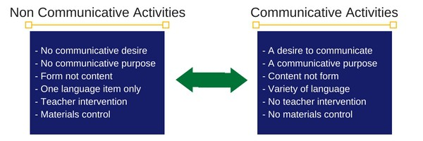

Ideas for Communicative Activities
- Picture Differences
- Group Planning
- List Sequencing
- Pyramid Construction (Individual work, then pairs, then fours etc)
- Board Games
- Puzzles and Problems
Tips for Communicative Activities
- Use a lead in to help the students ease into the activity and theme of the lesson.
- Give students plenty of time to prepare their thoughts.
- Try to keep the flow of communication fluid.
- Use specific problems as opposed to general ones. This gives the students direction and focus.
- Use role cards, role plays and real plays.
- Use buzz groups – breaking a class group into smaller groups and asking them to summarize or add to the discussion.
A version of this article originally appeared in Shane English Schools Taiwan’s Teaching English to Young Learners (TEYL) program, which is part of all new teachers’ orientation.

Citations
Bales, K. (2020, July 09). How to Use Microteaching to Refine Your Teaching Skills. Retrieved October 19, 2020, from https://www.thoughtco.com/microteaching-4580453
EPIK. (2012, July 24). EPIK Lesson Plan Template. Retrieved October 19, 2020, from http://www.epik.go.kr/board.do?menuNo=322&boardConfigNo=85&action=view&boardNo=1353
Porter, J. (2018, March 26). How to Give Feedback People Can Actually Use. Retrieved October 19, 2020, from https://hbr.org/2017/10/how-to-give-feedback-people-can-actually-use
Shane English Schools. (2016, August 8). 5 Alternative Methods for Teaching Language. Retrieved October 20, 2020, from https://shaneschools.com/en/alternative-methods-for-teaching-language/
Wil. (2020, June 08). Simple ways to give advice in English. Retrieved October 19, 2020, from https://englishlive.ef.com/blog/english-in-the-real-world/5-simple-ways-give-advice-english/

