Speaking / Listening
Tim Schilstra
Objectives
- Trainees will have an opportunity to strengthen their listening and speaking skills through games and activities designed to practice them.

Description of Unit
In this unite we will participate in many activities to practice speaking and listening. There will be a lot of interaction even though most classes will be online. Along with some lighter material (games) we will also discuss some deeper topics. We will examine intelligence and problem solve difficult situations at school. We will also listen to the wisdom of centenarians. Trainees will have an opportunity to talk about their personal experiences too. In the conversation classes, we will chat and try one of the Jackbox games. These games are good for groups up to 8 students online. This program will feel short, but there will be plenty of opportunity to practice listening and speaking.
Since this course will be conducted online, most of the resources will be available online for your viewing pleasure. I have added the materials to our Google Classroom:

However, if you want to access the materials used in this course after the program finishes, I have also uploaded them to my website:

Finally, if you find the course to be interesting, I also have a YouTube channel I started last year:

This year, at least half of the classes will be conducted online. We will be using Google Classroom, Google Meet, and possibly some other Google products. Additionally, other apps, like Kahoot, Mentimeter, and Quizlet might also be used. I wanted to highlight a few things that you should know before we get started. I just want everyone to have the same background knowledge, so we can focus on education.

Google Meet
At the top of our Google Classroom, there is a banner with a link that you can click to join the class. To sign into a Google Classroom Meet, just click that link. The first time signing in, you may need to choose a camera or microphone though it is not likely. Proceed by clicking on the “Join Now” button. This will take you to the lobby where your instructor and other trainees will meet. You should check your camera and microphone settings before joining the first meeting.
One thing to keep in mind while participating in an online conference call is the amount of noise. We ask that you mute your microphone when you are not speaking. You can do this by clicking the button at the bottom of the screen. When you are muted, the button will turn red.
It is also a good idea to wear headphones while participating in this program. This will reduce the chances of ‘feedback’. That high pitched noise you hear when a microphone is too close to the speaker.
We also ask that you keep your camera on during the meeting. This is a matter of manners as everyone should participate. Also, technology is very impersonal, so having faces to go with the meeting puts the humanity back into online teaching.
We will also be using a few online teaching tools, including Kahoot, Quizlet, Mentimeter and Jackbox Games. Teachers will provide details on how to use these sites during their lesson.

How did we get here?
How did we arrive at this point? It is an interesting question. Some use this question to inquire about humanity and the meaning of life. However, we just want to have a little fun with it today. In groups, you will attempt to figure out what happened that led up to these pictures. There are clues in each picture, but the answers may surprise you. Each person will make a guess. After each person describes what they think happened, you can scan the QR code to see the answer.
Most of these pictures are screen captures from videos by Daily Dose of Internet. You can check out his content here: https://www.youtube.com/channel/UCdC0An4ZPNr_YiFiYoVbwaw . This YouTube channel is a collection of interesting and funny video clips from around the internet. I tried to find some interesting clips, but there are many others that didn’t make this list. Enjoy!
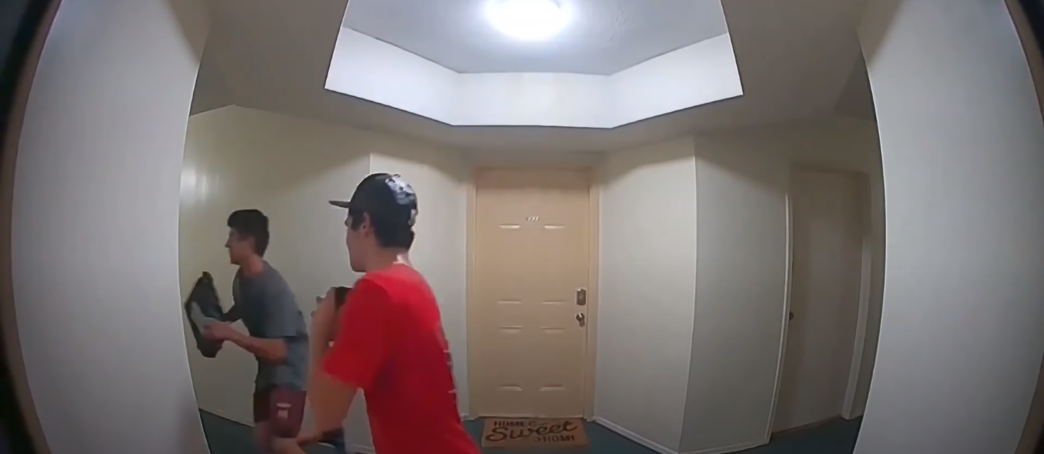
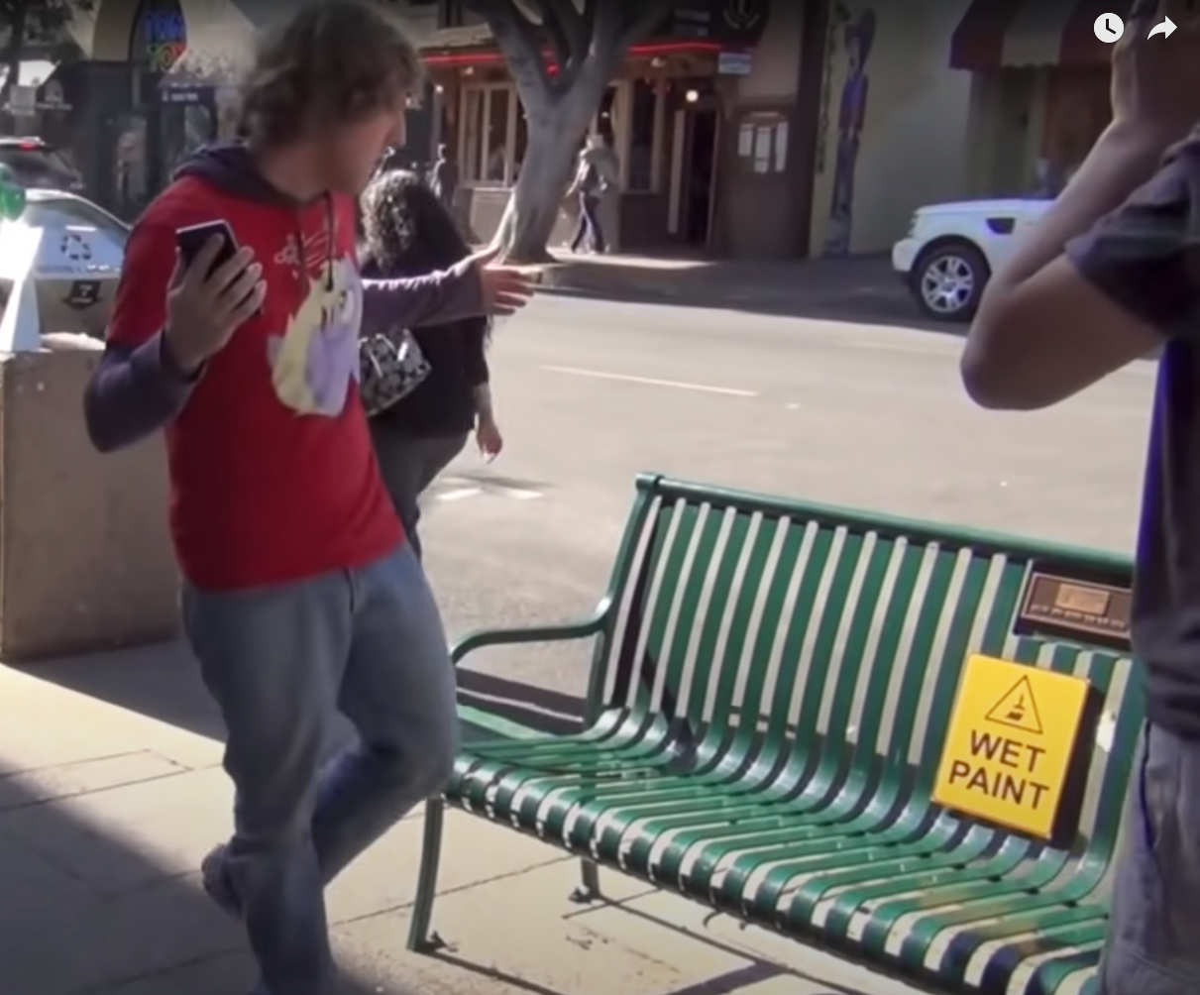
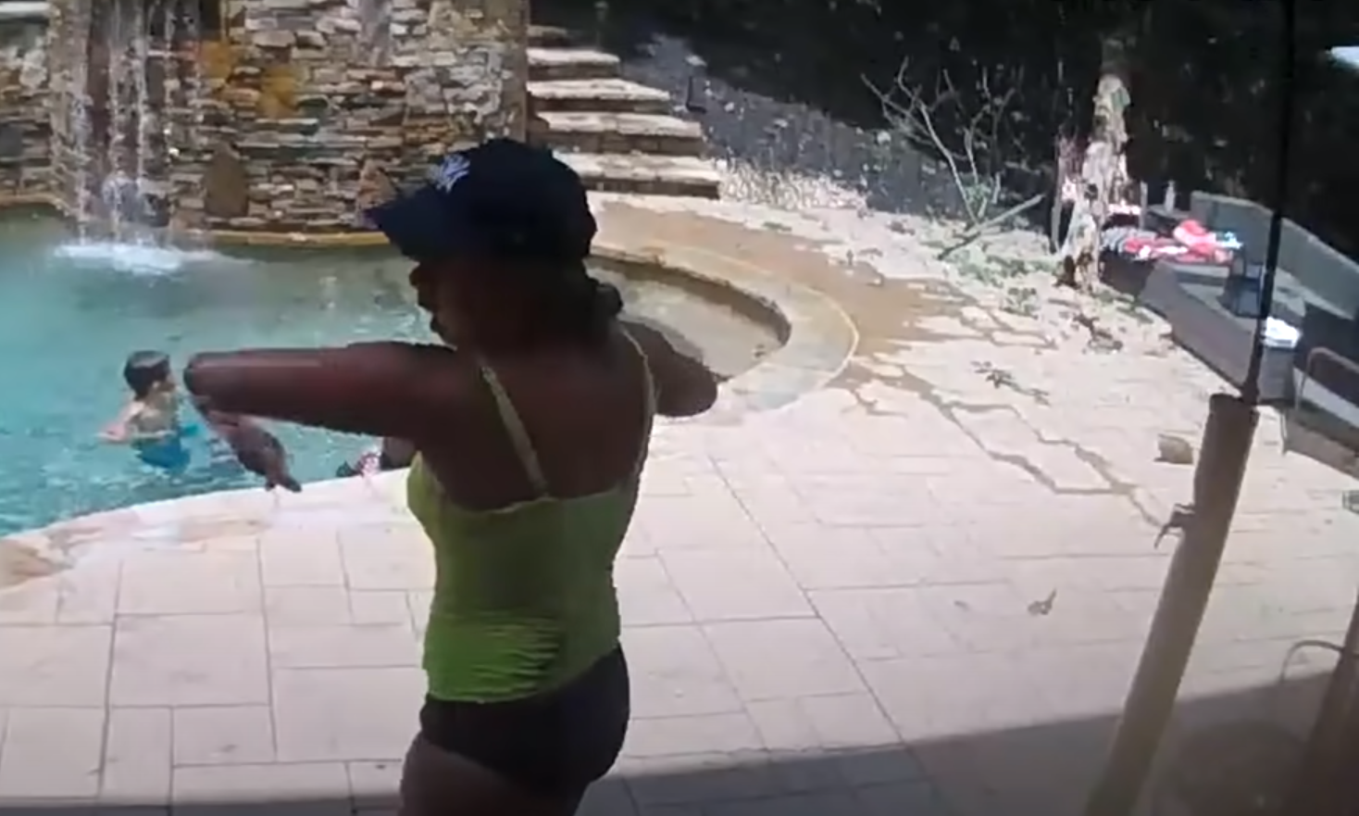

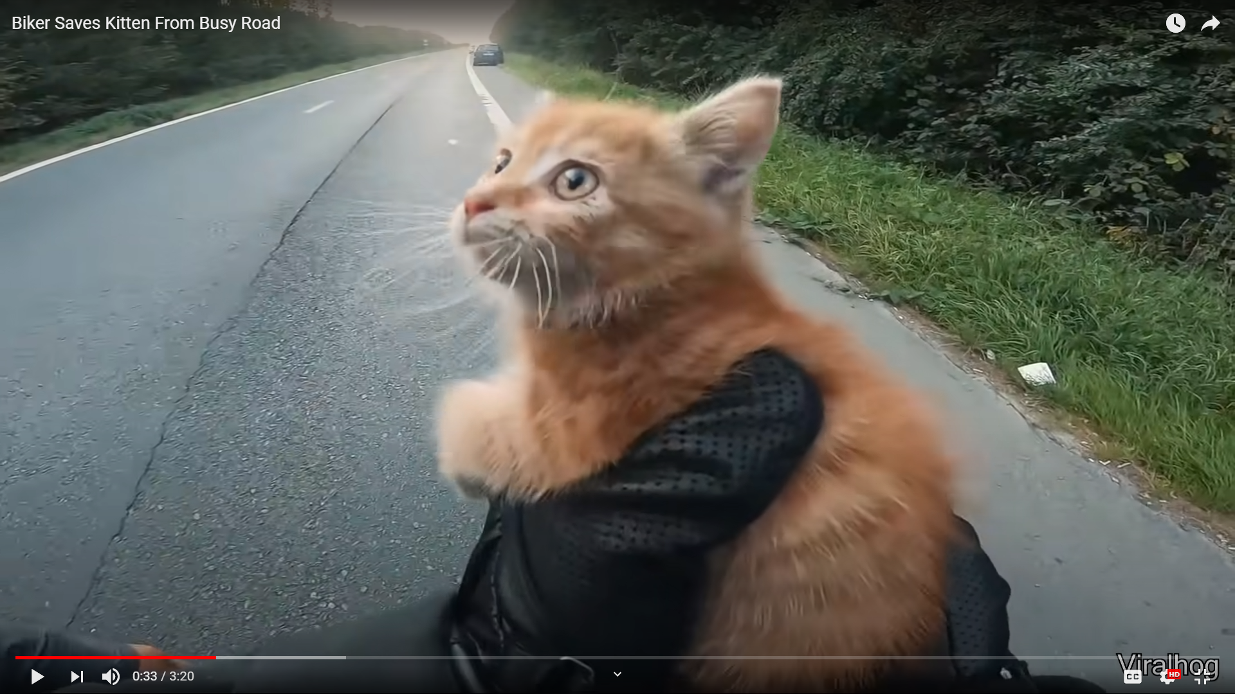

Perspectives
In the school role play activity, you will be taking on the role of someone at school: principal, teacher, student, parent. There are many situations that come up at work and everyone will look at the situation slightly differently. This activity is meant to reenact that while learning some ways to present your point of view.
Put yourself in someone else’s shoes.
Before you judge someone, walk a mile in their shoes.

Perspective = how you see the world
From my perspective, the health care costs in Korea are low.
Point of View (POV)
From my point of view, making mistakes in English is ok if people understand you.

In my eyes
In my eyes the most beautiful place on Earth is Antarctica.

It seems to me
It seems to me that quality of life is improving.

According to me
According to me, we should all become vegetarians.

Personally speaking = this is what I believe
Personally speaking, I think celebrities get paid too much money.

In my opinion
In my opinion, homework is bad.

My opinion
I think, I believe, I feel, I guess, I’m sure

With your group, come up with a hypothetical situation that you might experience at work. Think of a difficult situation as the other groups will offer advice on this situation.

This space is for you to write down any ideas you have about the three situations:
Situation 1:

Situation 2:

Situation 3:

A Story of Intelligence
In this story, the main character takes an IQ test. These are a few of the questions he got. Can you figure out the answer?

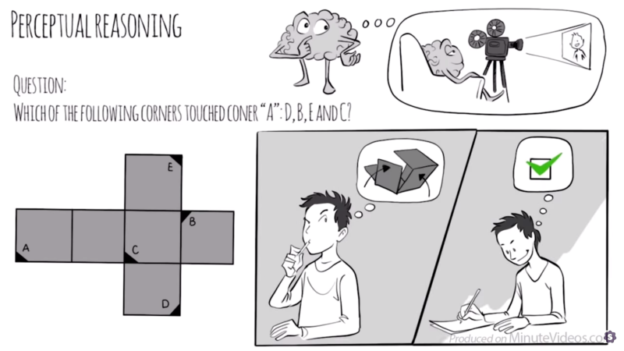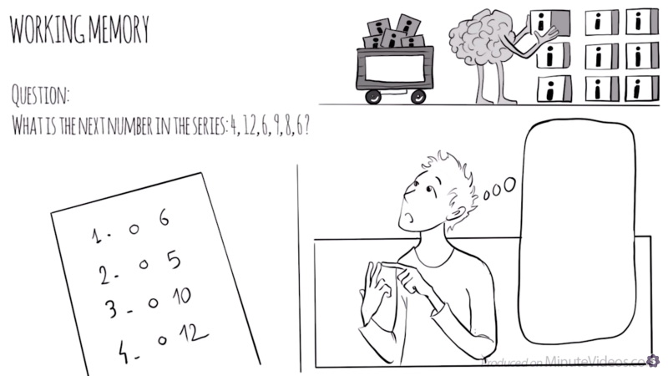

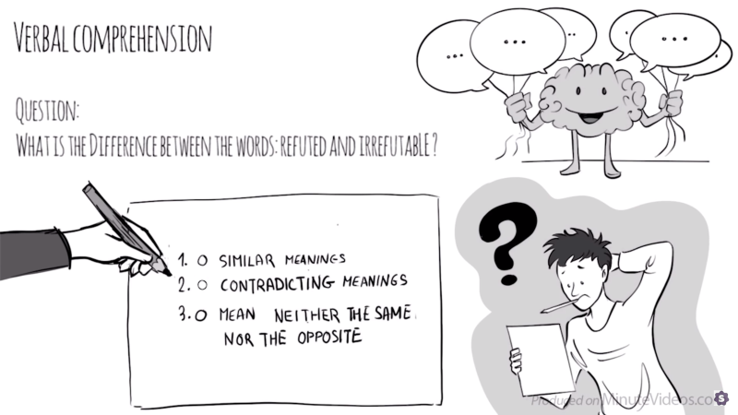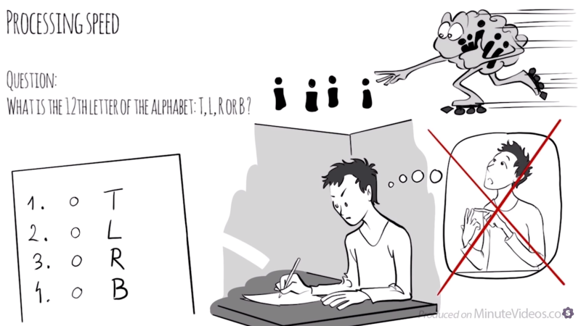

Pre-Listening
Over the next few pages, there is visual representation of this story, discuss with your group what you think the story is about? What will happen in the story?

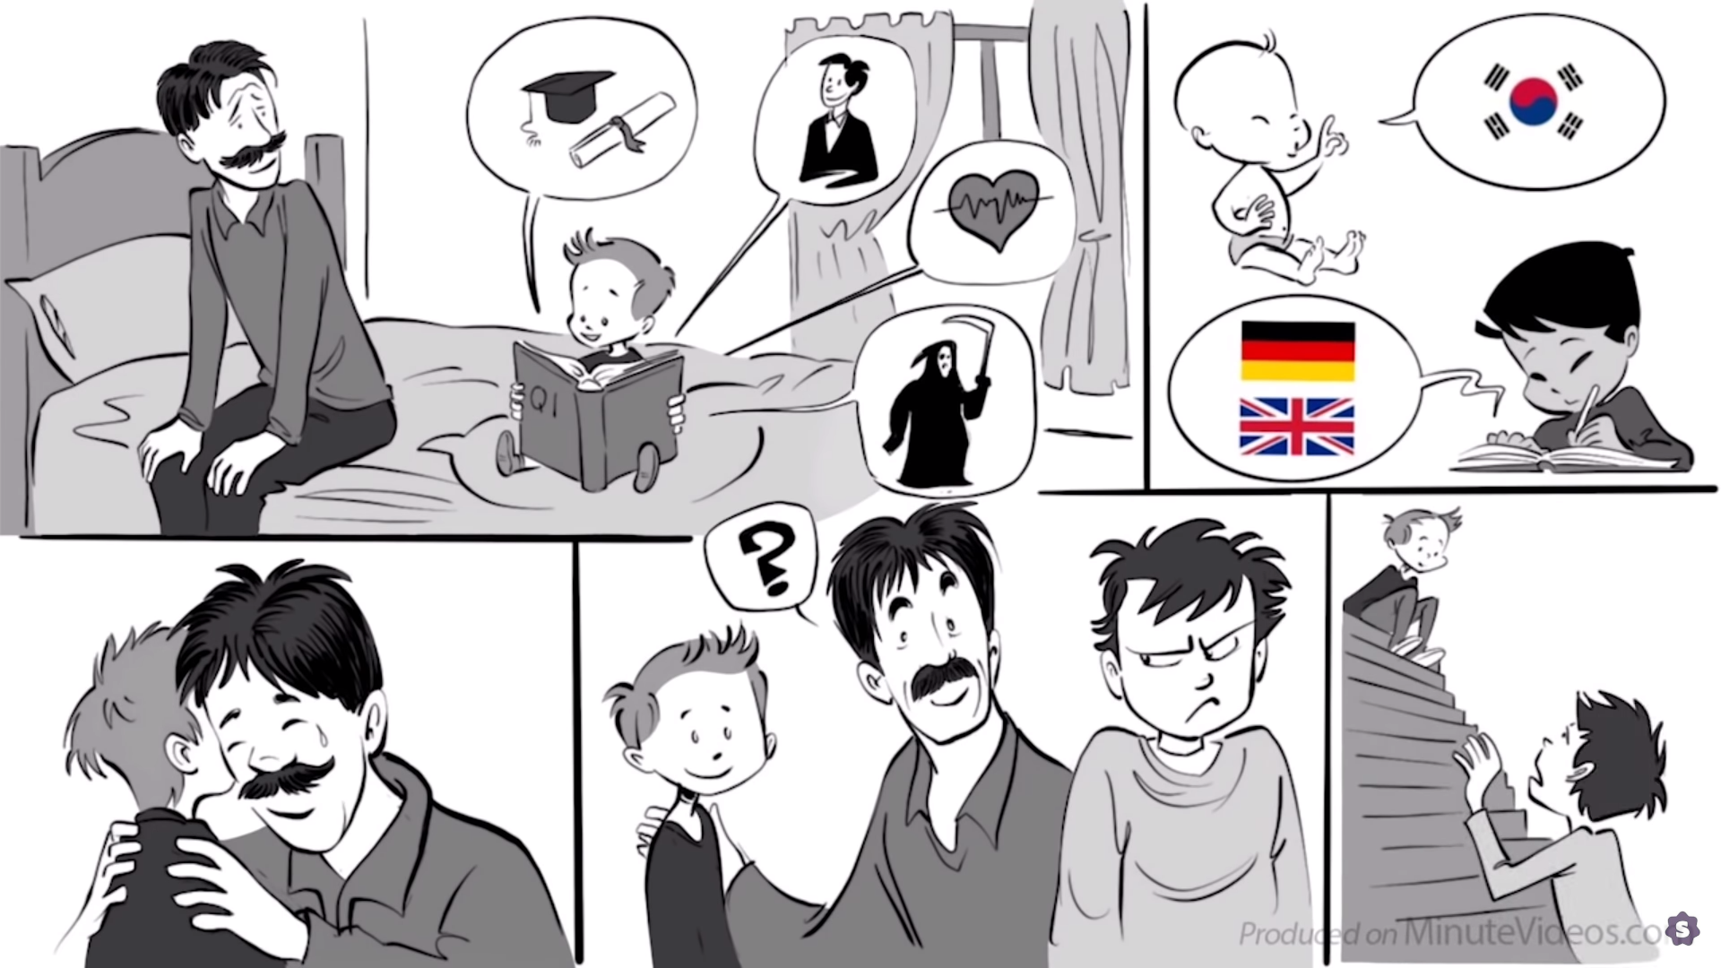
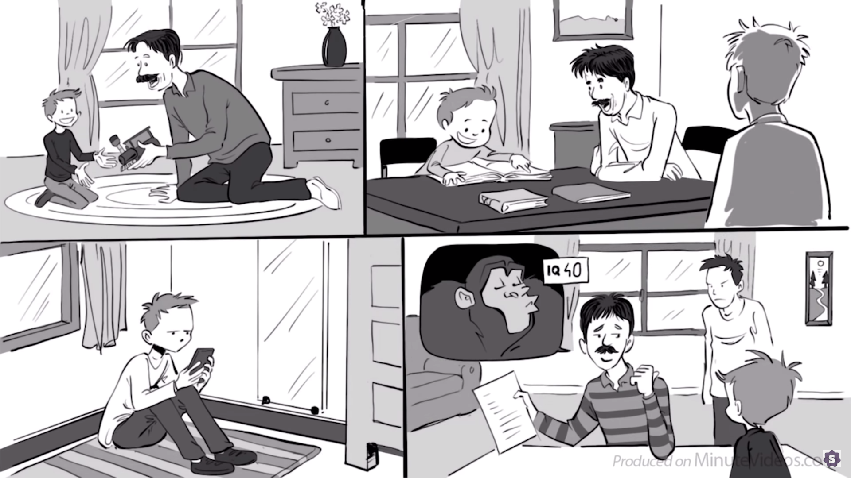
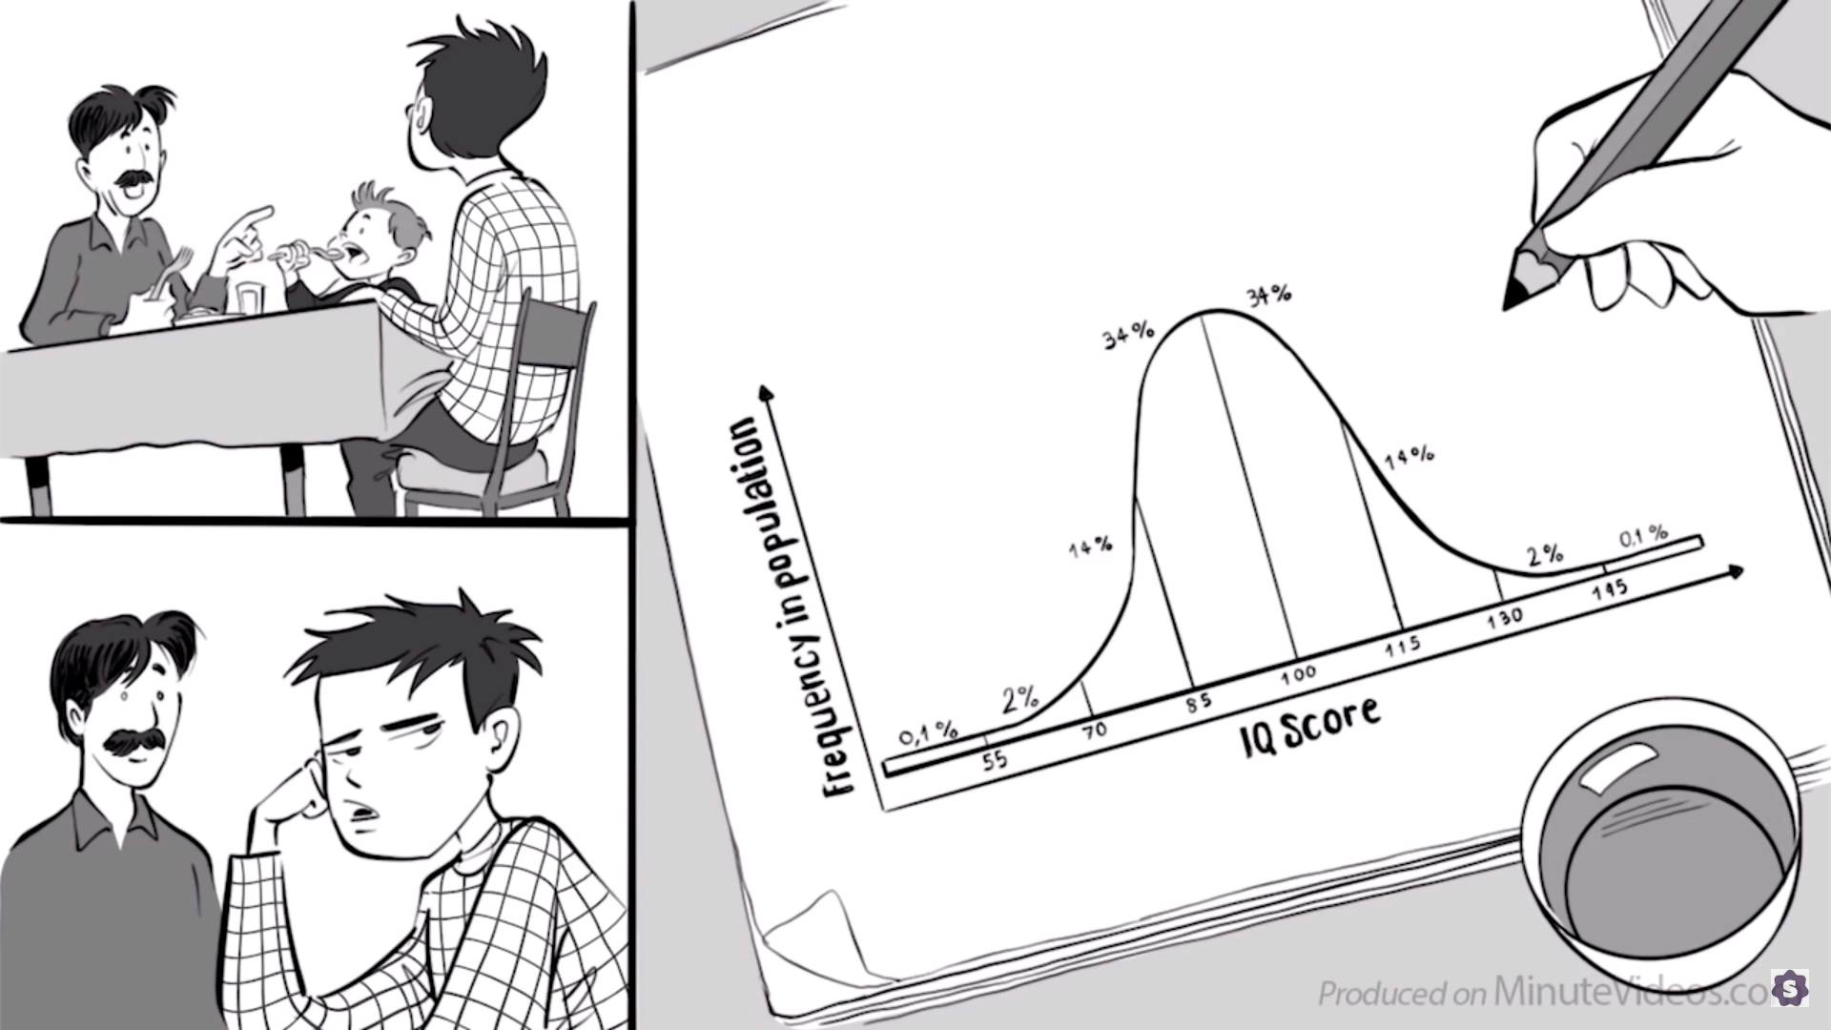
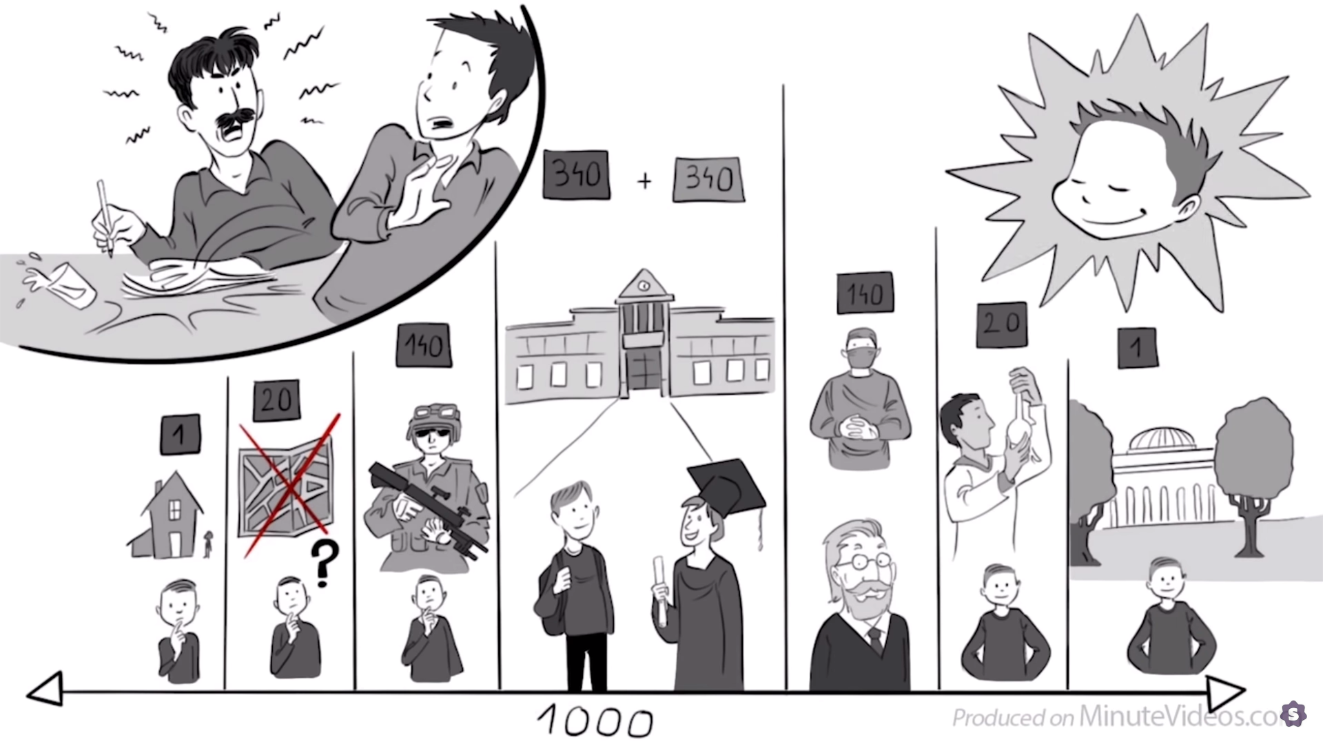
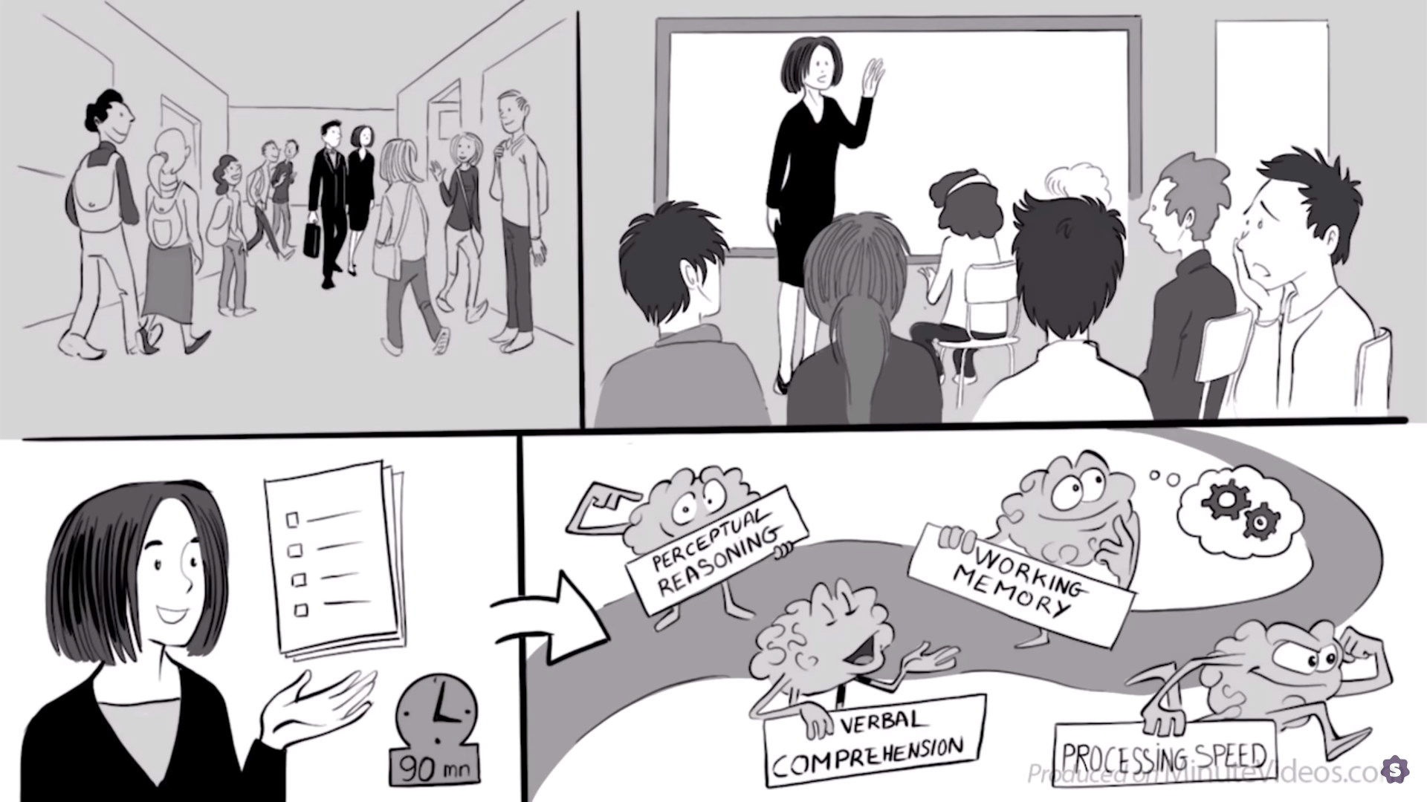
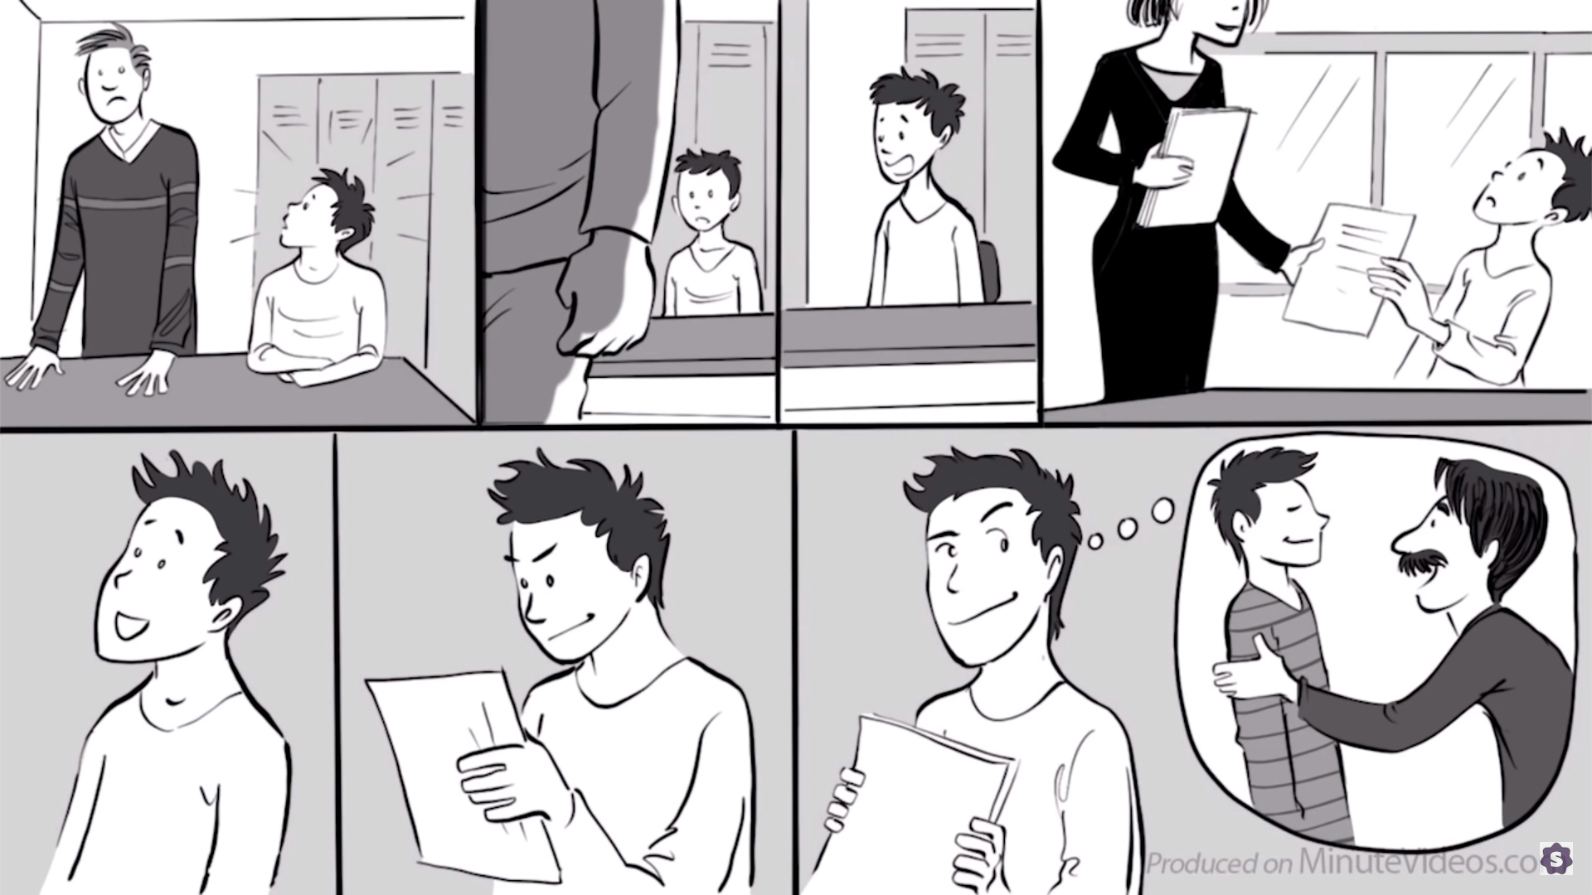
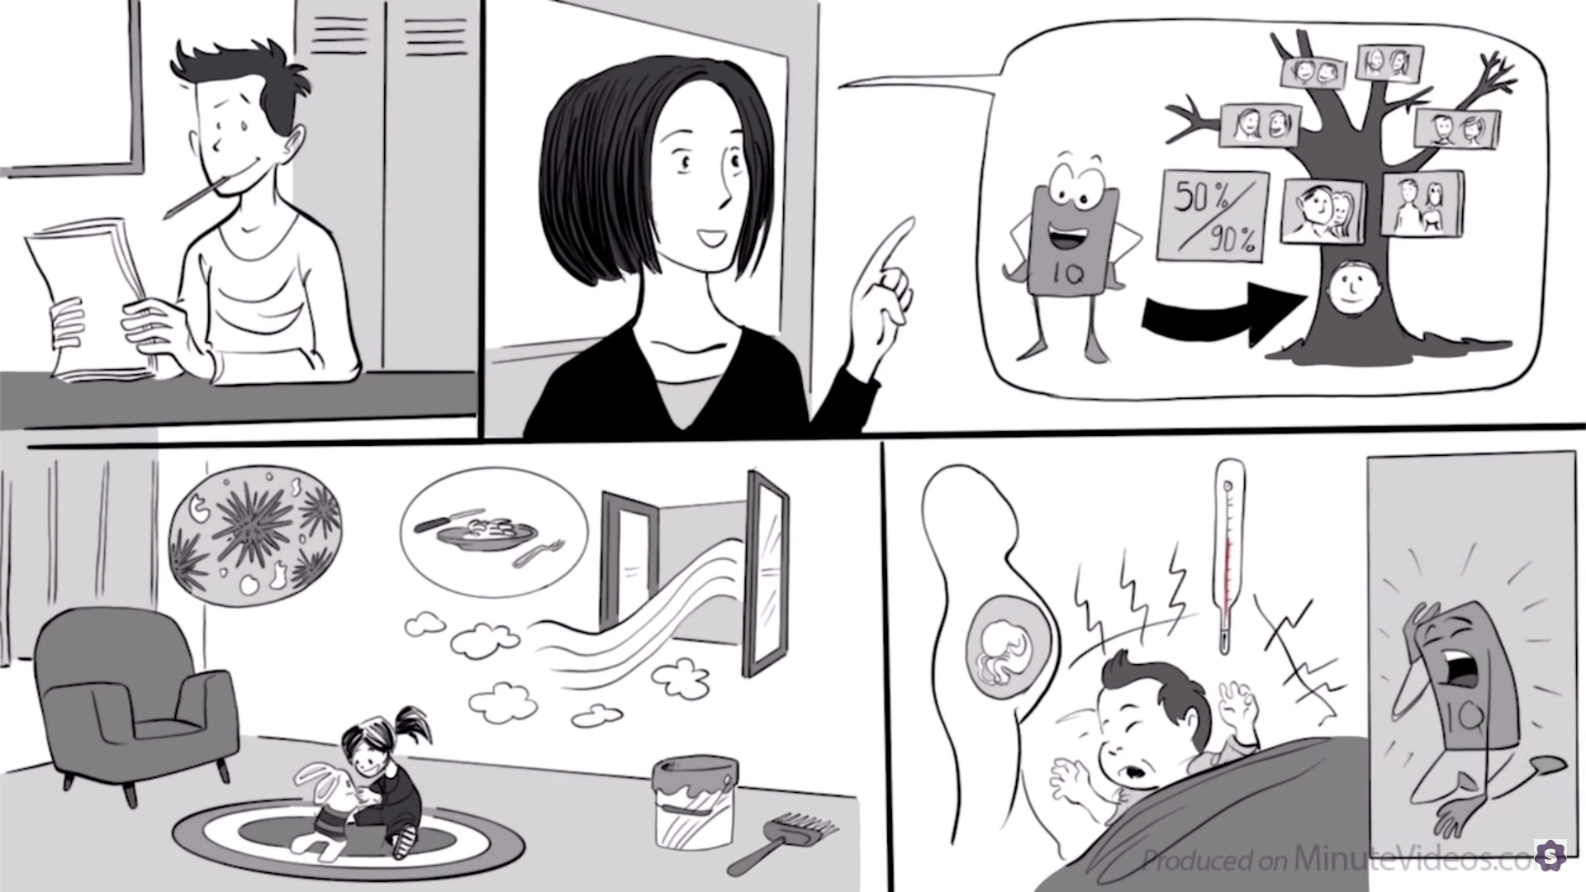
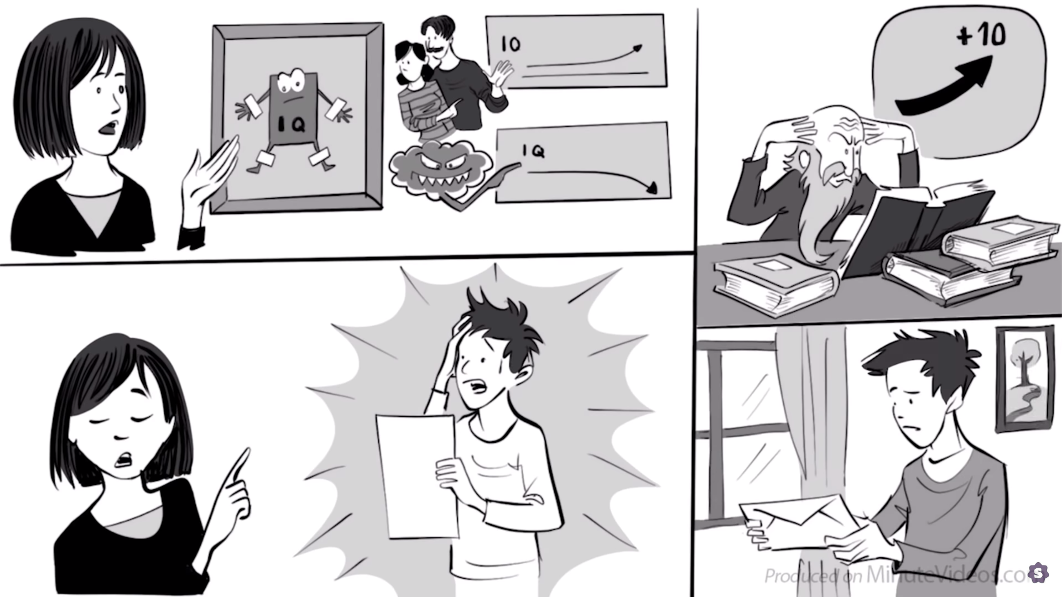
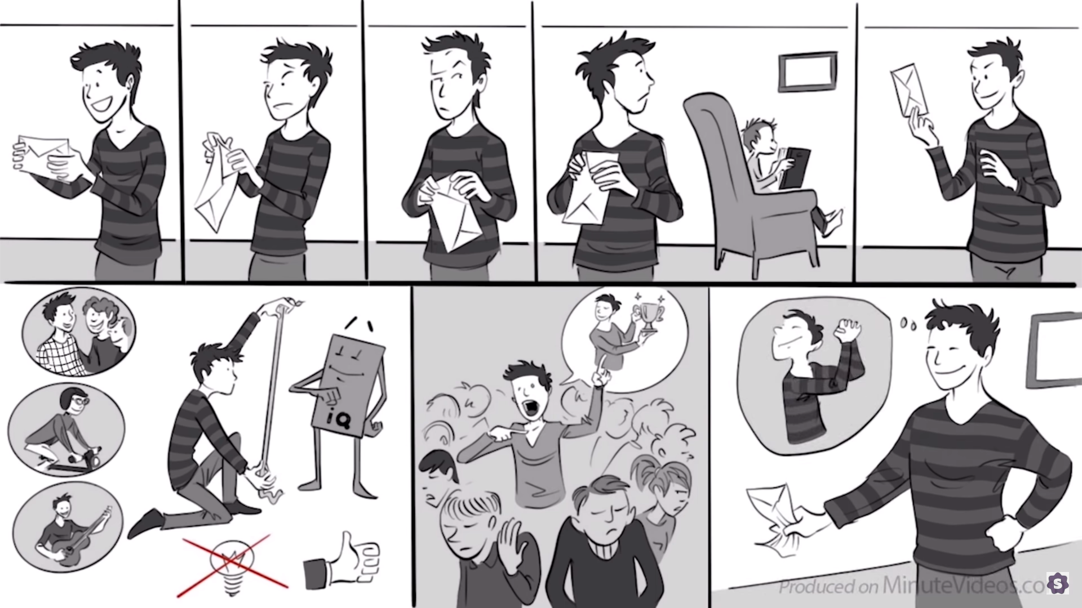
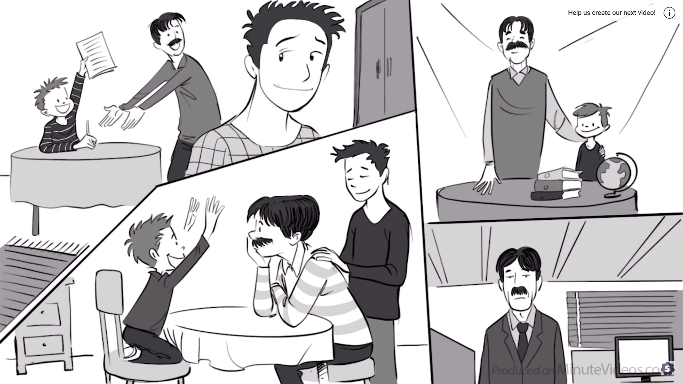
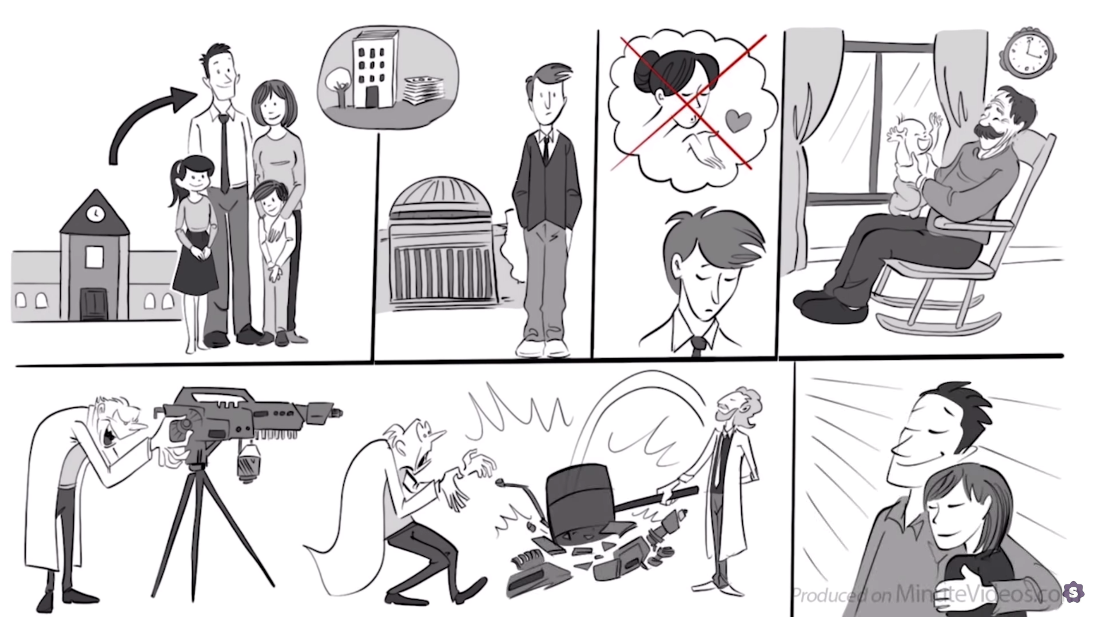

Listening
- Who does the father like best?

- What does IQ predict?

- Who is Kim Ung-Yong?

- What was the central conflict of the story?

- Describe his relationship to his father.

- What happened when he brought home a bad grade?

- How did that affect his confidence?

- 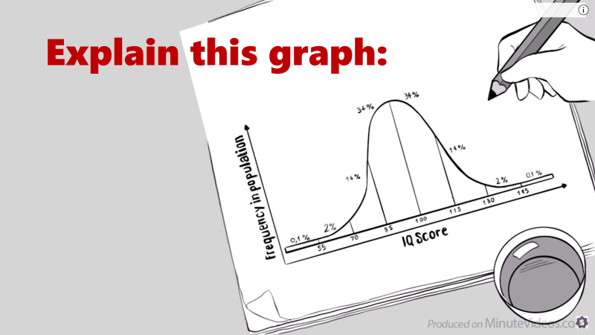

- What does the Wechsler IQ test?

- Is it mandatory or voluntary?

- Did he stay for the test?

- What gave him the confidence to stay?

- What is ‘perceptual reasoning’?

- What is ‘working memory’?

- What is ‘verbal comprehension’?

- What is ‘processing speed’?

- How much can you change your IQ?

- What was the choice he had?

- What was his IQ result?

- Why didn’t he open the envelope?

- Why is his dad so proud of his brother?

- Compare his life to his brother’s life?

- How does his father feel about IQ now?

Post-Listening
Now that you have listened to the Story of Intelligence, what do you think about IQ scores?
How important is intelligence?
Are there different types of intelligence?
What is more important than intelligence?
Should we reward intelligence or effort?

Snake Oil
The 13 Most Powerful Words in Advertising

- Now
- Easy
- Free
- New
- Saving
- Safe
- Proven
- Love
- Discover
- Guarantee
- Health
- Results
- You

Some PRICING vocabulary:
- Buy one, get one free
- Bargain
- Priced to sell
- Deal
- An offer he can’t refuse
- _____% off
- MSRP – Manufacturer’s suggested retail price

Some QUALITY vocabulary
- Money back Guarantee
- Satisfaction guaranteed
- High quality
- Well-designed
- Hand-made

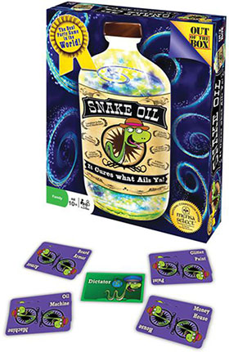

Snake Oil Game Rules

Setup

Each player takes a hand of six Word Cards.
Select one player to be the Customer for the first round.

Game Play
- The Customer takes a Customer Card from the center of the box, reads it aloud, and places it in front of him or herself.
The Customer takes on the role printed on the Customer Card for that round.
- The other players have 30-40 seconds to combine two Word Cards from their hands to create something for the Customer. Players place their two-card items face down on the table.
- In clockwise order from the Customer, players turn over and "pitch" their item to the Customer. The Customer can cut off any pitch that goes over 30 seconds.
- 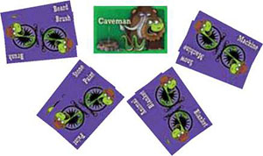
After each player has made a pitch, the Customer picks the best item and awards the Customer Card to the player who created that item.
- The Word Cards used in that round are discarded into the box top and players take enough Word Cards to bring their hands back up to six.
- The player to the left of the current Customer becomes the new Customer and play continues following steps 1-6 until each player has been the Customer once.

End of the Game
After each player has been the Customer once, the player with the most Customer Cards wins!
If two or more players are tied with the most Customer Cards, play one additional round with only the tied players submitting Word Cards and the next non-tied player acting as the Customer. The player whose item is selected wins the game!
If all players are tied with one Customer Card, start a new game - Everyone wins!

Among Us
There are two possible roles in Among Us; Crewmate or Imposter. The goal of the crewmate is to finish their tasks without getting killed by the imposters. The imposters will try to kill as many characters as possible without getting caught.
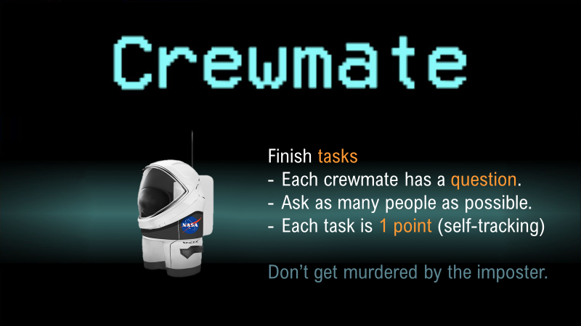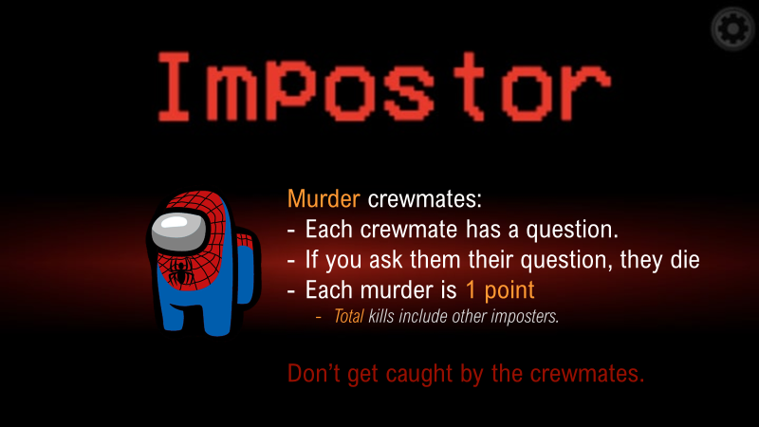

If you DIE:
- Someone asked you YOUR question
  - Or reasonably similar
- Quietly sit down
- Don’t speak or give hints.
VOTE:
- You can kick out a member
- If 4 people vote to kick you out, you die.
- “Kicked out” members follow the same rules for dying.
HINTS:
Crewmates
- Ask many questions
- Mix in the real question so imposters can’t guess
- “How are you? Did you have a good night last night? How old are you? Where did you go last night?”
Imposters:
- Don’t repeat each question
- Do it secretly
- Play along
- Listen
- Make up your own questions

Lessons from Centenarians

Put these animals in order of maximum lifespan.

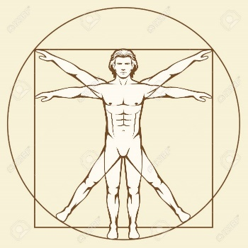

What is a centenarian?

What is a supercentenarian?

What is the Key to a long and happy life?

Clifford Crozier
How old is Cliff?
Where is he from?
How long has he been retired?
How is he robbing the government?
What is his secret to living?

Emilia Tereza Harper
How old is she?
Why is her name “Tereza”?
What does Emilia like to do?
Why was she living with her grandparents?
What makes her happy?
Why can she live happily forever?
“I’ve never been unlucky. Touch wood.”

John Millington Denerley
How old is John?
Where was he born?
What was john’s job?
Where did John climb a tower?
“I’ve always been fond of the water.” Why?
What is the RAF?
What is his feeling about fighting in the war?
Sometimes he would stay awake all night. Why?

Which of the following affects longevity?
Genetics
Diet
More medicine
No smoking
No alcohol
No obesity
Independence
Sex / Gender
Low Calorie Diet
Where you are born?
When you are born (month)?
Personality

Blueprints
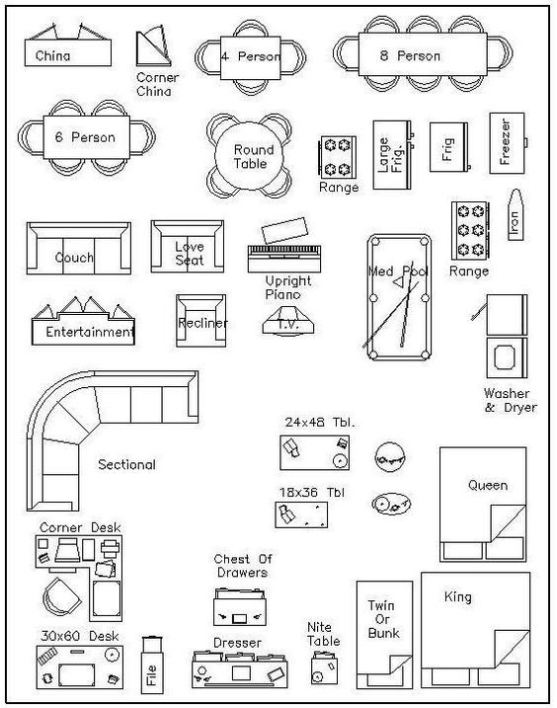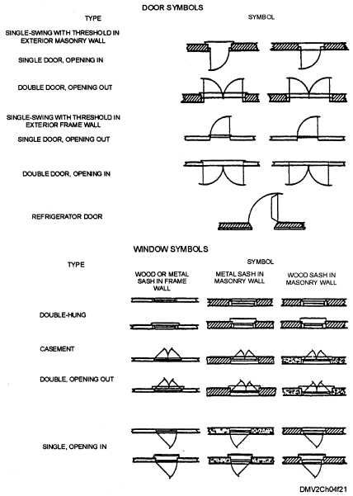

Six Degrees of Bacon
We are all connected. With the rise of social media and internet, it is so easy to keep in contact with friends around the world. Online gaming, interest forums, and web-based communities help us to meet similar people from across the globe. In this lesson, we will take a look at connectedness. Just how connected are we?

The small world phenomenon
Have you ever met someone in another country from your hometown? “It’s a small world”
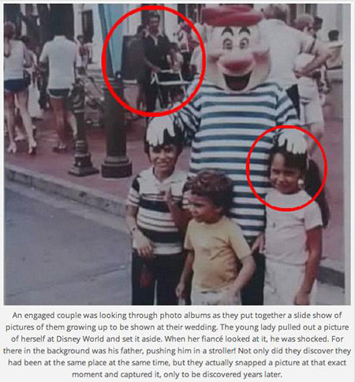

Six or Fewer Social Connections
- “A friend of a friend”
- A degree of separation is one step removed. So, You and your friend have one degree of separation. You know them directly. They are one step away from you.
- Two degrees of separation is a friend of a friend. So, you don’t know that person personally, but you know someone who knows that person.
- Similarly, three degrees of separation would be a friend of a friend of a friend.

How many degrees of separation?

Every celebrity is within 6 degrees of separation of Kevin Bacon.

Each group will get one of these videos to analyze and explain to the other groups:
The Science of 6 Degrees of Separation

How the Six Degrees Phenomenon has Changed Science
Six Degrees of Separation: It’s a Small World
The Math in Six Degrees of Separation
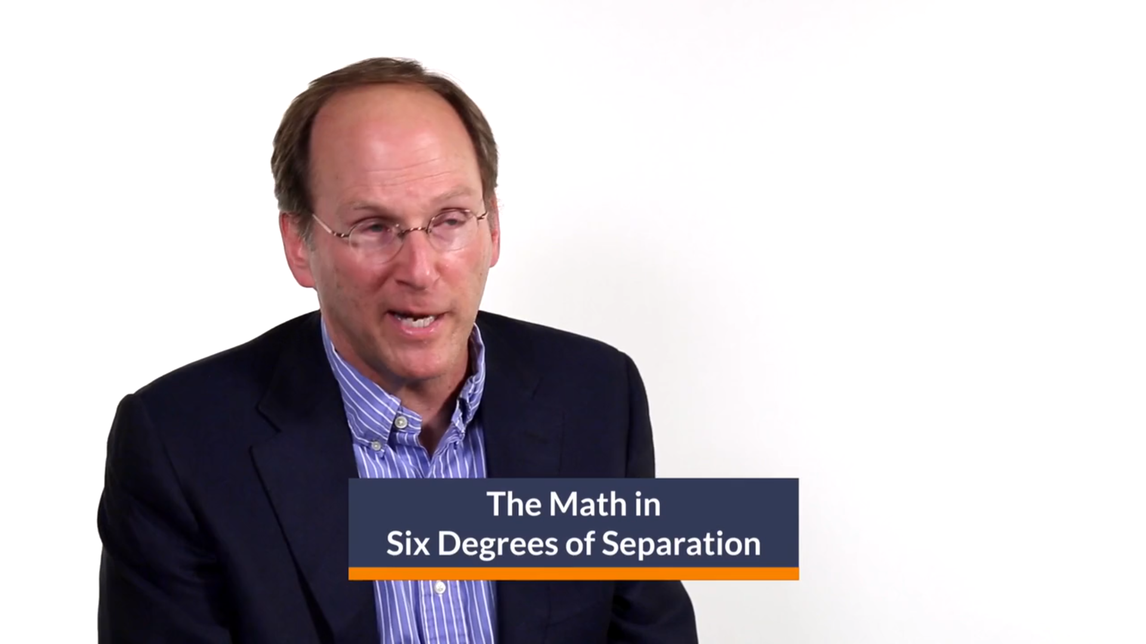

Murder Mysteries
A murder mystery is a party game where one or more characters die during the game and the other players must figure out who is the criminal. Usually murder mysteries are played in a large location. People dress up as their characters and act like their characters. Sometimes there is a script to follow, but usually participants are given an information sheet about their character and must act how their character will act. I have used murder mysteries many times in speaking class because they are a fun way to practice speaking and challenge your ability to think under pressure.
With the challenges we are facing this year (Covid-19), it has become difficult to participate in murder mysteries. So, there has been a large increase in the number of online murder mysteries. I have made my own online murder mystery that we are going to try together.
In this murder mystery, there is an assassination. Participants are eyewitnesses, suspects and investigators. Can you figure out who murdered Mr. Ess?

Setting:
Mr. Ess is a controversial politician. He believes that the government is spending too much on helping minorities. He feels it is irresponsible and uneconomical to spend so much on such a small percentage of the population. He is arguing for government to change how it spends money. People in the black community as outraged as this will negatively affect black people. Some people have said that Mr. Ess is a racist. There is a vigilante group called the black panthers that protests his speeches. They are at today’s rally as well.
During his speech, Mr. Ess is shot. The loud bang scares everyone and a lot of people begin running away. An ambulance is called quickly, but Mr. Ess is pronounced dead when the ambulance gets there. The event organizer, Irine, called the Chief of Police immediately and they just showed up. The chief of police, Stacy, will have to make an arrest at the end of the game. She has brought a couple investigators with her to help crack the case.
Stacy will make the final arrest, but everyone can participate in the investigation. Some people have special abilities that can use. Investigators may search one person each round. If they search you, you can send them the link in your profile. You can see your own items of course. Click on the items, because some items have links with more information. However, only certain characters have the knowledge to check those items. If you have a special ability for analyzing guns, you will be given a code to unlock more information about guns.
To start the game, it is a good idea to introduce your character and describe what they look like along with their name. The game will be played over a series of rounds. The first round we will split into four small groups. The second round has two groups and in the final round we will all meet in one large room. This is different from a normal murder mystery where you would freely walk around and talk to whoever you want.
Listen carefully to what people are saying and try to find the assassin!

References
1veritasium. (2015, August 25). The Science of Six Degrees of Separation. Retrieved December 28, 2020, from https://www.youtube.com/watch?v=TcxZSmzPw8k
Chauhan. (2014). 25 Phrases for Expressing Opinions [pdf]. Retrieved December 28, 2020, from http://myenglishonline.ca/wp-content/uploads/2014/08/100-Phrases.pdf
Lifehunterstv. (2016, December 23). Life Lessons From 100-Year-Olds. Retrieved December 28, 2020, from https://www.youtube.com/watch?v=9AThycGCakk
Media Marketing. (2017, May 21). The thirteen most powerful words in advertising. Retrieved December 28, 2020, from https://www.media-marketing.com/en/opinion/the-thirteen-most-powerful-words-in-advertising/
MrAndersLA. (2019, December 27). How I became the world's best wikipedia speedrunner. Retrieved December 28, 2020, from https://www.youtube.com/watch?v=cDIQhJH2ahY
Psych2GoTv. (2017, September 03). Six Degrees of Separation: It's a Small World. Retrieved December 28, 2020, from https://www.youtube.com/watch?v=a99ry70CnRs
Scishow. (2019, May 22). How The Six Degrees Phenomenon Has Changed Science. Retrieved December 28, 2020, from https://www.youtube.com/watch?v=X0mHf3oSUdU
Sprouts. (2019, June 26). A Story of IQ, Intelligence and Wisdom. Retrieved December 28, 2020, from https://youtu.be/17T3fZIpT8I
Supports, P. (2020, December 28). The Math in Six Degrees of Separation. Retrieved December 28, 2020, from https://vimeo.com/193114373
TEDEducation. (2019, April 02). How to spot a pyramid scheme - Stacie Bosley. Retrieved December 28, 2020, from https://www.youtube.com/watch?v=SBGfHk91Vrk
Ultraboardgames. (n.d.). Snake Oil Game Rules. Retrieved December 28, 2020, from https://www.ultraboardgames.com/snake-oil/game-rules.php
Vsauce2. (2018, December 18). The Birthday Paradox. Retrieved December 28, 2020, from https://www.youtube.com/watch?v=ofTb57aZHZs
Wenger, J. (n.d.). Six Degrees of Wikipedia. Retrieved December 28, 2020, from https://www.sixdegreesofwikipedia.com/

