Three Goats
1 Thing | Big | Old | Tall | Fast | Smart
2 Things | Bigger
3 Things | Biggest

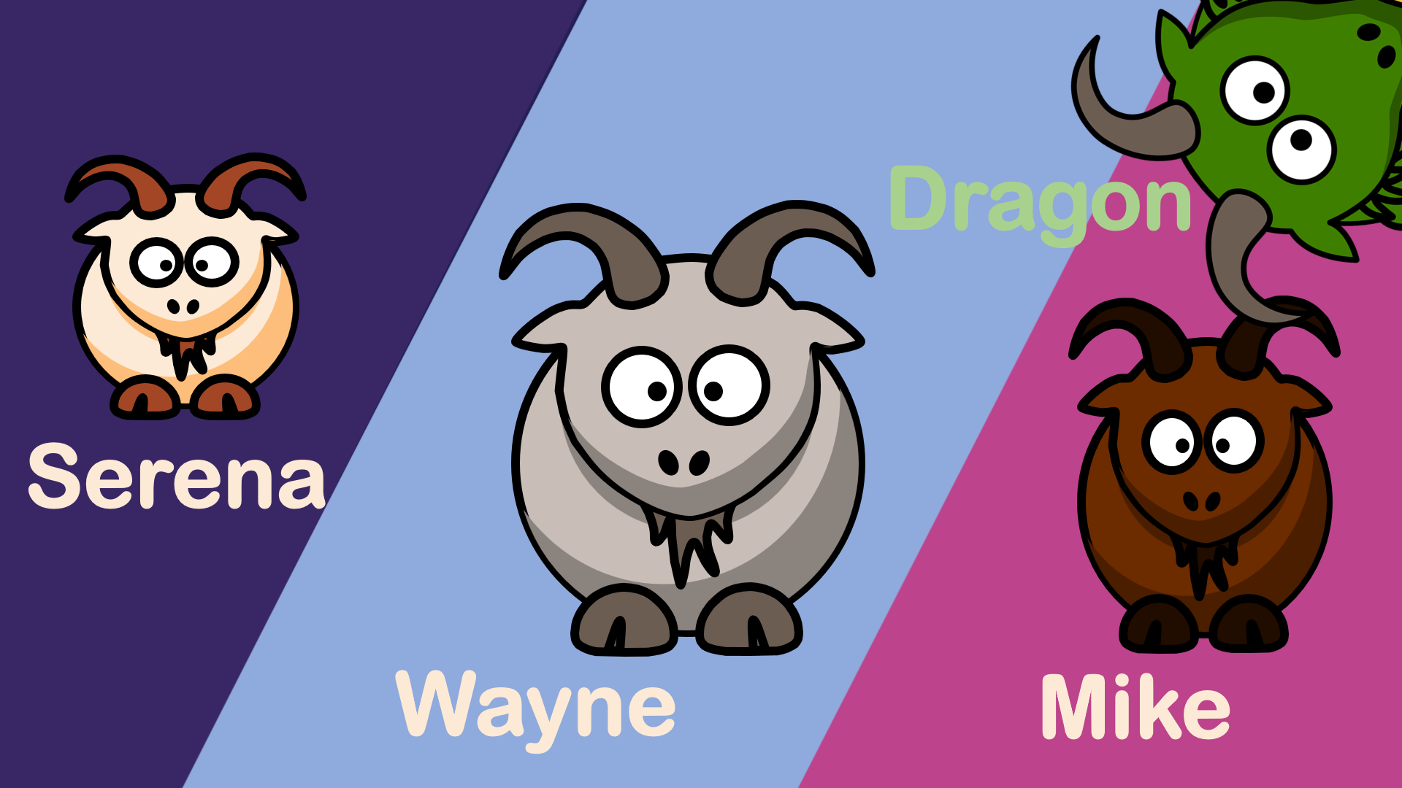
What are you good at?
I am good at _______(ing).

I am the best

