Vocabulary
Before reading, translate these words.

Racial
Pursue
Dressing room
On set
Industry
Collaborate
Sample (music)
Extended
Peak (verb)
Release
YOLO
Unintentionally
Meme
Bling
Debut
Introspective
Egotistical
Technical
Numerous
Ambassador
Key to the City
biography
Drake’s real name is Aubrey Drake Graham, but his artist name is Drake. He was born in Toronto, Ontario on October 24th, 1986. His mother was an English teacher. Drake was bullied in school because of his racial and religious background. Drake’s mother is white, and his father is black. His parents divorced when he was 5 years old. His mother also raised him to be Jewish. He dropped out of high school to pursue an acting career. He lived with his mother and they were very poor and his mother was sick. However, he went back and finished high school in 2012.
At 15-years-old, Drake got a part on the Canadian drama, Degrassi: The Next Generation. His character was a basketball player who was disabled after being shot by a classmate. Drake appeared in 100 episodes from 2001 to 2008. During this time, he also started recording music. He was so busy that sometimes he would sleep in a dressing room on set.
Drake had some early success in the music industry. He was able to collaborate with some well-known artists. He sampled a song by Lil Wayne, who invited him to tour with him. The two rappers recorded a few songs while touring together. Lil Wayne was a mentor for Drake and helped him grow as an artist. Drake’s first extended song, Best I Ever Had, peaked at #2 on the US Billboard Hot 100. Many record companies wanted to sign Drake.
In 2010, Drake release the album, Thank Me Later. It was the top selling debut album for any artist in 2010. In 2011, he popularized the word “YOLO” with the success of his song The Motto. He also gained a lot of recognition for the music video for Take Care featuring Rhianna. In 2012, Drake went on his first worldwide tour. He unintentionally created a very successful meme in 2015 with his music video for Hotline Bling. The song One Dance became Spotify’s most streamed song ever in 2016.
In 2017, he won 13 awards at the Billboard Music Awards. It was the most awards anyone has one in a single night. At this point, Drake had been present on the Hot 100 chart for 8 years in a row. He also has the record for most total songs on the Hot 100. God’s Plan was released in 2018 and broke many streaming records. In 2019, Drake became the first artist to have three songs debut at #1 on the Billboard Hot 100 with Toosie Slide. Drake is one of the most successful artists on the Billboard Hot 100. He holds the record for most top-10 singles, the most continuous time on the chart, and the most songs on the chart all time.
Drake is considered a pop-rap artist. He is known for his introspective lyrics and honesty. His lyrics are also egotistical but technical. He is one of the most successful rap artists of all time. He has won numerous awards and has had many hits in his career. Drake has won 4 Grammy Awards, 29 Billboard Music Awards, 6 American Music Awards, 15 BET Awards, 20 BET Hip Hop Awards, 23 MTV Music Video Awards, and 6 Juno Awards. He was named the IFPI Global Recording Artist in 2016 and 2018. Complex ranked him as the best rapper alive in 2011, 2012, and 2015. He was named Artist of the Decade at the 2021 Billboard Music Awards. Drake has been credited with leading a wave of Canadian artists having success in America. He is also inspiring new artists in Canada.
Drake is a proud Canadian. He mentions his home country and hometown a lot. His relationship to Toronto is one of the strongest bonds. Drake is responsible for 5% of Toronto’s tourism economy. He can also be found in the front row of Toronto Raptors basketball games. When the Raptors won the championship in 2019, Drake was right there celebrating with the team. He has been the “global ambassador” of the Raptors since 2013. In 2016, Toronto gave Drake the Key to the City.

Questions
- Where was Drake born?
- What is his real name?
- Why was he bullied?
- Why did he drop out of high school?
- Who was Drake’s mentor?
- What song made Drake a meme in 2015?
- What kind of artist is Drake?
- Describe his relationship with the city of Toronto.
- What sports franchise made him their Global Ambassador in 2013?
- Drake’s accomplishments are too numerous to list in this document. Have a look at his awards and hit songs.
- Listen to some of his most popular songs. What do you think about them?

Top Songs
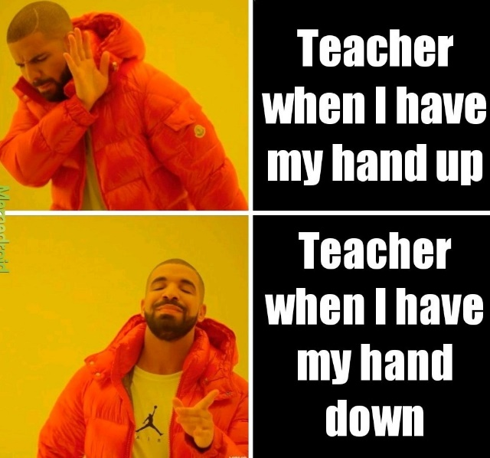
- One Dance
- God’s Plan
- Passionfruit
- Marvin’s Room
- Money in the Grave
- In My Feelings
- Hold On, We’re Going Home
- Hotline Bling
- Started from the Bottom

