Vocabulary
Before reading, translate these words.
Prime Minister
Proponent
Socialism
Unremarkable
Corps
Diplomat
Public life
Invade
Withdraw
Losing face
Time in office
Institute (verb)
Ancestry
Oversee
Social program

biography
Lester B. Pearson is a two-time Prime Minister of Canada and a recipient of the Nobel Peace Prize. Many of the things that Canadians are proud of started because of Pearson. He was a large proponent of socialism. He also was a key part in the Canadian flag.
Pearson was born in York, Ontario on April 23rd, 1897. His father was a Christian minister, so they moved around Ontario a few times. Pearson’s childhood was unremarkable. He studied hard and was a good student. He entered university when he was 16 years old.
He was too young to serve in the army when Canada declared war (WW1) in 1914. So, he volunteered to serve with a hospital unit instead. He joined the Royal Flying Corps two years later. After being injured in two accidents he was sent home. He was hit by a bus and survived a plane crash! Then, he was a training instructor for the rest of the war while studying at university. He graduated from the University of Toronto in 1919 and went on to Oxford University to pursue his education in history. He would go back to the University of Toronto as a professor for a time.
Pearson’s diplomatic life started in 1927. He had a fine career in the Department of External Affairs. In 1940, he served in the Canadian Embassy in Washington DC. Five years later he was promoted to Canadian Ambassador to the United States.
Pearson entered public life in 1948 as the Secretary of State for Foreign Affairs. He remained in that position until 1957. In 1957 he also received the Nobel Peace Prize for his involvement in the Suez Crisis. When he was given the prize, the committee claimed that Pearson had saved the world.
The Suez Crisis happened in 1956. Israel invaded Egypt first, followed by the United Kingdom and France. The goal was to gain control of the Suez Canal for Western countries. There was pressure from the Soviet Union, United States, and the United Nations to withdraw from the area. Pearson negotiated a way for the invading countries to withdraw without losing face. He is credited (along with UN Secretary-General Dag Hammarskjold) with developing the modern concept of peacekeeping.
Also in 1957, Pearson became the leader of the Liberal Party. Even though his party was defeated twice, he would become the Prime Minister of Canada in 1963. During his time in office, he did a lot for civil rights and strengthened the social programs. He created Canada’s national universal healthcare. Healthcare is something that Canadians are very proud of. Pearson also established the Canadian Pension Plan. The plan provides money for retired people. Additionally, Pearson strengthened the student loan program in Canada. Finally, he also instituted a 40-hour work week, required vacation time, and created a new minimum wage.
Pearson also oversaw the creation of the Canadian Flag. The Canadian flag is easily recognizable worldwide and is a major symbol of Canada. But, it did not exist until 1965. Before that, Canada’s flag was based off of the British Flag. French-Canadian were not happy that the flag was British because their ancestry was French. Pearson’s wanted a flag with blue bars on each side of the flag and a different design for the leaves. The blue bars represented the oceans on each side of Canada. However, it was not the final choice. The flag was introduced on February 15th, 1965.

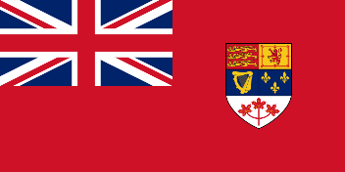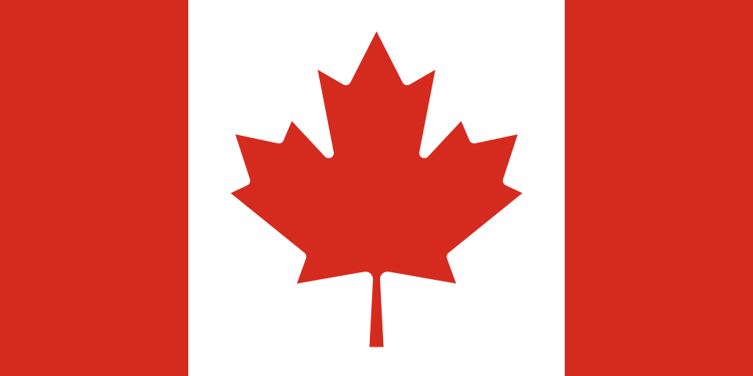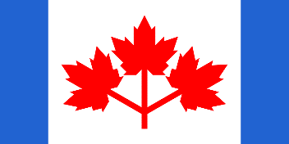

Pearson is remembered for his efforts in creating stronger social programs and for his role in the Suez Canal Crisis.

Questions
- Where was Lester B. Pearson born?
- Why didn’t he serve in World War 1?
- What did he do instead?
- What was his first job in ‘public life’?
- Why did Pearson receive the Nobel Prize?
- Why did Israel, France, and the United Kingdom invade Egypt?
- How did he help in the Suez Crisis?
- List his accomplishments as Prime Minister of Canada.
- What program are Canadians proud of?
- Describe the flag that Pearson wanted.
- Which flag of Canada do you like? Korea has also had a few different flags. What changes would you make to the current flag?
- What social programs are important to you?
- What do you think about military service?

