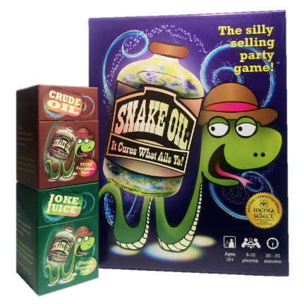
Snake Oil Game Rules

Setup
Each player takes a hand of six Word Cards.
Select one player to be the Customer for the first round.

Game Play
- The Customer takes a Customer Card from the center of the box, reads it aloud, and places it in front of him or herself.
The Customer takes on the role printed on the Customer Card for that round.
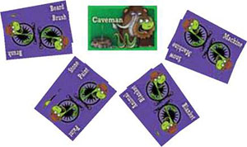
- The other players have 30-40 seconds to combine two Word Cards from their hands to create something for the Customer. Players place their two-card items face down on the table.
- In clockwise order from the Customer, players turn over and "pitch" their item to the Customer. The Customer can cut off any pitch that goes over 30 seconds.
- After each player has made a pitch, the Customer picks the best item and awards the Customer Card to the player who created that item.
- The Word Cards used in that round are discarded into the box top and players take enough Word Cards to bring their hands back up to six.
- The player to the left of the current Customer becomes the new Customer and play continues following steps 1-6 until each player has been the Customer once.

End of the Game
After each player has been the Customer once, the player with the most Customer Cards wins!

