Tim Hortons
Doughnuts / Donuts

Old-fashion
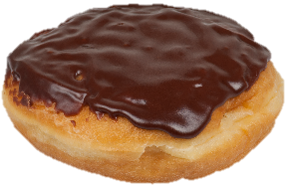Boston Cream
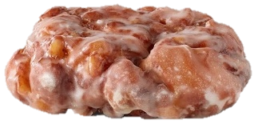Apple Fritter
Chocolate Dip
Maple Dip
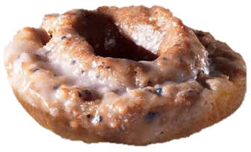Blueberry
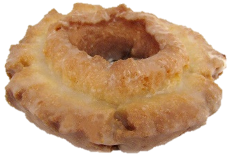Maple Glazed

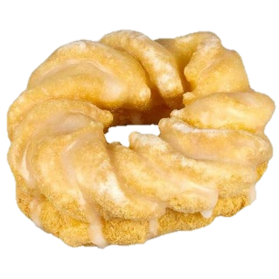Cruller
éclair

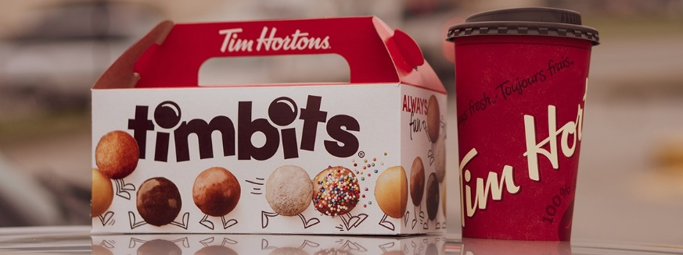
Hi, can I help you?
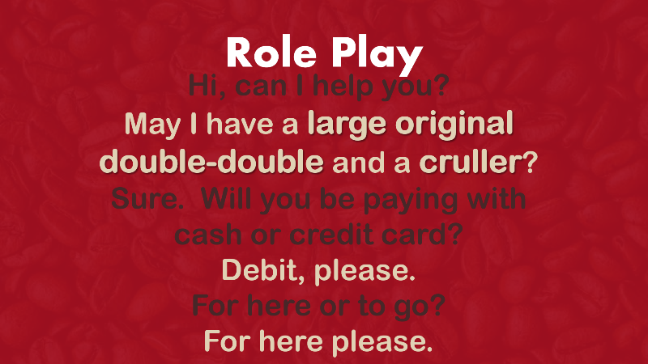
- Size
  - S, M, L, XL
- Blend
  - Original
  - Dark roast
  - Decaf
  - French vanilla
- Additives
  - Milk
    - 1 milk = 15 mL
  - Cream
  - Sugar
  - Sweetener
Regular = 1 milk + 1 sugar
Double-double = 2 cream + 2 sugar
Triple-triple = 3 cream + 3 sugar
Four by Four = 4 cream + 4 sugar
Three cream, Two sugars = 3 cream + 2 sugar
Black = 0 cream + 0 sugar

