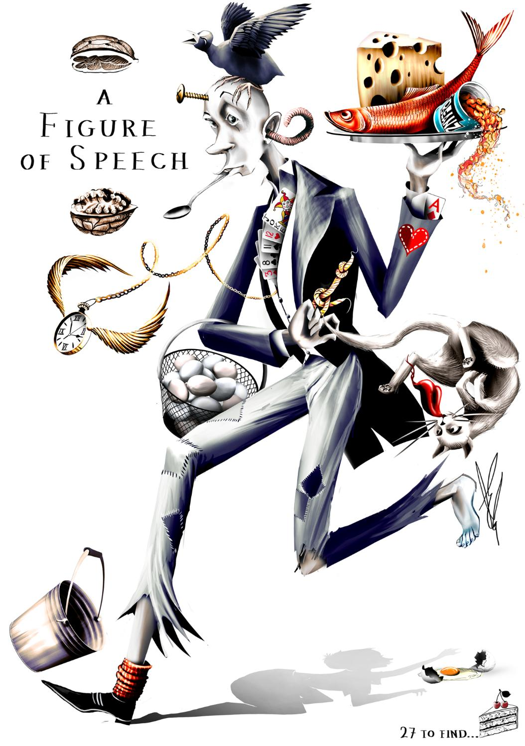
27 Idioms – Match the meaning to the idioms:

Stop making excuses and do the hard work =
There isn’t much room =
Taking a risk by committing all your resources (or effort) to one strategy =
A song stuck in your head =
An important person =
Born in a rich family =
A euphemism for death =
Things are happening too quickly =
Getting married =
An unpredictable (or different) person =
Something that makes it even better =
Not as good as you were when you were younger =
Do not show your emotions when you are upset =
No hair on your head =
To divulge (reveal) a secret =
Mislead or distract =
You don’t know what to say =
A summary of what has been said =
It’s very easy =
A crazy or weird person =
Don’t tell your secrets =
A secret skill, knowledge, or weapon =
Don’t hide your emotions and feelings =
Maybe they didn’t deserve it because they didn’t have to try hard =
You have to be cautious around someone =
Hesitant to do something =
Someone who was poor but is not rich =

