Canada’s ‘maple syrup heist’ thief must repay millions for sweet stolen goods
This article is more than 1 month old
Perpetrators siphoned syrup from barrels stored in Quebec’s strategic maple syrup reserves and replaced it with water
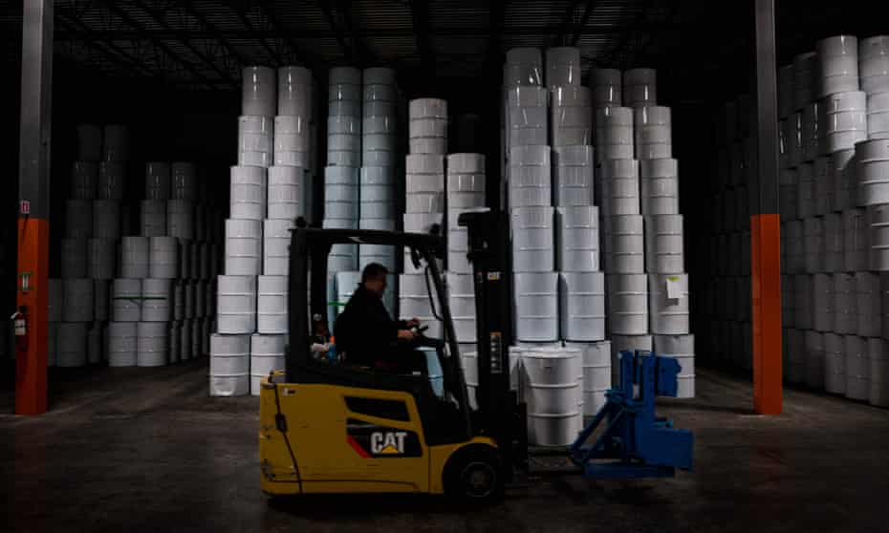
Leyland Cecco in Toronto
Fri 1 Apr 2022 17.44 BST
Richard Vallières’s plan to make millions of dollars was deceptively simple: secretly drain the province of Quebec’s strategic maple syrup reserve and then sell the illicit product.
But the Quebec man’s daring theft fell short after police were tipped off and he and his accomplices landed in jail.
Now, the ringleader behind Canada’s infamous heist has a new challenge: paying his victims C$9m (US$7m) or serving six more years in jail.
On Thursday, Canada’s supreme court ruled that Vallières, the mastermind behind “the Great Canada maple syrup heist”, a C$17m caper that spawned a wide-ranging investigation – and a Hollywood screenplay – is required to pay back the full amount of the syrup he stole and then sold, not just the profits from his crime spree.
Starting in 2011, a group of thieves covertly siphoned syrup from thousands of white metal barrels in warehouses rented by the Federation of Maple Syrup Producers, an organization that represents nearly 7,000 syrup producers and controls nearly 80% of the world’s maple syrup supply.
Knowing the barrels in the strategic reserve were inspected only once a year, the thieves replaced the syrup with water. Because the Federation controls the sale of syrup in Quebec, the illicit product was transported over the border to the province of New Brunswick, where it was packaged into smaller batches and sold to both legitimate buyers and black market exporters.
In 2012, after an inspector noticed some barrels were empty and others were lighter than they should be, the Federation realized that 9,571 barrels – worth nearly C$18m – had been stolen from under its nose.
The theft led to police raids in New Brunswick, Ontario and south of the border in Vermont and New Hampshire.
Sticky situation: maple syrup bandits face Quebec courts for infamous heist

Quebec police arrested 16 people in their investigation, identifying Vallières as the group’s leader. They also seized two forklifts, tanker trucks used to transport the stolen product and four huge kettles used to boil the syrup down.
The brazen theft become an episode of the Netflix show Dirty Money.
In 2016, Vallières was found guilty of fraud, trafficking and theft and sentenced to eight years in prison, the harshest penalty handed down to those involved in the heist. The judge, Raymond Pronovost, fined him C$9.4m, based on the value of the syrup he was able to sell. Vallières was given 10 years to make the payment, or face a six-year prison term.
The judge cited Canadian law, which holds that when stolen property cannot be returned to its owner the fine must be equal to the value of the stolen goods.
On appeal, that amount was reduced to only C$1m – the amount Vallières claimed had been the profit on his theft.
But on Thursday, Canada’s top court disagreed, arguing that a court doesn’t have the power to diminish a fine and that the original fine should be restored.
“Distinguishing between an offender’s income and expenses in order to determine the offender’s profit margin would essentially amount to legitimating criminal activity,” the court wrote.
The court said lawmakers in Canada had drafted the criminal code to “deprive offenders of the fruits of their crimes” and to deter them.
“Parliament is sending a clear message that ‘crime does not pay’ and is thus attempting to discourage individuals from organizing themselves and committing profit-driven crimes,” the court wrote.
Vallières was recently granted day parole after two failed attempts and told the parole board he planned the heist for the lure of large profits, but also to settle a grudge against the Federation.

Maple syrup heist: Quebec producers bounce back from sticky situation
In 2007, he was fined C$1.8m for selling maple syrup illegally. “I wanted revenge [against the Federation] because they pursued me and had my house seized.”
But his time behind bars, in a maximum security facility, appears to have left him shaken. At his hearing, Vallières told the board he “saw a guy get killed over a pear – a fight over a pear”.
Vallières’s lawyer, Julie Giroux, told reporters her client was disappointed by the decision and that paying back such a large fine would be difficult.

A series about Canada's $18M maple syrup heist is in the works & Jamie Lee Curtis is co-producing
A series about Canada’s $18M maple syrup heist is in the works & Jamie Lee Curtis is co-producing
And it sounds deliciously scandalous.
Photo via Tinseltown / Shutterstock.com
Posted
Apr 14, 2022
By
Curiocity Staff

Canadian history is littered with notable events, but none quite as sticky as the legendary maple syrup heist of 2011. In fact, it was SO significant that several big production companies (including Jamie Lee Curtis’s Comet Pictures) will be working together on a new Amazon Original series aptly named The Sticky – a story of deceit, breakfast food, and devastation.
Based on the very real crime that saw $18 million of Quebec’s national maple syrup reserves stolen, the upcoming comedy will be filmed entirely in Montreal next fall.
“The Sticky is a unique story that can only be set in Quebec and a crime caper that we think audiences around the world will enjoy,” said producer Chris McCumber, president of Blumhouse Television in a press release.
“Not only did it make total sense to partner with Amazon Studios’ development team in Canada, but Canada has some of the best talent working in front of and behind the camera.”
Though it doesn’t have a premiere date quite yet, the platform confirmed that the show will follow Ruth Clarke, a tough, competent middle-aged Canadian maple syrup farmer who’s down on her luck, but changes her fate when she teams up with a low-level mobster.
“Comet Pictures is proud to be producing The Sticky with Blumhouse, Amazon Prime Video, and our partners,’ said producers Jamie Lee Curtis and Russell Goldman.
“When we read Ed and Brian’s pilot, not only was the story so strange and delightful, the whole genesis of their series came from an older woman whose life is being ruined by bureaucratic men and her deciding to finally stop taking their s**t. It’s the beginning of a crime story that will make for funny and riveting television.”
And we can’t wait to see this.

