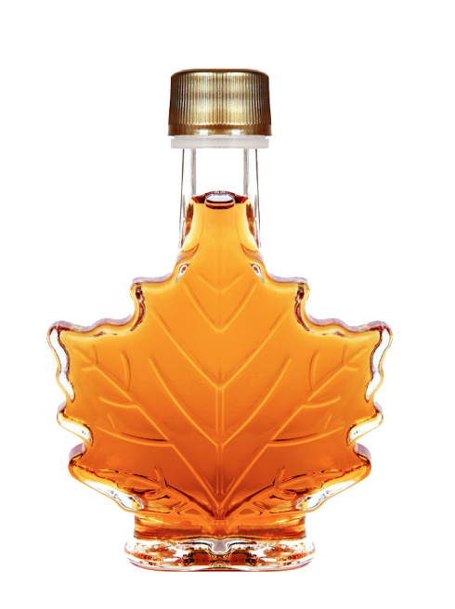
The Maple Syrup Heist Questions

- Who did it?
- What did he do?
- How did he do it?

- How much did he steal?
- Why was he caught?
- What is his punishment?
- What is Quebec’s strategic maple syrup reserve?
- How is maple syrup produced?
- How was restorative justice used in this case?
- Why did the Supreme Court of Canada (Canada’s top court) fine him $9.4mil?
- Why did he want revenge against the Federation of Maple Syrup Producers?
- What did he witness in prison that left him shaken?
- How do you feel about Canada’s prison system?

