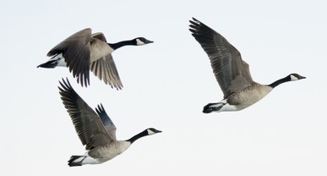
Canadian Geese
Why are they a problem?

How would you get rid of them?

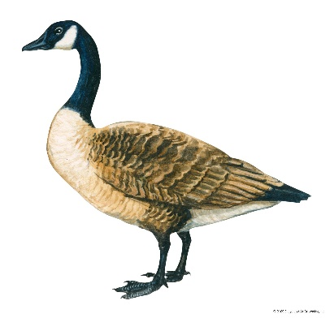

The Canada geese that rode a truck from the 416 to the 506

Wildlife biologists collected 500 birds from Toronto and relocated them to New Brunswick in 1993
CBC Archives · Posted: Jun 24, 2020 8:30 AM ET | Last Updated: June 24, 2021

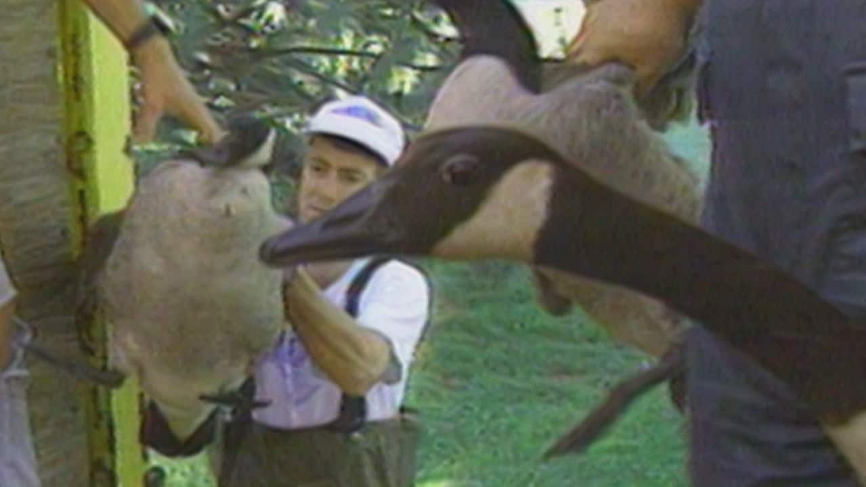
In June 1993, the CBC's Kas Roussy reports on an effort to relocate some Canada geese to New Brunswick. 1:59

Hundreds of Canada geese were heading out east, though it wasn't a typical migration journey.
They were being trucked to New Brunswick in June of 1993, as part of an effort to repopulate provincial wetlands.
The birds had come from Toronto, where some residents were happy to see them move from the 416 to the 506.
"Hogtown couldn't be more pleased," the CBC's Kas Roussy told viewers, when reporting on the Maritimes-bound geese on The National on June 26, 1993.

The 'delight' of N.B.

There were lots of Canada geese living in Toronto at the time that biologists were involved in moving 500 of the birds out to New Brunswick in 1993. (The National/CBC Archives)
It seemed, at the very least, Toronto had enough Canada geese hanging around the city to spare a few for relocation.
But as Roussy pointed out, "Ontario's nuisance is New Brunswick's delight."
The birds arrived in Chipman, N.B., where they were greeted by some locals who wanted to see the incoming feathered New Brunswickers.
"Something should come out of Toronto that's decent," one man joked to Roussy.
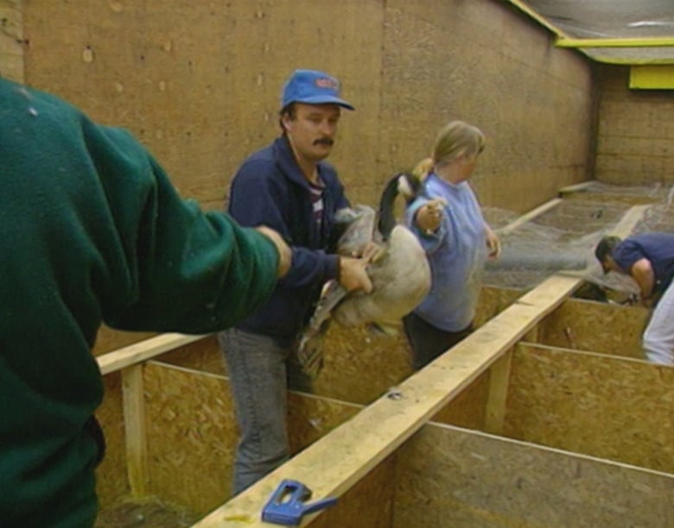
The National reported that 500 Canada geese were being moved from Toronto to New Brunswick, as part of an effort to repopulate provincial wetlands in the Maritime province. (The National/CBC Archives)

Hundreds of messy, unloved geese trucked into Essex County
Just when you might have thought there's already too many of the feathered varmints messing up our riverfront and parklands, hundreds more Canada geese are being shipped into Essex County, literally by the truckload.
Author of the article:
Doug Schmidt • Windsor Star
Publishing date:
Jun 20, 2016 • June 20, 2016 • 3 minute read
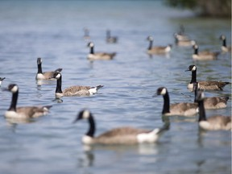
Geese wade in the Detroit River along Windsor's riverfront at McKee Park, Saturday, June 18, 2016. PHOTO BY DAX MELMER /Windsor Star

Just when you might have thought there’s already too many of the feathered varmints messing up our riverfront and parklands, hundreds more Canada geese are being shipped into Essex County, literally by the truckload.
Last week, the City of St. Catharines, sick of the iconic big birds pooping up local lakeside parks and docks, gathered up 500 Canada geese and loaded them on to trailers for special delivery to Amherstburg.
Capturing them at this time of year is relatively easy. The goslings can’t fly yet, and it’s moulting season for the adults, when they lose their flying feathers (Mother Nature’s way of making them better, stay-around parents).
After years of egg oiling, spraying grass with soapy water, habitat modification attempts and even employing exotic measures — letting dogs chase them, deploying dead goose decoys and flashing them with laser pointers — St. Catharines decided to up the ante this year in its war on geese. For the first time, the city received a permit from the Canadian Wildlife Services to forcibly exile the unwanted fowl by truck to parts far removed.
“We’ve got nothing against you guys,” contractor Norm North, who knows geese “really well” and who did the moving, said of dumping that city’s unwanted fowl on Essex County.
Of the 2,000 geese he’ll personally move this season, North said some will be transported relatively short distances. But the 500 shipped locally went to the perfect destination, an Amherstburg farm near wetlands and a hunting club.
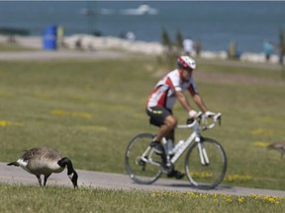
A cyclist passes as a goose grazes on grass along Windsor’s riverfront Sunday, June 19, 2016. PHOTO BY DAX MELMER /Windsor Star
Geese feces litters a boarded walkway at McKee Park, Saturday, June 18, 2016. PHOTO BY DAX MELMER /Windsor Star

North, a former CWS waterfowl specialist, said most of the geese brought to Amherstburg are not from St. Catharines but visitors from places like New York and Pennsylvania. Allow them to nest, settle and raise their families, however, and the city along Lake Ontario could turn into the new home for them and their ever-growing numbers of offspring.

The rise of Canada geese: How the birds bounced back from near extinction
By Adina Bresge The Associated Press
Posted June 30, 2020 11:41 am
Video will begin after these messages...
close video

They came, they honked, they conquered.
Flying in their signature V-formation, Canada geese are often hailed as a symbol of the Canadian wilderness, marking the change of seasons with their southern migration each winter and return every spring.
In recent decades, however, “honkers” have been derided as urban pests as the big, black-necked birds overran new habitats across North America, where in some cases, they’ve taken up residence year-round.
This has given rise to a contentious coexistence: Gaggles of geese swarm public grounds, scattering their droppings across parks and beaches. There are clashes between protective mother geese and unwitting human intruders who stray too close to their nests. Between crop losses and car crashes, one province pegs the cost of goose-related damage at hundreds of thousands of dollars per year.
As Canada Day approaches, experts say we have no one but ourselves to blame for the proliferation of Canada’s avian agitators, so ultimately, it’s up to us to find a way to live in peace.
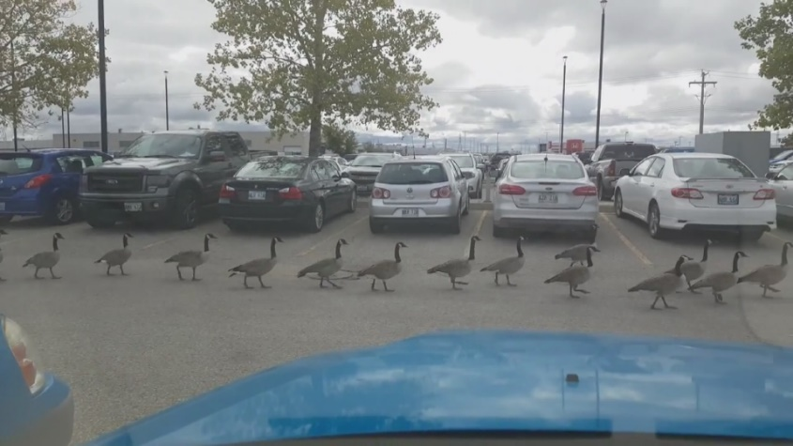o
Convoy of Canadian geese causes parking lot jam – Sep 13, 2016

“Canada geese are very polarizing,” said Christopher Sharp, a population management biologist with the Canadian Wildlife Service in the Ontario region.
“Because there’s a lot of people who hate them … but there’s also a lot of people who still have a soft spot for Canada geese.”
Prior to European colonization, the historical nesting grounds of Canada geese was limited to southwest Ontario and the southern Prairies.
By the turn of the 20th century, Sharp said unregulated hunting drove Canada geese to the brink of extinction from these native habitats.
This prompted a concerted effort by wildlife officials and amateur aviculturists, who bred the birds on their homesteads, to boost the numbers of Canada geese, sometimes introducing them to new areas.

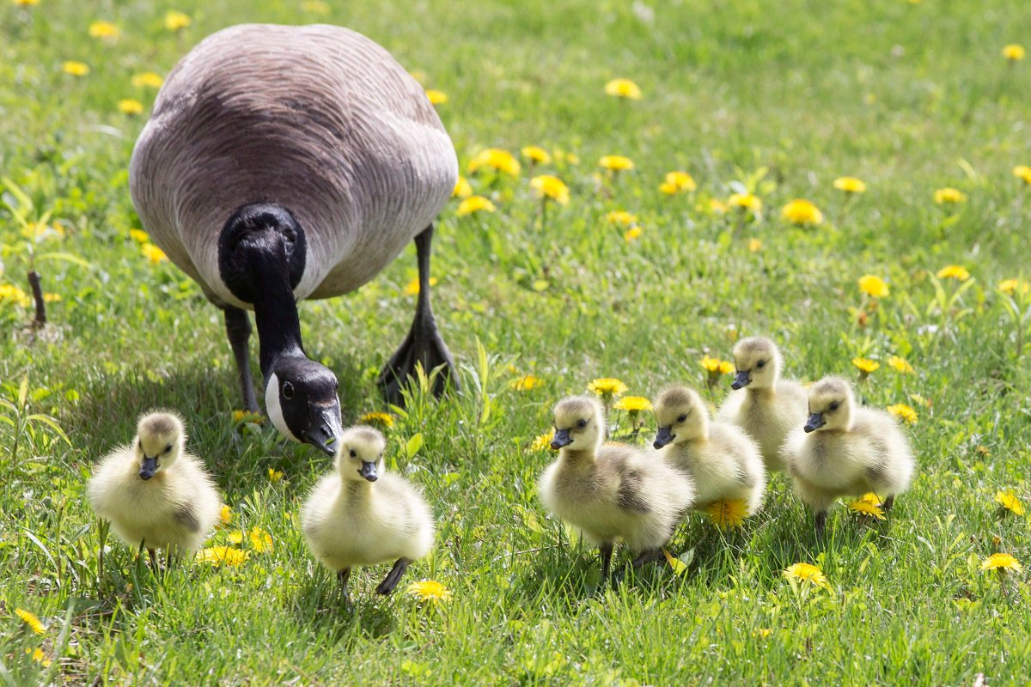
A Canada Goose moves goslings along a lawn in Toronto on Monday, May 14, 2018. THE CANADIAN PRESS/Chris Young

This mission, enshrined in the Migratory Birds Convention between Canada and the U.S. in 1916, coincided with human changes to the natural landscape that would prove to be a boon to the savvy birds, said Sharp.
As forests were razed in favour of commercial crops and manicured lawns and waterfronts, Sharp said Canada geese flocked to these open pastures and “urban refuges” with an abundant supply of food and relatively few predators.
Today, there are an estimated seven million Canada geese living in North America, according to the Canadian Wildlife Service.
In regions with mild climates in much of the U.S. and some parts of Canada, so-called “resident geese” have gotten so comfortable that they’ve stopped migrating to breed and instead stay in the same place throughout the year.
What’s good for the goose, however, isn’t always good for their human neighbours, said Sharp. As the population of Canada geese has boomed, so too has the prevalence of “human-goose conflict.”
“Geese are just doing what geese do,” said Sharp.
“It’s only when you throw humans in the mix that there’s conflict.”
Frank Baldwin, a wildlife biologist with the Canadian Wildlife Service in Manitoba, said the consequences of these conflicts can range from disturbance to damage to danger.
According to the Manitoba Agricultural Services Corporation, crop damage by Canada geese resulted in an average annual compensation claims of more than $416,000 from 2015 to 2018.

Security camera footage shows Canada geese attacking employees at BMW service Centre – May 8, 2019

That doesn’t account for other types of property damage, Baldwin noted, or public nuisances caused by high concentrations of geese, such as noise concerns, droppings and water quality.
Geese can also become aggressive when they believe their nests are under threat, which can cause serious injury, Baldwin said.
They can also be a traffic hazard, he said. From 2015 to 2018, an annual average of approximately $372,528 in car crash claims in Manitoba could be attributed to Canada geese, according to Manitoba Public Insurance.
Canada geese also pose risks to aircraft, said Baldwin. For example, the birds have been blamed for bringing down the jetliner that Chesley “Sully” Sullenberger safely landed on New York’s Hudson River in 2009.
At current growth rates, the number of Canada geese in Manitoba could double in eight years, despite population control efforts such as loosening hunting regulations and egg sterilization programs.
The Canadian Wildlife Service has put forward a proposal to designate temperate-breeding Canada geese in southern Manitoba as “overabundant,” meaning their population size is considered detrimental to the conservation of other migratory birds, as well as agricultural, environmental or other interests.
The move would also establish a spring hunting season for Canada geese with a daily bag limit of eight.
Sharp, the wildlife biologist in Ontario, said the province isn’t considering such drastic measures yet.
The growth rate of the Canada goose population in southern Ontario has levelled off since the mid-2000s, he said.
He noted wildlife officials in the province are working on strategies to reduce clashes between humans and geese in urban areas where hunting is not allowed.
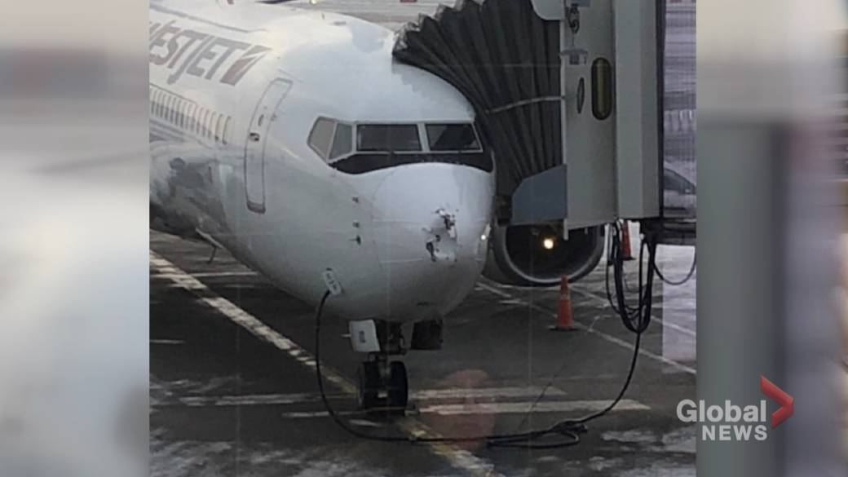1:56WestJet plane heading to Victoria from Calgary makes emergency landing after hitting geese
WestJet plane heading to Victoria from Calgary makes emergency landing after hitting geese – Jan 14, 2020
Between education and habitat modification, Sharp believes there’s potential for waterfowl and city-dwellers to live more harmoniously.
At the risk of anthropomorphism, he admits that Canadians may have more in common with Canada geese than they think.
They provide a connection to nature amid a concrete jungle, and are harbingers of warm weather to come, he said.
Canada geese are social, family-oriented and mate for life (at least to some degree), Sharp said.
“They’re good parents, and these things that humans try to be,” said Sharp.
“I’m a biologist for crying out loud. And still, just looking at them interact, it’s hard not to say, ‘They’re thinking what I’m thinking.’
© 2020 The Canadian Press

